[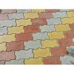zig zag](https://www.google.com/search?q=interlocking+pavers+and+tiles++color+and+hardness&tbm=isch&hl=en&chips=q:interlocking+pavers+and+tiles+color+and+hardness,online_chips:zig+zag:lr6N_3CVKMI%3D&bih=722&biw=1519&rlz=1C1YTUH_enIN1004IN1004&sa=X&ved=2ahUKEwiS7Z-0wZL9AhU3_TgGHdP2CQQQ4lYoAHoECAEQJQ)

[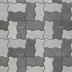wall tiles](https://www.google.com/search?q=interlocking+pavers+and+tiles++color+and+hardness&tbm=isch&hl=en&chips=q:interlocking+pavers+and+tiles+color+and+hardness,online_chips:wall+tiles:F3NsK8jFZmA%3D&bih=722&biw=1519&rlz=1C1YTUH_enIN1004IN1004&sa=X&ved=2ahUKEwiS7Z-0wZL9AhU3_TgGHdP2CQQQ4lYoAXoECAEQJw)

[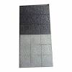vitrified tiles](https://www.google.com/search?q=interlocking+pavers+and+tiles++color+and+hardness&tbm=isch&hl=en&chips=q:interlocking+pavers+and+tiles+color+and+hardness,online_chips:vitrified+tiles:HvUtxenpMf4%3D&bih=722&biw=1519&rlz=1C1YTUH_enIN1004IN1004&sa=X&ved=2ahUKEwiS7Z-0wZL9AhU3_TgGHdP2CQQQ4lYoAnoECAEQKQ)

[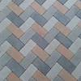paver blocks](https://www.google.com/search?q=interlocking+pavers+and+tiles++color+and+hardness&tbm=isch&hl=en&chips=q:interlocking+pavers+and+tiles+color+and+hardness,online_chips:paver+blocks:sGXc4-lnZgo%3D&bih=722&biw=1519&rlz=1C1YTUH_enIN1004IN1004&sa=X&ved=2ahUKEwiS7Z-0wZL9AhU3_TgGHdP2CQQQ4lYoA3oECAEQKw)

[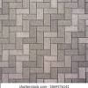interlocking concrete pavers](https://www.google.com/search?q=interlocking+pavers+and+tiles++color+and+hardness&tbm=isch&hl=en&chips=q:interlocking+pavers+and+tiles+color+and+hardness,online_chips:interlocking+concrete+pavers:k3YyZYnnNGQ%3D&bih=722&biw=1519&rlz=1C1YTUH_enIN1004IN1004&sa=X&ved=2ahUKEwiS7Z-0wZL9AhU3_TgGHdP2CQQQ4lYoBHoECAEQLQ)

[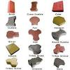floor tiles](https://www.google.com/search?q=interlocking+pavers+and+tiles++color+and+hardness&tbm=isch&hl=en&chips=q:interlocking+pavers+and+tiles+color+and+hardness,online_chips:floor+tiles:fQIpJBUk70A%3D&bih=722&biw=1519&rlz=1C1YTUH_enIN1004IN1004&sa=X&ved=2ahUKEwiS7Z-0wZL9AhU3_TgGHdP2CQQQ4lYoBXoECAEQLw)

[meerut](https://www.google.com/search?q=interlocking+pavers+and+tiles++color+and+hardness&tbm=isch&hl=en&chips=q:interlocking+pavers+and+tiles+color+and+hardness,online_chips:meerut:7fNfNSCZaHk%3D&bih=722&biw=1519&rlz=1C1YTUH_enIN1004IN1004&sa=X&ved=2ahUKEwiS7Z-0wZL9AhU3_TgGHdP2CQQQ4lYoBnoECAEQMQ)

[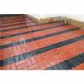chequered tiles](https://www.google.com/search?q=interlocking+pavers+and+tiles++color+and+hardness&tbm=isch&hl=en&chips=q:interlocking+pavers+and+tiles+color+and+hardness,online_chips:chequered+tiles:P3TAFHef1SA%3D&bih=722&biw=1519&rlz=1C1YTUH_enIN1004IN1004&sa=X&ved=2ahUKEwiS7Z-0wZL9AhU3_TgGHdP2CQQQ4lYoB3oECAEQMw)

[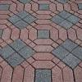dayal](https://www.google.com/search?q=interlocking+pavers+and+tiles++color+and+hardness&tbm=isch&hl=en&chips=q:interlocking+pavers+and+tiles+color+and+hardness,online_chips:dayal:FXt-DV2nZwU%3D&bih=722&biw=1519&rlz=1C1YTUH_enIN1004IN1004&sa=X&ved=2ahUKEwiS7Z-0wZL9AhU3_TgGHdP2CQQQ4lYoCHoECAEQNQ)

[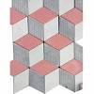cement tiles](https://www.google.com/search?q=interlocking+pavers+and+tiles++color+and+hardness&tbm=isch&hl=en&chips=q:interlocking+pavers+and+tiles+color+and+hardness,online_chips:cement+tiles:pplIxjhljRc%3D&bih=722&biw=1519&rlz=1C1YTUH_enIN1004IN1004&sa=X&ved=2ahUKEwiS7Z-0wZL9AhU3_TgGHdP2CQQQ4lYoCXoECAEQNw)

[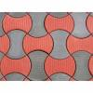indiamart](https://www.google.com/search?q=interlocking+pavers+and+tiles++color+and+hardness&tbm=isch&hl=en&chips=q:interlocking+pavers+and+tiles+color+and+hardness,online_chips:indiamart:TILaESrfxlM%3D&bih=722&biw=1519&rlz=1C1YTUH_enIN1004IN1004&sa=X&ved=2ahUKEwiS7Z-0wZL9AhU3_TgGHdP2CQQQ4lYoCnoECAEQOQ)

[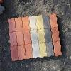zigzag](https://www.google.com/search?q=interlocking+pavers+and+tiles++color+and+hardness&tbm=isch&hl=en&chips=q:interlocking+pavers+and+tiles+color+and+hardness,online_chips:zigzag:vuRMNSAwIv8%3D&bih=722&biw=1519&rlz=1C1YTUH_enIN1004IN1004&sa=X&ved=2ahUKEwiS7Z-0wZL9AhU3_TgGHdP2CQQQ4lYoC3oECAEQOw)

**Search Results**

**Image Results**

**Interlocking Paver Tiles, for Pavement at Rs 25/square feet in Jammu | ID: 16012034155**

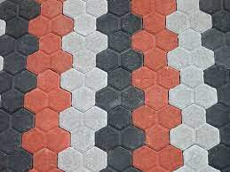

[](https://www.indiamart.com/proddetail/interlocking-paver-tiles-16012034155.html" \o "Interlocking Paver Tiles, for Pavement at Rs 25/square feet in Jammu | ID:  16012034155" \t "_blank)

[IndiaMART](https://www.indiamart.com/proddetail/interlocking-paver-tiles-16012034155.html" \o "Interlocking Paver Tiles, for Pavement at Rs 25/square feet in Jammu | ID:  16012034155" \t "_blank)

[Interlocking Paver Tiles, for Pavement ...](https://www.indiamart.com/proddetail/interlocking-paver-tiles-16012034155.html" \o "Interlocking Paver Tiles, for Pavement at Rs 25/square feet in Jammu | ID:  16012034155" \t "_blank)

**Colored Concrete Interlocking Paver, For Pavement, Thickness: 2.5 Inch at Rs 15/piece in Delhi**

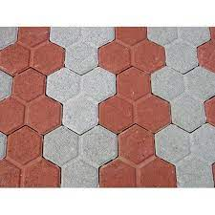

[](https://www.indiamart.com/proddetail/colored-concrete-interlocking-paver-21780876062.html" \o "Colored Concrete Interlocking Paver, For Pavement, Thickness: 2.5 Inch at  Rs 15/piece in Delhi" \t "_blank)

[IndiaMART](https://www.indiamart.com/proddetail/colored-concrete-interlocking-paver-21780876062.html" \o "Colored Concrete Interlocking Paver, For Pavement, Thickness: 2.5 Inch at  Rs 15/piece in Delhi" \t "_blank)

[Colored Concrete Interlocking Paver ...](https://www.indiamart.com/proddetail/colored-concrete-interlocking-paver-21780876062.html" \o "Colored Concrete Interlocking Paver, For Pavement, Thickness: 2.5 Inch at  Rs 15/piece in Delhi" \t "_blank)

**Cemented Footpath Tiles | Paver blocks, Interlocking pavers, Paving design**

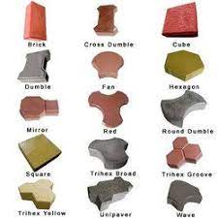

[](https://www.pinterest.com/pin/464293042805320598/" \o "Cemented Footpath Tiles | Paver blocks, Interlocking pavers, Paving design" \t "_blank)

[Pinterest](https://www.pinterest.com/pin/464293042805320598/" \o "Cemented Footpath Tiles | Paver blocks, Interlocking pavers, Paving design" \t "_blank)

[Cemented Footpath Tiles | Paver blocks ...](https://www.pinterest.com/pin/464293042805320598/" \o "Cemented Footpath Tiles | Paver blocks, Interlocking pavers, Paving design" \t "_blank)

**Concrete Red,Grey Interlocking Paver Tiles, For Landscaping, 15-25 mm at Rs 15/piece in Ranchi**

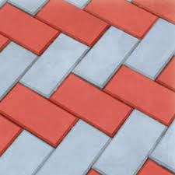

[](https://www.indiamart.com/proddetail/interlocking-paver-tiles-20118936973.html" \o "Concrete Red,Grey Interlocking Paver Tiles, For Landscaping, 15-25 mm at Rs  15/piece in Ranchi" \t "_blank)

[IndiaMART](https://www.indiamart.com/proddetail/interlocking-paver-tiles-20118936973.html" \o "Concrete Red,Grey Interlocking Paver Tiles, For Landscaping, 15-25 mm at Rs  15/piece in Ranchi" \t "_blank)

[Grey Interlocking Paver Tiles ...](https://www.indiamart.com/proddetail/interlocking-paver-tiles-20118936973.html" \o "Concrete Red,Grey Interlocking Paver Tiles, For Landscaping, 15-25 mm at Rs  15/piece in Ranchi" \t "_blank)

**Interlocking Paver Blocks - 300x150x60mm Interlocking Pavers Manufacturer from Gurgaon**

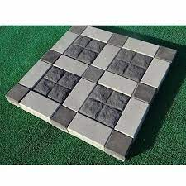

[](https://www.acmeccproducts.net.in/interlocking-paver-blocks.html" \o "Interlocking Paver Blocks - 300x150x60mm Interlocking Pavers Manufacturer  from Gurgaon" \t "_blank)

[Acme CC Products](https://www.acmeccproducts.net.in/interlocking-paver-blocks.html" \o "Interlocking Paver Blocks - 300x150x60mm Interlocking Pavers Manufacturer  from Gurgaon" \t "_blank)

[Interlocking Paver Blocks ...](https://www.acmeccproducts.net.in/interlocking-paver-blocks.html" \o "Interlocking Paver Blocks - 300x150x60mm Interlocking Pavers Manufacturer  from Gurgaon" \t "_blank)

**Top Delhi 50+ Paver Blocks Designs | Block design | interlock pattern | tiles pattern Part - 4 - YouTube**

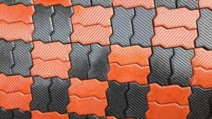

[](https://www.youtube.com/watch?v=kQK88LfYq7k" \o "Top Delhi 50+ Paver Blocks Designs | Block design | interlock pattern |  tiles pattern Part - 4 - YouTube" \t "_blank)

[YouTube](https://www.youtube.com/watch?v=kQK88LfYq7k" \o "Top Delhi 50+ Paver Blocks Designs | Block design | interlock pattern |  tiles pattern Part - 4 - YouTube" \t "_blank)

[Paver Blocks Designs | Block design ...](https://www.youtube.com/watch?v=kQK88LfYq7k" \o "Top Delhi 50+ Paver Blocks Designs | Block design | interlock pattern |  tiles pattern Part - 4 - YouTube" \t "_blank)

**Interlocking Pavers Manufactuer,Interlocking Titles Supplier, Dayal RCC Interlocking Pavers Tiles Manufacturer Meerut**

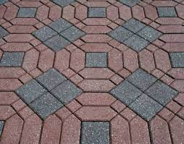

[](https://www.dayalpipes.com/interlockingPavers.html" \o "Interlocking Pavers Manufactuer,Interlocking Titles Supplier, Dayal RCC Interlocking  Pavers Tiles Manufacturer Meerut" \t "_blank)

[RCC Pipes](https://www.dayalpipes.com/interlockingPavers.html" \o "Interlocking Pavers Manufactuer,Interlocking Titles Supplier, Dayal RCC Interlocking  Pavers Tiles Manufacturer Meerut" \t "_blank)

[Interlocking Pavers Manufactuer ...](https://www.dayalpipes.com/interlockingPavers.html" \o "Interlocking Pavers Manufactuer,Interlocking Titles Supplier, Dayal RCC Interlocking  Pavers Tiles Manufacturer Meerut" \t "_blank)

**What are the advantages of interlocking concrete tiles? - Quora**



[](https://www.quora.com/What-are-the-advantages-of-interlocking-concrete-tiles" \o "What are the advantages of interlocking concrete tiles? - Quora" \t "_blank)

[Quora](https://www.quora.com/What-are-the-advantages-of-interlocking-concrete-tiles" \o "What are the advantages of interlocking concrete tiles? - Quora" \t "_blank)

[interlocking concrete tiles ...](https://www.quora.com/What-are-the-advantages-of-interlocking-concrete-tiles" \o "What are the advantages of interlocking concrete tiles? - Quora" \t "_blank)

**887 Interlocking Concrete Pavers Images, Stock Photos & Vectors | Shutterstock**

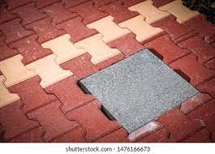

[](https://www.shutterstock.com/search/interlocking-concrete-pavers" \o "887 Interlocking Concrete Pavers Images, Stock Photos & Vectors |  Shutterstock" \t "_blank)

[Shutterstock](https://www.shutterstock.com/search/interlocking-concrete-pavers" \o "887 Interlocking Concrete Pavers Images, Stock Photos & Vectors |  Shutterstock" \t "_blank)

[887 Interlocking Concrete Pavers Images ...](https://www.shutterstock.com/search/interlocking-concrete-pavers" \o "887 Interlocking Concrete Pavers Images, Stock Photos & Vectors |  Shutterstock" \t "_blank)

**New colors for Interlocking pavers... - Jain Tiles Industries | Facebook**

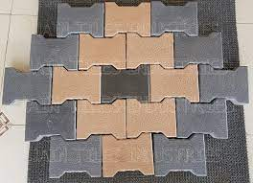

[](https://www.facebook.com/Jaintilesindustries/posts/new-colors-for-interlocking-pavers-i-shapecolors-almond-brown-grey-black-slatebr/4508943179145320/" \o "New colors for Interlocking pavers... - Jain Tiles Industries | Facebook" \t "_blank)

[Facebook](https://www.facebook.com/Jaintilesindustries/posts/new-colors-for-interlocking-pavers-i-shapecolors-almond-brown-grey-black-slatebr/4508943179145320/" \o "New colors for Interlocking pavers... - Jain Tiles Industries | Facebook" \t "_blank)

[New colors for Interlocking pavers ...](https://www.facebook.com/Jaintilesindustries/posts/new-colors-for-interlocking-pavers-i-shapecolors-almond-brown-grey-black-slatebr/4508943179145320/" \o "New colors for Interlocking pavers... - Jain Tiles Industries | Facebook" \t "_blank)

**Interlocking Pavers Manufactuer,Interlocking Titles Supplier, Dayal RCC Interlocking Pavers Tiles Manufacturer Meerut**

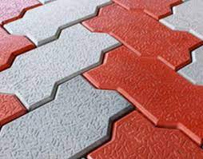

[](https://www.dayalpipes.com/interlockingPavers.html" \o "Interlocking Pavers Manufactuer,Interlocking Titles Supplier, Dayal RCC Interlocking  Pavers Tiles Manufacturer Meerut" \t "_blank)

[RCC Pipes](https://www.dayalpipes.com/interlockingPavers.html" \o "Interlocking Pavers Manufactuer,Interlocking Titles Supplier, Dayal RCC Interlocking  Pavers Tiles Manufacturer Meerut" \t "_blank)

[Interlocking Pavers Manufactuer ...](https://www.dayalpipes.com/interlockingPavers.html" \o "Interlocking Pavers Manufactuer,Interlocking Titles Supplier, Dayal RCC Interlocking  Pavers Tiles Manufacturer Meerut" \t "_blank)

**Pure Garden Polypropylene Patio and Deck Tiles Interlocking Look Outdoor Flooring Pavers Weather Resistant and Anti-slip Square DIY Mat (Brick Red), 6 Pack : Amazon.in: Home & Kitchen**

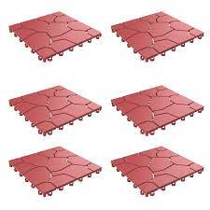

[](https://www.amazon.in/Pure-Garden-Interlocking-Resistant-Anti-slip/dp/B07N26R4ZX" \o "Pure Garden Polypropylene Patio and Deck Tiles Interlocking Look Outdoor  Flooring Pavers Weather Resistant and Anti-slip Square DIY Mat (Brick Red),  6 Pack : Amazon.in: Home & Kitchen" \t "_blank)

[Amazon.in](https://www.amazon.in/Pure-Garden-Interlocking-Resistant-Anti-slip/dp/B07N26R4ZX" \o "Pure Garden Polypropylene Patio and Deck Tiles Interlocking Look Outdoor  Flooring Pavers Weather Resistant and Anti-slip Square DIY Mat (Brick Red),  6 Pack : Amazon.in: Home & Kitchen" \t "_blank)

[Outdoor Flooring Pavers ...](https://www.amazon.in/Pure-Garden-Interlocking-Resistant-Anti-slip/dp/B07N26R4ZX" \o "Pure Garden Polypropylene Patio and Deck Tiles Interlocking Look Outdoor  Flooring Pavers Weather Resistant and Anti-slip Square DIY Mat (Brick Red),  6 Pack : Amazon.in: Home & Kitchen" \t "_blank)

**Top Interlocking Paver Tile Manufacturers in Delhi - इंटरलॉकिंग पावेर टाइल मनुफक्चरर्स, दिल्ली - Justdial**

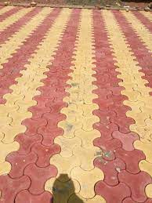

[](https://www.justdial.com/Delhi/Interlocking-Paver-Tile-Manufacturers/nct-10951868" \o "Top Interlocking Paver Tile Manufacturers in Delhi - इंटरलॉकिंग पावेर टाइल  मनुफक्चरर्स, दिल्ली - Justdial" \t "_blank)

[Justdial](https://www.justdial.com/Delhi/Interlocking-Paver-Tile-Manufacturers/nct-10951868" \o "Top Interlocking Paver Tile Manufacturers in Delhi - इंटरलॉकिंग पावेर टाइल  मनुफक्चरर्स, दिल्ली - Justdial" \t "_blank)

[Interlocking Paver Tile Manufacturers ...](https://www.justdial.com/Delhi/Interlocking-Paver-Tile-Manufacturers/nct-10951868" \o "Top Interlocking Paver Tile Manufacturers in Delhi - इंटरलॉकिंग पावेर टाइल  मनुफक्चरर्स, दिल्ली - Justdial" \t "_blank)

**Paver Blocks - Interlocking Concrete Paver Block Wholesale Trader from Chennai**

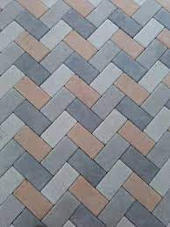

[](https://www.techno-design.co.in/paver-blocks.html" \o "Paver Blocks - Interlocking Concrete Paver Block Wholesale Trader from  Chennai" \t "_blank)

[Techno Design](https://www.techno-design.co.in/paver-blocks.html" \o "Paver Blocks - Interlocking Concrete Paver Block Wholesale Trader from  Chennai" \t "_blank)

[Interlocking Concrete Paver Block ...](https://www.techno-design.co.in/paver-blocks.html" \o "Paver Blocks - Interlocking Concrete Paver Block Wholesale Trader from  Chennai" \t "_blank)

**Vel Murugan Paver Blocks Manufacturing & Marketing Unit - Manufacturer of Paver Block & Rubber Paver from Chennai**

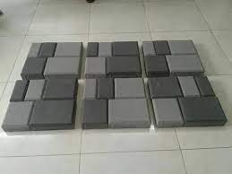

[](https://www.paverblockschennai.com/" \o "Vel Murugan Paver Blocks Manufacturing & Marketing Unit - Manufacturer of  Paver Block & Rubber Paver from Chennai" \t "_blank)

[www.paverblockschennai.com](https://www.paverblockschennai.com/" \o "Vel Murugan Paver Blocks Manufacturing & Marketing Unit - Manufacturer of  Paver Block & Rubber Paver from Chennai" \t "_blank)

[Vel Murugan Paver Blocks Manufacturing ...](https://www.paverblockschennai.com/" \o "Vel Murugan Paver Blocks Manufacturing & Marketing Unit - Manufacturer of  Paver Block & Rubber Paver from Chennai" \t "_blank)

**Interlocking Tiles Buy Online in Gurgaon, Order Online in Delhi NCR**

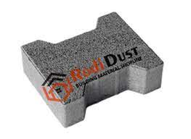

[](https://www.rodidust.com/interlocking-floor-tiles.html" \o "Interlocking Tiles Buy Online in Gurgaon, Order Online in Delhi NCR" \t "_blank)

[Rodi Dust](https://www.rodidust.com/interlocking-floor-tiles.html" \o "Interlocking Tiles Buy Online in Gurgaon, Order Online in Delhi NCR" \t "_blank)

[Interlocking Tiles Buy Online in ...](https://www.rodidust.com/interlocking-floor-tiles.html" \o "Interlocking Tiles Buy Online in Gurgaon, Order Online in Delhi NCR" \t "_blank)

**What are interlocking paver blocks? - their advantages & disadvantages. ~ PARAM VISIONS**

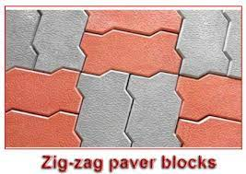

[PARAM VISIONS](https://www.paramvisions.com/2021/08/what-are-interlocking-paver-blocks.html" \o "What are interlocking paver blocks? - their advantages & disadvantages. ~  PARAM VISIONS" \t "_blank)

[What are interlocking paver blocks ...](https://www.paramvisions.com/2021/08/what-are-interlocking-paver-blocks.html" \o "What are interlocking paver blocks? - their advantages & disadvantages. ~  PARAM VISIONS" \t "_blank)

**1,591 Interlocking Paver Images, Stock Photos & Vectors | Shutterstock**

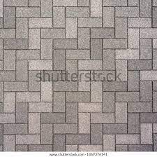

[](https://www.shutterstock.com/search/interlocking-paver" \o "1,591 Interlocking Paver Images, Stock Photos & Vectors | Shutterstock" \t "_blank)

[Shutterstock](https://www.shutterstock.com/search/interlocking-paver" \o "1,591 Interlocking Paver Images, Stock Photos & Vectors | Shutterstock" \t "_blank)

[1,591 Interlocking Paver Images, Stock ...](https://www.shutterstock.com/search/interlocking-paver" \o "1,591 Interlocking Paver Images, Stock Photos & Vectors | Shutterstock" \t "_blank)

**Terracon Tiles - Paving Tiles Manufacturers in Kerala, Thrissur, Paver Blocks Design, Outdoor floor tiles Product company, Ernakulam, Kottayam, Kochi**

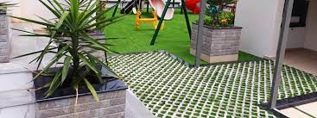

[[](http://www.terracontilesindia.com/)](http://www.terracontilesindia.com/" \o "Terracon Tiles - Paving Tiles Manufacturers in Kerala, Thrissur, Paver  Blocks Design, Outdoor floor tiles Product company, Ernakulam, Kottayam,  Kochi" \t "_blank)

[www.terracontilesindia.com](http://www.terracontilesindia.com/" \o "Terracon Tiles - Paving Tiles Manufacturers in Kerala, Thrissur, Paver  Blocks Design, Outdoor floor tiles Product company, Ernakulam, Kottayam,  Kochi" \t "_blank)

[Terracon Tiles - Paving Tiles ...](http://www.terracontilesindia.com/" \o "Terracon Tiles - Paving Tiles Manufacturers in Kerala, Thrissur, Paver  Blocks Design, Outdoor floor tiles Product company, Ernakulam, Kottayam,  Kochi" \t "_blank)

**551 Interlocking Paving Stone Stock Photos and Images - 123RF**

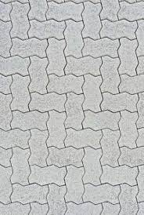

[](https://www.123rf.com/stock-photo/interlocking_paving_stone.html" \o "551 Interlocking Paving Stone Stock Photos and Images - 123RF" \t "_blank)

[123RF](https://www.123rf.com/stock-photo/interlocking_paving_stone.html" \o "551 Interlocking Paving Stone Stock Photos and Images - 123RF" \t "_blank)

[551 Interlocking Paving Stone Stock ...](https://www.123rf.com/stock-photo/interlocking_paving_stone.html" \o "551 Interlocking Paving Stone Stock Photos and Images - 123RF" \t "_blank)

**Interlocking Pavers Images – Browse 862 Stock Photos, Vectors, and Video | Adobe Stock**

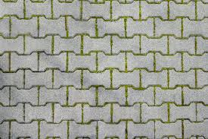

[[](https://stock.adobe.com/search?k=interlocking+pavers)](https://stock.adobe.com/search?k=interlocking+pavers" \o "Interlocking Pavers Images – Browse 862 Stock Photos, Vectors, and Video |  Adobe Stock" \t "_blank)

[Adobe Stock](https://stock.adobe.com/search?k=interlocking+pavers" \o "Interlocking Pavers Images – Browse 862 Stock Photos, Vectors, and Video |  Adobe Stock" \t "_blank)

[Interlocking Pavers Images – Browse 862 ...](https://stock.adobe.com/search?k=interlocking+pavers" \o "Interlocking Pavers Images – Browse 862 Stock Photos, Vectors, and Video |  Adobe Stock" \t "_blank)

**Pavers India - Interlocking Pavers | Paver Block Manufacturers | Paver Blocks Price**

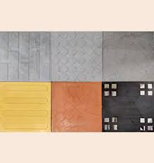

[[](https://www.paversindia.com/)](https://www.paversindia.com/" \o "Pavers India - Interlocking Pavers | Paver Block Manufacturers | Paver  Blocks Price" \t "_blank)

[www.paversindia.com](https://www.paversindia.com/" \o "Pavers India - Interlocking Pavers | Paver Block Manufacturers | Paver  Blocks Price" \t "_blank)

[Pavers India - Interlocking Pavers ...](https://www.paversindia.com/" \o "Pavers India - Interlocking Pavers | Paver Block Manufacturers | Paver  Blocks Price" \t "_blank)

**Concrete Paver Block And Tiles Making Process. | RED IRON OXIDE PIGMENT, INTERLOCKING TILE MAKING MACHINE, PAVER MOULD**

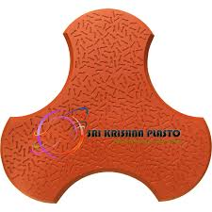

[[](https://srikrishnaplasto.com/interlocking-pvc-paver-mould/concrete-paver-block-and-tiles-making-process.html)](https://srikrishnaplasto.com/interlocking-pvc-paver-mould/concrete-paver-block-and-tiles-making-process.html" \o "Concrete Paver Block And Tiles Making Process. | RED IRON OXIDE PIGMENT, INTERLOCKING  TILE MAKING MACHINE, PAVER MOULD" \t "_blank)

[RED IRON OXIDE PIGMENT, INTERLOCKING TILE MAKING MACHINE, PAVER MOULD](https://srikrishnaplasto.com/interlocking-pvc-paver-mould/concrete-paver-block-and-tiles-making-process.html" \o "Concrete Paver Block And Tiles Making Process. | RED IRON OXIDE PIGMENT, INTERLOCKING  TILE MAKING MACHINE, PAVER MOULD" \t "_blank)

[Concrete Paver Block And Tiles Making ...](https://srikrishnaplasto.com/interlocking-pvc-paver-mould/concrete-paver-block-and-tiles-making-process.html" \o "Concrete Paver Block And Tiles Making Process. | RED IRON OXIDE PIGMENT, INTERLOCKING  TILE MAKING MACHINE, PAVER MOULD" \t "_blank)

**Grey And Yellow Concrete Colored Zig Zag Interlocking Paver Block, 80 mm at Rs 16/piece in Patna**

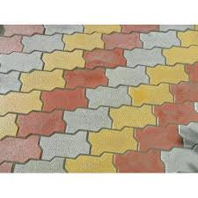

[[](https://www.indiamart.com/proddetail/colored-zig-zag-interlocking-paver-block-19056547962.html)](https://www.indiamart.com/proddetail/colored-zig-zag-interlocking-paver-block-19056547962.html" \o "Grey And Yellow Concrete Colored Zig Zag Interlocking Paver Block, 80 mm at  Rs 16/piece in Patna" \t "_blank)

[IndiaMART](https://www.indiamart.com/proddetail/colored-zig-zag-interlocking-paver-block-19056547962.html" \o "Grey And Yellow Concrete Colored Zig Zag Interlocking Paver Block, 80 mm at  Rs 16/piece in Patna" \t "_blank)

[Zig Zag Interlocking Paver Block ...](https://www.indiamart.com/proddetail/colored-zig-zag-interlocking-paver-block-19056547962.html" \o "Grey And Yellow Concrete Colored Zig Zag Interlocking Paver Block, 80 mm at  Rs 16/piece in Patna" \t "_blank)

Related searches

[[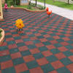](https://www.google.com/search?q=outdoor+interlocking+tiles&tbm=isch&hl=en&bih=722&biw=1519&rlz=1C1YTUH_enIN1004IN1004&sa=X&ved=2ahUKEwiS7Z-0wZL9AhU3_TgGHdP2CQQQrNwCKAB6BQgBEPIB)](https://www.google.com/search?q=outdoor+interlocking+tiles&tbm=isch&hl=en&bih=722&biw=1519&rlz=1C1YTUH_enIN1004IN1004&sa=X&ved=2ahUKEwiS7Z-0wZL9AhU3_TgGHdP2CQQQrNwCKAB6BQgBEPIB)

**[outdoor](https://www.google.com/search?q=outdoor+interlocking+tiles&tbm=isch&hl=en&bih=722&biw=1519&rlz=1C1YTUH_enIN1004IN1004&sa=X&ved=2ahUKEwiS7Z-0wZL9AhU3_TgGHdP2CQQQrNwCKAB6BQgBEPIB)**[interlocking tiles](https://www.google.com/search?q=outdoor+interlocking+tiles&tbm=isch&hl=en&bih=722&biw=1519&rlz=1C1YTUH_enIN1004IN1004&sa=X&ved=2ahUKEwiS7Z-0wZL9AhU3_TgGHdP2CQQQrNwCKAB6BQgBEPIB)

[[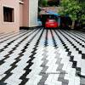](https://www.google.com/search?q=outdoor+interlock+tiles+design&tbm=isch&hl=en&bih=722&biw=1519&rlz=1C1YTUH_enIN1004IN1004&sa=X&ved=2ahUKEwiS7Z-0wZL9AhU3_TgGHdP2CQQQrNwCKAB6BQgBEPQB)](https://www.google.com/search?q=outdoor+interlock+tiles+design&tbm=isch&hl=en&bih=722&biw=1519&rlz=1C1YTUH_enIN1004IN1004&sa=X&ved=2ahUKEwiS7Z-0wZL9AhU3_TgGHdP2CQQQrNwCKAB6BQgBEPQB)

**[outdoor interlock](https://www.google.com/search?q=outdoor+interlock+tiles+design&tbm=isch&hl=en&bih=722&biw=1519&rlz=1C1YTUH_enIN1004IN1004&sa=X&ved=2ahUKEwiS7Z-0wZL9AhU3_TgGHdP2CQQQrNwCKAB6BQgBEPQB)**[tiles](https://www.google.com/search?q=outdoor+interlock+tiles+design&tbm=isch&hl=en&bih=722&biw=1519&rlz=1C1YTUH_enIN1004IN1004&sa=X&ved=2ahUKEwiS7Z-0wZL9AhU3_TgGHdP2CQQQrNwCKAB6BQgBEPQB)**[design](https://www.google.com/search?q=outdoor+interlock+tiles+design&tbm=isch&hl=en&bih=722&biw=1519&rlz=1C1YTUH_enIN1004IN1004&sa=X&ved=2ahUKEwiS7Z-0wZL9AhU3_TgGHdP2CQQQrNwCKAB6BQgBEPQB)**

[[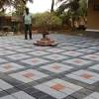](https://www.google.com/search?q=interlocking+paver+block+design&tbm=isch&hl=en&bih=722&biw=1519&rlz=1C1YTUH_enIN1004IN1004&sa=X&ved=2ahUKEwiS7Z-0wZL9AhU3_TgGHdP2CQQQrNwCKAB6BQgBEPYB)](https://www.google.com/search?q=interlocking+paver+block+design&tbm=isch&hl=en&bih=722&biw=1519&rlz=1C1YTUH_enIN1004IN1004&sa=X&ved=2ahUKEwiS7Z-0wZL9AhU3_TgGHdP2CQQQrNwCKAB6BQgBEPYB)

[interlocking](https://www.google.com/search?q=interlocking+paver+block+design&tbm=isch&hl=en&bih=722&biw=1519&rlz=1C1YTUH_enIN1004IN1004&sa=X&ved=2ahUKEwiS7Z-0wZL9AhU3_TgGHdP2CQQQrNwCKAB6BQgBEPYB)**[paver block design](https://www.google.com/search?q=interlocking+paver+block+design&tbm=isch&hl=en&bih=722&biw=1519&rlz=1C1YTUH_enIN1004IN1004&sa=X&ved=2ahUKEwiS7Z-0wZL9AhU3_TgGHdP2CQQQrNwCKAB6BQgBEPYB)**

**Image Results**

**Did you Know the Disadvantages of Interlocking Paver Block?**

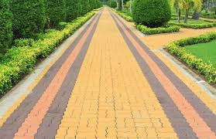

[[](https://gharpedia.com/blog/disadvantages-of-interlocking-paver-block/)](https://gharpedia.com/blog/disadvantages-of-interlocking-paver-block/" \o "Did you Know the Disadvantages of Interlocking Paver Block?" \t "_blank)

[Gharpedia](https://gharpedia.com/blog/disadvantages-of-interlocking-paver-block/" \o "Did you Know the Disadvantages of Interlocking Paver Block?" \t "_blank)

[Interlocking Paver Block ...](https://gharpedia.com/blog/disadvantages-of-interlocking-paver-block/" \o "Did you Know the Disadvantages of Interlocking Paver Block?" \t "_blank)

**Available many colors Interlocking Paver Block at best price INR 280 / Square Meter in Gurugram Haryana from Saraswati Tiles | ID:5666655**

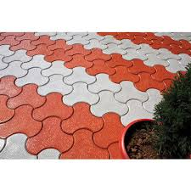

[[](https://www.exportersindia.com/product-detail/available-many-colors-interlocking-paver-block-5666655.htm)](https://www.exportersindia.com/product-detail/available-many-colors-interlocking-paver-block-5666655.htm" \o "Available many colors Interlocking Paver Block at best price INR 280 /  Square Meter in Gurugram Haryana from Saraswati Tiles | ID:5666655" \t "_blank)

[Exporters India](https://www.exportersindia.com/product-detail/available-many-colors-interlocking-paver-block-5666655.htm" \o "Available many colors Interlocking Paver Block at best price INR 280 /  Square Meter in Gurugram Haryana from Saraswati Tiles | ID:5666655" \t "_blank)

[colors Interlocking Paver Block ...](https://www.exportersindia.com/product-detail/available-many-colors-interlocking-paver-block-5666655.htm" \o "Available many colors Interlocking Paver Block at best price INR 280 /  Square Meter in Gurugram Haryana from Saraswati Tiles | ID:5666655" \t "_blank)

**interlocking Floor Tile Red Paint | Kerbstone Mould | Paver Mould | Interlocking Tiles Paver Mould**



[[](https://www.srikrishnaoverseas.com/products/paints/interlocking-floor-tile-red-paint)](https://www.srikrishnaoverseas.com/products/paints/interlocking-floor-tile-red-paint" \o "interlocking Floor Tile Red Paint | Kerbstone Mould | Paver Mould | Interlocking  Tiles Paver Mould" \t "_blank)

[Paver Block Making Machine](https://www.srikrishnaoverseas.com/products/paints/interlocking-floor-tile-red-paint" \o "interlocking Floor Tile Red Paint | Kerbstone Mould | Paver Mould | Interlocking  Tiles Paver Mould" \t "_blank)

[interlocking Floor Tile Red Paint ...](https://www.srikrishnaoverseas.com/products/paints/interlocking-floor-tile-red-paint" \o "interlocking Floor Tile Red Paint | Kerbstone Mould | Paver Mould | Interlocking  Tiles Paver Mould" \t "_blank)

**Interlocking Tile Color - Manufacturers in India**



[[](https://www.interlockingtilesmachine.com/interlocking-tile-color.html)](https://www.interlockingtilesmachine.com/interlocking-tile-color.html" \o "Interlocking Tile Color - Manufacturers in India" \t "_blank)

[Interlocking Tiles Making Machine](https://www.interlockingtilesmachine.com/interlocking-tile-color.html" \o "Interlocking Tile Color - Manufacturers in India" \t "_blank)

[Interlocking Tile Color - Manufacturers ...](https://www.interlockingtilesmachine.com/interlocking-tile-color.html" \o "Interlocking Tile Color - Manufacturers in India" \t "_blank)

**Grass Pavers Manufacturers and supplier in Delhi - Pavers India**

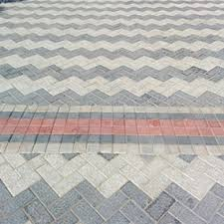

[[](https://www.paversindia.com/product/paving-blocks)](https://www.paversindia.com/product/paving-blocks" \o "Grass Pavers Manufacturers and supplier in Delhi - Pavers India" \t "_blank)

[Pavers India](https://www.paversindia.com/product/paving-blocks" \o "Grass Pavers Manufacturers and supplier in Delhi - Pavers India" \t "_blank)

[Grass Pavers Manufacturers and supplier ...](https://www.paversindia.com/product/paving-blocks" \o "Grass Pavers Manufacturers and supplier in Delhi - Pavers India" \t "_blank)

**Square And Brick Paver Block Combination in 2023 | Paving design, Paver blocks, Precast concrete**

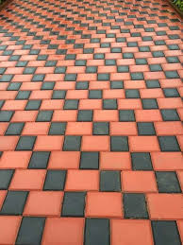

[[](https://in.pinterest.com/pin/291326669656657746/)](https://in.pinterest.com/pin/291326669656657746/" \o "Square And Brick Paver Block Combination in 2023 | Paving design, Paver  blocks, Precast concrete" \t "_blank)

[Pinterest](https://in.pinterest.com/pin/291326669656657746/" \o "Square And Brick Paver Block Combination in 2023 | Paving design, Paver  blocks, Precast concrete" \t "_blank)

[Square And Brick Paver Block ...](https://in.pinterest.com/pin/291326669656657746/" \o "Square And Brick Paver Block Combination in 2023 | Paving design, Paver  blocks, Precast concrete" \t "_blank)

**Terracon Tiles - Paving Tiles Manufacturers in Kerala, Thrissur, Paver Blocks Design, Outdoor floor tiles Product company, Ernakulam, Kottayam, Kochi**

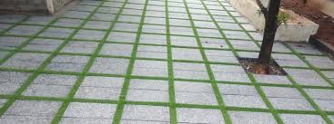

[[](http://www.terracontilesindia.com/)](http://www.terracontilesindia.com/" \o "Terracon Tiles - Paving Tiles Manufacturers in Kerala, Thrissur, Paver  Blocks Design, Outdoor floor tiles Product company, Ernakulam, Kottayam,  Kochi" \t "_blank)

[www.terracontilesindia.com](http://www.terracontilesindia.com/" \o "Terracon Tiles - Paving Tiles Manufacturers in Kerala, Thrissur, Paver  Blocks Design, Outdoor floor tiles Product company, Ernakulam, Kottayam,  Kochi" \t "_blank)

[Terracon Tiles - Paving Tiles ...](http://www.terracontilesindia.com/" \o "Terracon Tiles - Paving Tiles Manufacturers in Kerala, Thrissur, Paver  Blocks Design, Outdoor floor tiles Product company, Ernakulam, Kottayam,  Kochi" \t "_blank)

**New colors for Interlocking pavers... - Jain Tiles Industries | Facebook**

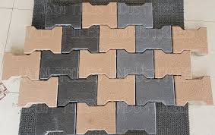

[[](https://www.facebook.com/Jaintilesindustries/posts/new-colors-for-interlocking-pavers-i-shapecolors-almond-brown-grey-black-slatebr/4508943179145320/)](https://www.facebook.com/Jaintilesindustries/posts/new-colors-for-interlocking-pavers-i-shapecolors-almond-brown-grey-black-slatebr/4508943179145320/" \o "New colors for Interlocking pavers... - Jain Tiles Industries | Facebook" \t "_blank)

[Facebook](https://www.facebook.com/Jaintilesindustries/posts/new-colors-for-interlocking-pavers-i-shapecolors-almond-brown-grey-black-slatebr/4508943179145320/" \o "New colors for Interlocking pavers... - Jain Tiles Industries | Facebook" \t "_blank)

[New colors for Interlocking pavers ...](https://www.facebook.com/Jaintilesindustries/posts/new-colors-for-interlocking-pavers-i-shapecolors-almond-brown-grey-black-slatebr/4508943179145320/" \o "New colors for Interlocking pavers... - Jain Tiles Industries | Facebook" \t "_blank)

**Best Fly Ash Bricks In Coimbatore | Udayam Flyash Bricks**

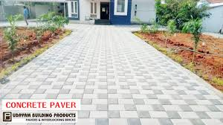

[[](https://www.udayampavers.com/)](https://www.udayampavers.com/" \o "Best Fly Ash Bricks In Coimbatore | Udayam Flyash Bricks" \t "_blank)

[www.udayampavers.com](https://www.udayampavers.com/" \o "Best Fly Ash Bricks In Coimbatore | Udayam Flyash Bricks" \t "_blank)

[Best Fly Ash Bricks In Coimbatore ...](https://www.udayampavers.com/" \o "Best Fly Ash Bricks In Coimbatore | Udayam Flyash Bricks" \t "_blank)

**Interlocking Concrete Tile Manufacturer from Noida**

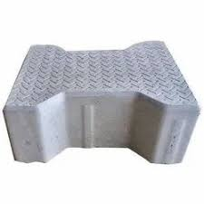

[[](https://www.jcctiles.in/interlocking-concrete-tile.html)](https://www.jcctiles.in/interlocking-concrete-tile.html" \o "Interlocking Concrete Tile Manufacturer from Noida" \t "_blank)

[Jcc Tiles Private Limited](https://www.jcctiles.in/interlocking-concrete-tile.html" \o "Interlocking Concrete Tile Manufacturer from Noida" \t "_blank)

[Interlocking Concrete Tile Manufacturer ...](https://www.jcctiles.in/interlocking-concrete-tile.html" \o "Interlocking Concrete Tile Manufacturer from Noida" \t "_blank)

**Cement Interlocking Tiles - Colored Cement Interlocking Tiles Manufacturer from Jaipur**

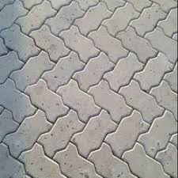

[Ankit Traders](https://www.ankittraders.in/cement-interlocking-tiles.html" \o "Cement Interlocking Tiles - Colored Cement Interlocking Tiles Manufacturer  from Jaipur" \t "_blank)

[Colored Cement Interlocking Tiles ...](https://www.ankittraders.in/cement-interlocking-tiles.html" \o "Cement Interlocking Tiles - Colored Cement Interlocking Tiles Manufacturer  from Jaipur" \t "_blank)

**Concrete Paving Tiles Kottayam | Interlocking Pavers in Kerala | V-CON**

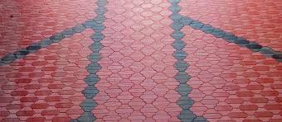

[[](https://www.citymapia.com/kottayam/v-con-industries/product/galaxy-607)](https://www.citymapia.com/kottayam/v-con-industries/product/galaxy-607" \o "Concrete Paving Tiles Kottayam | Interlocking Pavers in Kerala | V-CON" \t "_blank)

[Citymapia](https://www.citymapia.com/kottayam/v-con-industries/product/galaxy-607" \o "Concrete Paving Tiles Kottayam | Interlocking Pavers in Kerala | V-CON" \t "_blank)

[Concrete Paving Tiles Kottayam ...](https://www.citymapia.com/kottayam/v-con-industries/product/galaxy-607" \o "Concrete Paving Tiles Kottayam | Interlocking Pavers in Kerala | V-CON" \t "_blank)

**Interlock Paver Blocks| Paver Block Designs| Interlock Tiles Design - YouTube**

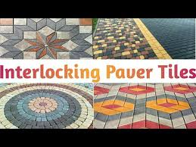

[[](https://www.youtube.com/watch?v=k7zGGjyfgyM)](https://www.youtube.com/watch?v=k7zGGjyfgyM" \o "Interlock Paver Blocks| Paver Block Designs| Interlock Tiles Design -  YouTube" \t "_blank)

[YouTube](https://www.youtube.com/watch?v=k7zGGjyfgyM" \o "Interlock Paver Blocks| Paver Block Designs| Interlock Tiles Design -  YouTube" \t "_blank)

[Interlock Paver Blocks| Paver Block ...](https://www.youtube.com/watch?v=k7zGGjyfgyM" \o "Interlock Paver Blocks| Paver Block Designs| Interlock Tiles Design -  YouTube" \t "_blank)

**Purchase a wide range of tiles and interlocking pavers from krishna pre feb! by Krishna Prefeb - Issuu**

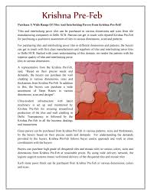

[[](https://issuu.com/krishnaprefeb/docs/purchase_a_wide_range_of_tiles_and_)](https://issuu.com/krishnaprefeb/docs/purchase_a_wide_range_of_tiles_and_" \o "Purchase a wide range of tiles and interlocking pavers from krishna pre  feb! by Krishna Prefeb - Issuu" \t "_blank)

[Issuu](https://issuu.com/krishnaprefeb/docs/purchase_a_wide_range_of_tiles_and_" \o "Purchase a wide range of tiles and interlocking pavers from krishna pre  feb! by Krishna Prefeb - Issuu" \t "_blank)

[tiles and interlocking pavers ...](https://issuu.com/krishnaprefeb/docs/purchase_a_wide_range_of_tiles_and_" \o "Purchase a wide range of tiles and interlocking pavers from krishna pre  feb! by Krishna Prefeb - Issuu" \t "_blank)

**551 Interlocking Paving Stone Stock Photos and Images - 123RF**

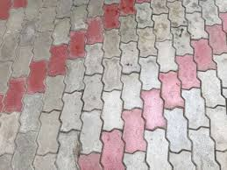

[[](https://www.123rf.com/stock-photo/interlocking_paving_stone.html)](https://www.123rf.com/stock-photo/interlocking_paving_stone.html" \o "551 Interlocking Paving Stone Stock Photos and Images - 123RF" \t "_blank)

[123RF](https://www.123rf.com/stock-photo/interlocking_paving_stone.html" \o "551 Interlocking Paving Stone Stock Photos and Images - 123RF" \t "_blank)

[551 Interlocking Paving Stone Stock ...](https://www.123rf.com/stock-photo/interlocking_paving_stone.html" \o "551 Interlocking Paving Stone Stock Photos and Images - 123RF" \t "_blank)

**Colorfull Interlocking Paver Size: 60 Mm at Best Price in Gurugram | Acme Cc Products**

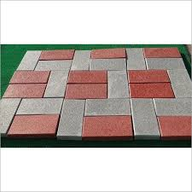

[[](https://www.tradeindia.com/products/colorfull-interlocking-paver-c5211474.html)](https://www.tradeindia.com/products/colorfull-interlocking-paver-c5211474.html" \o "Colorfull Interlocking Paver Size: 60 Mm at Best Price in Gurugram | Acme  Cc Products" \t "_blank)

[TradeIndia](https://www.tradeindia.com/products/colorfull-interlocking-paver-c5211474.html" \o "Colorfull Interlocking Paver Size: 60 Mm at Best Price in Gurugram | Acme  Cc Products" \t "_blank)

[Colorfull Interlocking Paver Size: 60 ...](https://www.tradeindia.com/products/colorfull-interlocking-paver-c5211474.html" \o "Colorfull Interlocking Paver Size: 60 Mm at Best Price in Gurugram | Acme  Cc Products" \t "_blank)

**Reflective Paver Block - Damroo Paver Block Manufacturer from Ahmedabad**

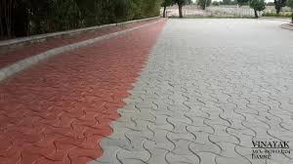

[[](https://www.vinayaktechnocast.co.in/reflective-paver-block.html)](https://www.vinayaktechnocast.co.in/reflective-paver-block.html" \o "Reflective Paver Block - Damroo Paver Block Manufacturer from Ahmedabad" \t "_blank)

[Vinayak Technocast Industries](https://www.vinayaktechnocast.co.in/reflective-paver-block.html" \o "Reflective Paver Block - Damroo Paver Block Manufacturer from Ahmedabad" \t "_blank)

[Reflective Paver Block - Damroo Paver ...](https://www.vinayaktechnocast.co.in/reflective-paver-block.html" \o "Reflective Paver Block - Damroo Paver Block Manufacturer from Ahmedabad" \t "_blank)

**Doublet Interlocking Paver Block Seamless Texture Map Seams Of Tile Displace Stock Illustration - Download Image Now - iStock**



[[](https://www.istockphoto.com/vector/double-t-interlocking-paver-block-seamless-texture-map-seams-of-tile-displace-gm1021119460-274267540)](https://www.istockphoto.com/vector/double-t-interlocking-paver-block-seamless-texture-map-seams-of-tile-displace-gm1021119460-274267540" \o "Doublet Interlocking Paver Block Seamless Texture Map Seams Of Tile  Displace Stock Illustration - Download Image Now - iStock" \t "_blank)

[iStock](https://www.istockphoto.com/vector/double-t-interlocking-paver-block-seamless-texture-map-seams-of-tile-displace-gm1021119460-274267540" \o "Doublet Interlocking Paver Block Seamless Texture Map Seams Of Tile  Displace Stock Illustration - Download Image Now - iStock" \t "_blank)

[Doublet Interlocking Paver Block ...](https://www.istockphoto.com/vector/double-t-interlocking-paver-block-seamless-texture-map-seams-of-tile-displace-gm1021119460-274267540" \o "Doublet Interlocking Paver Block Seamless Texture Map Seams Of Tile  Displace Stock Illustration - Download Image Now - iStock" \t "_blank)

**Interlocking Paving Tile - Interlocking Paving Tile buyers, suppliers, importers, exporters and manufacturers - Latest price and trends**

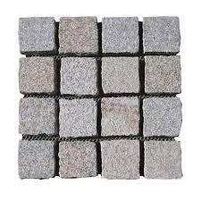

[[](https://connect2india.com/Interlocking-Paving-Tile)](https://connect2india.com/Interlocking-Paving-Tile" \o "Interlocking Paving Tile - Interlocking Paving Tile buyers, suppliers,  importers, exporters and manufacturers - Latest price and trends" \t "_blank)

[Connect2India](https://connect2india.com/Interlocking-Paving-Tile" \o "Interlocking Paving Tile - Interlocking Paving Tile buyers, suppliers,  importers, exporters and manufacturers - Latest price and trends" \t "_blank)

[Interlocking Paving Tile - Interlocking ...](https://connect2india.com/Interlocking-Paving-Tile" \o "Interlocking Paving Tile - Interlocking Paving Tile buyers, suppliers,  importers, exporters and manufacturers - Latest price and trends" \t "_blank)

**Paver Blocks - Concrete Interlocking Paver Block Manufacturer from Navi Mumbai**

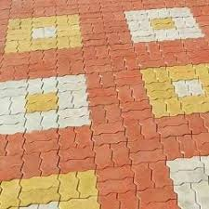

[[](https://www.srcprecast.in/paver-blocks.html)](https://www.srcprecast.in/paver-blocks.html" \o "Paver Blocks - Concrete Interlocking Paver Block Manufacturer from Navi  Mumbai" \t "_blank)

[SRC Precast](https://www.srcprecast.in/paver-blocks.html" \o "Paver Blocks - Concrete Interlocking Paver Block Manufacturer from Navi  Mumbai" \t "_blank)

[Concrete Interlocking Paver Block ...](https://www.srcprecast.in/paver-blocks.html" \o "Paver Blocks - Concrete Interlocking Paver Block Manufacturer from Navi  Mumbai" \t "_blank)

**Various features why you should install the Zig Zag Interlocking Pavers**

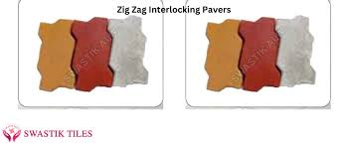

[Swastik Tiles](https://www.swastiktiles.co.in/blog/various-features-why-you-should-install-the-zig-zag-interlocking-pavers_14108.htm" \o "Various features why you should install the Zig Zag Interlocking Pavers" \t "_blank)

[install the Zig Zag Interlocking Pavers](https://www.swastiktiles.co.in/blog/various-features-why-you-should-install-the-zig-zag-interlocking-pavers_14108.htm" \o "Various features why you should install the Zig Zag Interlocking Pavers" \t "_blank)

**Cement Floor Tiles - Ultra Pavers Floor Tile Manufacturer from Mumbai**

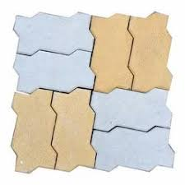

[[](https://www.eclatpavers.com/cement-floor-tiles.html)](https://www.eclatpavers.com/cement-floor-tiles.html" \o "Cement Floor Tiles - Ultra Pavers Floor Tile Manufacturer from Mumbai" \t "_blank)

[Eclat Pavers](https://www.eclatpavers.com/cement-floor-tiles.html" \o "Cement Floor Tiles - Ultra Pavers Floor Tile Manufacturer from Mumbai" \t "_blank)

[Cement Floor Tiles - Ultra Pavers Floor ...](https://www.eclatpavers.com/cement-floor-tiles.html" \o "Cement Floor Tiles - Ultra Pavers Floor Tile Manufacturer from Mumbai" \t "_blank)

**Double-T Interlocking Paver Block, Seamless Texture Map, Seams O Stock Illustration - Illustration of block, paver: 124042947**

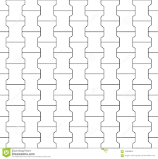

[[](https://www.dreamstime.com/example-ornamental-tile-paving-texture-wireflame-double-t-interlocking-paver-block-seamless-map-seams-o-image124042947)](https://www.dreamstime.com/example-ornamental-tile-paving-texture-wireflame-double-t-interlocking-paver-block-seamless-map-seams-o-image124042947" \o "Double-T Interlocking Paver Block, Seamless Texture Map, Seams O Stock  Illustration - Illustration of block, paver: 124042947" \t "_blank)

[Dreamstime.com](https://www.dreamstime.com/example-ornamental-tile-paving-texture-wireflame-double-t-interlocking-paver-block-seamless-map-seams-o-image124042947" \o "Double-T Interlocking Paver Block, Seamless Texture Map, Seams O Stock  Illustration - Illustration of block, paver: 124042947" \t "_blank)

[Double-T Interlocking Paver Block ...](https://www.dreamstime.com/example-ornamental-tile-paving-texture-wireflame-double-t-interlocking-paver-block-seamless-map-seams-o-image124042947" \o "Double-T Interlocking Paver Block, Seamless Texture Map, Seams O Stock  Illustration - Illustration of block, paver: 124042947" \t "_blank)

**Types of Pavers - The Home Depot**

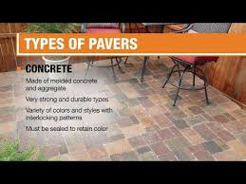

[[](https://www.homedepot.com/c/ab/types-of-pavers/9ba683603be9fa5395fab90a1021aa8)](https://www.homedepot.com/c/ab/types-of-pavers/9ba683603be9fa5395fab90a1021aa8" \o "Types of Pavers - The Home Depot" \t "_blank)

[The Home Depot](https://www.homedepot.com/c/ab/types-of-pavers/9ba683603be9fa5395fab90a1021aa8" \o "Types of Pavers - The Home Depot" \t "_blank)

[Types of Pavers - The Home Depot](https://www.homedepot.com/c/ab/types-of-pavers/9ba683603be9fa5395fab90a1021aa8" \o "Types of Pavers - The Home Depot" \t "_blank)

Related searches

[[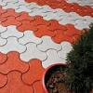](https://www.google.com/search?q=interlock+design+patterns&tbm=isch&hl=en&bih=722&biw=1519&rlz=1C1YTUH_enIN1004IN1004&sa=X&ved=2ahUKEwiS7Z-0wZL9AhU3_TgGHdP2CQQQrNwCKAB6BQgBEKwC)](https://www.google.com/search?q=interlock+design+patterns&tbm=isch&hl=en&bih=722&biw=1519&rlz=1C1YTUH_enIN1004IN1004&sa=X&ved=2ahUKEwiS7Z-0wZL9AhU3_TgGHdP2CQQQrNwCKAB6BQgBEKwC)

[interlock design patterns](https://www.google.com/search?q=interlock+design+patterns&tbm=isch&hl=en&bih=722&biw=1519&rlz=1C1YTUH_enIN1004IN1004&sa=X&ved=2ahUKEwiS7Z-0wZL9AhU3_TgGHdP2CQQQrNwCKAB6BQgBEKwC)

[[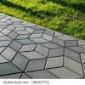](https://www.google.com/search?q=modern+interlock+designs&tbm=isch&hl=en&bih=722&biw=1519&rlz=1C1YTUH_enIN1004IN1004&sa=X&ved=2ahUKEwiS7Z-0wZL9AhU3_TgGHdP2CQQQrNwCKAB6BQgBEK4C)](https://www.google.com/search?q=modern+interlock+designs&tbm=isch&hl=en&bih=722&biw=1519&rlz=1C1YTUH_enIN1004IN1004&sa=X&ved=2ahUKEwiS7Z-0wZL9AhU3_TgGHdP2CQQQrNwCKAB6BQgBEK4C)

[modern interlock designs](https://www.google.com/search?q=modern+interlock+designs&tbm=isch&hl=en&bih=722&biw=1519&rlz=1C1YTUH_enIN1004IN1004&sa=X&ved=2ahUKEwiS7Z-0wZL9AhU3_TgGHdP2CQQQrNwCKAB6BQgBEK4C)

[[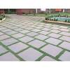](https://www.google.com/search?q=outdoor+paver+tiles&tbm=isch&hl=en&bih=722&biw=1519&rlz=1C1YTUH_enIN1004IN1004&sa=X&ved=2ahUKEwiS7Z-0wZL9AhU3_TgGHdP2CQQQrNwCKAB6BQgBELAC)](https://www.google.com/search?q=outdoor+paver+tiles&tbm=isch&hl=en&bih=722&biw=1519&rlz=1C1YTUH_enIN1004IN1004&sa=X&ved=2ahUKEwiS7Z-0wZL9AhU3_TgGHdP2CQQQrNwCKAB6BQgBELAC)

**[outdoor paver](https://www.google.com/search?q=outdoor+paver+tiles&tbm=isch&hl=en&bih=722&biw=1519&rlz=1C1YTUH_enIN1004IN1004&sa=X&ved=2ahUKEwiS7Z-0wZL9AhU3_TgGHdP2CQQQrNwCKAB6BQgBELAC)**[tiles](https://www.google.com/search?q=outdoor+paver+tiles&tbm=isch&hl=en&bih=722&biw=1519&rlz=1C1YTUH_enIN1004IN1004&sa=X&ved=2ahUKEwiS7Z-0wZL9AhU3_TgGHdP2CQQQrNwCKAB6BQgBELAC)

**Image Results**

**Top Interlocking Paver Tile Manufacturers in Thanjavur - इंटरलॉकिंग पावेर टाइल मनुफक्चरर्स, थंजावुर - Justdial**

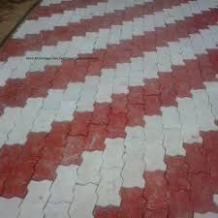

[[](https://www.justdial.com/Thanjavur/Interlocking-Paver-Tile-Manufacturers/nct-10951868)](https://www.justdial.com/Thanjavur/Interlocking-Paver-Tile-Manufacturers/nct-10951868" \o "Top Interlocking Paver Tile Manufacturers in Thanjavur - इंटरलॉकिंग पावेर  टाइल मनुफक्चरर्स, थंजावुर - Justdial" \t "_blank)

[Justdial](https://www.justdial.com/Thanjavur/Interlocking-Paver-Tile-Manufacturers/nct-10951868" \o "Top Interlocking Paver Tile Manufacturers in Thanjavur - इंटरलॉकिंग पावेर  टाइल मनुफक्चरर्स, थंजावुर - Justdial" \t "_blank)

[Interlocking Paver Tile Manufacturers ...](https://www.justdial.com/Thanjavur/Interlocking-Paver-Tile-Manufacturers/nct-10951868" \o "Top Interlocking Paver Tile Manufacturers in Thanjavur - इंटरलॉकिंग पावेर  टाइल मनुफक्चरर्स, थंजावुर - Justdial" \t "_blank)

**The Benefits And Use Of Interlocking Paving Stones - Bayside Pavers**

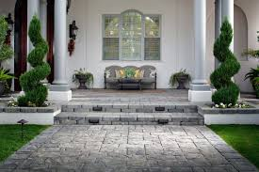

[[](https://baysidepavers.com/the-benefits-and-use-of-interlocking-paving-stones/)](https://baysidepavers.com/the-benefits-and-use-of-interlocking-paving-stones/" \o "The Benefits And Use Of Interlocking Paving Stones - Bayside Pavers" \t "_blank)

[Bayside Pavers](https://baysidepavers.com/the-benefits-and-use-of-interlocking-paving-stones/" \o "The Benefits And Use Of Interlocking Paving Stones - Bayside Pavers" \t "_blank)

[Interlocking Paving Stones ...](https://baysidepavers.com/the-benefits-and-use-of-interlocking-paving-stones/" \o "The Benefits And Use Of Interlocking Paving Stones - Bayside Pavers" \t "_blank)

**Advantages Of Interlock Pavers | Artex | Interlock Pavers, & Terrazzo Tiles**

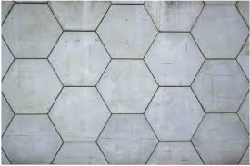

[[](https://artex.com.np/advantage-of-interlocks/)](https://artex.com.np/advantage-of-interlocks/" \o "Advantages Of Interlock Pavers | Artex | Interlock Pavers, & Terrazzo Tiles" \t "_blank)

[Artex | Interlock Pavers, & Terrazzo Tiles](https://artex.com.np/advantage-of-interlocks/" \o "Advantages Of Interlock Pavers | Artex | Interlock Pavers, & Terrazzo Tiles" \t "_blank)

[Advantages Of Interlock Pavers | Artex ...](https://artex.com.np/advantage-of-interlocks/" \o "Advantages Of Interlock Pavers | Artex | Interlock Pavers, & Terrazzo Tiles" \t "_blank)

**Drivelok Pavers | Interlocking Commercial Pavers | Driveway Pavers**

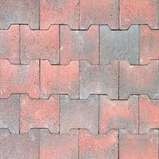

[[](https://apclonsdale.com.au/product/drivelok/)](https://apclonsdale.com.au/product/drivelok/" \o "Drivelok Pavers | Interlocking Commercial Pavers | Driveway Pavers" \t "_blank)

[Australian Paving Centre Lonsdale](https://apclonsdale.com.au/product/drivelok/" \o "Drivelok Pavers | Interlocking Commercial Pavers | Driveway Pavers" \t "_blank)

[Drivelok Pavers | Interlocking ...](https://apclonsdale.com.au/product/drivelok/" \o "Drivelok Pavers | Interlocking Commercial Pavers | Driveway Pavers" \t "_blank)

**What are the Advantages of Interlocking Paver Block?**



[[](https://gharpedia.com/blog/advantages-of-interlocking-paver-block/)](https://gharpedia.com/blog/advantages-of-interlocking-paver-block/" \o "What are the Advantages of Interlocking Paver Block?" \t "_blank)

[Gharpedia](https://gharpedia.com/blog/advantages-of-interlocking-paver-block/" \o "What are the Advantages of Interlocking Paver Block?" \t "_blank)

[Interlocking Paver Block ...](https://gharpedia.com/blog/advantages-of-interlocking-paver-block/" \o "What are the Advantages of Interlocking Paver Block?" \t "_blank)

**Paver Blocks - Interlocking Paver Stone Block Manufacturer from Mohali**

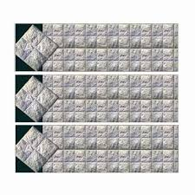

[[](https://www.mcfindia.com/paver-blocks.html)](https://www.mcfindia.com/paver-blocks.html" \o "Paver Blocks - Interlocking Paver Stone Block Manufacturer from Mohali" \t "_blank)

[A-1 Tiles (Unit Of Manju Concrete Fabricators & Developers Private Limited)](https://www.mcfindia.com/paver-blocks.html" \o "Paver Blocks - Interlocking Paver Stone Block Manufacturer from Mohali" \t "_blank)

[Paver Blocks - Interlocking Paver Stone ...](https://www.mcfindia.com/paver-blocks.html" \o "Paver Blocks - Interlocking Paver Stone Block Manufacturer from Mohali" \t "_blank)

**Interlocking Trends Lineup: Interlocking Pavers Design Ideas - Grand River Stone**

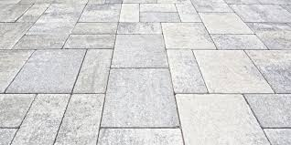

[[](https://www.grandriverstone.com/blog/interlocking-trends-lineup-interlocking-pavers-design-ideas/)](https://www.grandriverstone.com/blog/interlocking-trends-lineup-interlocking-pavers-design-ideas/" \o "Interlocking Trends Lineup: Interlocking Pavers Design Ideas - Grand River  Stone" \t "_blank)

[Grand River Natural Stone](https://www.grandriverstone.com/blog/interlocking-trends-lineup-interlocking-pavers-design-ideas/" \o "Interlocking Trends Lineup: Interlocking Pavers Design Ideas - Grand River  Stone" \t "_blank)

[Interlocking Pavers Design Ideas ...](https://www.grandriverstone.com/blog/interlocking-trends-lineup-interlocking-pavers-design-ideas/" \o "Interlocking Trends Lineup: Interlocking Pavers Design Ideas - Grand River  Stone" \t "_blank)

**Interlocking Paver Tile - Milano Paver Tile Manufacturer from Ghaziabad**

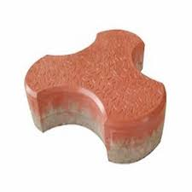

[[](https://www.anushkacementproducts.com/interlocking-paver-tile.html)](https://www.anushkacementproducts.com/interlocking-paver-tile.html" \o "Interlocking Paver Tile - Milano Paver Tile Manufacturer from Ghaziabad" \t "_blank)

[Anushka Cement Products](https://www.anushkacementproducts.com/interlocking-paver-tile.html" \o "Interlocking Paver Tile - Milano Paver Tile Manufacturer from Ghaziabad" \t "_blank)

[Interlocking Paver Tile - Milano Paver ...](https://www.anushkacementproducts.com/interlocking-paver-tile.html" \o "Interlocking Paver Tile - Milano Paver Tile Manufacturer from Ghaziabad" \t "_blank)

**Hexagon Rubber Paver Moulds~best~Interlocking Tile Making Mould**



[[](https://srikrishnaplasto.com/p/rubber-paver-moulds/hexagon-rubber-paver-moulds/)](https://srikrishnaplasto.com/p/rubber-paver-moulds/hexagon-rubber-paver-moulds/" \o "Hexagon Rubber Paver Moulds~best~Interlocking Tile Making Mould" \t "_blank)

[RED IRON OXIDE PIGMENT, INTERLOCKING TILE MAKING MACHINE, PAVER MOULD](https://srikrishnaplasto.com/p/rubber-paver-moulds/hexagon-rubber-paver-moulds/" \o "Hexagon Rubber Paver Moulds~best~Interlocking Tile Making Mould" \t "_blank)

[Hexagon Rubber Paver Moulds~best ...](https://srikrishnaplasto.com/p/rubber-paver-moulds/hexagon-rubber-paver-moulds/" \o "Hexagon Rubber Paver Moulds~best~Interlocking Tile Making Mould" \t "_blank)

**Buy INTERLOCKING TILE Online at Low Prices in India - Amazon.in**

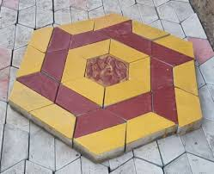

[[](https://www.amazon.in/Tiles-INTERLOCKING-TILE/dp/B08NC6KRBX)](https://www.amazon.in/Tiles-INTERLOCKING-TILE/dp/B08NC6KRBX" \o "Buy INTERLOCKING TILE Online at Low Prices in India - Amazon.in" \t "_blank)

[Amazon.in](https://www.amazon.in/Tiles-INTERLOCKING-TILE/dp/B08NC6KRBX" \o "Buy INTERLOCKING TILE Online at Low Prices in India - Amazon.in" \t "_blank)

[Buy INTERLOCKING TILE Online at Low ...](https://www.amazon.in/Tiles-INTERLOCKING-TILE/dp/B08NC6KRBX" \o "Buy INTERLOCKING TILE Online at Low Prices in India - Amazon.in" \t "_blank)

**Plastic Interlock Tile Making Rubber Mold Interlocking Paver Stone Polyurethane Pavement Concrete Paving Mould - Buy Concrete Paver Mould,Paver Mould Plastic,Concrete Paving Mould Product on Alibaba.com**

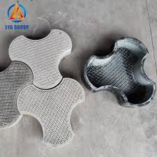

[[](https://www.alibaba.com/product-detail/Plastic-Interlock-Tile-Making-Rubber-Mold_60835492396.html)](https://www.alibaba.com/product-detail/Plastic-Interlock-Tile-Making-Rubber-Mold_60835492396.html" \o "Plastic Interlock Tile Making Rubber Mold Interlocking Paver Stone  Polyurethane Pavement Concrete Paving Mould - Buy Concrete Paver Mould,Paver  Mould Plastic,Concrete Paving Mould Product on Alibaba.com" \t "_blank)

[Alibaba.com](https://www.alibaba.com/product-detail/Plastic-Interlock-Tile-Making-Rubber-Mold_60835492396.html" \o "Plastic Interlock Tile Making Rubber Mold Interlocking Paver Stone  Polyurethane Pavement Concrete Paving Mould - Buy Concrete Paver Mould,Paver  Mould Plastic,Concrete Paving Mould Product on Alibaba.com" \t "_blank)

[Rubber Mold Interlocking Paver Stone ...](https://www.alibaba.com/product-detail/Plastic-Interlock-Tile-Making-Rubber-Mold_60835492396.html" \o "Plastic Interlock Tile Making Rubber Mold Interlocking Paver Stone  Polyurethane Pavement Concrete Paving Mould - Buy Concrete Paver Mould,Paver  Mould Plastic,Concrete Paving Mould Product on Alibaba.com" \t "_blank)

**interlocking tiles making machine - Interlocking Pavers Block Making Plant Manufacturer from Noida**



[[](https://www.globaltilesproducts.com/interlocking-tiles-making-machine.html)](https://www.globaltilesproducts.com/interlocking-tiles-making-machine.html" \o "interlocking tiles making machine - Interlocking Pavers Block Making Plant  Manufacturer from Noida" \t "_blank)

[Global Tiles Products](https://www.globaltilesproducts.com/interlocking-tiles-making-machine.html" \o "interlocking tiles making machine - Interlocking Pavers Block Making Plant  Manufacturer from Noida" \t "_blank)

[Interlocking Pavers Block Making Plant ...](https://www.globaltilesproducts.com/interlocking-tiles-making-machine.html" \o "interlocking tiles making machine - Interlocking Pavers Block Making Plant  Manufacturer from Noida" \t "_blank)

**Interlock Paver Color Guide For 2021**

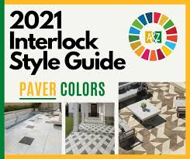

[[](https://a-zlandscape.ca/interlock-color-guide-2021/)](https://a-zlandscape.ca/interlock-color-guide-2021/" \o "Interlock Paver Color Guide For 2021" \t "_blank)

[A&Z Interlock Ottawa](https://a-zlandscape.ca/interlock-color-guide-2021/" \o "Interlock Paver Color Guide For 2021" \t "_blank)

[Interlock Paver Color Guide For 2021](https://a-zlandscape.ca/interlock-color-guide-2021/" \o "Interlock Paver Color Guide For 2021" \t "_blank)

**Nature Spring 0.5-in x 11.5-in 6-Pack Stone Gray Prefinished Vinyl/Plastic Deck Tile in the Deck Tiles department at Lowes.com**

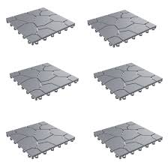

[[](https://www.lowes.com/pd/Nature-Spring-Patio-and-Deck-Tiles-Interlocking-Stone-Look-Outdoor-Flooring-Pavers-Weather-Resistant-and-Anti-Slip-by-Nature-Spring-Grey-Set-of-6/5001380349)](https://www.lowes.com/pd/Nature-Spring-Patio-and-Deck-Tiles-Interlocking-Stone-Look-Outdoor-Flooring-Pavers-Weather-Resistant-and-Anti-Slip-by-Nature-Spring-Grey-Set-of-6/5001380349" \o "Nature Spring 0.5-in x 11.5-in 6-Pack Stone Gray Prefinished Vinyl/Plastic  Deck Tile in the Deck Tiles department at Lowes.com" \t "_blank)

[Lowe's](https://www.lowes.com/pd/Nature-Spring-Patio-and-Deck-Tiles-Interlocking-Stone-Look-Outdoor-Flooring-Pavers-Weather-Resistant-and-Anti-Slip-by-Nature-Spring-Grey-Set-of-6/5001380349" \o "Nature Spring 0.5-in x 11.5-in 6-Pack Stone Gray Prefinished Vinyl/Plastic  Deck Tile in the Deck Tiles department at Lowes.com" \t "_blank)

[Plastic Deck Tile in the Deck Tiles ...](https://www.lowes.com/pd/Nature-Spring-Patio-and-Deck-Tiles-Interlocking-Stone-Look-Outdoor-Flooring-Pavers-Weather-Resistant-and-Anti-Slip-by-Nature-Spring-Grey-Set-of-6/5001380349" \o "Nature Spring 0.5-in x 11.5-in 6-Pack Stone Gray Prefinished Vinyl/Plastic  Deck Tile in the Deck Tiles department at Lowes.com" \t "_blank)

**Paving Tiles - Kajaria | India's No.1 Tile Company**

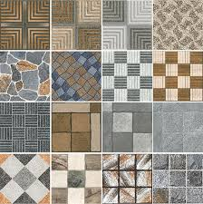

[[](https://www.kajariaceramics.com/blog/essential-tips-to-choose-the-right-paving-tiles.php)](https://www.kajariaceramics.com/blog/essential-tips-to-choose-the-right-paving-tiles.php" \o "Paving Tiles - Kajaria | India's No.1 Tile Company" \t "_blank)

[Kajaria](https://www.kajariaceramics.com/blog/essential-tips-to-choose-the-right-paving-tiles.php" \o "Paving Tiles - Kajaria | India's No.1 Tile Company" \t "_blank)

[Paving Tiles - Kajaria | India's No.1 ...](https://www.kajariaceramics.com/blog/essential-tips-to-choose-the-right-paving-tiles.php" \o "Paving Tiles - Kajaria | India's No.1 Tile Company" \t "_blank)

**3-D Manufacturer,3-D Exporter & Supplier in Alwar India**

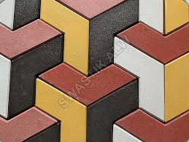

[Swastik Tiles](https://www.swastiktiles.co.in/3d-interlocking-tile.htm" \o "3-D Manufacturer,3-D Exporter & Supplier in Alwar India" \t "_blank)

[Exporter & Supplier in Alwar India](https://www.swastiktiles.co.in/3d-interlocking-tile.htm" \o "3-D Manufacturer,3-D Exporter & Supplier in Alwar India" \t "_blank)

**Rinox How to choose the right interlock pavers for your home - Rinox**

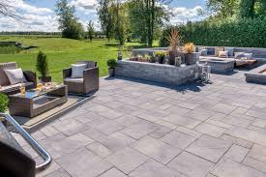

[[](https://www.rinox.com/blog/2018/04/25/interlock-pavers-choice/)](https://www.rinox.com/blog/2018/04/25/interlock-pavers-choice/" \o "Rinox How to choose the right interlock pavers for your home - Rinox" \t "_blank)

[Rinox](https://www.rinox.com/blog/2018/04/25/interlock-pavers-choice/" \o "Rinox How to choose the right interlock pavers for your home - Rinox" \t "_blank)

[interlock pavers ...](https://www.rinox.com/blog/2018/04/25/interlock-pavers-choice/" \o "Rinox How to choose the right interlock pavers for your home - Rinox" \t "_blank)

**Types of Interlocking Pavers | eHow**

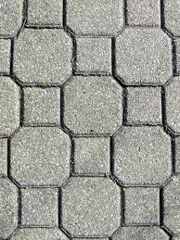

[[](https://www.ehow.com/list_6957183_types-interlocking-pavers.html)](https://www.ehow.com/list_6957183_types-interlocking-pavers.html" \o "Types of Interlocking Pavers | eHow" \t "_blank)

[eHow](https://www.ehow.com/list_6957183_types-interlocking-pavers.html" \o "Types of Interlocking Pavers | eHow" \t "_blank)

[Types of Interlocking Pavers | eHow](https://www.ehow.com/list_6957183_types-interlocking-pavers.html" \o "Types of Interlocking Pavers | eHow" \t "_blank)

**Driveway Interlocking Pavers Adelaide | Driveway Pavers Adelaide**

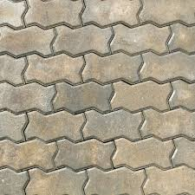

[[](https://australianpaving.com/product/driveway-interlocking-pavers/)](https://australianpaving.com/product/driveway-interlocking-pavers/" \o "Driveway Interlocking Pavers Adelaide | Driveway Pavers Adelaide" \t "_blank)

[Australian Paving Centre](https://australianpaving.com/product/driveway-interlocking-pavers/" \o "Driveway Interlocking Pavers Adelaide | Driveway Pavers Adelaide" \t "_blank)

[Driveway Interlocking Pavers Adelaide ...](https://australianpaving.com/product/driveway-interlocking-pavers/" \o "Driveway Interlocking Pavers Adelaide | Driveway Pavers Adelaide" \t "_blank)

**2,304 Interlocked Floor Concrete Images, Stock Photos & Vectors | Shutterstock**

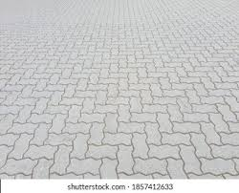

[[](https://www.shutterstock.com/search/interlocked-floor-concrete)](https://www.shutterstock.com/search/interlocked-floor-concrete" \o "2,304 Interlocked Floor Concrete Images, Stock Photos & Vectors |  Shutterstock" \t "_blank)

[Shutterstock](https://www.shutterstock.com/search/interlocked-floor-concrete" \o "2,304 Interlocked Floor Concrete Images, Stock Photos & Vectors |  Shutterstock" \t "_blank)

[2,304 Interlocked Floor Concrete Images ...](https://www.shutterstock.com/search/interlocked-floor-concrete" \o "2,304 Interlocked Floor Concrete Images, Stock Photos & Vectors |  Shutterstock" \t "_blank)

**Kaajma 100 mm Grey I Shaped/Behaton Interlocking Paver Block, Grade M-30**

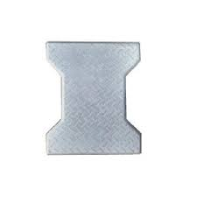

[[](https://spacemantra.com/kaajma-100-mm-grey-i-shaped-behaton-interlocking-paver-block-grade-m-30.html)](https://spacemantra.com/kaajma-100-mm-grey-i-shaped-behaton-interlocking-paver-block-grade-m-30.html" \o "Kaajma 100 mm Grey I Shaped/Behaton Interlocking Paver Block, Grade M-30" \t "_blank)

[SpaceMantra](https://spacemantra.com/kaajma-100-mm-grey-i-shaped-behaton-interlocking-paver-block-grade-m-30.html" \o "Kaajma 100 mm Grey I Shaped/Behaton Interlocking Paver Block, Grade M-30" \t "_blank)

[Behaton Interlocking Paver Block, Grade ...](https://spacemantra.com/kaajma-100-mm-grey-i-shaped-behaton-interlocking-paver-block-grade-m-30.html" \o "Kaajma 100 mm Grey I Shaped/Behaton Interlocking Paver Block, Grade M-30" \t "_blank)

**Double-T Interlocking Paver Block, Seamless Texture Map, Seams O Stock Illustration - Illustration of block, paver: 124042947**



[[](https://www.dreamstime.com/example-ornamental-tile-paving-texture-wireflame-double-t-interlocking-paver-block-seamless-map-seams-o-image124042947)](https://www.dreamstime.com/example-ornamental-tile-paving-texture-wireflame-double-t-interlocking-paver-block-seamless-map-seams-o-image124042947" \o "Double-T Interlocking Paver Block, Seamless Texture Map, Seams O Stock  Illustration - Illustration of block, paver: 124042947" \t "_blank)

[Dreamstime.com](https://www.dreamstime.com/example-ornamental-tile-paving-texture-wireflame-double-t-interlocking-paver-block-seamless-map-seams-o-image124042947" \o "Double-T Interlocking Paver Block, Seamless Texture Map, Seams O Stock  Illustration - Illustration of block, paver: 124042947" \t "_blank)

[Double-T Interlocking Paver Block ...](https://www.dreamstime.com/example-ornamental-tile-paving-texture-wireflame-double-t-interlocking-paver-block-seamless-map-seams-o-image124042947" \o "Double-T Interlocking Paver Block, Seamless Texture Map, Seams O Stock  Illustration - Illustration of block, paver: 124042947" \t "_blank)

**Interlocking Paver Blocks | Salasar Tiles Pvt. Ltd.**

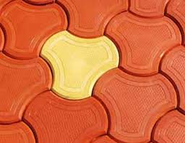

[[](http://www.salasartiles.com/interlocking-paver-blocks.html)](http://www.salasartiles.com/interlocking-paver-blocks.html" \o "Interlocking Paver Blocks | Salasar Tiles Pvt. Ltd." \t "_blank)

[Salasar Tiles Pvt. Ltd.](http://www.salasartiles.com/interlocking-paver-blocks.html" \o "Interlocking Paver Blocks | Salasar Tiles Pvt. Ltd." \t "_blank)

[Interlocking Paver Blocks | Salasar ...](http://www.salasartiles.com/interlocking-paver-blocks.html" \o "Interlocking Paver Blocks | Salasar Tiles Pvt. Ltd." \t "_blank)

**Milano Paver Tile Manufacturer, Milano Paver Tile Supplier In Sonbhadra**



[[](https://www.bharatchemicalsindustries.com/milano-paver-tile-4606538.html)](https://www.bharatchemicalsindustries.com/milano-paver-tile-4606538.html" \o "Milano Paver Tile Manufacturer, Milano Paver Tile Supplier In Sonbhadra" \t "_blank)

[bharat chemicals industries](https://www.bharatchemicalsindustries.com/milano-paver-tile-4606538.html" \o "Milano Paver Tile Manufacturer, Milano Paver Tile Supplier In Sonbhadra" \t "_blank)

[Milano Paver Tile Manufacturer, Milano ...](https://www.bharatchemicalsindustries.com/milano-paver-tile-4606538.html" \o "Milano Paver Tile Manufacturer, Milano Paver Tile Supplier In Sonbhadra" \t "_blank)

Related searches

[[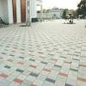](https://www.google.com/search?q=interlock+tiles+design+in+punjab&tbm=isch&hl=en&bih=722&biw=1519&rlz=1C1YTUH_enIN1004IN1004&sa=X&ved=2ahUKEwiS7Z-0wZL9AhU3_TgGHdP2CQQQrNwCKAB6BAgBEHQ)](https://www.google.com/search?q=interlock+tiles+design+in+punjab&tbm=isch&hl=en&bih=722&biw=1519&rlz=1C1YTUH_enIN1004IN1004&sa=X&ved=2ahUKEwiS7Z-0wZL9AhU3_TgGHdP2CQQQrNwCKAB6BAgBEHQ)

**[interlock](https://www.google.com/search?q=interlock+tiles+design+in+punjab&tbm=isch&hl=en&bih=722&biw=1519&rlz=1C1YTUH_enIN1004IN1004&sa=X&ved=2ahUKEwiS7Z-0wZL9AhU3_TgGHdP2CQQQrNwCKAB6BAgBEHQ)**[tiles](https://www.google.com/search?q=interlock+tiles+design+in+punjab&tbm=isch&hl=en&bih=722&biw=1519&rlz=1C1YTUH_enIN1004IN1004&sa=X&ved=2ahUKEwiS7Z-0wZL9AhU3_TgGHdP2CQQQrNwCKAB6BAgBEHQ)**[design in punjab](https://www.google.com/search?q=interlock+tiles+design+in+punjab&tbm=isch&hl=en&bih=722&biw=1519&rlz=1C1YTUH_enIN1004IN1004&sa=X&ved=2ahUKEwiS7Z-0wZL9AhU3_TgGHdP2CQQQrNwCKAB6BAgBEHQ)**

[[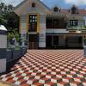](https://www.google.com/search?q=house+interlock+tiles&tbm=isch&hl=en&bih=722&biw=1519&rlz=1C1YTUH_enIN1004IN1004&sa=X&ved=2ahUKEwiS7Z-0wZL9AhU3_TgGHdP2CQQQrNwCKAB6BAgBEHY)](https://www.google.com/search?q=house+interlock+tiles&tbm=isch&hl=en&bih=722&biw=1519&rlz=1C1YTUH_enIN1004IN1004&sa=X&ved=2ahUKEwiS7Z-0wZL9AhU3_TgGHdP2CQQQrNwCKAB6BAgBEHY)

**[house interlock](https://www.google.com/search?q=house+interlock+tiles&tbm=isch&hl=en&bih=722&biw=1519&rlz=1C1YTUH_enIN1004IN1004&sa=X&ved=2ahUKEwiS7Z-0wZL9AhU3_TgGHdP2CQQQrNwCKAB6BAgBEHY)**[tiles](https://www.google.com/search?q=house+interlock+tiles&tbm=isch&hl=en&bih=722&biw=1519&rlz=1C1YTUH_enIN1004IN1004&sa=X&ved=2ahUKEwiS7Z-0wZL9AhU3_TgGHdP2CQQQrNwCKAB6BAgBEHY)

[[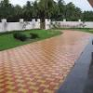](https://www.google.com/search?q=garden+paver+block+design&tbm=isch&hl=en&bih=722&biw=1519&rlz=1C1YTUH_enIN1004IN1004&sa=X&ved=2ahUKEwiS7Z-0wZL9AhU3_TgGHdP2CQQQrNwCKAB6BAgBEHg)](https://www.google.com/search?q=garden+paver+block+design&tbm=isch&hl=en&bih=722&biw=1519&rlz=1C1YTUH_enIN1004IN1004&sa=X&ved=2ahUKEwiS7Z-0wZL9AhU3_TgGHdP2CQQQrNwCKAB6BAgBEHg)

[garden paver block design](https://www.google.com/search?q=garden+paver+block+design&tbm=isch&hl=en&bih=722&biw=1519&rlz=1C1YTUH_enIN1004IN1004&sa=X&ved=2ahUKEwiS7Z-0wZL9AhU3_TgGHdP2CQQQrNwCKAB6BAgBEHg)

**Image Results**

**Interlocking Tiles Hardener Chemical - Cement Concrete Hardener Chemical Manufacturer from Gautam Budh Nagar**



[[](https://www.mktilesmachinery.in/interlocking-tiles-hardener-chemical.html)](https://www.mktilesmachinery.in/interlocking-tiles-hardener-chemical.html" \o "Interlocking Tiles Hardener Chemical - Cement Concrete Hardener Chemical  Manufacturer from Gautam Budh Nagar" \t "_blank)

[MK Tiles Machinery](https://www.mktilesmachinery.in/interlocking-tiles-hardener-chemical.html" \o "Interlocking Tiles Hardener Chemical - Cement Concrete Hardener Chemical  Manufacturer from Gautam Budh Nagar" \t "_blank)

[Interlocking Tiles Hardener Chemical ...](https://www.mktilesmachinery.in/interlocking-tiles-hardener-chemical.html" \o "Interlocking Tiles Hardener Chemical - Cement Concrete Hardener Chemical  Manufacturer from Gautam Budh Nagar" \t "_blank)

**14 Different Types of Tiles for Outdoor Patios and How to Choose One**

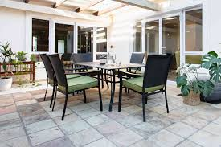

[[](https://www.thespruce.com/how-to-set-outdoor-patio-tile-2132506)](https://www.thespruce.com/how-to-set-outdoor-patio-tile-2132506" \o "14 Different Types of Tiles for Outdoor Patios and How to Choose One" \t "_blank)

[The Spruce](https://www.thespruce.com/how-to-set-outdoor-patio-tile-2132506" \o "14 Different Types of Tiles for Outdoor Patios and How to Choose One" \t "_blank)

[Tiles for Outdoor Patios ...](https://www.thespruce.com/how-to-set-outdoor-patio-tile-2132506" \o "14 Different Types of Tiles for Outdoor Patios and How to Choose One" \t "_blank)

**Paver Tile & Block - Jambo Colored Outdoor Tiles Manufacturer from Jaipur**



[[](https://www.supremebalaji.net/paver-tile-block.html)](https://www.supremebalaji.net/paver-tile-block.html" \o "Paver Tile & Block - Jambo Colored Outdoor Tiles Manufacturer from Jaipur" \t "_blank)

[Floor Tiles](https://www.supremebalaji.net/paver-tile-block.html" \o "Paver Tile & Block - Jambo Colored Outdoor Tiles Manufacturer from Jaipur" \t "_blank)

[Paver Tile & Block - Jambo Colored ...](https://www.supremebalaji.net/paver-tile-block.html" \o "Paver Tile & Block - Jambo Colored Outdoor Tiles Manufacturer from Jaipur" \t "_blank)

**Natural Granite Interlock Pavers For Sale - Buy Granite Pavers For Driveways,Granite Driveway Pavers,Interlock Paver Tiles Product on Alibaba.com**

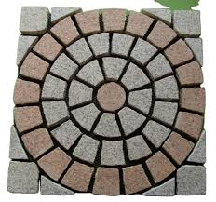

[[](https://www.alibaba.com/product-detail/Natural-granite-interlock-pavers-for-sale_1762563895.html)](https://www.alibaba.com/product-detail/Natural-granite-interlock-pavers-for-sale_1762563895.html" \o "Natural Granite Interlock Pavers For Sale - Buy Granite Pavers For  Driveways,Granite Driveway Pavers,Interlock Paver Tiles Product on  Alibaba.com" \t "_blank)

[Alibaba.com](https://www.alibaba.com/product-detail/Natural-granite-interlock-pavers-for-sale_1762563895.html" \o "Natural Granite Interlock Pavers For Sale - Buy Granite Pavers For  Driveways,Granite Driveway Pavers,Interlock Paver Tiles Product on  Alibaba.com" \t "_blank)

[Natural Granite Interlock Pavers For ...](https://www.alibaba.com/product-detail/Natural-granite-interlock-pavers-for-sale_1762563895.html" \o "Natural Granite Interlock Pavers For Sale - Buy Granite Pavers For  Driveways,Granite Driveway Pavers,Interlock Paver Tiles Product on  Alibaba.com" \t "_blank)

**Red Interlocking Color Tiles, Thickness: 60-80 at Rs 16/piece in Sandila**

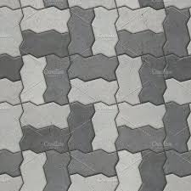

[[](https://www.indiamart.com/proddetail/interlocking-color-tiles-25167692962.html)](https://www.indiamart.com/proddetail/interlocking-color-tiles-25167692962.html" \o "Red Interlocking Color Tiles, Thickness: 60-80 at Rs 16/piece in Sandila" \t "_blank)

[IndiaMART](https://www.indiamart.com/proddetail/interlocking-color-tiles-25167692962.html" \o "Red Interlocking Color Tiles, Thickness: 60-80 at Rs 16/piece in Sandila" \t "_blank)

[Red Interlocking Color Tiles, Thickness ...](https://www.indiamart.com/proddetail/interlocking-color-tiles-25167692962.html" \o "Red Interlocking Color Tiles, Thickness: 60-80 at Rs 16/piece in Sandila" \t "_blank)

**INTERLOCKING TILES ∕ PAVERS**



[[](https://www.slideshare.net/sanjeevsingh462/interlocking-tiles-pavers)](https://www.slideshare.net/sanjeevsingh462/interlocking-tiles-pavers" \o "INTERLOCKING TILES ∕ PAVERS" \t "_blank)

[SlideShare](https://www.slideshare.net/sanjeevsingh462/interlocking-tiles-pavers" \o "INTERLOCKING TILES ∕ PAVERS" \t "_blank)

[INTERLOCKING TILES ∕ PAVERS](https://www.slideshare.net/sanjeevsingh462/interlocking-tiles-pavers" \o "INTERLOCKING TILES ∕ PAVERS" \t "_blank)

**Rubber Paving Tiles - Conso Mats**

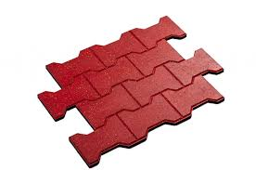

[[](https://www.consomats.com/rubber-paving-tiles/)](https://www.consomats.com/rubber-paving-tiles/" \o "Rubber Paving Tiles - Conso Mats" \t "_blank)

[Conso Mats](https://www.consomats.com/rubber-paving-tiles/" \o "Rubber Paving Tiles - Conso Mats" \t "_blank)

[Rubber Paving Tiles - Conso Mats](https://www.consomats.com/rubber-paving-tiles/" \o "Rubber Paving Tiles - Conso Mats" \t "_blank)

**How to calculate the number of interlocking paver blocks required for any given area? ~ PARAM VISIONS**

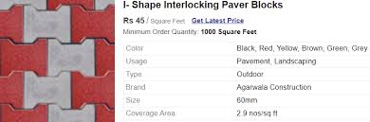

[PARAM VISIONS](https://www.paramvisions.com/2021/06/how-to-calculate-number-of-interlocking.html" \o "How to calculate the number of interlocking paver blocks required for any  given area? ~ PARAM VISIONS" \t "_blank)

[interlocking paver blocks ...](https://www.paramvisions.com/2021/06/how-to-calculate-number-of-interlocking.html" \o "How to calculate the number of interlocking paver blocks required for any  given area? ~ PARAM VISIONS" \t "_blank)

**Interlocking Pavers Color Chart - David Wayne Hardscapes, LLC.**

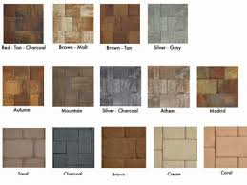

[[](https://www.dwhardscapes.com/services/interlocking-pavers-color-chart/)](https://www.dwhardscapes.com/services/interlocking-pavers-color-chart/" \o "Interlocking Pavers Color Chart - David Wayne Hardscapes, LLC." \t "_blank)

[David Wayne Hardscapes, LLC.](https://www.dwhardscapes.com/services/interlocking-pavers-color-chart/" \o "Interlocking Pavers Color Chart - David Wayne Hardscapes, LLC." \t "_blank)

[Interlocking Pavers Color Chart - David ...](https://www.dwhardscapes.com/services/interlocking-pavers-color-chart/" \o "Interlocking Pavers Color Chart - David Wayne Hardscapes, LLC." \t "_blank)

**Gold Yellow Swimming Pool Coping Pavers,Golden Beige Quartzite Pool Deck Pavers,More Yellow Less Grey Interlocking Patio Pavers,Beige Color Pool Pavers Tiles from China - StoneContact.com**

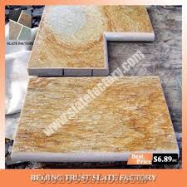

[[](https://www.stonecontact.com/products-193480/gold-yellow-swimming-pool-coping-pavers)](https://www.stonecontact.com/products-193480/gold-yellow-swimming-pool-coping-pavers" \o "Gold Yellow Swimming Pool Coping Pavers,Golden Beige Quartzite Pool Deck  Pavers,More Yellow Less Grey Interlocking Patio Pavers,Beige Color Pool Pavers  Tiles from China - StoneContact.com" \t "_blank)

[StoneContact.com](https://www.stonecontact.com/products-193480/gold-yellow-swimming-pool-coping-pavers" \o "Gold Yellow Swimming Pool Coping Pavers,Golden Beige Quartzite Pool Deck  Pavers,More Yellow Less Grey Interlocking Patio Pavers,Beige Color Pool Pavers  Tiles from China - StoneContact.com" \t "_blank)

[Gold Yellow Swimming Pool Coping Pavers ...](https://www.stonecontact.com/products-193480/gold-yellow-swimming-pool-coping-pavers" \o "Gold Yellow Swimming Pool Coping Pavers,Golden Beige Quartzite Pool Deck  Pavers,More Yellow Less Grey Interlocking Patio Pavers,Beige Color Pool Pavers  Tiles from China - StoneContact.com" \t "_blank)

**Paver Blocks - I Shape Paver Blocks Manufacturer from Hyderabad**

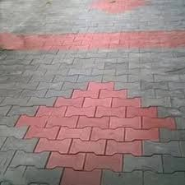

[[](https://www.royaltiles.in.net/paver-blocks.html)](https://www.royaltiles.in.net/paver-blocks.html" \o "Paver Blocks - I Shape Paver Blocks Manufacturer from Hyderabad" \t "_blank)

[Royal Tiles & Traders](https://www.royaltiles.in.net/paver-blocks.html" \o "Paver Blocks - I Shape Paver Blocks Manufacturer from Hyderabad" \t "_blank)

[Paver Blocks - I Shape Paver Blocks ...](https://www.royaltiles.in.net/paver-blocks.html" \o "Paver Blocks - I Shape Paver Blocks Manufacturer from Hyderabad" \t "_blank)

**Seamless pattern of cobblestone pavers. Seamless pattern of tiled cobblestone pavers. geometric mosaic street tiles. red and | CanStock**

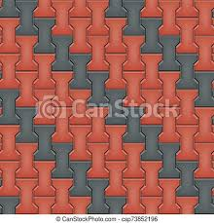

[[](https://www.canstockphoto.com/seamless-pattern-of-cobblestone-pavers-73852196.html)](https://www.canstockphoto.com/seamless-pattern-of-cobblestone-pavers-73852196.html" \o "Seamless pattern of cobblestone pavers. Seamless pattern of tiled  cobblestone pavers. geometric mosaic street tiles. red and | CanStock" \t "_blank)

[Can Stock Photo](https://www.canstockphoto.com/seamless-pattern-of-cobblestone-pavers-73852196.html" \o "Seamless pattern of cobblestone pavers. Seamless pattern of tiled  cobblestone pavers. geometric mosaic street tiles. red and | CanStock" \t "_blank)

[cobblestone pavers. Seamless pattern ...](https://www.canstockphoto.com/seamless-pattern-of-cobblestone-pavers-73852196.html" \o "Seamless pattern of cobblestone pavers. Seamless pattern of tiled  cobblestone pavers. geometric mosaic street tiles. red and | CanStock" \t "_blank)

**Plastic Tile Mould - Galaxy Silicon Plastic Mould Manufacturer from New Delhi**

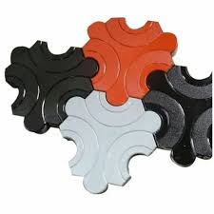

[[](https://www.liaqengineering.com/plastic-tile-mould.html)](https://www.liaqengineering.com/plastic-tile-mould.html" \o "Plastic Tile Mould - Galaxy Silicon Plastic Mould Manufacturer from New  Delhi" \t "_blank)

[Liaq Engineering Works](https://www.liaqengineering.com/plastic-tile-mould.html" \o "Plastic Tile Mould - Galaxy Silicon Plastic Mould Manufacturer from New  Delhi" \t "_blank)

[Plastic Tile Mould - Galaxy Silicon ...](https://www.liaqengineering.com/plastic-tile-mould.html" \o "Plastic Tile Mould - Galaxy Silicon Plastic Mould Manufacturer from New  Delhi" \t "_blank)

**Driveway Interlocking Pavers Adelaide | Driveway Pavers Adelaide**

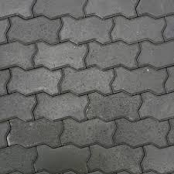

[[](https://australianpaving.com/product/driveway-interlocking-pavers/)](https://australianpaving.com/product/driveway-interlocking-pavers/" \o "Driveway Interlocking Pavers Adelaide | Driveway Pavers Adelaide" \t "_blank)

[Australian Paving Centre](https://australianpaving.com/product/driveway-interlocking-pavers/" \o "Driveway Interlocking Pavers Adelaide | Driveway Pavers Adelaide" \t "_blank)

[Driveway Interlocking Pavers Adelaide ...](https://australianpaving.com/product/driveway-interlocking-pavers/" \o "Driveway Interlocking Pavers Adelaide | Driveway Pavers Adelaide" \t "_blank)

**Interlocking Pavers Introduction - Tile Tech Pavers**

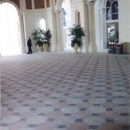

[[](https://tiletechpavers.com/resources/available-styles-of-concrete-pavers/introduction-of-interlocking-pavers/)](https://tiletechpavers.com/resources/available-styles-of-concrete-pavers/introduction-of-interlocking-pavers/" \o "Interlocking Pavers Introduction - Tile Tech Pavers" \t "_blank)

[Tile Tech Pavers](https://tiletechpavers.com/resources/available-styles-of-concrete-pavers/introduction-of-interlocking-pavers/" \o "Interlocking Pavers Introduction - Tile Tech Pavers" \t "_blank)

[Interlocking Pavers Introduction - Tile ...](https://tiletechpavers.com/resources/available-styles-of-concrete-pavers/introduction-of-interlocking-pavers/" \o "Interlocking Pavers Introduction - Tile Tech Pavers" \t "_blank)

**Deck Tiles - Patio Pavers - Acacia Wood Outdoor Flooring - Interlocking Patio Tiles - 12"x12" (10 Pack) - Modern Grey Finish - Checker Pattern Decking - Walmart.com**

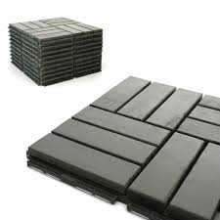

[[](https://www.walmart.com/ip/Deck-Tiles-Patio-Pavers-Acacia-Wood-Outdoor-Flooring-Interlocking-12-x12-10-Pack-Modern-Grey-Finish-Checker-Pattern-Decking/519256331)](https://www.walmart.com/ip/Deck-Tiles-Patio-Pavers-Acacia-Wood-Outdoor-Flooring-Interlocking-12-x12-10-Pack-Modern-Grey-Finish-Checker-Pattern-Decking/519256331" \o "Deck Tiles - Patio Pavers - Acacia Wood Outdoor Flooring - Interlocking  Patio Tiles - 12\"x12\" (10 Pack) - Modern Grey Finish - Checker Pattern  Decking - Walmart.com" \t "_blank)

[Walmart](https://www.walmart.com/ip/Deck-Tiles-Patio-Pavers-Acacia-Wood-Outdoor-Flooring-Interlocking-12-x12-10-Pack-Modern-Grey-Finish-Checker-Pattern-Decking/519256331" \o "Deck Tiles - Patio Pavers - Acacia Wood Outdoor Flooring - Interlocking  Patio Tiles - 12\"x12\" (10 Pack) - Modern Grey Finish - Checker Pattern  Decking - Walmart.com" \t "_blank)

[Deck Tiles - Patio Pavers - Acacia Wood ...](https://www.walmart.com/ip/Deck-Tiles-Patio-Pavers-Acacia-Wood-Outdoor-Flooring-Interlocking-12-x12-10-Pack-Modern-Grey-Finish-Checker-Pattern-Decking/519256331" \o "Deck Tiles - Patio Pavers - Acacia Wood Outdoor Flooring - Interlocking  Patio Tiles - 12\"x12\" (10 Pack) - Modern Grey Finish - Checker Pattern  Decking - Walmart.com" \t "_blank)

**Gardenised Gray Plastic Garden Path Track Interlocking Stone Look Design Pathway Tile Floor Paver (Pack of 4) QI004108.4 - The Home Depot**

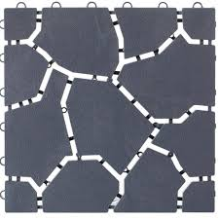

[[](https://www.homedepot.com/p/Gardenised-Gray-Plastic-Garden-Path-Track-Interlocking-Stone-Look-Design-Pathway-Tile-Floor-Paver-Pack-of-4-QI004108-4/317909834)](https://www.homedepot.com/p/Gardenised-Gray-Plastic-Garden-Path-Track-Interlocking-Stone-Look-Design-Pathway-Tile-Floor-Paver-Pack-of-4-QI004108-4/317909834" \o "Gardenised Gray Plastic Garden Path Track Interlocking Stone Look Design  Pathway Tile Floor Paver (Pack of 4) QI004108.4 - The Home Depot" \t "_blank)

[The Home Depot](https://www.homedepot.com/p/Gardenised-Gray-Plastic-Garden-Path-Track-Interlocking-Stone-Look-Design-Pathway-Tile-Floor-Paver-Pack-of-4-QI004108-4/317909834" \o "Gardenised Gray Plastic Garden Path Track Interlocking Stone Look Design  Pathway Tile Floor Paver (Pack of 4) QI004108.4 - The Home Depot" \t "_blank)

[Gardenised Gray Plastic Garden Path ...](https://www.homedepot.com/p/Gardenised-Gray-Plastic-Garden-Path-Track-Interlocking-Stone-Look-Design-Pathway-Tile-Floor-Paver-Pack-of-4-QI004108-4/317909834" \o "Gardenised Gray Plastic Garden Path Track Interlocking Stone Look Design  Pathway Tile Floor Paver (Pack of 4) QI004108.4 - The Home Depot" \t "_blank)

**Exterior | Paver blocks, Patio pavers design, Paver designs**

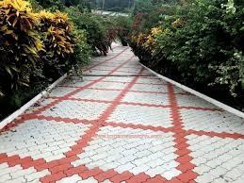

[[](https://in.pinterest.com/pin/581175526916065581/)](https://in.pinterest.com/pin/581175526916065581/" \o "Exterior | Paver blocks, Patio pavers design, Paver designs" \t "_blank)

[Pinterest](https://in.pinterest.com/pin/581175526916065581/" \o "Exterior | Paver blocks, Patio pavers design, Paver designs" \t "_blank)

[Paver blocks, Patio pavers design ...](https://in.pinterest.com/pin/581175526916065581/" \o "Exterior | Paver blocks, Patio pavers design, Paver designs" \t "_blank)

**Paver Block Iron Oxide Colour Pigment - Concrete Tiles Colour Manufacturer from New Delhi**



[[](https://www.jsdesignertilesproduct.com/paver-block-iron-oxide-colour-pigment.html)](https://www.jsdesignertilesproduct.com/paver-block-iron-oxide-colour-pigment.html" \o "Paver Block Iron Oxide Colour Pigment - Concrete Tiles Colour Manufacturer  from New Delhi" \t "_blank)

[JS Designer Tiles Product](https://www.jsdesignertilesproduct.com/paver-block-iron-oxide-colour-pigment.html" \o "Paver Block Iron Oxide Colour Pigment - Concrete Tiles Colour Manufacturer  from New Delhi" \t "_blank)

[Paver Block Iron Oxide Colour Pigment ...](https://www.jsdesignertilesproduct.com/paver-block-iron-oxide-colour-pigment.html" \o "Paver Block Iron Oxide Colour Pigment - Concrete Tiles Colour Manufacturer  from New Delhi" \t "_blank)

**Multi Color Paver Block Tiles at Best Price in Saharanpur | Parthvi Tiles**

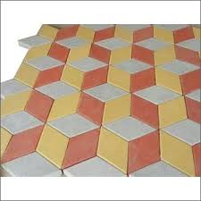

[[](https://www.tradeindia.com/products/paver-block-tiles-c7463935.html)](https://www.tradeindia.com/products/paver-block-tiles-c7463935.html" \o "Multi Color Paver Block Tiles at Best Price in Saharanpur | Parthvi Tiles" \t "_blank)

[TradeIndia](https://www.tradeindia.com/products/paver-block-tiles-c7463935.html" \o "Multi Color Paver Block Tiles at Best Price in Saharanpur | Parthvi Tiles" \t "_blank)

[Multi Color Paver Block Tiles at Best ...](https://www.tradeindia.com/products/paver-block-tiles-c7463935.html" \o "Multi Color Paver Block Tiles at Best Price in Saharanpur | Parthvi Tiles" \t "_blank)

**INTERLOCKING TILES ∕ PAVERS**

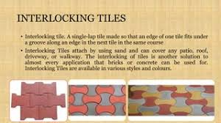

[[](https://www.slideshare.net/sanjeevsingh462/interlocking-tiles-pavers)](https://www.slideshare.net/sanjeevsingh462/interlocking-tiles-pavers" \o "INTERLOCKING TILES ∕ PAVERS" \t "_blank)

[SlideShare](https://www.slideshare.net/sanjeevsingh462/interlocking-tiles-pavers" \o "INTERLOCKING TILES ∕ PAVERS" \t "_blank)

[INTERLOCKING TILES ∕ PAVERS](https://www.slideshare.net/sanjeevsingh462/interlocking-tiles-pavers" \o "INTERLOCKING TILES ∕ PAVERS" \t "_blank)

**Interlocking paver blocks, Color : Blue, Green, INR 1INR 2 / pcs by jashma tiles from Surat Gujarat | ID - 6060146**

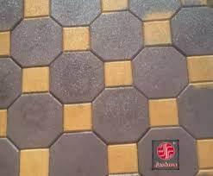

[[](https://www.exportersindia.com/product-detail/blue-green-interlocking-paver-blocks-6060146.htm)](https://www.exportersindia.com/product-detail/blue-green-interlocking-paver-blocks-6060146.htm" \o "Interlocking paver blocks, Color : Blue, Green, INR 1INR 2 / pcs by jashma  tiles from Surat Gujarat | ID - 6060146" \t "_blank)

[Exporters India](https://www.exportersindia.com/product-detail/blue-green-interlocking-paver-blocks-6060146.htm" \o "Interlocking paver blocks, Color : Blue, Green, INR 1INR 2 / pcs by jashma  tiles from Surat Gujarat | ID - 6060146" \t "_blank)

[Interlocking paver blocks, Color : Blue ...](https://www.exportersindia.com/product-detail/blue-green-interlocking-paver-blocks-6060146.htm" \o "Interlocking paver blocks, Color : Blue, Green, INR 1INR 2 / pcs by jashma  tiles from Surat Gujarat | ID - 6060146" \t "_blank)

**Interlocking Paving Tiles - TRAPEZIOD – Jubilee Tower Equipment Supply**

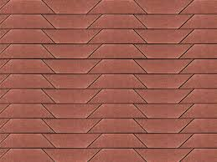

[[](https://jubileetower.com/products/interlocking-paving-tiles-trapeziod)](https://jubileetower.com/products/interlocking-paving-tiles-trapeziod" \o "Interlocking Paving Tiles - TRAPEZIOD – Jubilee Tower Equipment Supply" \t "_blank)

[Jubilee Tower Equipment Supply](https://jubileetower.com/products/interlocking-paving-tiles-trapeziod" \o "Interlocking Paving Tiles - TRAPEZIOD – Jubilee Tower Equipment Supply" \t "_blank)

[Interlocking Paving Tiles - TRAPEZIOD ...](https://jubileetower.com/products/interlocking-paving-tiles-trapeziod" \o "Interlocking Paving Tiles - TRAPEZIOD – Jubilee Tower Equipment Supply" \t "_blank)

**551 Interlocking Paving Stone Stock Photos and Images - 123RF**

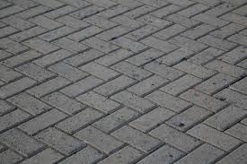

[[](https://www.123rf.com/stock-photo/interlocking_paving_stone.html)](https://www.123rf.com/stock-photo/interlocking_paving_stone.html" \o "551 Interlocking Paving Stone Stock Photos and Images - 123RF" \t "_blank)

[123RF](https://www.123rf.com/stock-photo/interlocking_paving_stone.html" \o "551 Interlocking Paving Stone Stock Photos and Images - 123RF" \t "_blank)

[551 Interlocking Paving Stone Stock ...](https://www.123rf.com/stock-photo/interlocking_paving_stone.html" \o "551 Interlocking Paving Stone Stock Photos and Images - 123RF" \t "_blank)

Related searches

[[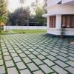](https://www.google.com/search?q=interlock+tiles+price&tbm=isch&hl=en&bih=722&biw=1519&rlz=1C1YTUH_enIN1004IN1004&sa=X&ved=2ahUKEwiS7Z-0wZL9AhU3_TgGHdP2CQQQrNwCKAB6BQgBEK0B)](https://www.google.com/search?q=interlock+tiles+price&tbm=isch&hl=en&bih=722&biw=1519&rlz=1C1YTUH_enIN1004IN1004&sa=X&ved=2ahUKEwiS7Z-0wZL9AhU3_TgGHdP2CQQQrNwCKAB6BQgBEK0B)

**[interlock](https://www.google.com/search?q=interlock+tiles+price&tbm=isch&hl=en&bih=722&biw=1519&rlz=1C1YTUH_enIN1004IN1004&sa=X&ved=2ahUKEwiS7Z-0wZL9AhU3_TgGHdP2CQQQrNwCKAB6BQgBEK0B)**[tiles](https://www.google.com/search?q=interlock+tiles+price&tbm=isch&hl=en&bih=722&biw=1519&rlz=1C1YTUH_enIN1004IN1004&sa=X&ved=2ahUKEwiS7Z-0wZL9AhU3_TgGHdP2CQQQrNwCKAB6BQgBEK0B)**[price](https://www.google.com/search?q=interlock+tiles+price&tbm=isch&hl=en&bih=722&biw=1519&rlz=1C1YTUH_enIN1004IN1004&sa=X&ved=2ahUKEwiS7Z-0wZL9AhU3_TgGHdP2CQQQrNwCKAB6BQgBEK0B)**

[[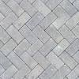](https://www.google.com/search?q=interlock+tiles+texture&tbm=isch&hl=en&bih=722&biw=1519&rlz=1C1YTUH_enIN1004IN1004&sa=X&ved=2ahUKEwiS7Z-0wZL9AhU3_TgGHdP2CQQQrNwCKAB6BQgBEK8B)](https://www.google.com/search?q=interlock+tiles+texture&tbm=isch&hl=en&bih=722&biw=1519&rlz=1C1YTUH_enIN1004IN1004&sa=X&ved=2ahUKEwiS7Z-0wZL9AhU3_TgGHdP2CQQQrNwCKAB6BQgBEK8B)

**[interlock](https://www.google.com/search?q=interlock+tiles+texture&tbm=isch&hl=en&bih=722&biw=1519&rlz=1C1YTUH_enIN1004IN1004&sa=X&ved=2ahUKEwiS7Z-0wZL9AhU3_TgGHdP2CQQQrNwCKAB6BQgBEK8B)**[tiles](https://www.google.com/search?q=interlock+tiles+texture&tbm=isch&hl=en&bih=722&biw=1519&rlz=1C1YTUH_enIN1004IN1004&sa=X&ved=2ahUKEwiS7Z-0wZL9AhU3_TgGHdP2CQQQrNwCKAB6BQgBEK8B)**[texture](https://www.google.com/search?q=interlock+tiles+texture&tbm=isch&hl=en&bih=722&biw=1519&rlz=1C1YTUH_enIN1004IN1004&sa=X&ved=2ahUKEwiS7Z-0wZL9AhU3_TgGHdP2CQQQrNwCKAB6BQgBEK8B)**

[[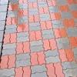](https://www.google.com/search?q=zig+zag+paver+block+design&tbm=isch&hl=en&bih=722&biw=1519&rlz=1C1YTUH_enIN1004IN1004&sa=X&ved=2ahUKEwiS7Z-0wZL9AhU3_TgGHdP2CQQQrNwCKAB6BQgBELEB)](https://www.google.com/search?q=zig+zag+paver+block+design&tbm=isch&hl=en&bih=722&biw=1519&rlz=1C1YTUH_enIN1004IN1004&sa=X&ved=2ahUKEwiS7Z-0wZL9AhU3_TgGHdP2CQQQrNwCKAB6BQgBELEB)

[zig zag paver block design](https://www.google.com/search?q=zig+zag+paver+block+design&tbm=isch&hl=en&bih=722&biw=1519&rlz=1C1YTUH_enIN1004IN1004&sa=X&ved=2ahUKEwiS7Z-0wZL9AhU3_TgGHdP2CQQQrNwCKAB6BQgBELEB)

**Image Results**

**Seamless pattern of tiled cobblestone pavers. Geometric mosaic street tiles. Red and yellow color. Paver block of paving slabs. Editable Vector Illust Stock Vector Image & Art - Alamy**

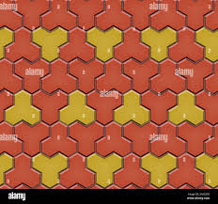

[[](https://www.alamy.com/seamless-pattern-of-tiled-cobblestone-pavers-geometric-mosaic-street-tiles-red-and-yellow-color-paver-block-of-paving-slabs-editable-vector-illust-image330797410.html)](https://www.alamy.com/seamless-pattern-of-tiled-cobblestone-pavers-geometric-mosaic-street-tiles-red-and-yellow-color-paver-block-of-paving-slabs-editable-vector-illust-image330797410.html" \o "Seamless pattern of tiled cobblestone pavers. Geometric mosaic street tiles.  Red and yellow color. Paver block of paving slabs. Editable Vector Illust  Stock Vector Image & Art - Alamy" \t "_blank)

[Alamy](https://www.alamy.com/seamless-pattern-of-tiled-cobblestone-pavers-geometric-mosaic-street-tiles-red-and-yellow-color-paver-block-of-paving-slabs-editable-vector-illust-image330797410.html" \o "Seamless pattern of tiled cobblestone pavers. Geometric mosaic street tiles.  Red and yellow color. Paver block of paving slabs. Editable Vector Illust  Stock Vector Image & Art - Alamy" \t "_blank)

[Seamless pattern of tiled cobblestone ...](https://www.alamy.com/seamless-pattern-of-tiled-cobblestone-pavers-geometric-mosaic-street-tiles-red-and-yellow-color-paver-block-of-paving-slabs-editable-vector-illust-image330797410.html" \o "Seamless pattern of tiled cobblestone pavers. Geometric mosaic street tiles.  Red and yellow color. Paver block of paving slabs. Editable Vector Illust  Stock Vector Image & Art - Alamy" \t "_blank)

**Types of Interlocking Pavers | eHow**

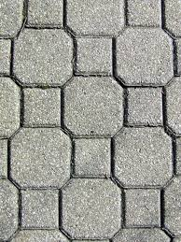

[[](https://www.ehow.com/list_6957183_types-interlocking-pavers.html)](https://www.ehow.com/list_6957183_types-interlocking-pavers.html" \o "Types of Interlocking Pavers | eHow" \t "_blank)

[eHow](https://www.ehow.com/list_6957183_types-interlocking-pavers.html" \o "Types of Interlocking Pavers | eHow" \t "_blank)

[Types of Interlocking Pavers | eHow](https://www.ehow.com/list_6957183_types-interlocking-pavers.html" \o "Types of Interlocking Pavers | eHow" \t "_blank)

**Interlocking Pavers Images – Browse 862 Stock Photos, Vectors, and Video | Adobe Stock**

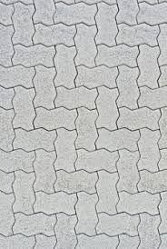

[[](https://stock.adobe.com/search?k=interlocking+pavers)](https://stock.adobe.com/search?k=interlocking+pavers" \o "Interlocking Pavers Images – Browse 862 Stock Photos, Vectors, and Video |  Adobe Stock" \t "_blank)

[Adobe Stock](https://stock.adobe.com/search?k=interlocking+pavers" \o "Interlocking Pavers Images – Browse 862 Stock Photos, Vectors, and Video |  Adobe Stock" \t "_blank)

[Interlocking Pavers Images – Browse 862 ...](https://stock.adobe.com/search?k=interlocking+pavers" \o "Interlocking Pavers Images – Browse 862 Stock Photos, Vectors, and Video |  Adobe Stock" \t "_blank)

**Terracon Tiles - Paving Tiles Manufacturers in Kerala, Thrissur, Paver Blocks Design, Outdoor floor tiles Product company, Ernakulam, Kottayam, Kochi**

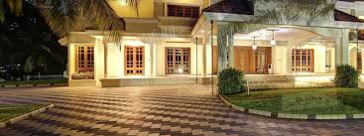

[[](http://www.terracontilesindia.com/)](http://www.terracontilesindia.com/" \o "Terracon Tiles - Paving Tiles Manufacturers in Kerala, Thrissur, Paver  Blocks Design, Outdoor floor tiles Product company, Ernakulam, Kottayam,  Kochi" \t "_blank)

[www.terracontilesindia.com](http://www.terracontilesindia.com/" \o "Terracon Tiles - Paving Tiles Manufacturers in Kerala, Thrissur, Paver  Blocks Design, Outdoor floor tiles Product company, Ernakulam, Kottayam,  Kochi" \t "_blank)

[Terracon Tiles - Paving Tiles ...](http://www.terracontilesindia.com/" \o "Terracon Tiles - Paving Tiles Manufacturers in Kerala, Thrissur, Paver  Blocks Design, Outdoor floor tiles Product company, Ernakulam, Kottayam,  Kochi" \t "_blank)

**REGUM Interlocking Pavers | BECO**

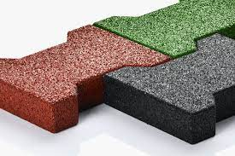

[[](https://www.beco-bermueller.de/en/products/fall-protection-edgings-surfacing/fall-protection-and-elastic-products/regum-interlocking-pavers/)](https://www.beco-bermueller.de/en/products/fall-protection-edgings-surfacing/fall-protection-and-elastic-products/regum-interlocking-pavers/" \o "REGUM Interlocking Pavers | BECO" \t "_blank)

[beco-bermueller.de](https://www.beco-bermueller.de/en/products/fall-protection-edgings-surfacing/fall-protection-and-elastic-products/regum-interlocking-pavers/" \o "REGUM Interlocking Pavers | BECO" \t "_blank)

[REGUM Interlocking Pavers | BECO](https://www.beco-bermueller.de/en/products/fall-protection-edgings-surfacing/fall-protection-and-elastic-products/regum-interlocking-pavers/" \o "REGUM Interlocking Pavers | BECO" \t "_blank)

**Interlocking Pavers & Wallstone Kitchener & Cambridge | Landscape Materials Supply**

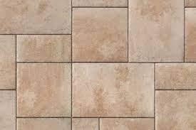

[[](https://www.cambridgegardencentre.ca/interlocking-pavers-and-wallstone/)](https://www.cambridgegardencentre.ca/interlocking-pavers-and-wallstone/" \o "Interlocking Pavers & Wallstone Kitchener & Cambridge | Landscape Materials  Supply" \t "_blank)

[Cambridge Garden Centre](https://www.cambridgegardencentre.ca/interlocking-pavers-and-wallstone/" \o "Interlocking Pavers & Wallstone Kitchener & Cambridge | Landscape Materials  Supply" \t "_blank)

[Interlocking Pavers & Wallstone ...](https://www.cambridgegardencentre.ca/interlocking-pavers-and-wallstone/" \o "Interlocking Pavers & Wallstone Kitchener & Cambridge | Landscape Materials  Supply" \t "_blank)

**Interlocking vs Concrete: Which is Better? - Markstone Landscaping**

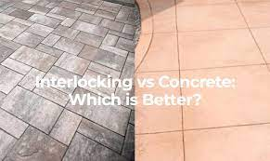

[[](https://markstonelandscaping.com/interlocking-vs-concrete/)](https://markstonelandscaping.com/interlocking-vs-concrete/" \o "Interlocking vs Concrete: Which is Better? - Markstone Landscaping" \t "_blank)

[Markstone Landscaping](https://markstonelandscaping.com/interlocking-vs-concrete/" \o "Interlocking vs Concrete: Which is Better? - Markstone Landscaping" \t "_blank)

[Interlocking vs Concrete: Which is ...](https://markstonelandscaping.com/interlocking-vs-concrete/" \o "Interlocking vs Concrete: Which is Better? - Markstone Landscaping" \t "_blank)

**14 Different Types of Tiles for Outdoor Patios and How to Choose One**

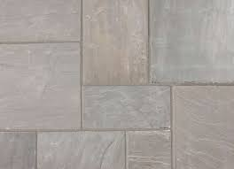

[[](https://www.thespruce.com/how-to-set-outdoor-patio-tile-2132506)](https://www.thespruce.com/how-to-set-outdoor-patio-tile-2132506" \o "14 Different Types of Tiles for Outdoor Patios and How to Choose One" \t "_blank)

[The Spruce](https://www.thespruce.com/how-to-set-outdoor-patio-tile-2132506" \o "14 Different Types of Tiles for Outdoor Patios and How to Choose One" \t "_blank)

[Tiles for Outdoor Patios ...](https://www.thespruce.com/how-to-set-outdoor-patio-tile-2132506" \o "14 Different Types of Tiles for Outdoor Patios and How to Choose One" \t "_blank)

**CARPET TILE in a noida/CARPET TILE in a noida/CARPET TILE in a noida/CARPET TILE in a noida/CARPET TILE in a noida/CARPET TILE in a noida/CARPET TILE in a noida/CARPET TILE in a**



[[](https://www.trade4asia.com/Lighting/single-product.jsp?p_id=8084544&s_id=Color%20Pan%20Mixer)](https://www.trade4asia.com/Lighting/single-product.jsp?p_id=8084544&s_id=Color%20Pan%20Mixer" \o "CARPET TILE in a noida/CARPET TILE in a noida/CARPET TILE in a noida/CARPET  TILE in a noida/CARPET TILE in a noida/CARPET TILE in a noida/CARPET TILE  in a noida/CARPET TILE in a" \t "_blank)

[Trade4asia.com](https://www.trade4asia.com/Lighting/single-product.jsp?p_id=8084544&s_id=Color%20Pan%20Mixer" \o "CARPET TILE in a noida/CARPET TILE in a noida/CARPET TILE in a noida/CARPET  TILE in a noida/CARPET TILE in a noida/CARPET TILE in a noida/CARPET TILE  in a noida/CARPET TILE in a" \t "_blank)

[CARPET TILE in a noida/CARPET TILE in a ...](https://www.trade4asia.com/Lighting/single-product.jsp?p_id=8084544&s_id=Color%20Pan%20Mixer" \o "CARPET TILE in a noida/CARPET TILE in a noida/CARPET TILE in a noida/CARPET  TILE in a noida/CARPET TILE in a noida/CARPET TILE in a noida/CARPET TILE  in a noida/CARPET TILE in a" \t "_blank)

**Benefits of Concrete Pavers - RCP Block & Brick**

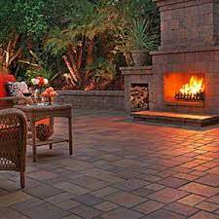

[[](https://www.rcpblock.com/articles-benefits-of-interlocking-concrete-pavers.html)](https://www.rcpblock.com/articles-benefits-of-interlocking-concrete-pavers.html" \o "Benefits of Concrete Pavers - RCP Block & Brick" \t "_blank)

[RCP Block & Brick](https://www.rcpblock.com/articles-benefits-of-interlocking-concrete-pavers.html" \o "Benefits of Concrete Pavers - RCP Block & Brick" \t "_blank)

[Benefits of Concrete Pavers - RCP Block ...](https://www.rcpblock.com/articles-benefits-of-interlocking-concrete-pavers.html" \o "Benefits of Concrete Pavers - RCP Block & Brick" \t "_blank)

**Concrete Paving Tiles Kottayam | Interlocking Pavers in Kerala | V-CON**

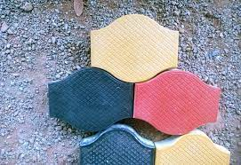

[[](https://www.citymapia.com/kottayam/v-con-industries/product/galaxy-607)](https://www.citymapia.com/kottayam/v-con-industries/product/galaxy-607" \o "Concrete Paving Tiles Kottayam | Interlocking Pavers in Kerala | V-CON" \t "_blank)

[Citymapia](https://www.citymapia.com/kottayam/v-con-industries/product/galaxy-607" \o "Concrete Paving Tiles Kottayam | Interlocking Pavers in Kerala | V-CON" \t "_blank)

[Concrete Paving Tiles Kottayam ...](https://www.citymapia.com/kottayam/v-con-industries/product/galaxy-607" \o "Concrete Paving Tiles Kottayam | Interlocking Pavers in Kerala | V-CON" \t "_blank)

**Interlocking Concrete Pavers - Tile Tech Pavers**

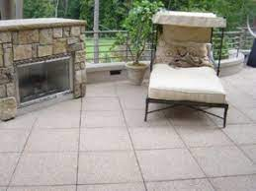

[[](https://tiletechpavers.com/resources/available-styles-of-concrete-pavers/benefits-of-interlocking-pavers/)](https://tiletechpavers.com/resources/available-styles-of-concrete-pavers/benefits-of-interlocking-pavers/" \o "Interlocking Concrete Pavers - Tile Tech Pavers" \t "_blank)

[Tile Tech Pavers](https://tiletechpavers.com/resources/available-styles-of-concrete-pavers/benefits-of-interlocking-pavers/" \o "Interlocking Concrete Pavers - Tile Tech Pavers" \t "_blank)

[Interlocking Concrete Pavers - Tile ...](https://tiletechpavers.com/resources/available-styles-of-concrete-pavers/benefits-of-interlocking-pavers/" \o "Interlocking Concrete Pavers - Tile Tech Pavers" \t "_blank)

**Interlocking Rubber Deck Paver, BLACK, 24 x 24 x 2 inch**

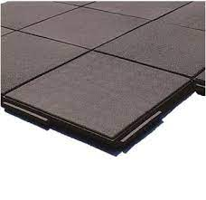

[[](https://www.bestmaterials.com/detail.aspx?ID=18722)](https://www.bestmaterials.com/detail.aspx?ID=18722" \o "Interlocking Rubber Deck Paver, BLACK, 24 x 24 x 2 inch" \t "_blank)

[Best Materials](https://www.bestmaterials.com/detail.aspx?ID=18722" \o "Interlocking Rubber Deck Paver, BLACK, 24 x 24 x 2 inch" \t "_blank)

[Interlocking Rubber Deck Paver, BLACK ...](https://www.bestmaterials.com/detail.aspx?ID=18722" \o "Interlocking Rubber Deck Paver, BLACK, 24 x 24 x 2 inch" \t "_blank)

**Interlocking floor tiles price | Delhi 2023| paver block plant in delhi - YouTube**

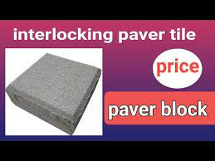

[[](https://www.youtube.com/watch?v=r8L2KCO5xFI)](https://www.youtube.com/watch?v=r8L2KCO5xFI" \o "Interlocking floor tiles price | Delhi 2023| paver block plant in delhi -  YouTube" \t "_blank)

[YouTube](https://www.youtube.com/watch?v=r8L2KCO5xFI" \o "Interlocking floor tiles price | Delhi 2023| paver block plant in delhi -  YouTube" \t "_blank)

[Interlocking floor tiles price | Delhi ...](https://www.youtube.com/watch?v=r8L2KCO5xFI" \o "Interlocking floor tiles price | Delhi 2023| paver block plant in delhi -  YouTube" \t "_blank)

**Doublet Interlocking Paver Block Seamless Texture Map Seams Of Tile Bump Stock Illustration - Download Image Now - iStock**



[[](https://www.istockphoto.com/vector/double-t-interlocking-paver-block-seamless-texture-map-seams-of-tile-bump-gm1021117708-274267527)](https://www.istockphoto.com/vector/double-t-interlocking-paver-block-seamless-texture-map-seams-of-tile-bump-gm1021117708-274267527" \o "Doublet Interlocking Paver Block Seamless Texture Map Seams Of Tile Bump  Stock Illustration - Download Image Now - iStock" \t "_blank)

[iStock](https://www.istockphoto.com/vector/double-t-interlocking-paver-block-seamless-texture-map-seams-of-tile-bump-gm1021117708-274267527" \o "Doublet Interlocking Paver Block Seamless Texture Map Seams Of Tile Bump  Stock Illustration - Download Image Now - iStock" \t "_blank)

[Doublet Interlocking Paver Block ...](https://www.istockphoto.com/vector/double-t-interlocking-paver-block-seamless-texture-map-seams-of-tile-bump-gm1021117708-274267527" \o "Doublet Interlocking Paver Block Seamless Texture Map Seams Of Tile Bump  Stock Illustration - Download Image Now - iStock" \t "_blank)

**Concrete Cobble Stones Color -... - Jain Tiles Industries | Facebook**

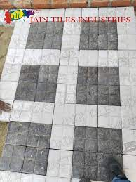

[[](https://www.facebook.com/Jaintilesindustries/posts/552494190226962/)](https://www.facebook.com/Jaintilesindustries/posts/552494190226962/" \o "Concrete Cobble Stones Color -... - Jain Tiles Industries | Facebook" \t "_blank)

[Facebook](https://www.facebook.com/Jaintilesindustries/posts/552494190226962/" \o "Concrete Cobble Stones Color -... - Jain Tiles Industries | Facebook" \t "_blank)

[Concrete Cobble Stones Color ...](https://www.facebook.com/Jaintilesindustries/posts/552494190226962/" \o "Concrete Cobble Stones Color -... - Jain Tiles Industries | Facebook" \t "_blank)

**Gold Yellow Swimming Pool Coping Pavers,Golden Beige Quartzite Pool Deck Pavers,More Yellow Less Grey Interlocking Patio Pavers,Beige Color Pool Pavers Tiles from China - StoneContact.com**

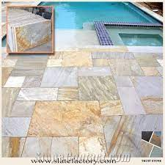

[[](https://www.stonecontact.com/products-193480/gold-yellow-swimming-pool-coping-pavers)](https://www.stonecontact.com/products-193480/gold-yellow-swimming-pool-coping-pavers" \o "Gold Yellow Swimming Pool Coping Pavers,Golden Beige Quartzite Pool Deck  Pavers,More Yellow Less Grey Interlocking Patio Pavers,Beige Color Pool Pavers  Tiles from China - StoneContact.com" \t "_blank)

[StoneContact.com](https://www.stonecontact.com/products-193480/gold-yellow-swimming-pool-coping-pavers" \o "Gold Yellow Swimming Pool Coping Pavers,Golden Beige Quartzite Pool Deck  Pavers,More Yellow Less Grey Interlocking Patio Pavers,Beige Color Pool Pavers  Tiles from China - StoneContact.com" \t "_blank)

[Gold Yellow Swimming Pool Coping Pavers ...](https://www.stonecontact.com/products-193480/gold-yellow-swimming-pool-coping-pavers" \o "Gold Yellow Swimming Pool Coping Pavers,Golden Beige Quartzite Pool Deck  Pavers,More Yellow Less Grey Interlocking Patio Pavers,Beige Color Pool Pavers  Tiles from China - StoneContact.com" \t "_blank)

**Premium Vector | Seamless pattern of old pavement with moss and dumble interlocking textured bricks**

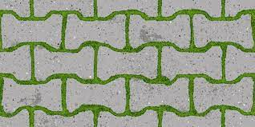

[[](https://www.freepik.com/premium-vector/seamless-pattern-old-pavement-with-moss-dumble-interlocking-textured-bricks_35341089.htm)](https://www.freepik.com/premium-vector/seamless-pattern-old-pavement-with-moss-dumble-interlocking-textured-bricks_35341089.htm" \o "Premium Vector | Seamless pattern of old pavement with moss and dumble  interlocking textured bricks" \t "_blank)

[Freepik](https://www.freepik.com/premium-vector/seamless-pattern-old-pavement-with-moss-dumble-interlocking-textured-bricks_35341089.htm" \o "Premium Vector | Seamless pattern of old pavement with moss and dumble  interlocking textured bricks" \t "_blank)

[dumble interlocking textured bricks](https://www.freepik.com/premium-vector/seamless-pattern-old-pavement-with-moss-dumble-interlocking-textured-bricks_35341089.htm" \o "Premium Vector | Seamless pattern of old pavement with moss and dumble  interlocking textured bricks" \t "_blank)

**Interlocking Pavers Stone - Interlocking Tile Manufacturer from Bahadurgarh**

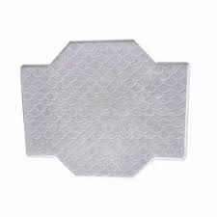

[[](https://www.shreejeetiles.in/interlocking-pavers-stone.html)](https://www.shreejeetiles.in/interlocking-pavers-stone.html" \o "Interlocking Pavers Stone - Interlocking Tile Manufacturer from Bahadurgarh" \t "_blank)

[Shree Jee Tiles](https://www.shreejeetiles.in/interlocking-pavers-stone.html" \o "Interlocking Pavers Stone - Interlocking Tile Manufacturer from Bahadurgarh" \t "_blank)

[Interlocking Pavers Stone ...](https://www.shreejeetiles.in/interlocking-pavers-stone.html" \o "Interlocking Pavers Stone - Interlocking Tile Manufacturer from Bahadurgarh" \t "_blank)

**POPLARBOX 12" x 12" Composite Interlocking Deck Tile in Brown | Wayfair**

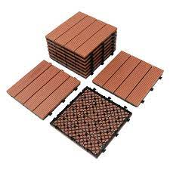

[[](https://www.wayfair.com/home-improvement/pdp/poplarbox-12-x-12-composite-interlocking-deck-tile-in-brown-kdwx1097.html)](https://www.wayfair.com/home-improvement/pdp/poplarbox-12-x-12-composite-interlocking-deck-tile-in-brown-kdwx1097.html" \o "POPLARBOX 12\" x 12\" Composite Interlocking Deck Tile in Brown | Wayfair" \t "_blank)

[Wayfair](https://www.wayfair.com/home-improvement/pdp/poplarbox-12-x-12-composite-interlocking-deck-tile-in-brown-kdwx1097.html" \o "POPLARBOX 12\" x 12\" Composite Interlocking Deck Tile in Brown | Wayfair" \t "_blank)

[Composite Interlocking Deck Tile ...](https://www.wayfair.com/home-improvement/pdp/poplarbox-12-x-12-composite-interlocking-deck-tile-in-brown-kdwx1097.html" \o "POPLARBOX 12\" x 12\" Composite Interlocking Deck Tile in Brown | Wayfair" \t "_blank)

**Customized Mold Rubber Interlocking Paver Tiles Molding Plastic Paving Moulds - Chine Mould, Silicone Rubber**

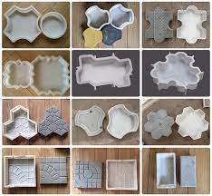

[[](https://fr.made-in-china.com/co_kiiwoo-technology/product_Customized-Mold-Rubber-Interlocking-Paver-Tiles-Molding-Plastic-Paving-Moulds_uoeorigisg.html)](https://fr.made-in-china.com/co_kiiwoo-technology/product_Customized-Mold-Rubber-Interlocking-Paver-Tiles-Molding-Plastic-Paving-Moulds_uoeorigisg.html" \o "Customized Mold Rubber Interlocking Paver Tiles Molding Plastic Paving  Moulds - Chine Mould, Silicone Rubber" \t "_blank)

[Made in China](https://fr.made-in-china.com/co_kiiwoo-technology/product_Customized-Mold-Rubber-Interlocking-Paver-Tiles-Molding-Plastic-Paving-Moulds_uoeorigisg.html" \o "Customized Mold Rubber Interlocking Paver Tiles Molding Plastic Paving  Moulds - Chine Mould, Silicone Rubber" \t "_blank)

[Customized Mold Rubber Interlocking ...](https://fr.made-in-china.com/co_kiiwoo-technology/product_Customized-Mold-Rubber-Interlocking-Paver-Tiles-Molding-Plastic-Paving-Moulds_uoeorigisg.html" \o "Customized Mold Rubber Interlocking Paver Tiles Molding Plastic Paving  Moulds - Chine Mould, Silicone Rubber" \t "_blank)

**Interlocking Paver Tile in Indore at best price by Muskan Industries - Justdial**

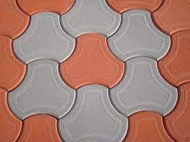

[[](https://www.justdial.com/jdmart/Indore/Interlocking-Paver-Tile/pid-2025976535/0731PX731-X731-210726144137-X7Q1)](https://www.justdial.com/jdmart/Indore/Interlocking-Paver-Tile/pid-2025976535/0731PX731-X731-210726144137-X7Q1" \o "Interlocking Paver Tile in Indore at best price by Muskan Industries -  Justdial" \t "_blank)

[Justdial](https://www.justdial.com/jdmart/Indore/Interlocking-Paver-Tile/pid-2025976535/0731PX731-X731-210726144137-X7Q1" \o "Interlocking Paver Tile in Indore at best price by Muskan Industries -  Justdial" \t "_blank)

[Interlocking Paver Tile in Indore at ...](https://www.justdial.com/jdmart/Indore/Interlocking-Paver-Tile/pid-2025976535/0731PX731-X731-210726144137-X7Q1" \o "Interlocking Paver Tile in Indore at best price by Muskan Industries -  Justdial" \t "_blank)

**Mcombo 10Pcs Patio Wood Deck Tiles 12"x12",Outdoor Interlocking Deck Flooring Oiled Finish,Patio Paver Tiles - Overstock - 32697675**

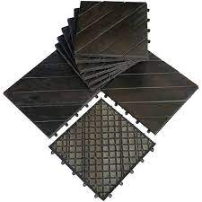

[[](https://www.overstock.com/Home-Garden/Mcombo-10Pcs-Patio-Wood-Deck-Tiles-12-x12-Outdoor-Interlocking-Deck-Flooring-Oiled-Finish-Patio-Paver-Tiles-6083-WF01-02-BK-WD/32697675/product.html)](https://www.overstock.com/Home-Garden/Mcombo-10Pcs-Patio-Wood-Deck-Tiles-12-x12-Outdoor-Interlocking-Deck-Flooring-Oiled-Finish-Patio-Paver-Tiles-6083-WF01-02-BK-WD/32697675/product.html" \o "Mcombo 10Pcs Patio Wood Deck Tiles 12\"x12\",Outdoor Interlocking Deck  Flooring Oiled Finish,Patio Paver Tiles - Overstock - 32697675" \t "_blank)

[Overstock.com](https://www.overstock.com/Home-Garden/Mcombo-10Pcs-Patio-Wood-Deck-Tiles-12-x12-Outdoor-Interlocking-Deck-Flooring-Oiled-Finish-Patio-Paver-Tiles-6083-WF01-02-BK-WD/32697675/product.html" \o "Mcombo 10Pcs Patio Wood Deck Tiles 12\"x12\",Outdoor Interlocking Deck  Flooring Oiled Finish,Patio Paver Tiles - Overstock - 32697675" \t "_blank)

[Mcombo 10Pcs Patio Wood Deck Tiles 12 ...](https://www.overstock.com/Home-Garden/Mcombo-10Pcs-Patio-Wood-Deck-Tiles-12-x12-Outdoor-Interlocking-Deck-Flooring-Oiled-Finish-Patio-Paver-Tiles-6083-WF01-02-BK-WD/32697675/product.html" \o "Mcombo 10Pcs Patio Wood Deck Tiles 12\"x12\",Outdoor Interlocking Deck  Flooring Oiled Finish,Patio Paver Tiles - Overstock - 32697675" \t "_blank)

**8 Ways to Add Colour and Interest to Your Interlock Driveway**

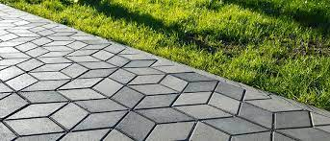

[[](https://www.simple-solutions.ca/blog/8-interlock-driveway-ideas-for-an-inviting-entrance-look/)](https://www.simple-solutions.ca/blog/8-interlock-driveway-ideas-for-an-inviting-entrance-look/" \o "8 Ways to Add Colour and Interest to Your Interlock Driveway" \t "_blank)

[Simple Solutions Landscaping](https://www.simple-solutions.ca/blog/8-interlock-driveway-ideas-for-an-inviting-entrance-look/" \o "8 Ways to Add Colour and Interest to Your Interlock Driveway" \t "_blank)

[Interlock Driveway](https://www.simple-solutions.ca/blog/8-interlock-driveway-ideas-for-an-inviting-entrance-look/" \o "8 Ways to Add Colour and Interest to Your Interlock Driveway" \t "_blank)

Related searches

[[](https://www.google.com/search?q=paver%20tiles%20design&tbm=isch&hl=en&bih=722&biw=1519&rlz=1C1YTUH_enIN1004IN1004&sa=X&ved=0CC0QrNwCKABqFwoTCMDX8LTBkv0CFQAAAAAdAAAAABAD)](https://www.google.com/search?q=paver%20tiles%20design&tbm=isch&hl=en&bih=722&biw=1519&rlz=1C1YTUH_enIN1004IN1004&sa=X&ved=0CC0QrNwCKABqFwoTCMDX8LTBkv0CFQAAAAAdAAAAABAD)

**[paver](https://www.google.com/search?q=paver%20tiles%20design&tbm=isch&hl=en&bih=722&biw=1519&rlz=1C1YTUH_enIN1004IN1004&sa=X&ved=0CC0QrNwCKABqFwoTCMDX8LTBkv0CFQAAAAAdAAAAABAD)**[tiles](https://www.google.com/search?q=paver%20tiles%20design&tbm=isch&hl=en&bih=722&biw=1519&rlz=1C1YTUH_enIN1004IN1004&sa=X&ved=0CC0QrNwCKABqFwoTCMDX8LTBkv0CFQAAAAAdAAAAABAD)**[design](https://www.google.com/search?q=paver%20tiles%20design&tbm=isch&hl=en&bih=722&biw=1519&rlz=1C1YTUH_enIN1004IN1004&sa=X&ved=0CC0QrNwCKABqFwoTCMDX8LTBkv0CFQAAAAAdAAAAABAD)**

[[](https://www.google.com/search?q=dumble%20interlock%20tiles%20design%20in%20punjab&tbm=isch&hl=en&bih=722&biw=1519&rlz=1C1YTUH_enIN1004IN1004&sa=X&ved=0CC8QrNwCKAFqFwoTCMDX8LTBkv0CFQAAAAAdAAAAABAD)](https://www.google.com/search?q=dumble%20interlock%20tiles%20design%20in%20punjab&tbm=isch&hl=en&bih=722&biw=1519&rlz=1C1YTUH_enIN1004IN1004&sa=X&ved=0CC8QrNwCKAFqFwoTCMDX8LTBkv0CFQAAAAAdAAAAABAD)

**[dumble interlock](https://www.google.com/search?q=dumble%20interlock%20tiles%20design%20in%20punjab&tbm=isch&hl=en&bih=722&biw=1519&rlz=1C1YTUH_enIN1004IN1004&sa=X&ved=0CC8QrNwCKAFqFwoTCMDX8LTBkv0CFQAAAAAdAAAAABAD)**[tiles](https://www.google.com/search?q=dumble%20interlock%20tiles%20design%20in%20punjab&tbm=isch&hl=en&bih=722&biw=1519&rlz=1C1YTUH_enIN1004IN1004&sa=X&ved=0CC8QrNwCKAFqFwoTCMDX8LTBkv0CFQAAAAAdAAAAABAD)**[design in punjab](https://www.google.com/search?q=dumble%20interlock%20tiles%20design%20in%20punjab&tbm=isch&hl=en&bih=722&biw=1519&rlz=1C1YTUH_enIN1004IN1004&sa=X&ved=0CC8QrNwCKAFqFwoTCMDX8LTBkv0CFQAAAAAdAAAAABAD)**

[[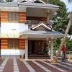](https://www.google.com/search?q=house%20interlock%20design&tbm=isch&hl=en&bih=722&biw=1519&rlz=1C1YTUH_enIN1004IN1004&sa=X&ved=0CDEQrNwCKAJqFwoTCMDX8LTBkv0CFQAAAAAdAAAAABAD)](https://www.google.com/search?q=house%20interlock%20design&tbm=isch&hl=en&bih=722&biw=1519&rlz=1C1YTUH_enIN1004IN1004&sa=X&ved=0CDEQrNwCKAJqFwoTCMDX8LTBkv0CFQAAAAAdAAAAABAD)

[house interlock design](https://www.google.com/search?q=house%20interlock%20design&tbm=isch&hl=en&bih=722&biw=1519&rlz=1C1YTUH_enIN1004IN1004&sa=X&ved=0CDEQrNwCKAJqFwoTCMDX8LTBkv0CFQAAAAAdAAAAABAD)

**What are Interlocking Pavers? (with pictures)**

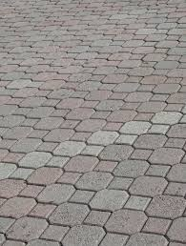

[[](https://www.homequestionsanswered.com/what-are-interlocking-pavers.htm)](https://www.homequestionsanswered.com/what-are-interlocking-pavers.htm" \o "What are Interlocking Pavers? (with pictures)" \t "_blank)

[HomeQuestionsAnswered](https://www.homequestionsanswered.com/what-are-interlocking-pavers.htm" \o "What are Interlocking Pavers? (with pictures)" \t "_blank)

[What are Interlocking Pavers? (with ...](https://www.homequestionsanswered.com/what-are-interlocking-pavers.htm" \o "What are Interlocking Pavers? (with pictures)" \t "_blank)

**McNear Interlocking Paver Project Photos**

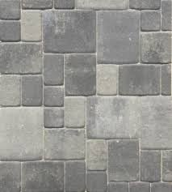

[[](https://www.mcnear.com/paving/project-photos-2/)](https://www.mcnear.com/paving/project-photos-2/" \o "McNear Interlocking Paver Project Photos" \t "_blank)

[McNear Brick and Block](https://www.mcnear.com/paving/project-photos-2/" \o "McNear Interlocking Paver Project Photos" \t "_blank)

[McNear Interlocking Paver Project Photos](https://www.mcnear.com/paving/project-photos-2/" \o "McNear Interlocking Paver Project Photos" \t "_blank)

**Pavers India - Interlocking Pavers | Paver Block Manufacturers | Paver Blocks Price**

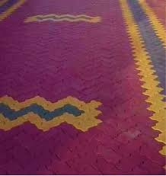

[[](https://www.paversindia.com/)](https://www.paversindia.com/" \o "Pavers India - Interlocking Pavers | Paver Block Manufacturers | Paver  Blocks Price" \t "_blank)

[www.paversindia.com](https://www.paversindia.com/" \o "Pavers India - Interlocking Pavers | Paver Block Manufacturers | Paver  Blocks Price" \t "_blank)

[Pavers India - Interlocking Pavers ...](https://www.paversindia.com/" \o "Pavers India - Interlocking Pavers | Paver Block Manufacturers | Paver  Blocks Price" \t "_blank)

**red iron oxide 120s,cement tile color,interlocking tile color,paver block color**

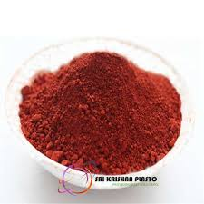

[[](https://www.srikrishnaoverseas.com/products/concrete-colors/red-iron-oxide-120s)](https://www.srikrishnaoverseas.com/products/concrete-colors/red-iron-oxide-120s" \o "red iron oxide 120s,cement tile color,interlocking tile color,paver block  color" \t "_blank)

[Paver Block Making Machine](https://www.srikrishnaoverseas.com/products/concrete-colors/red-iron-oxide-120s" \o "red iron oxide 120s,cement tile color,interlocking tile color,paver block  color" \t "_blank)

[red iron oxide 120s,cement tile color ...](https://www.srikrishnaoverseas.com/products/concrete-colors/red-iron-oxide-120s" \o "red iron oxide 120s,cement tile color,interlocking tile color,paver block  color" \t "_blank)

**Driveway Pavers Lonsdale | Australian Paving Centre Experts for paving**

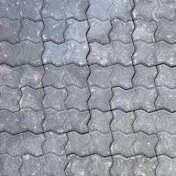

[[](https://apclonsdale.com.au/project-type/driveway-pavers/)](https://apclonsdale.com.au/project-type/driveway-pavers/" \o "Driveway Pavers Lonsdale | Australian Paving Centre Experts for paving" \t "_blank)

[Australian Paving Centre Lonsdale](https://apclonsdale.com.au/project-type/driveway-pavers/" \o "Driveway Pavers Lonsdale | Australian Paving Centre Experts for paving" \t "_blank)

[Driveway Pavers Lonsdale | Australian ...](https://apclonsdale.com.au/project-type/driveway-pavers/" \o "Driveway Pavers Lonsdale | Australian Paving Centre Experts for paving" \t "_blank)

**Rubber Paving Tiles - Conso Mats**

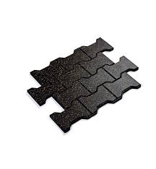

[[](https://www.consomats.com/rubber-paving-tiles/)](https://www.consomats.com/rubber-paving-tiles/" \o "Rubber Paving Tiles - Conso Mats" \t "_blank)

[Conso Mats](https://www.consomats.com/rubber-paving-tiles/" \o "Rubber Paving Tiles - Conso Mats" \t "_blank)

[Rubber Paving Tiles - Conso Mats](https://www.consomats.com/rubber-paving-tiles/" \o "Rubber Paving Tiles - Conso Mats" \t "_blank)

**Reyal Paver Block Mould I-Shape Pack of 2 Interlocking Block Mould For Flooring Garden Outdoor Home Cement Paver Block : Amazon.in: Industrial & Scientific**

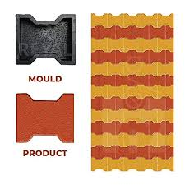

[[](https://www.amazon.in/Reyal-I-Shape-Interlocking-Flooring-Outdoor/dp/B09NKRNGHH)](https://www.amazon.in/Reyal-I-Shape-Interlocking-Flooring-Outdoor/dp/B09NKRNGHH" \o "Reyal Paver Block Mould I-Shape Pack of 2 Interlocking Block Mould For  Flooring Garden Outdoor Home Cement Paver Block : Amazon.in: Industrial &  Scientific" \t "_blank)

[Amazon.in](https://www.amazon.in/Reyal-I-Shape-Interlocking-Flooring-Outdoor/dp/B09NKRNGHH" \o "Reyal Paver Block Mould I-Shape Pack of 2 Interlocking Block Mould For  Flooring Garden Outdoor Home Cement Paver Block : Amazon.in: Industrial &  Scientific" \t "_blank)

[Reyal Paver Block Mould I-Shape Pack of ...](https://www.amazon.in/Reyal-I-Shape-Interlocking-Flooring-Outdoor/dp/B09NKRNGHH" \o "Reyal Paver Block Mould I-Shape Pack of 2 Interlocking Block Mould For  Flooring Garden Outdoor Home Cement Paver Block : Amazon.in: Industrial &  Scientific" \t "_blank)

**Choose the Right Paving Tiles Designs - Charbhujatiles**

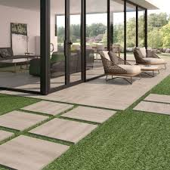

[[](https://charbhujatiles.com/blog-details/choose-the-right-paving-tiles-designs-with-these-useful-tips)](https://charbhujatiles.com/blog-details/choose-the-right-paving-tiles-designs-with-these-useful-tips" \o "Choose the Right Paving Tiles Designs - Charbhujatiles" \t "_blank)

[Charbhuja Tiles](https://charbhujatiles.com/blog-details/choose-the-right-paving-tiles-designs-with-these-useful-tips" \o "Choose the Right Paving Tiles Designs - Charbhujatiles" \t "_blank)

[Choose the Right Paving Tiles Designs ...](https://charbhujatiles.com/blog-details/choose-the-right-paving-tiles-designs-with-these-useful-tips" \o "Choose the Right Paving Tiles Designs - Charbhujatiles" \t "_blank)

**Pan Mixer Machine - Paver Block Color Mixer Machine Manufacturer from New Delhi**

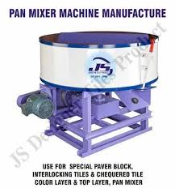

[[](https://www.jsdesignertilesproduct.com/pan-mixer-machine.html)](https://www.jsdesignertilesproduct.com/pan-mixer-machine.html" \o "Pan Mixer Machine - Paver Block Color Mixer Machine Manufacturer from New  Delhi" \t "_blank)

[JS Designer Tiles Product](https://www.jsdesignertilesproduct.com/pan-mixer-machine.html" \o "Pan Mixer Machine - Paver Block Color Mixer Machine Manufacturer from New  Delhi" \t "_blank)

[Pan Mixer Machine - Paver Block Color ...](https://www.jsdesignertilesproduct.com/pan-mixer-machine.html" \o "Pan Mixer Machine - Paver Block Color Mixer Machine Manufacturer from New  Delhi" \t "_blank)

**Vel Murugan Paver Blocks Manufacturing & Marketing Unit - Manufacturer of Paver Block & Rubber Paver from Chennai**

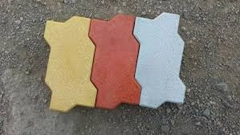

[[](https://www.paverblockschennai.com/)](https://www.paverblockschennai.com/" \o "Vel Murugan Paver Blocks Manufacturing & Marketing Unit - Manufacturer of  Paver Block & Rubber Paver from Chennai" \t "_blank)

[www.paverblockschennai.com](https://www.paverblockschennai.com/" \o "Vel Murugan Paver Blocks Manufacturing & Marketing Unit - Manufacturer of  Paver Block & Rubber Paver from Chennai" \t "_blank)

[Vel Murugan Paver Blocks Manufacturing ...](https://www.paverblockschennai.com/" \o "Vel Murugan Paver Blocks Manufacturing & Marketing Unit - Manufacturer of  Paver Block & Rubber Paver from Chennai" \t "_blank)

**11,516 Concrete Paver Tiles Images, Stock Photos & Vectors | Shutterstock**

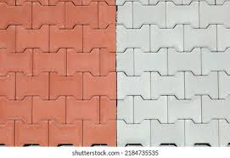

[[](https://www.shutterstock.com/search/concrete-paver-tiles)](https://www.shutterstock.com/search/concrete-paver-tiles" \o "11,516 Concrete Paver Tiles Images, Stock Photos & Vectors | Shutterstock" \t "_blank)

[Shutterstock](https://www.shutterstock.com/search/concrete-paver-tiles" \o "11,516 Concrete Paver Tiles Images, Stock Photos & Vectors | Shutterstock" \t "_blank)

[11,516 Concrete Paver Tiles Images ...](https://www.shutterstock.com/search/concrete-paver-tiles" \o "11,516 Concrete Paver Tiles Images, Stock Photos & Vectors | Shutterstock" \t "_blank)

**Interlocking Paver Tiles Suppliers | Interlocking Paver Tiles विक्रेता and आपूर्तिकर्ता | Suppliers of Interlocking Paver Tiles**

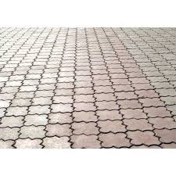

[[](https://connect2india.com/Interlocking-Paver-Tiles-suppliers)](https://connect2india.com/Interlocking-Paver-Tiles-suppliers" \o "Interlocking Paver Tiles Suppliers | Interlocking Paver Tiles विक्रेता and  आपूर्तिकर्ता | Suppliers of Interlocking Paver Tiles" \t "_blank)

[Connect2India](https://connect2india.com/Interlocking-Paver-Tiles-suppliers" \o "Interlocking Paver Tiles Suppliers | Interlocking Paver Tiles विक्रेता and  आपूर्तिकर्ता | Suppliers of Interlocking Paver Tiles" \t "_blank)

[Interlocking Paver Tiles Suppliers ...](https://connect2india.com/Interlocking-Paver-Tiles-suppliers" \o "Interlocking Paver Tiles Suppliers | Interlocking Paver Tiles विक्रेता and  आपूर्तिकर्ता | Suppliers of Interlocking Paver Tiles" \t "_blank)

**Pavestone Rumblestone 7-in L x 7-in W x 1.75-in H Gray Slate/Tumbled Concrete Interlocking Paver in the Pavers & Stepping Stones department at Lowes.com**

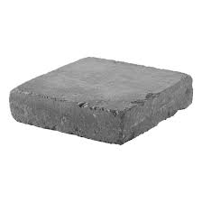

[[](https://www.lowes.com/pd/Pavestone-7-x-7-Rumblestone-Square-Granite/1003287840)](https://www.lowes.com/pd/Pavestone-7-x-7-Rumblestone-Square-Granite/1003287840" \o "Pavestone Rumblestone 7-in L x 7-in W x 1.75-in H Gray Slate/Tumbled Concrete  Interlocking Paver in the Pavers & Stepping Stones department at Lowes.com" \t "_blank)

[Lowe's](https://www.lowes.com/pd/Pavestone-7-x-7-Rumblestone-Square-Granite/1003287840" \o "Pavestone Rumblestone 7-in L x 7-in W x 1.75-in H Gray Slate/Tumbled Concrete  Interlocking Paver in the Pavers & Stepping Stones department at Lowes.com" \t "_blank)

[Pavestone Rumblestone 7-in L x 7-in W x ...](https://www.lowes.com/pd/Pavestone-7-x-7-Rumblestone-Square-Granite/1003287840" \o "Pavestone Rumblestone 7-in L x 7-in W x 1.75-in H Gray Slate/Tumbled Concrete  Interlocking Paver in the Pavers & Stepping Stones department at Lowes.com" \t "_blank)

**Tile Hardener - Interlocking Paver Hardener Chemical Manufacturer from Hyderabad**



[[](https://www.jktilesmachinery.org/tile-hardener.html)](https://www.jktilesmachinery.org/tile-hardener.html" \o "Tile Hardener - Interlocking Paver Hardener Chemical Manufacturer from  Hyderabad" \t "_blank)

[J K Tiles Machinery](https://www.jktilesmachinery.org/tile-hardener.html" \o "Tile Hardener - Interlocking Paver Hardener Chemical Manufacturer from  Hyderabad" \t "_blank)

[Tile Hardener - Interlocking Paver ...](https://www.jktilesmachinery.org/tile-hardener.html" \o "Tile Hardener - Interlocking Paver Hardener Chemical Manufacturer from  Hyderabad" \t "_blank)

**How to Choose the Right Paver Color | Western Interlock**

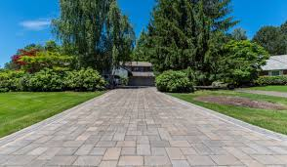

[[](https://westerninterlock.com/how-to-choose-the-right-paver-color/)](https://westerninterlock.com/how-to-choose-the-right-paver-color/" \o "How to Choose the Right Paver Color | Western Interlock" \t "_blank)

[Western Interlock](https://westerninterlock.com/how-to-choose-the-right-paver-color/" \o "How to Choose the Right Paver Color | Western Interlock" \t "_blank)

[How to Choose the Right Paver Color ...](https://westerninterlock.com/how-to-choose-the-right-paver-color/" \o "How to Choose the Right Paver Color | Western Interlock" \t "_blank)

**Interlocking Plastic Pathway Paver Stone Concrete Bricks Tiles Mould - China Interlocking Brick Paver Mold and Pavement Brick Moulds**

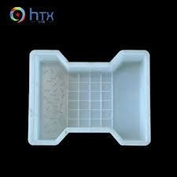

[[](https://zzhtxags.en.made-in-china.com/product/yvwxklzcSSUZ/China-Interlocking-Plastic-Pathway-Paver-Stone-Concrete-Bricks-Tiles-Mould.html)](https://zzhtxags.en.made-in-china.com/product/yvwxklzcSSUZ/China-Interlocking-Plastic-Pathway-Paver-Stone-Concrete-Bricks-Tiles-Mould.html" \o "Interlocking Plastic Pathway Paver Stone Concrete Bricks Tiles Mould -  China Interlocking Brick Paver Mold and Pavement Brick Moulds" \t "_blank)

[HENAN HTX GROUP CO., LTD.](https://zzhtxags.en.made-in-china.com/product/yvwxklzcSSUZ/China-Interlocking-Plastic-Pathway-Paver-Stone-Concrete-Bricks-Tiles-Mould.html" \o "Interlocking Plastic Pathway Paver Stone Concrete Bricks Tiles Mould -  China Interlocking Brick Paver Mold and Pavement Brick Moulds" \t "_blank)

[Interlocking Plastic Pathway Paver ...](https://zzhtxags.en.made-in-china.com/product/yvwxklzcSSUZ/China-Interlocking-Plastic-Pathway-Paver-Stone-Concrete-Bricks-Tiles-Mould.html" \o "Interlocking Plastic Pathway Paver Stone Concrete Bricks Tiles Mould -  China Interlocking Brick Paver Mold and Pavement Brick Moulds" \t "_blank)

**Interlocking pavers - Interlock**

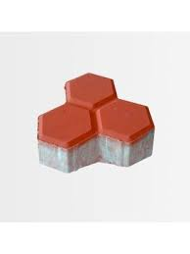

[[](https://store.artic.com.sa/interlock/interlocking-pavers.html)](https://store.artic.com.sa/interlock/interlocking-pavers.html" \o "Interlocking pavers - Interlock" \t "_blank)

[Artic Store](https://store.artic.com.sa/interlock/interlocking-pavers.html" \o "Interlocking pavers - Interlock" \t "_blank)

[Interlocking pavers - Interlock](https://store.artic.com.sa/interlock/interlocking-pavers.html" \o "Interlocking pavers - Interlock" \t "_blank)

**Page 16 | Tiled pavement Vectors & Illustrations for Free Download | Freepik**

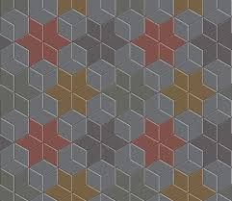

[[](https://www.freepik.com/vectors/tiled-pavement/16)](https://www.freepik.com/vectors/tiled-pavement/16" \o "Page 16 | Tiled pavement Vectors & Illustrations for Free Download | Freepik" \t "_blank)

[Freepik](https://www.freepik.com/vectors/tiled-pavement/16" \o "Page 16 | Tiled pavement Vectors & Illustrations for Free Download | Freepik" \t "_blank)

[Tiled pavement Vectors & Illustrations ...](https://www.freepik.com/vectors/tiled-pavement/16" \o "Page 16 | Tiled pavement Vectors & Illustrations for Free Download | Freepik" \t "_blank)

**Popular Interlock Pavers In Different Designs - Buy Interlock Pavers,Interlock Paver Tiles,Interlock Tile Prices Product on Alibaba.com**

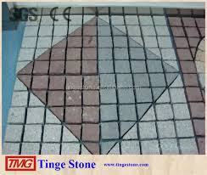

[[](https://www.alibaba.com/product-detail/Popular-interlock-pavers-In-Different-Designs_60531796407.html)](https://www.alibaba.com/product-detail/Popular-interlock-pavers-In-Different-Designs_60531796407.html" \o "Popular Interlock Pavers In Different Designs - Buy Interlock Pavers,Interlock  Paver Tiles,Interlock Tile Prices Product on Alibaba.com" \t "_blank)

[Alibaba.com](https://www.alibaba.com/product-detail/Popular-interlock-pavers-In-Different-Designs_60531796407.html" \o "Popular Interlock Pavers In Different Designs - Buy Interlock Pavers,Interlock  Paver Tiles,Interlock Tile Prices Product on Alibaba.com" \t "_blank)

[Buy Interlock Pavers,Interlock Paver ...](https://www.alibaba.com/product-detail/Popular-interlock-pavers-In-Different-Designs_60531796407.html" \o "Popular Interlock Pavers In Different Designs - Buy Interlock Pavers,Interlock  Paver Tiles,Interlock Tile Prices Product on Alibaba.com" \t "_blank)

**Reasons To Install Interlocking Pavers, Concrete & Stone Pavers**

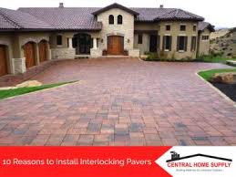

3 days ago

[[](https://www.centralhomesupply.com/10-reasons-install-interlocking-pavers/)](https://www.centralhomesupply.com/10-reasons-install-interlocking-pavers/" \o "Reasons To Install Interlocking Pavers, Concrete & Stone Pavers" \t "_blank)

[Central Home Supply](https://www.centralhomesupply.com/10-reasons-install-interlocking-pavers/" \o "Reasons To Install Interlocking Pavers, Concrete & Stone Pavers" \t "_blank)

[Reasons To Install Interlocking Pavers ...](https://www.centralhomesupply.com/10-reasons-install-interlocking-pavers/" \o "Reasons To Install Interlocking Pavers, Concrete & Stone Pavers" \t "_blank)

**Interlocking garden mould path slab brick plastic floor tile paving decking | eBay**

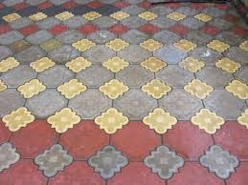

[[](https://www.ebay.co.uk/itm/323391721076)](https://www.ebay.co.uk/itm/323391721076" \o "Interlocking garden mould path slab brick plastic floor tile paving decking  | eBay" \t "_blank)

[eBay](https://www.ebay.co.uk/itm/323391721076" \o "Interlocking garden mould path slab brick plastic floor tile paving decking  | eBay" \t "_blank)

[Interlocking garden mould path slab ...](https://www.ebay.co.uk/itm/323391721076" \o "Interlocking garden mould path slab brick plastic floor tile paving decking  | eBay" \t "_blank)

**Cost of Interlocking Driveway, Patios, Walkways | Mississauga, Brampton, Burlington, Ontario**

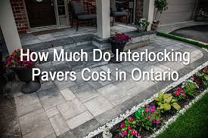

[[](https://markstonelandscaping.com/how-much-interlocking-cost/)](https://markstonelandscaping.com/how-much-interlocking-cost/" \o "Cost of Interlocking Driveway, Patios, Walkways | Mississauga, Brampton,  Burlington, Ontario" \t "_blank)

[Markstone Landscaping](https://markstonelandscaping.com/how-much-interlocking-cost/" \o "Cost of Interlocking Driveway, Patios, Walkways | Mississauga, Brampton,  Burlington, Ontario" \t "_blank)

[Cost of Interlocking Driveway, Patios ...](https://markstonelandscaping.com/how-much-interlocking-cost/" \o "Cost of Interlocking Driveway, Patios, Walkways | Mississauga, Brampton,  Burlington, Ontario" \t "_blank)

**Reyal Plastic BROOK Paver Block Mould Paving Tile Mold Outdoor Garden Column Cap & Base Price in India - Buy Reyal Plastic BROOK Paver Block Mould Paving Tile Mold Outdoor Garden Column**

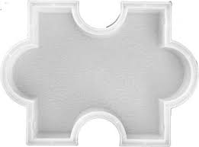

[[](https://www.flipkart.com/reyal-plastic-brook-paver-block-mould-paving-tile-mold-outdoor-garden-column-cap-base/p/itmb6458ea94b7f8)](https://www.flipkart.com/reyal-plastic-brook-paver-block-mould-paving-tile-mold-outdoor-garden-column-cap-base/p/itmb6458ea94b7f8" \o "Reyal Plastic BROOK Paver Block Mould Paving Tile Mold Outdoor Garden  Column Cap & Base Price in India - Buy Reyal Plastic BROOK Paver Block  Mould Paving Tile Mold Outdoor Garden Column" \t "_blank)

[Flipkart](https://www.flipkart.com/reyal-plastic-brook-paver-block-mould-paving-tile-mold-outdoor-garden-column-cap-base/p/itmb6458ea94b7f8" \o "Reyal Plastic BROOK Paver Block Mould Paving Tile Mold Outdoor Garden  Column Cap & Base Price in India - Buy Reyal Plastic BROOK Paver Block  Mould Paving Tile Mold Outdoor Garden Column" \t "_blank)

[Reyal Plastic BROOK Paver Block Mould ...](https://www.flipkart.com/reyal-plastic-brook-paver-block-mould-paving-tile-mold-outdoor-garden-column-cap-base/p/itmb6458ea94b7f8" \o "Reyal Plastic BROOK Paver Block Mould Paving Tile Mold Outdoor Garden  Column Cap & Base Price in India - Buy Reyal Plastic BROOK Paver Block  Mould Paving Tile Mold Outdoor Garden Column" \t "_blank)

**Driveway Interlocking Pavers Adelaide | Driveway Pavers Adelaide**

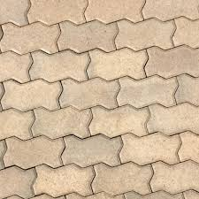

[[](https://australianpaving.com/product/driveway-interlocking-pavers/)](https://australianpaving.com/product/driveway-interlocking-pavers/" \o "Driveway Interlocking Pavers Adelaide | Driveway Pavers Adelaide" \t "_blank)

[Australian Paving Centre](https://australianpaving.com/product/driveway-interlocking-pavers/" \o "Driveway Interlocking Pavers Adelaide | Driveway Pavers Adelaide" \t "_blank)

[Driveway Interlocking Pavers Adelaide ...](https://australianpaving.com/product/driveway-interlocking-pavers/" \o "Driveway Interlocking Pavers Adelaide | Driveway Pavers Adelaide" \t "_blank)

Popular searches

[[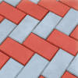](https://www.google.com/search?q=interlock%20tiles%20price&tbm=isch&hl=en&bih=722&biw=1519&rlz=1C1YTUH_enIN1004IN1004&sa=X&ved=0CGUQrNwCKABqFwoTCMDX8LTBkv0CFQAAAAAdAAAAABAD)](https://www.google.com/search?q=interlock%20tiles%20price&tbm=isch&hl=en&bih=722&biw=1519&rlz=1C1YTUH_enIN1004IN1004&sa=X&ved=0CGUQrNwCKABqFwoTCMDX8LTBkv0CFQAAAAAdAAAAABAD)

**[interlock](https://www.google.com/search?q=interlock%20tiles%20price&tbm=isch&hl=en&bih=722&biw=1519&rlz=1C1YTUH_enIN1004IN1004&sa=X&ved=0CGUQrNwCKABqFwoTCMDX8LTBkv0CFQAAAAAdAAAAABAD)**[tiles](https://www.google.com/search?q=interlock%20tiles%20price&tbm=isch&hl=en&bih=722&biw=1519&rlz=1C1YTUH_enIN1004IN1004&sa=X&ved=0CGUQrNwCKABqFwoTCMDX8LTBkv0CFQAAAAAdAAAAABAD)**[price](https://www.google.com/search?q=interlock%20tiles%20price&tbm=isch&hl=en&bih=722&biw=1519&rlz=1C1YTUH_enIN1004IN1004&sa=X&ved=0CGUQrNwCKABqFwoTCMDX8LTBkv0CFQAAAAAdAAAAABAD)**

[[](https://www.google.com/search?q=paver%20tiles&tbm=isch&hl=en&bih=722&biw=1519&rlz=1C1YTUH_enIN1004IN1004&sa=X&ved=0CGcQrNwCKAFqFwoTCMDX8LTBkv0CFQAAAAAdAAAAABAD)](https://www.google.com/search?q=paver%20tiles&tbm=isch&hl=en&bih=722&biw=1519&rlz=1C1YTUH_enIN1004IN1004&sa=X&ved=0CGcQrNwCKAFqFwoTCMDX8LTBkv0CFQAAAAAdAAAAABAD)

**[paver](https://www.google.com/search?q=paver%20tiles&tbm=isch&hl=en&bih=722&biw=1519&rlz=1C1YTUH_enIN1004IN1004&sa=X&ved=0CGcQrNwCKAFqFwoTCMDX8LTBkv0CFQAAAAAdAAAAABAD)**[tiles](https://www.google.com/search?q=paver%20tiles&tbm=isch&hl=en&bih=722&biw=1519&rlz=1C1YTUH_enIN1004IN1004&sa=X&ved=0CGcQrNwCKAFqFwoTCMDX8LTBkv0CFQAAAAAdAAAAABAD)

[[](https://www.google.com/search?q=interlock%20tiles&tbm=isch&hl=en&bih=722&biw=1519&rlz=1C1YTUH_enIN1004IN1004&sa=X&ved=0CGkQrNwCKAJqFwoTCMDX8LTBkv0CFQAAAAAdAAAAABAD)](https://www.google.com/search?q=interlock%20tiles&tbm=isch&hl=en&bih=722&biw=1519&rlz=1C1YTUH_enIN1004IN1004&sa=X&ved=0CGkQrNwCKAJqFwoTCMDX8LTBkv0CFQAAAAAdAAAAABAD)

**[interlock](https://www.google.com/search?q=interlock%20tiles&tbm=isch&hl=en&bih=722&biw=1519&rlz=1C1YTUH_enIN1004IN1004&sa=X&ved=0CGkQrNwCKAJqFwoTCMDX8LTBkv0CFQAAAAAdAAAAABAD)**[tiles](https://www.google.com/search?q=interlock%20tiles&tbm=isch&hl=en&bih=722&biw=1519&rlz=1C1YTUH_enIN1004IN1004&sa=X&ved=0CGkQrNwCKAJqFwoTCMDX8LTBkv0CFQAAAAAdAAAAABAD)

**Interlock tile | Paving design, Pvc moulding, Plastic moulding**

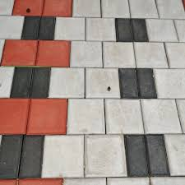

[[](https://www.pinterest.com/pin/interlock-tile--768074911440340230/)](https://www.pinterest.com/pin/interlock-tile--768074911440340230/" \o "Interlock tile | Paving design, Pvc moulding, Plastic moulding" \t "_blank)

[Pinterest](https://www.pinterest.com/pin/interlock-tile--768074911440340230/" \o "Interlock tile | Paving design, Pvc moulding, Plastic moulding" \t "_blank)

[Interlock tile | Paving design, Pvc ...](https://www.pinterest.com/pin/interlock-tile--768074911440340230/" \o "Interlock tile | Paving design, Pvc moulding, Plastic moulding" \t "_blank)

**Barn Board 18 x 18 Rubber Interlocking Tile at Menards®**

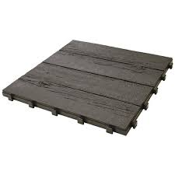

[[](https://www.menards.com/main/building-materials/landscaping-materials/pavers-patio-blocks/barn-board-18-x-18-rubber-interlocking-tile/mt5100157/p-1453088148127-c-5786.htm)](https://www.menards.com/main/building-materials/landscaping-materials/pavers-patio-blocks/barn-board-18-x-18-rubber-interlocking-tile/mt5100157/p-1453088148127-c-5786.htm" \o "Barn Board 18 x 18 Rubber Interlocking Tile at Menards®" \t "_blank)

[Menards](https://www.menards.com/main/building-materials/landscaping-materials/pavers-patio-blocks/barn-board-18-x-18-rubber-interlocking-tile/mt5100157/p-1453088148127-c-5786.htm" \o "Barn Board 18 x 18 Rubber Interlocking Tile at Menards®" \t "_blank)

[Rubber Interlocking Tile at Menards ...](https://www.menards.com/main/building-materials/landscaping-materials/pavers-patio-blocks/barn-board-18-x-18-rubber-interlocking-tile/mt5100157/p-1453088148127-c-5786.htm" \o "Barn Board 18 x 18 Rubber Interlocking Tile at Menards®" \t "_blank)

**Extensive area of a lock pavement in the bright red and yellow color in the shapes of rectangles and rhombus. | CanStock**

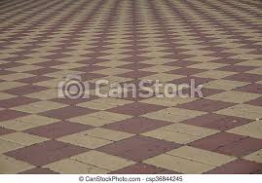

[[](https://www.canstockphoto.com/extensive-area-of-a-lock-pavement-36844245.html)](https://www.canstockphoto.com/extensive-area-of-a-lock-pavement-36844245.html" \o "Extensive area of a lock pavement in the bright red and yellow color in the  shapes of rectangles and rhombus. | CanStock" \t "_blank)

[Can Stock Photo](https://www.canstockphoto.com/extensive-area-of-a-lock-pavement-36844245.html" \o "Extensive area of a lock pavement in the bright red and yellow color in the  shapes of rectangles and rhombus. | CanStock" \t "_blank)

[Extensive area of a lock pavement in ...](https://www.canstockphoto.com/extensive-area-of-a-lock-pavement-36844245.html" \o "Extensive area of a lock pavement in the bright red and yellow color in the  shapes of rectangles and rhombus. | CanStock" \t "_blank)

**Brick pavers Stock Photos, Royalty Free Brick pavers Images | Depositphotos**

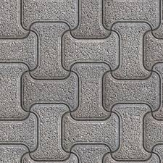

[[](https://depositphotos.com/stock-photos/brick-pavers.html)](https://depositphotos.com/stock-photos/brick-pavers.html" \o "Brick pavers Stock Photos, Royalty Free Brick pavers Images | Depositphotos" \t "_blank)

[Depositphotos](https://depositphotos.com/stock-photos/brick-pavers.html" \o "Brick pavers Stock Photos, Royalty Free Brick pavers Images | Depositphotos" \t "_blank)

[Brick pavers Stock Photos, Royalty Free ...](https://depositphotos.com/stock-photos/brick-pavers.html" \o "Brick pavers Stock Photos, Royalty Free Brick pavers Images | Depositphotos" \t "_blank)

**Interlocking Milano Paver Size: 23P/Sqmt at Best Price in Gurugram | R.S.D. Pavers**

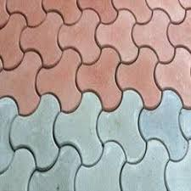

[[](https://www.tradeindia.com/products/interlocking-milano-paver-1719994.html)](https://www.tradeindia.com/products/interlocking-milano-paver-1719994.html" \o "Interlocking Milano Paver Size: 23P/Sqmt at Best Price in Gurugram | R.S.D.  Pavers" \t "_blank)

[TradeIndia](https://www.tradeindia.com/products/interlocking-milano-paver-1719994.html" \o "Interlocking Milano Paver Size: 23P/Sqmt at Best Price in Gurugram | R.S.D.  Pavers" \t "_blank)

[Interlocking Milano Paver Size: 23P ...](https://www.tradeindia.com/products/interlocking-milano-paver-1719994.html" \o "Interlocking Milano Paver Size: 23P/Sqmt at Best Price in Gurugram | R.S.D.  Pavers" \t "_blank)

**Products for Pavers & Designer Tiles - Cement Tiles Color Manufacturer from New Delhi**

[[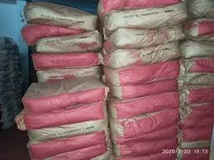](https://www.google.com/imgres?imgurl=https%3A%2F%2F5.imimg.com%2Fdata5%2FHN%2FFD%2FRD%2FSELLER-3420530%2Fbayferrox-red-yellow-colour-iron-oxide--500x500.jpeg&imgrefurl=https%3A%2F%2Fwww.novapolychem.in%2Fproducts-for-pavers-designer-tiles.html&tbnid=TCMqev9F7-V3-M&vet=10CHYQMyibAWoXChMIwNfwtMGS_QIVAAAAAB0AAAAAEAM..i&docid=BQqybIk495bIyM&w=500&h=375&q=interlocking%20pavers%20and%20tiles%20%20color%20and%20hardness&hl=en&ved=0CHYQMyibAWoXChMIwNfwtMGS_QIVAAAAAB0AAAAAEAM)](https://www.google.com/imgres?imgurl=https%3A%2F%2F5.imimg.com%2Fdata5%2FHN%2FFD%2FRD%2FSELLER-3420530%2Fbayferrox-red-yellow-colour-iron-oxide--500x500.jpeg&imgrefurl=https%3A%2F%2Fwww.novapolychem.in%2Fproducts-for-pavers-designer-tiles.html&tbnid=TCMqev9F7-V3-M&vet=10CHYQMyibAWoXChMIwNfwtMGS_QIVAAAAAB0AAAAAEAM..i&docid=BQqybIk495bIyM&w=500&h=375&q=interlocking%20pavers%20and%20tiles%20%20color%20and%20hardness&hl=en&ved=0CHYQMyibAWoXChMIwNfwtMGS_QIVAAAAAB0AAAAAEAM)

[[](https://www.novapolychem.in/products-for-pavers-designer-tiles.html)](https://www.novapolychem.in/products-for-pavers-designer-tiles.html" \o "Products for Pavers & Designer Tiles - Cement Tiles Color Manufacturer from  New Delhi" \t "_blank)

[Nova Polychem](https://www.novapolychem.in/products-for-pavers-designer-tiles.html" \o "Products for Pavers & Designer Tiles - Cement Tiles Color Manufacturer from  New Delhi" \t "_blank)

[Products for Pavers & Designer Tiles ...](https://www.novapolychem.in/products-for-pavers-designer-tiles.html" \o "Products for Pavers & Designer Tiles - Cement Tiles Color Manufacturer from  New Delhi" \t "_blank)

**Mosaic of color stylish modern paving stones. Beautiful abstract background. City stone path Stock Photo - Alamy**

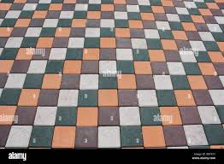

[[](https://www.alamy.com/mosaic-of-color-stylish-modern-paving-stones-beautiful-abstract-background-city-stone-path-image263605923.html)](https://www.alamy.com/mosaic-of-color-stylish-modern-paving-stones-beautiful-abstract-background-city-stone-path-image263605923.html" \o "Mosaic of color stylish modern paving stones. Beautiful abstract  background. City stone path Stock Photo - Alamy" \t "_blank)

[Alamy](https://www.alamy.com/mosaic-of-color-stylish-modern-paving-stones-beautiful-abstract-background-city-stone-path-image263605923.html" \o "Mosaic of color stylish modern paving stones. Beautiful abstract  background. City stone path Stock Photo - Alamy" \t "_blank)

[Mosaic of color stylish modern paving ...](https://www.alamy.com/mosaic-of-color-stylish-modern-paving-stones-beautiful-abstract-background-city-stone-path-image263605923.html" \o "Mosaic of color stylish modern paving stones. Beautiful abstract  background. City stone path Stock Photo - Alamy" \t "_blank)

**Interlocking pavers - Interlock**

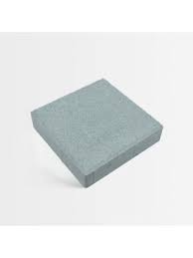

[[](https://store.artic.com.sa/interlock/interlocking-pavers.html)](https://store.artic.com.sa/interlock/interlocking-pavers.html" \o "Interlocking pavers - Interlock" \t "_blank)

[Artic Store](https://store.artic.com.sa/interlock/interlocking-pavers.html" \o "Interlocking pavers - Interlock" \t "_blank)

[Interlocking pavers - Interlock](https://store.artic.com.sa/interlock/interlocking-pavers.html" \o "Interlocking pavers - Interlock" \t "_blank)

**What Is Polymeric Sand and How Is It Used for Locking Patio Pavers? | Unilock**

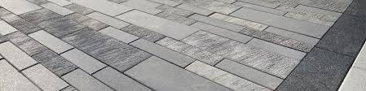

[[](https://unilock.com/articles/what-is-polymeric-sand-and-how-is-it-used-for-locking-patio-pavers-yorktown-heights-ny/)](https://unilock.com/articles/what-is-polymeric-sand-and-how-is-it-used-for-locking-patio-pavers-yorktown-heights-ny/" \o "What Is Polymeric Sand and How Is It Used for Locking Patio Pavers? |  Unilock" \t "_blank)

[Unilock](https://unilock.com/articles/what-is-polymeric-sand-and-how-is-it-used-for-locking-patio-pavers-yorktown-heights-ny/" \o "What Is Polymeric Sand and How Is It Used for Locking Patio Pavers? |  Unilock" \t "_blank)

[Locking Patio Pavers ...](https://unilock.com/articles/what-is-polymeric-sand-and-how-is-it-used-for-locking-patio-pavers-yorktown-heights-ny/" \o "What Is Polymeric Sand and How Is It Used for Locking Patio Pavers? |  Unilock" \t "_blank)

**Building Materials Interlocking Wood Plastic Composite Tiles Outdoors Garden Porch Balcony 12x12 24, Grey YuPaoPao Wood Flooring Decking Patio Pavers innerwestphysionsw.com.au**

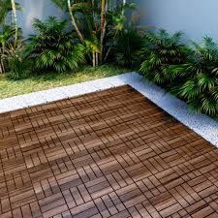

[[](https://www.innerwestphysionsw.com.au/thumbnaile/?p=Interlocking-Wood-Plastic-Composite-Tiles-Outdoors-Garden-Porch-Balcony-237064)](https://www.innerwestphysionsw.com.au/thumbnaile/?p=Interlocking-Wood-Plastic-Composite-Tiles-Outdoors-Garden-Porch-Balcony-237064" \o "Building Materials Interlocking Wood Plastic Composite Tiles Outdoors  Garden Porch Balcony 12x12 24, Grey YuPaoPao Wood Flooring Decking Patio  Pavers innerwestphysionsw.com.au" \t "_blank)

[Inner West Physiotherapy](https://www.innerwestphysionsw.com.au/thumbnaile/?p=Interlocking-Wood-Plastic-Composite-Tiles-Outdoors-Garden-Porch-Balcony-237064" \o "Building Materials Interlocking Wood Plastic Composite Tiles Outdoors  Garden Porch Balcony 12x12 24, Grey YuPaoPao Wood Flooring Decking Patio  Pavers innerwestphysionsw.com.au" \t "_blank)

[Garden Porch Balcony 12x12 ...](https://www.innerwestphysionsw.com.au/thumbnaile/?p=Interlocking-Wood-Plastic-Composite-Tiles-Outdoors-Garden-Porch-Balcony-237064" \o "Building Materials Interlocking Wood Plastic Composite Tiles Outdoors  Garden Porch Balcony 12x12 24, Grey YuPaoPao Wood Flooring Decking Patio  Pavers innerwestphysionsw.com.au" \t "_blank)

**5 Applications of AquiPor's New Permeable Concrete You Might Not Have Thought Of – The Aquipor Solution**

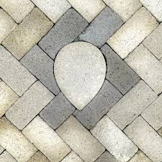

[[](https://aquipor.com/5-applications-of-aquipors-new-permeable-concrete-you-might-not-have-thought-of/)](https://aquipor.com/5-applications-of-aquipors-new-permeable-concrete-you-might-not-have-thought-of/" \o "5 Applications of AquiPor's New Permeable Concrete You Might Not Have  Thought Of – The Aquipor Solution" \t "_blank)

[AquiPor Technologies](https://aquipor.com/5-applications-of-aquipors-new-permeable-concrete-you-might-not-have-thought-of/" \o "5 Applications of AquiPor's New Permeable Concrete You Might Not Have  Thought Of – The Aquipor Solution" \t "_blank)

[Permeable Concrete ...](https://aquipor.com/5-applications-of-aquipors-new-permeable-concrete-you-might-not-have-thought-of/" \o "5 Applications of AquiPor's New Permeable Concrete You Might Not Have  Thought Of – The Aquipor Solution" \t "_blank)

**INTERLOCKING TILES ∕ PAVERS**

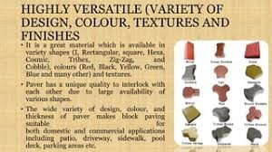

[[](https://www.slideshare.net/sanjeevsingh462/interlocking-tiles-pavers)](https://www.slideshare.net/sanjeevsingh462/interlocking-tiles-pavers" \o "INTERLOCKING TILES ∕ PAVERS" \t "_blank)

[SlideShare](https://www.slideshare.net/sanjeevsingh462/interlocking-tiles-pavers" \o "INTERLOCKING TILES ∕ PAVERS" \t "_blank)

[INTERLOCKING TILES ∕ PAVERS](https://www.slideshare.net/sanjeevsingh462/interlocking-tiles-pavers" \o "INTERLOCKING TILES ∕ PAVERS" \t "_blank)

**Interlocking concrete paver tiles Stock Photo | Adobe Stock**

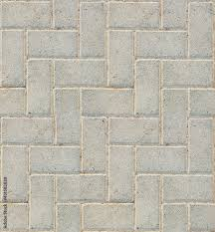

[[](https://stock.adobe.com/images/interlocking-concrete-paver-tiles/431582028?as_campaign=ftmigration2&as_channel=dpcft&as_campclass=brand&as_source=ft_web&as_camptype=acquisition&as_audience=users&as_content=closure_asset-detail-page)](https://stock.adobe.com/images/interlocking-concrete-paver-tiles/431582028?as_campaign=ftmigration2&as_channel=dpcft&as_campclass=brand&as_source=ft_web&as_camptype=acquisition&as_audience=users&as_content=closure_asset-detail-page" \o "Interlocking concrete paver tiles Stock Photo | Adobe Stock" \t "_blank)

[Adobe Stock](https://stock.adobe.com/images/interlocking-concrete-paver-tiles/431582028?as_campaign=ftmigration2&as_channel=dpcft&as_campclass=brand&as_source=ft_web&as_camptype=acquisition&as_audience=users&as_content=closure_asset-detail-page" \o "Interlocking concrete paver tiles Stock Photo | Adobe Stock" \t "_blank)

[Interlocking concrete paver tiles Stock ...](https://stock.adobe.com/images/interlocking-concrete-paver-tiles/431582028?as_campaign=ftmigration2&as_channel=dpcft&as_campclass=brand&as_source=ft_web&as_camptype=acquisition&as_audience=users&as_content=closure_asset-detail-page" \o "Interlocking concrete paver tiles Stock Photo | Adobe Stock" \t "_blank)

**Interlocking Pavers Tiles, Color : Grey, Red, INR 550 / Meter by Ambuj Mohan Enterpises from Koderma Jharkhand | ID - 4617296**

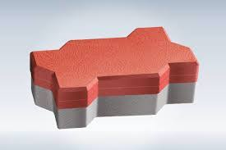

[[](https://www.exportersindia.com/product-detail/interlocking-pavers-tiles-4617296.htm)](https://www.exportersindia.com/product-detail/interlocking-pavers-tiles-4617296.htm" \o "Interlocking Pavers Tiles, Color : Grey, Red, INR 550 / Meter by Ambuj  Mohan Enterpises from Koderma Jharkhand | ID - 4617296" \t "_blank)

[Exporters India](https://www.exportersindia.com/product-detail/interlocking-pavers-tiles-4617296.htm" \o "Interlocking Pavers Tiles, Color : Grey, Red, INR 550 / Meter by Ambuj  Mohan Enterpises from Koderma Jharkhand | ID - 4617296" \t "_blank)

[Interlocking Pavers Tiles, Color : Grey ...](https://www.exportersindia.com/product-detail/interlocking-pavers-tiles-4617296.htm" \o "Interlocking Pavers Tiles, Color : Grey, Red, INR 550 / Meter by Ambuj  Mohan Enterpises from Koderma Jharkhand | ID - 4617296" \t "_blank)

**Interlocking Blocks Bricks & Tiles Paving Best Method Statement – Method Statement HQ**

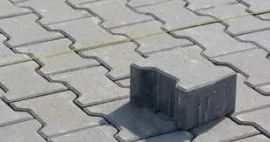

[[](https://methodstatementhq.com/interlocking-blocks-bricks-tiles-paving.html)](https://methodstatementhq.com/interlocking-blocks-bricks-tiles-paving.html" \o "Interlocking Blocks Bricks & Tiles Paving Best Method Statement – Method  Statement HQ" \t "_blank)

[Method Statement HQ](https://methodstatementhq.com/interlocking-blocks-bricks-tiles-paving.html" \o "Interlocking Blocks Bricks & Tiles Paving Best Method Statement – Method  Statement HQ" \t "_blank)

[Interlocking Blocks Bricks & Tiles ...](https://methodstatementhq.com/interlocking-blocks-bricks-tiles-paving.html" \o "Interlocking Blocks Bricks & Tiles Paving Best Method Statement – Method  Statement HQ" \t "_blank)

**Types of Interlocking Pavers | Home Guides | SF Gate**

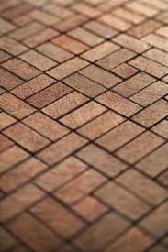

[[](https://homeguides.sfgate.com/types-interlocking-pavers-50331.html)](https://homeguides.sfgate.com/types-interlocking-pavers-50331.html" \o "Types of Interlocking Pavers | Home Guides | SF Gate" \t "_blank)

[Home Guides](https://homeguides.sfgate.com/types-interlocking-pavers-50331.html" \o "Types of Interlocking Pavers | Home Guides | SF Gate" \t "_blank)

[Types of Interlocking Pavers | Home ...](https://homeguides.sfgate.com/types-interlocking-pavers-50331.html" \o "Types of Interlocking Pavers | Home Guides | SF Gate" \t "_blank)

**NITCO TILES | New Delhi**

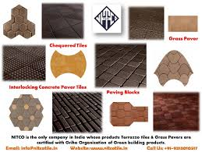

[[](https://www.facebook.com/NitcoTilesOfficial/)](https://www.facebook.com/NitcoTilesOfficial/" \o "NITCO TILES | New Delhi" \t "_blank)

[Facebook](https://www.facebook.com/NitcoTilesOfficial/" \o "NITCO TILES | New Delhi" \t "_blank)

[NITCO TILES | New Delhi](https://www.facebook.com/NitcoTilesOfficial/" \o "NITCO TILES | New Delhi" \t "_blank)

**551 Interlocking Paving Stone Stock Photos and Images - 123RF**

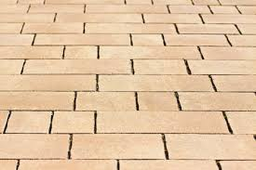

[[](https://www.123rf.com/stock-photo/interlocking_paving_stone.html)](https://www.123rf.com/stock-photo/interlocking_paving_stone.html" \o "551 Interlocking Paving Stone Stock Photos and Images - 123RF" \t "_blank)

[123RF](https://www.123rf.com/stock-photo/interlocking_paving_stone.html" \o "551 Interlocking Paving Stone Stock Photos and Images - 123RF" \t "_blank)

[551 Interlocking Paving Stone Stock ...](https://www.123rf.com/stock-photo/interlocking_paving_stone.html" \o "551 Interlocking Paving Stone Stock Photos and Images - 123RF" \t "_blank)

**Outdoor, Flooring Designs by Service Provider Thanveer VI, Ernakulam | Kolo**

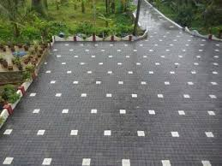

[[](https://koloapp.in/kerala/service-provider/thanveer-vi-1--ernakulam/posts/1628552090)](https://koloapp.in/kerala/service-provider/thanveer-vi-1--ernakulam/posts/1628552090" \o "Outdoor, Flooring Designs by Service Provider Thanveer VI, Ernakulam | Kolo" \t "_blank)

[Kolo](https://koloapp.in/kerala/service-provider/thanveer-vi-1--ernakulam/posts/1628552090" \o "Outdoor, Flooring Designs by Service Provider Thanveer VI, Ernakulam | Kolo" \t "_blank)

[Thanveer VI, Ernakulam | Kolo](https://koloapp.in/kerala/service-provider/thanveer-vi-1--ernakulam/posts/1628552090" \o "Outdoor, Flooring Designs by Service Provider Thanveer VI, Ernakulam | Kolo" \t "_blank)

**Paving tile (stone finish with multi colour) in Kottayam at best price by Zion Interlocking Tiles and Pavings - Justdial**

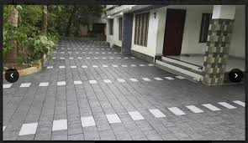

[[](https://www.justdial.com/jdmart/Kottayam/Paving-tile-stone-finish-with-multi-colour/pid-2183095374/9999PX481-X481-190828162238-L6X9)](https://www.justdial.com/jdmart/Kottayam/Paving-tile-stone-finish-with-multi-colour/pid-2183095374/9999PX481-X481-190828162238-L6X9" \o "Paving tile (stone finish with multi colour) in Kottayam at best price by  Zion Interlocking Tiles and Pavings - Justdial" \t "_blank)

[Justdial](https://www.justdial.com/jdmart/Kottayam/Paving-tile-stone-finish-with-multi-colour/pid-2183095374/9999PX481-X481-190828162238-L6X9" \o "Paving tile (stone finish with multi colour) in Kottayam at best price by  Zion Interlocking Tiles and Pavings - Justdial" \t "_blank)

[Paving tile (stone finish with multi ...](https://www.justdial.com/jdmart/Kottayam/Paving-tile-stone-finish-with-multi-colour/pid-2183095374/9999PX481-X481-190828162238-L6X9" \o "Paving tile (stone finish with multi colour) in Kottayam at best price by  Zion Interlocking Tiles and Pavings - Justdial" \t "_blank)

**Pavers India - Interlocking Pavers | Paver Block Manufacturers | Paver Blocks Price**

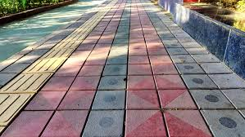

[[](https://www.paversindia.com/)](https://www.paversindia.com/" \o "Pavers India - Interlocking Pavers | Paver Block Manufacturers | Paver  Blocks Price" \t "_blank)

[www.paversindia.com](https://www.paversindia.com/" \o "Pavers India - Interlocking Pavers | Paver Block Manufacturers | Paver  Blocks Price" \t "_blank)

[Pavers India - Interlocking Pavers ...](https://www.paversindia.com/" \o "Pavers India - Interlocking Pavers | Paver Block Manufacturers | Paver  Blocks Price" \t "_blank)

**Grey,Red Interlock Paver I Shape Paving Blocks, For Pavement, Dimensions: 225 X175 X 60mm at Rs 50/square feet in Chennai**

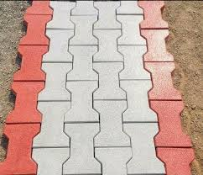

[[](https://www.indiamart.com/proddetail/i-shape-paving-blocks-15897490988.html)](https://www.indiamart.com/proddetail/i-shape-paving-blocks-15897490988.html" \o "Grey,Red Interlock Paver I Shape Paving Blocks, For Pavement, Dimensions:  225 X175 X 60mm at Rs 50/square feet in Chennai" \t "_blank)

[IndiaMART](https://www.indiamart.com/proddetail/i-shape-paving-blocks-15897490988.html" \o "Grey,Red Interlock Paver I Shape Paving Blocks, For Pavement, Dimensions:  225 X175 X 60mm at Rs 50/square feet in Chennai" \t "_blank)

[Interlock Paver I Shape Paving Blocks ...](https://www.indiamart.com/proddetail/i-shape-paving-blocks-15897490988.html" \o "Grey,Red Interlock Paver I Shape Paving Blocks, For Pavement, Dimensions:  225 X175 X 60mm at Rs 50/square feet in Chennai" \t "_blank)

**Interlocking Paver Block Making Process. | RED IRON OXIDE PIGMENT, INTERLOCKING TILE MAKING MACHINE, PAVER MOULD**

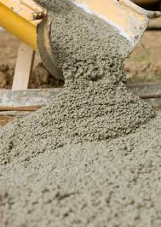

[[](https://srikrishnaplasto.com/interlocking-pvc-paver-mould/interlocking-paver-block-making-process.html)](https://srikrishnaplasto.com/interlocking-pvc-paver-mould/interlocking-paver-block-making-process.html" \o "Interlocking Paver Block Making Process. | RED IRON OXIDE PIGMENT, INTERLOCKING  TILE MAKING MACHINE, PAVER MOULD" \t "_blank)

[RED IRON OXIDE PIGMENT, INTERLOCKING TILE MAKING MACHINE, PAVER MOULD](https://srikrishnaplasto.com/interlocking-pvc-paver-mould/interlocking-paver-block-making-process.html" \o "Interlocking Paver Block Making Process. | RED IRON OXIDE PIGMENT, INTERLOCKING  TILE MAKING MACHINE, PAVER MOULD" \t "_blank)

[Interlocking Paver Block Making Process ...](https://srikrishnaplasto.com/interlocking-pvc-paver-mould/interlocking-paver-block-making-process.html" \o "Interlocking Paver Block Making Process. | RED IRON OXIDE PIGMENT, INTERLOCKING  TILE MAKING MACHINE, PAVER MOULD" \t "_blank)

**Red Iron Oxide Color Pigment SRIO-3130 | Kerbstone Mould | Paver Mould | Interlocking Tiles Paver Mould**

[[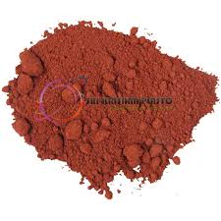](https://www.google.com/imgres?imgurl=https%3A%2F%2Fwww.srikrishnaoverseas.com%2Fwp-content%2Fuploads%2F2019%2F03%2FRed-Iron-Oxide-Color-Pigment-SRIO-3130.jpg&imgrefurl=https%3A%2F%2Fwww.srikrishnaoverseas.com%2Fproducts%2Fcolors-and-pigments%2Fcolors-for-plastic%2Fred-iron-oxide-color-pigment-srio-3130&tbnid=gog1BpyFUkR4TM&vet=10CJ0BEDMorQFqFwoTCMDX8LTBkv0CFQAAAAAdAAAAABAD..i&docid=HQnOy8zPWphElM&w=650&h=650&q=interlocking%20pavers%20and%20tiles%20%20color%20and%20hardness&hl=en&ved=0CJ0BEDMorQFqFwoTCMDX8LTBkv0CFQAAAAAdAAAAABAD)](https://www.google.com/imgres?imgurl=https%3A%2F%2Fwww.srikrishnaoverseas.com%2Fwp-content%2Fuploads%2F2019%2F03%2FRed-Iron-Oxide-Color-Pigment-SRIO-3130.jpg&imgrefurl=https%3A%2F%2Fwww.srikrishnaoverseas.com%2Fproducts%2Fcolors-and-pigments%2Fcolors-for-plastic%2Fred-iron-oxide-color-pigment-srio-3130&tbnid=gog1BpyFUkR4TM&vet=10CJ0BEDMorQFqFwoTCMDX8LTBkv0CFQAAAAAdAAAAABAD..i&docid=HQnOy8zPWphElM&w=650&h=650&q=interlocking%20pavers%20and%20tiles%20%20color%20and%20hardness&hl=en&ved=0CJ0BEDMorQFqFwoTCMDX8LTBkv0CFQAAAAAdAAAAABAD)

[[](https://www.srikrishnaoverseas.com/products/colors-and-pigments/colors-for-plastic/red-iron-oxide-color-pigment-srio-3130)](https://www.srikrishnaoverseas.com/products/colors-and-pigments/colors-for-plastic/red-iron-oxide-color-pigment-srio-3130" \o "Red Iron Oxide Color Pigment SRIO-3130 | Kerbstone Mould | Paver Mould | Interlocking  Tiles Paver Mould" \t "_blank)

[Paver Block Making Machine](https://www.srikrishnaoverseas.com/products/colors-and-pigments/colors-for-plastic/red-iron-oxide-color-pigment-srio-3130" \o "Red Iron Oxide Color Pigment SRIO-3130 | Kerbstone Mould | Paver Mould | Interlocking  Tiles Paver Mould" \t "_blank)

[Red Iron Oxide Color Pigment SRIO-3130 ...](https://www.srikrishnaoverseas.com/products/colors-and-pigments/colors-for-plastic/red-iron-oxide-color-pigment-srio-3130" \o "Red Iron Oxide Color Pigment SRIO-3130 | Kerbstone Mould | Paver Mould | Interlocking  Tiles Paver Mould" \t "_blank)

Popular searches

[[](https://www.google.com/search?q=paver%20block&tbm=isch&hl=en&bih=722&biw=1519&rlz=1C1YTUH_enIN1004IN1004&sa=X&ved=0CKABEKzcAigAahcKEwjA1_C0wZL9AhUAAAAAHQAAAAAQAw)](https://www.google.com/search?q=paver%20block&tbm=isch&hl=en&bih=722&biw=1519&rlz=1C1YTUH_enIN1004IN1004&sa=X&ved=0CKABEKzcAigAahcKEwjA1_C0wZL9AhUAAAAAHQAAAAAQAw)

[paver block](https://www.google.com/search?q=paver%20block&tbm=isch&hl=en&bih=722&biw=1519&rlz=1C1YTUH_enIN1004IN1004&sa=X&ved=0CKABEKzcAigAahcKEwjA1_C0wZL9AhUAAAAAHQAAAAAQAw)

[[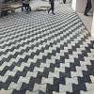](https://www.google.com/search?q=interlock%20colors&tbm=isch&hl=en&bih=722&biw=1519&rlz=1C1YTUH_enIN1004IN1004&sa=X&ved=0CKIBEKzcAigBahcKEwjA1_C0wZL9AhUAAAAAHQAAAAAQAw)](https://www.google.com/search?q=interlock%20colors&tbm=isch&hl=en&bih=722&biw=1519&rlz=1C1YTUH_enIN1004IN1004&sa=X&ved=0CKIBEKzcAigBahcKEwjA1_C0wZL9AhUAAAAAHQAAAAAQAw)

[interlock colors](https://www.google.com/search?q=interlock%20colors&tbm=isch&hl=en&bih=722&biw=1519&rlz=1C1YTUH_enIN1004IN1004&sa=X&ved=0CKIBEKzcAigBahcKEwjA1_C0wZL9AhUAAAAAHQAAAAAQAw)

[[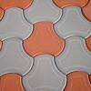](https://www.google.com/search?q=paving%20interlock%20tiles%20texture&tbm=isch&hl=en&bih=722&biw=1519&rlz=1C1YTUH_enIN1004IN1004&sa=X&ved=0CKQBEKzcAigCahcKEwjA1_C0wZL9AhUAAAAAHQAAAAAQAw)](https://www.google.com/search?q=paving%20interlock%20tiles%20texture&tbm=isch&hl=en&bih=722&biw=1519&rlz=1C1YTUH_enIN1004IN1004&sa=X&ved=0CKQBEKzcAigCahcKEwjA1_C0wZL9AhUAAAAAHQAAAAAQAw)

**[paving interlock](https://www.google.com/search?q=paving%20interlock%20tiles%20texture&tbm=isch&hl=en&bih=722&biw=1519&rlz=1C1YTUH_enIN1004IN1004&sa=X&ved=0CKQBEKzcAigCahcKEwjA1_C0wZL9AhUAAAAAHQAAAAAQAw)**[tiles](https://www.google.com/search?q=paving%20interlock%20tiles%20texture&tbm=isch&hl=en&bih=722&biw=1519&rlz=1C1YTUH_enIN1004IN1004&sa=X&ved=0CKQBEKzcAigCahcKEwjA1_C0wZL9AhUAAAAAHQAAAAAQAw)**[texture](https://www.google.com/search?q=paving%20interlock%20tiles%20texture&tbm=isch&hl=en&bih=722&biw=1519&rlz=1C1YTUH_enIN1004IN1004&sa=X&ved=0CKQBEKzcAigCahcKEwjA1_C0wZL9AhUAAAAAHQAAAAAQAw)**

**Interlock Paver Scale & Pattern Guide For 2021**

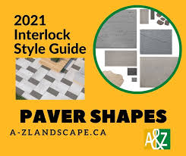

[[](https://a-zlandscape.ca/interlock-scale-guide-2021/)](https://a-zlandscape.ca/interlock-scale-guide-2021/" \o "Interlock Paver Scale & Pattern Guide For 2021" \t "_blank)

[A&Z Interlock Ottawa](https://a-zlandscape.ca/interlock-scale-guide-2021/" \o "Interlock Paver Scale & Pattern Guide For 2021" \t "_blank)

[Interlock Paver Scale & Pattern Guide ...](https://a-zlandscape.ca/interlock-scale-guide-2021/" \o "Interlock Paver Scale & Pattern Guide For 2021" \t "_blank)

**RSD PAVER & TILES | Interlocking Bindi Square Chequered Tiles Set of 5 (Red, 1x1 sq ft) : Amazon.in: Home & Kitchen**

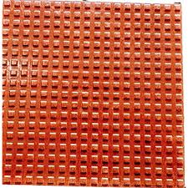

[[](https://www.amazon.in/RSD-Interlocking-Bindi-Square-Chequered/dp/B072LY3R31)](https://www.amazon.in/RSD-Interlocking-Bindi-Square-Chequered/dp/B072LY3R31" \o "RSD PAVER & TILES | Interlocking Bindi Square Chequered Tiles Set of 5  (Red, 1x1 sq ft) : Amazon.in: Home & Kitchen" \t "_blank)

[Amazon.in](https://www.amazon.in/RSD-Interlocking-Bindi-Square-Chequered/dp/B072LY3R31" \o "RSD PAVER & TILES | Interlocking Bindi Square Chequered Tiles Set of 5  (Red, 1x1 sq ft) : Amazon.in: Home & Kitchen" \t "_blank)

[RSD PAVER & TILES | Interlocking Bindi ...](https://www.amazon.in/RSD-Interlocking-Bindi-Square-Chequered/dp/B072LY3R31" \o "RSD PAVER & TILES | Interlocking Bindi Square Chequered Tiles Set of 5  (Red, 1x1 sq ft) : Amazon.in: Home & Kitchen" \t "_blank)

**Terracon Tiles - Paving Tiles Manufacturers in Kerala, Thrissur, Paver Blocks Design, Outdoor floor tiles Product company, Ernakulam, Kottayam, Kochi**



[[](http://www.terracontilesindia.com/)](http://www.terracontilesindia.com/" \o "Terracon Tiles - Paving Tiles Manufacturers in Kerala, Thrissur, Paver  Blocks Design, Outdoor floor tiles Product company, Ernakulam, Kottayam,  Kochi" \t "_blank)

[www.terracontilesindia.com](http://www.terracontilesindia.com/" \o "Terracon Tiles - Paving Tiles Manufacturers in Kerala, Thrissur, Paver  Blocks Design, Outdoor floor tiles Product company, Ernakulam, Kottayam,  Kochi" \t "_blank)

[Terracon Tiles - Paving Tiles ...](http://www.terracontilesindia.com/" \o "Terracon Tiles - Paving Tiles Manufacturers in Kerala, Thrissur, Paver  Blocks Design, Outdoor floor tiles Product company, Ernakulam, Kottayam,  Kochi" \t "_blank)

**Malmo Pearl Matte Internal tiles 600x600**

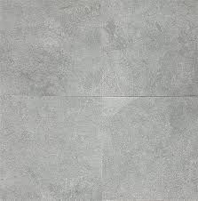

[[](https://www.cheaptilesonline.com.au/product/malmo-pearl-matte-internal-tiles-600x600/)](https://www.cheaptilesonline.com.au/product/malmo-pearl-matte-internal-tiles-600x600/" \o "Malmo Pearl Matte Internal tiles 600x600" \t "_blank)

[Cheap Tiles Online](https://www.cheaptilesonline.com.au/product/malmo-pearl-matte-internal-tiles-600x600/" \o "Malmo Pearl Matte Internal tiles 600x600" \t "_blank)

[Malmo Pearl Matte Internal tiles 600x600](https://www.cheaptilesonline.com.au/product/malmo-pearl-matte-internal-tiles-600x600/" \o "Malmo Pearl Matte Internal tiles 600x600" \t "_blank)

**Interlocking Paver Tiles - Interlocking Paver Tiles buyers, suppliers, importers, exporters and manufacturers - Latest price and trends**

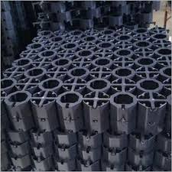

[[](https://connect2india.com/Interlocking-Paver-Tiles)](https://connect2india.com/Interlocking-Paver-Tiles" \o "Interlocking Paver Tiles - Interlocking Paver Tiles buyers, suppliers,  importers, exporters and manufacturers - Latest price and trends" \t "_blank)

[Connect2India](https://connect2india.com/Interlocking-Paver-Tiles" \o "Interlocking Paver Tiles - Interlocking Paver Tiles buyers, suppliers,  importers, exporters and manufacturers - Latest price and trends" \t "_blank)

[Interlocking Paver Tiles - Interlocking ...](https://connect2india.com/Interlocking-Paver-Tiles" \o "Interlocking Paver Tiles - Interlocking Paver Tiles buyers, suppliers,  importers, exporters and manufacturers - Latest price and trends" \t "_blank)

**Rubber Pavers & Stepping Stones at Lowes.com**

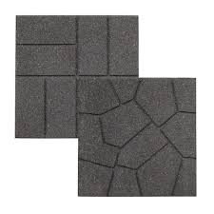

[[](https://www.lowes.com/pl/Rubber--Pavers-stepping-stones-Stones-pavers-Pavers-retaining-walls-Lawn-garden/2931858413?refinement=4294964925)](https://www.lowes.com/pl/Rubber--Pavers-stepping-stones-Stones-pavers-Pavers-retaining-walls-Lawn-garden/2931858413?refinement=4294964925" \o "Rubber Pavers & Stepping Stones at Lowes.com" \t "_blank)

[Lowe's](https://www.lowes.com/pl/Rubber--Pavers-stepping-stones-Stones-pavers-Pavers-retaining-walls-Lawn-garden/2931858413?refinement=4294964925" \o "Rubber Pavers & Stepping Stones at Lowes.com" \t "_blank)

[Rubber Pavers & Stepping Stones at ...](https://www.lowes.com/pl/Rubber--Pavers-stepping-stones-Stones-pavers-Pavers-retaining-walls-Lawn-garden/2931858413?refinement=4294964925" \o "Rubber Pavers & Stepping Stones at Lowes.com" \t "_blank)

**Choose the Right Paving Tiles Designs - Charbhujatiles**

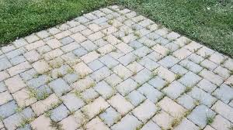

[[](https://charbhujatiles.com/blog-details/choose-the-right-paving-tiles-designs-with-these-useful-tips)](https://charbhujatiles.com/blog-details/choose-the-right-paving-tiles-designs-with-these-useful-tips" \o "Choose the Right Paving Tiles Designs - Charbhujatiles" \t "_blank)

[Charbhuja Tiles](https://charbhujatiles.com/blog-details/choose-the-right-paving-tiles-designs-with-these-useful-tips" \o "Choose the Right Paving Tiles Designs - Charbhujatiles" \t "_blank)

[Choose the Right Paving Tiles Designs ...](https://charbhujatiles.com/blog-details/choose-the-right-paving-tiles-designs-with-these-useful-tips" \o "Choose the Right Paving Tiles Designs - Charbhujatiles" \t "_blank)

**Gardenised Gray Plastic Garden Path Track Interlocking Stone Look Design Pathway Tile Floor Paver (Pack of 4) QI004108.4 - The Home Depot**

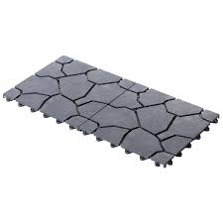

[[](https://www.homedepot.com/p/Gardenised-Gray-Plastic-Garden-Path-Track-Interlocking-Stone-Look-Design-Pathway-Tile-Floor-Paver-Pack-of-4-QI004108-4/317909834)](https://www.homedepot.com/p/Gardenised-Gray-Plastic-Garden-Path-Track-Interlocking-Stone-Look-Design-Pathway-Tile-Floor-Paver-Pack-of-4-QI004108-4/317909834" \o "Gardenised Gray Plastic Garden Path Track Interlocking Stone Look Design  Pathway Tile Floor Paver (Pack of 4) QI004108.4 - The Home Depot" \t "_blank)

[The Home Depot](https://www.homedepot.com/p/Gardenised-Gray-Plastic-Garden-Path-Track-Interlocking-Stone-Look-Design-Pathway-Tile-Floor-Paver-Pack-of-4-QI004108-4/317909834" \o "Gardenised Gray Plastic Garden Path Track Interlocking Stone Look Design  Pathway Tile Floor Paver (Pack of 4) QI004108.4 - The Home Depot" \t "_blank)

[Gardenised Gray Plastic Garden Path ...](https://www.homedepot.com/p/Gardenised-Gray-Plastic-Garden-Path-Track-Interlocking-Stone-Look-Design-Pathway-Tile-Floor-Paver-Pack-of-4-QI004108-4/317909834" \o "Gardenised Gray Plastic Garden Path Track Interlocking Stone Look Design  Pathway Tile Floor Paver (Pack of 4) QI004108.4 - The Home Depot" \t "_blank)

**1,591 Interlocking Paver Images, Stock Photos & Vectors | Shutterstock**

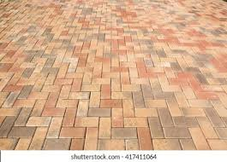

[[](https://www.shutterstock.com/search/interlocking-paver)](https://www.shutterstock.com/search/interlocking-paver" \o "1,591 Interlocking Paver Images, Stock Photos & Vectors | Shutterstock" \t "_blank)

[Shutterstock](https://www.shutterstock.com/search/interlocking-paver" \o "1,591 Interlocking Paver Images, Stock Photos & Vectors | Shutterstock" \t "_blank)

[1,591 Interlocking Paver Images, Stock ...](https://www.shutterstock.com/search/interlocking-paver" \o "1,591 Interlocking Paver Images, Stock Photos & Vectors | Shutterstock" \t "_blank)

**Paver Mould for Cement Concrete Interlocking Paving Tile - China Concrete Hollow Block Mould and Block Mould**

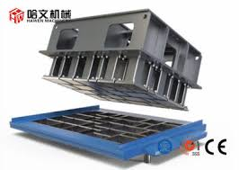

[[](https://hawenmachine.en.made-in-china.com/product/iZqTueWyhfpE/China-Paver-Mould-for-Cement-Concrete-Interlocking-Paving-Tile.html)](https://hawenmachine.en.made-in-china.com/product/iZqTueWyhfpE/China-Paver-Mould-for-Cement-Concrete-Interlocking-Paving-Tile.html" \o "Paver Mould for Cement Concrete Interlocking Paving Tile - China Concrete  Hollow Block Mould and Block Mould" \t "_blank)

[Quanzhou Hawen Machinery Co., Ltd.](https://hawenmachine.en.made-in-china.com/product/iZqTueWyhfpE/China-Paver-Mould-for-Cement-Concrete-Interlocking-Paving-Tile.html" \o "Paver Mould for Cement Concrete Interlocking Paving Tile - China Concrete  Hollow Block Mould and Block Mould" \t "_blank)

[Paver Mould for Cement Concrete ...](https://hawenmachine.en.made-in-china.com/product/iZqTueWyhfpE/China-Paver-Mould-for-Cement-Concrete-Interlocking-Paving-Tile.html" \o "Paver Mould for Cement Concrete Interlocking Paving Tile - China Concrete  Hollow Block Mould and Block Mould" \t "_blank)

**Home Impressions Venetian Paver 12 In. x 12 In. Vinyl Floor Tile (45 Sq. Ft./Box) - S.W. Collins**

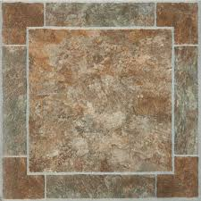

[[](https://swcollins.com/shop/building-materials/flooring-materials/vinyl-flooring/vinyl-floor-tile/home-impressions-venetian-paver-12-in-x-12-in-vinyl-floor-tile-45-sq-ftbox?SKU=278831)](https://swcollins.com/shop/building-materials/flooring-materials/vinyl-flooring/vinyl-floor-tile/home-impressions-venetian-paver-12-in-x-12-in-vinyl-floor-tile-45-sq-ftbox?SKU=278831" \o "Home Impressions Venetian Paver 12 In. x 12 In. Vinyl Floor Tile (45 Sq.  Ft./Box) - S.W. Collins" \t "_blank)

[S.W. Collins](https://swcollins.com/shop/building-materials/flooring-materials/vinyl-flooring/vinyl-floor-tile/home-impressions-venetian-paver-12-in-x-12-in-vinyl-floor-tile-45-sq-ftbox?SKU=278831" \o "Home Impressions Venetian Paver 12 In. x 12 In. Vinyl Floor Tile (45 Sq.  Ft./Box) - S.W. Collins" \t "_blank)

[Home Impressions Venetian Paver 12 In ...](https://swcollins.com/shop/building-materials/flooring-materials/vinyl-flooring/vinyl-floor-tile/home-impressions-venetian-paver-12-in-x-12-in-vinyl-floor-tile-45-sq-ftbox?SKU=278831" \o "Home Impressions Venetian Paver 12 In. x 12 In. Vinyl Floor Tile (45 Sq.  Ft./Box) - S.W. Collins" \t "_blank)

**Interlocking Pavers Manufactuer,Interlocking Titles Supplier, Dayal RCC Interlocking Pavers Tiles Manufacturer Meerut**

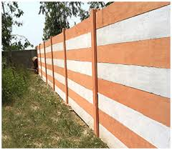

[[](https://www.dayalpipes.com/interlockingPavers.html)](https://www.dayalpipes.com/interlockingPavers.html" \o "Interlocking Pavers Manufactuer,Interlocking Titles Supplier, Dayal RCC Interlocking  Pavers Tiles Manufacturer Meerut" \t "_blank)

[RCC Pipes](https://www.dayalpipes.com/interlockingPavers.html" \o "Interlocking Pavers Manufactuer,Interlocking Titles Supplier, Dayal RCC Interlocking  Pavers Tiles Manufacturer Meerut" \t "_blank)

[Interlocking Pavers Manufactuer ...](https://www.dayalpipes.com/interlockingPavers.html" \o "Interlocking Pavers Manufactuer,Interlocking Titles Supplier, Dayal RCC Interlocking  Pavers Tiles Manufacturer Meerut" \t "_blank)

**SmartSand for Interlocking Paver Residential Installation | Techniseal**

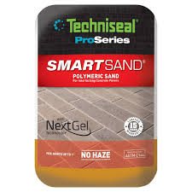

[[](https://techniseal.com/pro_en_us/smartsand-jointing-sand-for-interlocking-pavers-211-002)](https://techniseal.com/pro_en_us/smartsand-jointing-sand-for-interlocking-pavers-211-002" \o "SmartSand for Interlocking Paver Residential Installation | Techniseal" \t "_blank)

[Techniseal](https://techniseal.com/pro_en_us/smartsand-jointing-sand-for-interlocking-pavers-211-002" \o "SmartSand for Interlocking Paver Residential Installation | Techniseal" \t "_blank)

[SmartSand for Interlocking Paver ...](https://techniseal.com/pro_en_us/smartsand-jointing-sand-for-interlocking-pavers-211-002" \o "SmartSand for Interlocking Paver Residential Installation | Techniseal" \t "_blank)

**Gold Yellow Swimming Pool Coping Pavers,Golden Beige Quartzite Pool Deck Pavers,More Yellow Less Grey Interlocking Patio Pavers,Beige Color Pool Pavers Tiles from China - StoneContact.com**

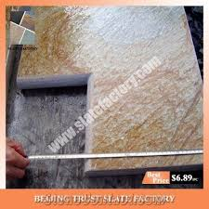

[[](https://www.stonecontact.com/products-193480/gold-yellow-swimming-pool-coping-pavers)](https://www.stonecontact.com/products-193480/gold-yellow-swimming-pool-coping-pavers" \o "Gold Yellow Swimming Pool Coping Pavers,Golden Beige Quartzite Pool Deck  Pavers,More Yellow Less Grey Interlocking Patio Pavers,Beige Color Pool Pavers  Tiles from China - StoneContact.com" \t "_blank)

[StoneContact.com](https://www.stonecontact.com/products-193480/gold-yellow-swimming-pool-coping-pavers" \o "Gold Yellow Swimming Pool Coping Pavers,Golden Beige Quartzite Pool Deck  Pavers,More Yellow Less Grey Interlocking Patio Pavers,Beige Color Pool Pavers  Tiles from China - StoneContact.com" \t "_blank)

[Gold Yellow Swimming Pool Coping Pavers ...](https://www.stonecontact.com/products-193480/gold-yellow-swimming-pool-coping-pavers" \o "Gold Yellow Swimming Pool Coping Pavers,Golden Beige Quartzite Pool Deck  Pavers,More Yellow Less Grey Interlocking Patio Pavers,Beige Color Pool Pavers  Tiles from China - StoneContact.com" \t "_blank)

**Mcombo 10Pcs Patio Wood Deck Tiles 12"x12",Outdoor Interlocking Deck Flooring Oiled Finish,Patio Paver Tiles - Overstock - 32697675**

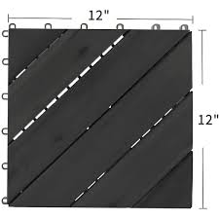

[[](https://www.overstock.com/Home-Garden/Mcombo-10Pcs-Patio-Wood-Deck-Tiles-12-x12-Outdoor-Interlocking-Deck-Flooring-Oiled-Finish-Patio-Paver-Tiles-6083-WF01-02-BK-WD/32697675/product.html)](https://www.overstock.com/Home-Garden/Mcombo-10Pcs-Patio-Wood-Deck-Tiles-12-x12-Outdoor-Interlocking-Deck-Flooring-Oiled-Finish-Patio-Paver-Tiles-6083-WF01-02-BK-WD/32697675/product.html" \o "Mcombo 10Pcs Patio Wood Deck Tiles 12\"x12\",Outdoor Interlocking Deck  Flooring Oiled Finish,Patio Paver Tiles - Overstock - 32697675" \t "_blank)

[Overstock.com](https://www.overstock.com/Home-Garden/Mcombo-10Pcs-Patio-Wood-Deck-Tiles-12-x12-Outdoor-Interlocking-Deck-Flooring-Oiled-Finish-Patio-Paver-Tiles-6083-WF01-02-BK-WD/32697675/product.html" \o "Mcombo 10Pcs Patio Wood Deck Tiles 12\"x12\",Outdoor Interlocking Deck  Flooring Oiled Finish,Patio Paver Tiles - Overstock - 32697675" \t "_blank)

[Mcombo 10Pcs Patio Wood Deck Tiles 12 ...](https://www.overstock.com/Home-Garden/Mcombo-10Pcs-Patio-Wood-Deck-Tiles-12-x12-Outdoor-Interlocking-Deck-Flooring-Oiled-Finish-Patio-Paver-Tiles-6083-WF01-02-BK-WD/32697675/product.html" \o "Mcombo 10Pcs Patio Wood Deck Tiles 12\"x12\",Outdoor Interlocking Deck  Flooring Oiled Finish,Patio Paver Tiles - Overstock - 32697675" \t "_blank)

**Concrete Interlocking Paving Tile Driveway Parking Place Street Stock Image - Image of block, landscaping: 218708743**

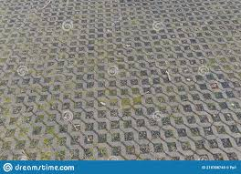

[[](https://www.dreamstime.com/concrete-interlocking-paving-tile-driveway-parking-place-street-concrete-interlocking-paving-tile-driveway-parking-place-street-image218708743)](https://www.dreamstime.com/concrete-interlocking-paving-tile-driveway-parking-place-street-concrete-interlocking-paving-tile-driveway-parking-place-street-image218708743" \o "Concrete Interlocking Paving Tile Driveway Parking Place Street Stock Image  - Image of block, landscaping: 218708743" \t "_blank)

[Dreamstime.com](https://www.dreamstime.com/concrete-interlocking-paving-tile-driveway-parking-place-street-concrete-interlocking-paving-tile-driveway-parking-place-street-image218708743" \o "Concrete Interlocking Paving Tile Driveway Parking Place Street Stock Image  - Image of block, landscaping: 218708743" \t "_blank)

[Concrete Interlocking Paving Tile ...](https://www.dreamstime.com/concrete-interlocking-paving-tile-driveway-parking-place-street-concrete-interlocking-paving-tile-driveway-parking-place-street-image218708743" \o "Concrete Interlocking Paving Tile Driveway Parking Place Street Stock Image  - Image of block, landscaping: 218708743" \t "_blank)

**Driveway Interlocking Pavers Adelaide | Driveway Pavers Adelaide**

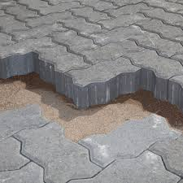

[[](https://australianpaving.com/product/driveway-interlocking-pavers/)](https://australianpaving.com/product/driveway-interlocking-pavers/" \o "Driveway Interlocking Pavers Adelaide | Driveway Pavers Adelaide" \t "_blank)

[Australian Paving Centre](https://australianpaving.com/product/driveway-interlocking-pavers/" \o "Driveway Interlocking Pavers Adelaide | Driveway Pavers Adelaide" \t "_blank)

[Driveway Interlocking Pavers Adelaide ...](https://australianpaving.com/product/driveway-interlocking-pavers/" \o "Driveway Interlocking Pavers Adelaide | Driveway Pavers Adelaide" \t "_blank)

**Popular Interlock Pavers In Different Designs - Buy Interlock Pavers,Interlock Paver Tiles,Interlock Tile Prices Product on Alibaba.com**

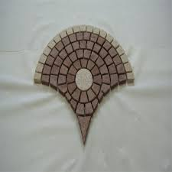

[[](https://www.alibaba.com/product-detail/Popular-interlock-pavers-In-Different-Designs_60531796407.html)](https://www.alibaba.com/product-detail/Popular-interlock-pavers-In-Different-Designs_60531796407.html" \o "Popular Interlock Pavers In Different Designs - Buy Interlock Pavers,Interlock  Paver Tiles,Interlock Tile Prices Product on Alibaba.com" \t "_blank)

[Alibaba.com](https://www.alibaba.com/product-detail/Popular-interlock-pavers-In-Different-Designs_60531796407.html" \o "Popular Interlock Pavers In Different Designs - Buy Interlock Pavers,Interlock  Paver Tiles,Interlock Tile Prices Product on Alibaba.com" \t "_blank)

[Buy Interlock Pavers,Interlock Paver ...](https://www.alibaba.com/product-detail/Popular-interlock-pavers-In-Different-Designs_60531796407.html" \o "Popular Interlock Pavers In Different Designs - Buy Interlock Pavers,Interlock  Paver Tiles,Interlock Tile Prices Product on Alibaba.com" \t "_blank)

**Wood Composite Decking, Deck Tiles, Interlocking Flooring Tiles, Patio & Flooring Pavers 30cm x 30cm/12 ×12 , Pack of 4 | Walmart Canada**

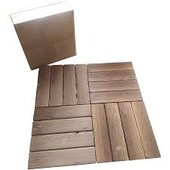

[[](https://www.walmart.ca/en/ip/Wood-Composite-Decking-Deck-Tiles-Interlocking-Flooring-Tiles-Patio-Flooring-Pavers-30cm-x-30cm-12-12-Pack-of-4/PRD4M1R0YNCJ70G)](https://www.walmart.ca/en/ip/Wood-Composite-Decking-Deck-Tiles-Interlocking-Flooring-Tiles-Patio-Flooring-Pavers-30cm-x-30cm-12-12-Pack-of-4/PRD4M1R0YNCJ70G" \o "Wood Composite Decking, Deck Tiles, Interlocking Flooring Tiles, Patio &  Flooring Pavers 30cm x 30cm/12 ×12 , Pack of 4 | Walmart Canada" \t "_blank)

[Walmart.ca](https://www.walmart.ca/en/ip/Wood-Composite-Decking-Deck-Tiles-Interlocking-Flooring-Tiles-Patio-Flooring-Pavers-30cm-x-30cm-12-12-Pack-of-4/PRD4M1R0YNCJ70G" \o "Wood Composite Decking, Deck Tiles, Interlocking Flooring Tiles, Patio &  Flooring Pavers 30cm x 30cm/12 ×12 , Pack of 4 | Walmart Canada" \t "_blank)

[Wood Composite Decking, Deck Tiles ...](https://www.walmart.ca/en/ip/Wood-Composite-Decking-Deck-Tiles-Interlocking-Flooring-Tiles-Patio-Flooring-Pavers-30cm-x-30cm-12-12-Pack-of-4/PRD4M1R0YNCJ70G" \o "Wood Composite Decking, Deck Tiles, Interlocking Flooring Tiles, Patio &  Flooring Pavers 30cm x 30cm/12 ×12 , Pack of 4 | Walmart Canada" \t "_blank)

**Premium Photo | Background from paving slabs with grass sprouting through them. stone tiles on the sidewalk. footpath. textured patterned background. eco-friendly covering - concrete lawn grating.**

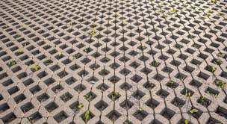

[[](https://www.freepik.com/premium-photo/background-from-paving-slabs-with-grass-sprouting-through-them-stone-tiles-sidewalk-footpath-textured-patterned-background-eco-friendly-covering-concrete-lawn-grating_20818618.htm)](https://www.freepik.com/premium-photo/background-from-paving-slabs-with-grass-sprouting-through-them-stone-tiles-sidewalk-footpath-textured-patterned-background-eco-friendly-covering-concrete-lawn-grating_20818618.htm" \o "Premium Photo | Background from paving slabs with grass sprouting through  them. stone tiles on the sidewalk. footpath. textured patterned background.  eco-friendly covering - concrete lawn grating." \t "_blank)

[Freepik](https://www.freepik.com/premium-photo/background-from-paving-slabs-with-grass-sprouting-through-them-stone-tiles-sidewalk-footpath-textured-patterned-background-eco-friendly-covering-concrete-lawn-grating_20818618.htm" \o "Premium Photo | Background from paving slabs with grass sprouting through  them. stone tiles on the sidewalk. footpath. textured patterned background.  eco-friendly covering - concrete lawn grating." \t "_blank)

[Background from paving slabs ...](https://www.freepik.com/premium-photo/background-from-paving-slabs-with-grass-sprouting-through-them-stone-tiles-sidewalk-footpath-textured-patterned-background-eco-friendly-covering-concrete-lawn-grating_20818618.htm" \o "Premium Photo | Background from paving slabs with grass sprouting through  them. stone tiles on the sidewalk. footpath. textured patterned background.  eco-friendly covering - concrete lawn grating." \t "_blank)

**Cosmic Interlocking Paver Block (Color - Red, Grey) 60 Mm Application: Floor Tiles at Best Price in Patna | Rsd - Manufacturer Of Interlocking Paver & Chequered Tiles**

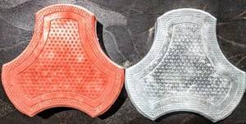

[[](https://www.tradeindia.com/products/cosmic-interlocking-paver-block-color-red-grey-60-mm-4001770.html)](https://www.tradeindia.com/products/cosmic-interlocking-paver-block-color-red-grey-60-mm-4001770.html" \o "Cosmic Interlocking Paver Block (Color - Red, Grey) 60 Mm Application:  Floor Tiles at Best Price in Patna | Rsd - Manufacturer Of Interlocking  Paver & Chequered Tiles" \t "_blank)

[TradeIndia](https://www.tradeindia.com/products/cosmic-interlocking-paver-block-color-red-grey-60-mm-4001770.html" \o "Cosmic Interlocking Paver Block (Color - Red, Grey) 60 Mm Application:  Floor Tiles at Best Price in Patna | Rsd - Manufacturer Of Interlocking  Paver & Chequered Tiles" \t "_blank)

[Cosmic Interlocking Paver Block (Color ...](https://www.tradeindia.com/products/cosmic-interlocking-paver-block-color-red-grey-60-mm-4001770.html" \o "Cosmic Interlocking Paver Block (Color - Red, Grey) 60 Mm Application:  Floor Tiles at Best Price in Patna | Rsd - Manufacturer Of Interlocking  Paver & Chequered Tiles" \t "_blank)

**Perforated Interlocking Patio Tiles over concrete - Made in USA**

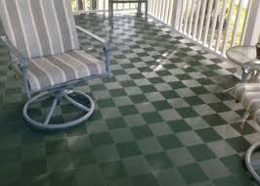

[[](https://modutile.com/product/interlocking-patio-tiles/)](https://modutile.com/product/interlocking-patio-tiles/" \o "Perforated Interlocking Patio Tiles over concrete - Made in USA" \t "_blank)

[ModuTile](https://modutile.com/product/interlocking-patio-tiles/" \o "Perforated Interlocking Patio Tiles over concrete - Made in USA" \t "_blank)

[Perforated Interlocking Patio Tiles ...](https://modutile.com/product/interlocking-patio-tiles/" \o "Perforated Interlocking Patio Tiles over concrete - Made in USA" \t "_blank)

**Paver block color pigments , Iron oxide for paver blocks which one is better??? 9650211786 - YouTube**



[[](https://www.youtube.com/watch?v=LNNcbFg8ZRw)](https://www.youtube.com/watch?v=LNNcbFg8ZRw" \o "Paver block color pigments , Iron oxide for paver blocks which one is  better??? 9650211786 - YouTube" \t "_blank)

[YouTube](https://www.youtube.com/watch?v=LNNcbFg8ZRw" \o "Paver block color pigments , Iron oxide for paver blocks which one is  better??? 9650211786 - YouTube" \t "_blank)

[Paver block color pigments , Iron oxide ...](https://www.youtube.com/watch?v=LNNcbFg8ZRw" \o "Paver block color pigments , Iron oxide for paver blocks which one is  better??? 9650211786 - YouTube" \t "_blank)

**Gray Pavement Consisting of Combined Quadrangle and Hexagons. Seamless Tileable Texture. | Paving texture, Stone floor texture, Pavement design**

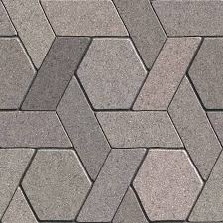

[[](https://www.pinterest.com/pin/591167888568200152/)](https://www.pinterest.com/pin/591167888568200152/" \o "Gray Pavement Consisting of Combined Quadrangle and Hexagons. Seamless  Tileable Texture. | Paving texture, Stone floor texture, Pavement design" \t "_blank)

[Pinterest](https://www.pinterest.com/pin/591167888568200152/" \o "Gray Pavement Consisting of Combined Quadrangle and Hexagons. Seamless  Tileable Texture. | Paving texture, Stone floor texture, Pavement design" \t "_blank)

[Paving texture ...](https://www.pinterest.com/pin/591167888568200152/" \o "Gray Pavement Consisting of Combined Quadrangle and Hexagons. Seamless  Tileable Texture. | Paving texture, Stone floor texture, Pavement design" \t "_blank)

Related searches

[[](https://www.google.com/search?q=outdoor%20interlocking%20tiles&tbm=isch&hl=en&bih=722&biw=1519&rlz=1C1YTUH_enIN1004IN1004&sa=X&ved=0CNgBEKzcAigAahcKEwjA1_C0wZL9AhUAAAAAHQAAAAAQAw)](https://www.google.com/search?q=outdoor%20interlocking%20tiles&tbm=isch&hl=en&bih=722&biw=1519&rlz=1C1YTUH_enIN1004IN1004&sa=X&ved=0CNgBEKzcAigAahcKEwjA1_C0wZL9AhUAAAAAHQAAAAAQAw)

**[outdoor](https://www.google.com/search?q=outdoor%20interlocking%20tiles&tbm=isch&hl=en&bih=722&biw=1519&rlz=1C1YTUH_enIN1004IN1004&sa=X&ved=0CNgBEKzcAigAahcKEwjA1_C0wZL9AhUAAAAAHQAAAAAQAw)**[interlocking tiles](https://www.google.com/search?q=outdoor%20interlocking%20tiles&tbm=isch&hl=en&bih=722&biw=1519&rlz=1C1YTUH_enIN1004IN1004&sa=X&ved=0CNgBEKzcAigAahcKEwjA1_C0wZL9AhUAAAAAHQAAAAAQAw)

[[](https://www.google.com/search?q=outdoor%20interlock%20tiles%20design&tbm=isch&hl=en&bih=722&biw=1519&rlz=1C1YTUH_enIN1004IN1004&sa=X&ved=0CNoBEKzcAigBahcKEwjA1_C0wZL9AhUAAAAAHQAAAAAQAw)](https://www.google.com/search?q=outdoor%20interlock%20tiles%20design&tbm=isch&hl=en&bih=722&biw=1519&rlz=1C1YTUH_enIN1004IN1004&sa=X&ved=0CNoBEKzcAigBahcKEwjA1_C0wZL9AhUAAAAAHQAAAAAQAw)

**[outdoor interlock](https://www.google.com/search?q=outdoor%20interlock%20tiles%20design&tbm=isch&hl=en&bih=722&biw=1519&rlz=1C1YTUH_enIN1004IN1004&sa=X&ved=0CNoBEKzcAigBahcKEwjA1_C0wZL9AhUAAAAAHQAAAAAQAw)**[tiles](https://www.google.com/search?q=outdoor%20interlock%20tiles%20design&tbm=isch&hl=en&bih=722&biw=1519&rlz=1C1YTUH_enIN1004IN1004&sa=X&ved=0CNoBEKzcAigBahcKEwjA1_C0wZL9AhUAAAAAHQAAAAAQAw)**[design](https://www.google.com/search?q=outdoor%20interlock%20tiles%20design&tbm=isch&hl=en&bih=722&biw=1519&rlz=1C1YTUH_enIN1004IN1004&sa=X&ved=0CNoBEKzcAigBahcKEwjA1_C0wZL9AhUAAAAAHQAAAAAQAw)**

[[](https://www.google.com/search?q=interlocking%20paver%20block%20design&tbm=isch&hl=en&bih=722&biw=1519&rlz=1C1YTUH_enIN1004IN1004&sa=X&ved=0CNwBEKzcAigCahcKEwjA1_C0wZL9AhUAAAAAHQAAAAAQAw)](https://www.google.com/search?q=interlocking%20paver%20block%20design&tbm=isch&hl=en&bih=722&biw=1519&rlz=1C1YTUH_enIN1004IN1004&sa=X&ved=0CNwBEKzcAigCahcKEwjA1_C0wZL9AhUAAAAAHQAAAAAQAw)

[interlocking](https://www.google.com/search?q=interlocking%20paver%20block%20design&tbm=isch&hl=en&bih=722&biw=1519&rlz=1C1YTUH_enIN1004IN1004&sa=X&ved=0CNwBEKzcAigCahcKEwjA1_C0wZL9AhUAAAAAHQAAAAAQAw)**[paver block design](https://www.google.com/search?q=interlocking%20paver%20block%20design&tbm=isch&hl=en&bih=722&biw=1519&rlz=1C1YTUH_enIN1004IN1004&sa=X&ved=0CNwBEKzcAigCahcKEwjA1_C0wZL9AhUAAAAAHQAAAAAQAw)**

**Paving Materials Photo Gallery**

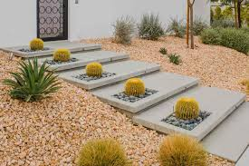

[[](https://www.thespruce.com/block-paving-materials-photo-gallery-4076497)](https://www.thespruce.com/block-paving-materials-photo-gallery-4076497" \o "Paving Materials Photo Gallery" \t "_blank)

[The Spruce](https://www.thespruce.com/block-paving-materials-photo-gallery-4076497" \o "Paving Materials Photo Gallery" \t "_blank)

[Paving Materials Photo Gallery](https://www.thespruce.com/block-paving-materials-photo-gallery-4076497" \o "Paving Materials Photo Gallery" \t "_blank)

**Pavers Soil Stock Photo - Download Image Now - 2015, Backgrounds, Cement - iStock**

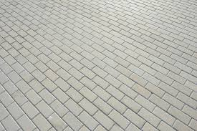

[[](https://www.istockphoto.com/photo/pavers-soil-gm477710886-66855327)](https://www.istockphoto.com/photo/pavers-soil-gm477710886-66855327" \o "Pavers Soil Stock Photo - Download Image Now - 2015, Backgrounds, Cement -  iStock" \t "_blank)

[iStock](https://www.istockphoto.com/photo/pavers-soil-gm477710886-66855327" \o "Pavers Soil Stock Photo - Download Image Now - 2015, Backgrounds, Cement -  iStock" \t "_blank)

[Pavers Soil Stock Photo - Download ...](https://www.istockphoto.com/photo/pavers-soil-gm477710886-66855327" \o "Pavers Soil Stock Photo - Download Image Now - 2015, Backgrounds, Cement -  iStock" \t "_blank)

**INTERLOCKING TILES ∕ PAVERS**

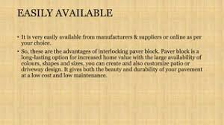

[[](https://www.slideshare.net/sanjeevsingh462/interlocking-tiles-pavers)](https://www.slideshare.net/sanjeevsingh462/interlocking-tiles-pavers" \o "INTERLOCKING TILES ∕ PAVERS" \t "_blank)

[SlideShare](https://www.slideshare.net/sanjeevsingh462/interlocking-tiles-pavers" \o "INTERLOCKING TILES ∕ PAVERS" \t "_blank)

[INTERLOCKING TILES ∕ PAVERS](https://www.slideshare.net/sanjeevsingh462/interlocking-tiles-pavers" \o "INTERLOCKING TILES ∕ PAVERS" \t "_blank)

**2,853 Interlocking Tiles Stock Photos and Images - 123RF**

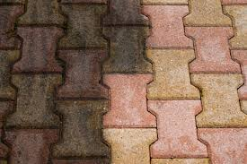

[[](https://www.123rf.com/stock-photo/interlocking_tiles.html)](https://www.123rf.com/stock-photo/interlocking_tiles.html" \o "2,853 Interlocking Tiles Stock Photos and Images - 123RF" \t "_blank)

[123RF](https://www.123rf.com/stock-photo/interlocking_tiles.html" \o "2,853 Interlocking Tiles Stock Photos and Images - 123RF" \t "_blank)

[2,853 Interlocking Tiles Stock Photos ...](https://www.123rf.com/stock-photo/interlocking_tiles.html" \o "2,853 Interlocking Tiles Stock Photos and Images - 123RF" \t "_blank)

**Interlocking pavers - Interlock**

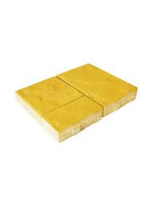

[[](https://store.artic.com.sa/interlock/interlocking-pavers.html)](https://store.artic.com.sa/interlock/interlocking-pavers.html" \o "Interlocking pavers - Interlock" \t "_blank)

[Artic Store](https://store.artic.com.sa/interlock/interlocking-pavers.html" \o "Interlocking pavers - Interlock" \t "_blank)

[Interlocking pavers - Interlock](https://store.artic.com.sa/interlock/interlocking-pavers.html" \o "Interlocking pavers - Interlock" \t "_blank)

**Top Interlocking Paver Tile Manufacturers in Ernakulam - इंटरलॉकिंग पावेर टाइल मनुफक्चरर्स, एर्नाकुलम - Justdial**

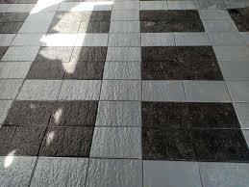

[[](https://www.justdial.com/Ernakulam/Interlocking-Paver-Tile-Manufacturers/nct-10951868)](https://www.justdial.com/Ernakulam/Interlocking-Paver-Tile-Manufacturers/nct-10951868" \o "Top Interlocking Paver Tile Manufacturers in Ernakulam - इंटरलॉकिंग पावेर  टाइल मनुफक्चरर्स, एर्नाकुलम - Justdial" \t "_blank)

[Justdial](https://www.justdial.com/Ernakulam/Interlocking-Paver-Tile-Manufacturers/nct-10951868" \o "Top Interlocking Paver Tile Manufacturers in Ernakulam - इंटरलॉकिंग पावेर  टाइल मनुफक्चरर्स, एर्नाकुलम - Justdial" \t "_blank)

[Interlocking Paver Tile Manufacturers ...](https://www.justdial.com/Ernakulam/Interlocking-Paver-Tile-Manufacturers/nct-10951868" \o "Top Interlocking Paver Tile Manufacturers in Ernakulam - इंटरलॉकिंग पावेर  टाइल मनुफक्चरर्स, एर्नाकुलम - Justdial" \t "_blank)

**Pavers India - Interlocking Pavers | Paver Block Manufacturers | Paver Blocks Price**

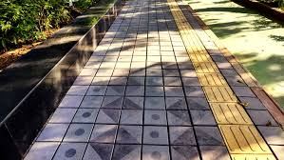

[[](https://www.paversindia.com/)](https://www.paversindia.com/" \o "Pavers India - Interlocking Pavers | Paver Block Manufacturers | Paver  Blocks Price" \t "_blank)

[www.paversindia.com](https://www.paversindia.com/" \o "Pavers India - Interlocking Pavers | Paver Block Manufacturers | Paver  Blocks Price" \t "_blank)

[Pavers India - Interlocking Pavers ...](https://www.paversindia.com/" \o "Pavers India - Interlocking Pavers | Paver Block Manufacturers | Paver  Blocks Price" \t "_blank)

**Jain Tiles Industries - Grass Pavers Color - Grey Brand - #JTI #grasspavers #grasspaver #paver #garden #park #parking #elevation #interlockingtiles # interlocking #pavers #interlockingpavers #jti #outdoor #parking #tiles #parkingtiles #exterior ...**

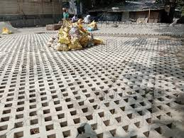

[[](https://m.facebook.com/Jaintilesindustries/photos/grass-paverscolor-greybrand-jtigrasspavers-grasspaver-paver-garden-park-parking-/4454505227922449/)](https://m.facebook.com/Jaintilesindustries/photos/grass-paverscolor-greybrand-jtigrasspavers-grasspaver-paver-garden-park-parking-/4454505227922449/" \o "Jain Tiles Industries - Grass Pavers Color - Grey Brand - #JTI #grasspavers  #grasspaver #paver #garden #park #parking #elevation #interlockingtiles # interlocking #pavers #interlockingpavers #jti #outdoor #parking #tiles  #parkingtiles #exterior ..." \t "_blank)

[Facebook](https://m.facebook.com/Jaintilesindustries/photos/grass-paverscolor-greybrand-jtigrasspavers-grasspaver-paver-garden-park-parking-/4454505227922449/" \o "Jain Tiles Industries - Grass Pavers Color - Grey Brand - #JTI #grasspavers  #grasspaver #paver #garden #park #parking #elevation #interlockingtiles # interlocking #pavers #interlockingpavers #jti #outdoor #parking #tiles  #parkingtiles #exterior ..." \t "_blank)

[Jain Tiles Industries - Grass Pavers ...](https://m.facebook.com/Jaintilesindustries/photos/grass-paverscolor-greybrand-jtigrasspavers-grasspaver-paver-garden-park-parking-/4454505227922449/" \o "Jain Tiles Industries - Grass Pavers Color - Grey Brand - #JTI #grasspavers  #grasspaver #paver #garden #park #parking #elevation #interlockingtiles # interlocking #pavers #interlockingpavers #jti #outdoor #parking #tiles  #parkingtiles #exterior ..." \t "_blank)

**Concrete Zigzag Interlocking Paver Tiles, for Flooring, Thickness: 80 mm at Rs 18/piece in Bhagalpur**

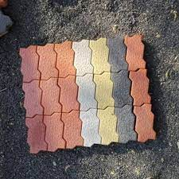

[[](https://www.indiamart.com/proddetail/zigzag-interlocking-paver-tiles-21625875355.html)](https://www.indiamart.com/proddetail/zigzag-interlocking-paver-tiles-21625875355.html" \o "Concrete Zigzag Interlocking Paver Tiles, for Flooring, Thickness: 80 mm at  Rs 18/piece in Bhagalpur" \t "_blank)

[IndiaMART](https://www.indiamart.com/proddetail/zigzag-interlocking-paver-tiles-21625875355.html" \o "Concrete Zigzag Interlocking Paver Tiles, for Flooring, Thickness: 80 mm at  Rs 18/piece in Bhagalpur" \t "_blank)

[Concrete Zigzag Interlocking Paver ...](https://www.indiamart.com/proddetail/zigzag-interlocking-paver-tiles-21625875355.html" \o "Concrete Zigzag Interlocking Paver Tiles, for Flooring, Thickness: 80 mm at  Rs 18/piece in Bhagalpur" \t "_blank)

**Precast Concrete Pavers - Tile Tech Pavers**

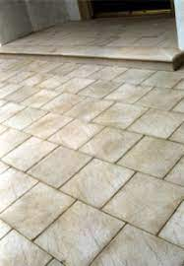

[[](https://tiletechpavers.com/resources/precast-concrete-pavers/)](https://tiletechpavers.com/resources/precast-concrete-pavers/" \o "Precast Concrete Pavers - Tile Tech Pavers" \t "_blank)

[Tile Tech Pavers](https://tiletechpavers.com/resources/precast-concrete-pavers/" \o "Precast Concrete Pavers - Tile Tech Pavers" \t "_blank)

[Precast Concrete Pavers - Tile Tech Pavers](https://tiletechpavers.com/resources/precast-concrete-pavers/" \o "Precast Concrete Pavers - Tile Tech Pavers" \t "_blank)

**Reyal Plastic Cosmic Paver Block Mould 60mm | DIY Paver Mould | for Outdoor Garden Road Paving Tiles : Amazon.in: Industrial & Scientific**

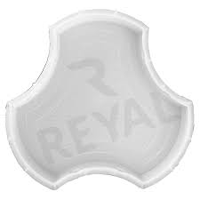

[[](https://www.amazon.in/Reyal-Plastic-Cosmic-Paver-Mould/dp/B094FQXX2W)](https://www.amazon.in/Reyal-Plastic-Cosmic-Paver-Mould/dp/B094FQXX2W" \o "Reyal Plastic Cosmic Paver Block Mould 60mm | DIY Paver Mould | for Outdoor  Garden Road Paving Tiles : Amazon.in: Industrial & Scientific" \t "_blank)

[Amazon.in](https://www.amazon.in/Reyal-Plastic-Cosmic-Paver-Mould/dp/B094FQXX2W" \o "Reyal Plastic Cosmic Paver Block Mould 60mm | DIY Paver Mould | for Outdoor  Garden Road Paving Tiles : Amazon.in: Industrial & Scientific" \t "_blank)

[Reyal Plastic Cosmic Paver Block Mould ...](https://www.amazon.in/Reyal-Plastic-Cosmic-Paver-Mould/dp/B094FQXX2W" \o "Reyal Plastic Cosmic Paver Block Mould 60mm | DIY Paver Mould | for Outdoor  Garden Road Paving Tiles : Amazon.in: Industrial & Scientific" \t "_blank)

**Interlocking Paver Block Latest Price from Manufacturers, Suppliers & Traders**

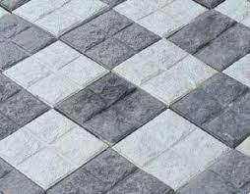

[[](https://www.exportersindia.com/indian-suppliers/interlocking-paver-block.htm)](https://www.exportersindia.com/indian-suppliers/interlocking-paver-block.htm" \o "Interlocking Paver Block Latest Price from Manufacturers, Suppliers &  Traders" \t "_blank)

[Exporters India](https://www.exportersindia.com/indian-suppliers/interlocking-paver-block.htm" \o "Interlocking Paver Block Latest Price from Manufacturers, Suppliers &  Traders" \t "_blank)

[Interlocking Paver Block Latest Price ...](https://www.exportersindia.com/indian-suppliers/interlocking-paver-block.htm" \o "Interlocking Paver Block Latest Price from Manufacturers, Suppliers &  Traders" \t "_blank)

**Interlocking Cobbled Stone Look Garden Pathway Tiles, Decorative Floor Grass Pavers Anti- Slip Mat, 5 pack - Gardenised**

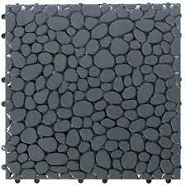

[[](https://gardenised.com/interlocking-cobbled-stone-look-garden-pathway-tiles-decorative-floor-grass-pavers-anti-slip-mat-5-pack/)](https://gardenised.com/interlocking-cobbled-stone-look-garden-pathway-tiles-decorative-floor-grass-pavers-anti-slip-mat-5-pack/" \o "Interlocking Cobbled Stone Look Garden Pathway Tiles, Decorative Floor  Grass Pavers Anti- Slip Mat, 5 pack - Gardenised" \t "_blank)

[Gardenised](https://gardenised.com/interlocking-cobbled-stone-look-garden-pathway-tiles-decorative-floor-grass-pavers-anti-slip-mat-5-pack/" \o "Interlocking Cobbled Stone Look Garden Pathway Tiles, Decorative Floor  Grass Pavers Anti- Slip Mat, 5 pack - Gardenised" \t "_blank)

[Interlocking Cobbled Stone Look Garden ...](https://gardenised.com/interlocking-cobbled-stone-look-garden-pathway-tiles-decorative-floor-grass-pavers-anti-slip-mat-5-pack/" \o "Interlocking Cobbled Stone Look Garden Pathway Tiles, Decorative Floor  Grass Pavers Anti- Slip Mat, 5 pack - Gardenised" \t "_blank)

**30pcs Deck Patio Tile Interlocking Flooring Pavers Tiles Indoor/Outdoor Balcony | eBay**

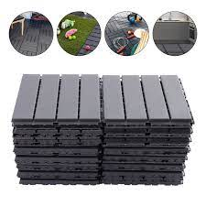

[[](https://www.ebay.com/itm/175400597857)](https://www.ebay.com/itm/175400597857" \o "30pcs Deck Patio Tile Interlocking Flooring Pavers Tiles Indoor/Outdoor  Balcony | eBay" \t "_blank)

[eBay](https://www.ebay.com/itm/175400597857" \o "30pcs Deck Patio Tile Interlocking Flooring Pavers Tiles Indoor/Outdoor  Balcony | eBay" \t "_blank)

[30pcs Deck Patio Tile Interlocking ...](https://www.ebay.com/itm/175400597857" \o "30pcs Deck Patio Tile Interlocking Flooring Pavers Tiles Indoor/Outdoor  Balcony | eBay" \t "_blank)

**Tiles in urban street decoration in Ljubljana, Slovenia Stock Photo - Alamy**

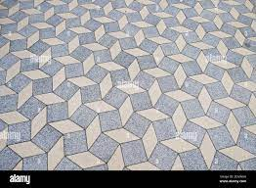

[[](https://www.alamy.com/tiles-in-urban-street-decoration-in-ljubljana-slovenia-image402400218.html)](https://www.alamy.com/tiles-in-urban-street-decoration-in-ljubljana-slovenia-image402400218.html" \o "Tiles in urban street decoration in Ljubljana, Slovenia Stock Photo - Alamy" \t "_blank)

[Alamy](https://www.alamy.com/tiles-in-urban-street-decoration-in-ljubljana-slovenia-image402400218.html" \o "Tiles in urban street decoration in Ljubljana, Slovenia Stock Photo - Alamy" \t "_blank)

[Tiles in urban street decoration in ...](https://www.alamy.com/tiles-in-urban-street-decoration-in-ljubljana-slovenia-image402400218.html" \o "Tiles in urban street decoration in Ljubljana, Slovenia Stock Photo - Alamy" \t "_blank)

**Riccobene Cobble Mat (Cobble Systems) 23.5-in L x 11.75-in W x 1-in H Charcoal Concrete Interlocking Patio Stone in the Pavers & Stepping Stones department at Lowes.com**

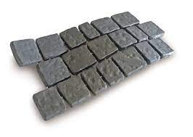

[[](https://www.lowes.com/pd/Riccobene-Cobble-Mat-Articulating-Paving-Mat-Charcoal-Dark-Gray-Concrete-Patio-Stone-Common-11-75-in-x-23-5-in-Actual-11-75-in-x-23-4-in/1001857592)](https://www.lowes.com/pd/Riccobene-Cobble-Mat-Articulating-Paving-Mat-Charcoal-Dark-Gray-Concrete-Patio-Stone-Common-11-75-in-x-23-5-in-Actual-11-75-in-x-23-4-in/1001857592" \o "Riccobene Cobble Mat (Cobble Systems) 23.5-in L x 11.75-in W x 1-in H  Charcoal Concrete Interlocking Patio Stone in the Pavers & Stepping Stones  department at Lowes.com" \t "_blank)

[Lowe's](https://www.lowes.com/pd/Riccobene-Cobble-Mat-Articulating-Paving-Mat-Charcoal-Dark-Gray-Concrete-Patio-Stone-Common-11-75-in-x-23-5-in-Actual-11-75-in-x-23-4-in/1001857592" \o "Riccobene Cobble Mat (Cobble Systems) 23.5-in L x 11.75-in W x 1-in H  Charcoal Concrete Interlocking Patio Stone in the Pavers & Stepping Stones  department at Lowes.com" \t "_blank)

[Riccobene Cobble Mat (Cobble Systems ...](https://www.lowes.com/pd/Riccobene-Cobble-Mat-Articulating-Paving-Mat-Charcoal-Dark-Gray-Concrete-Patio-Stone-Common-11-75-in-x-23-5-in-Actual-11-75-in-x-23-4-in/1001857592" \o "Riccobene Cobble Mat (Cobble Systems) 23.5-in L x 11.75-in W x 1-in H  Charcoal Concrete Interlocking Patio Stone in the Pavers & Stepping Stones  department at Lowes.com" \t "_blank)

**Plastic Paving Stone Forming Interlock Paver Tile Moulds - China Paver Molds and PVC Paver Mould**

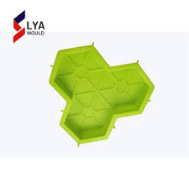

[[](https://zzlyags.en.made-in-china.com/product/SvBEOXKjkLrx/China-Plastic-Paving-Stone-Forming-Interlock-Paver-Tile-Moulds.html)](https://zzlyags.en.made-in-china.com/product/SvBEOXKjkLrx/China-Plastic-Paving-Stone-Forming-Interlock-Paver-Tile-Moulds.html" \o "Plastic Paving Stone Forming Interlock Paver Tile Moulds - China Paver  Molds and PVC Paver Mould" \t "_blank)

[ZHENGZHOU LYA MACHINERY CO., LTD.](https://zzlyags.en.made-in-china.com/product/SvBEOXKjkLrx/China-Plastic-Paving-Stone-Forming-Interlock-Paver-Tile-Moulds.html" \o "Plastic Paving Stone Forming Interlock Paver Tile Moulds - China Paver  Molds and PVC Paver Mould" \t "_blank)

[Interlock Paver Tile Moulds ...](https://zzlyags.en.made-in-china.com/product/SvBEOXKjkLrx/China-Plastic-Paving-Stone-Forming-Interlock-Paver-Tile-Moulds.html" \o "Plastic Paving Stone Forming Interlock Paver Tile Moulds - China Paver  Molds and PVC Paver Mould" \t "_blank)

**Gardenised Gray Plastic Garden Path Track Interlocking Stone Look Design Pathway Tile Floor Paver (Pack of 4) QI004108.4 - The Home Depot**

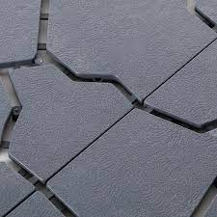

[[](https://www.homedepot.com/p/Gardenised-Gray-Plastic-Garden-Path-Track-Interlocking-Stone-Look-Design-Pathway-Tile-Floor-Paver-Pack-of-4-QI004108-4/317909834)](https://www.homedepot.com/p/Gardenised-Gray-Plastic-Garden-Path-Track-Interlocking-Stone-Look-Design-Pathway-Tile-Floor-Paver-Pack-of-4-QI004108-4/317909834" \o "Gardenised Gray Plastic Garden Path Track Interlocking Stone Look Design  Pathway Tile Floor Paver (Pack of 4) QI004108.4 - The Home Depot" \t "_blank)

[The Home Depot](https://www.homedepot.com/p/Gardenised-Gray-Plastic-Garden-Path-Track-Interlocking-Stone-Look-Design-Pathway-Tile-Floor-Paver-Pack-of-4-QI004108-4/317909834" \o "Gardenised Gray Plastic Garden Path Track Interlocking Stone Look Design  Pathway Tile Floor Paver (Pack of 4) QI004108.4 - The Home Depot" \t "_blank)

[Gardenised Gray Plastic Garden Path ...](https://www.homedepot.com/p/Gardenised-Gray-Plastic-Garden-Path-Track-Interlocking-Stone-Look-Design-Pathway-Tile-Floor-Paver-Pack-of-4-QI004108-4/317909834" \o "Gardenised Gray Plastic Garden Path Track Interlocking Stone Look Design  Pathway Tile Floor Paver (Pack of 4) QI004108.4 - The Home Depot" \t "_blank)

**Choose the Right Paving Tiles Designs - Charbhujatiles**

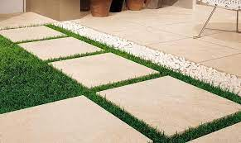

[[](https://charbhujatiles.com/blog-details/choose-the-right-paving-tiles-designs-with-these-useful-tips)](https://charbhujatiles.com/blog-details/choose-the-right-paving-tiles-designs-with-these-useful-tips" \o "Choose the Right Paving Tiles Designs - Charbhujatiles" \t "_blank)

[Charbhuja Tiles](https://charbhujatiles.com/blog-details/choose-the-right-paving-tiles-designs-with-these-useful-tips" \o "Choose the Right Paving Tiles Designs - Charbhujatiles" \t "_blank)

[Choose the Right Paving Tiles Designs ...](https://charbhujatiles.com/blog-details/choose-the-right-paving-tiles-designs-with-these-useful-tips" \o "Choose the Right Paving Tiles Designs - Charbhujatiles" \t "_blank)

**TKM Home 80Pcs 12" X 12" Acacia Wood Deck Tiles Interlocking Pavers Check Pattern**

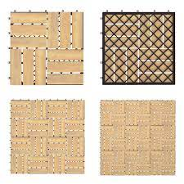

[[](https://www.sears.com/tkm-home-80pcs-12inch-x-12inch-acacia-wood/p-A114375269?sid=ISxMP3xSOxGGxDTxSURF)](https://www.sears.com/tkm-home-80pcs-12inch-x-12inch-acacia-wood/p-A114375269?sid=ISxMP3xSOxGGxDTxSURF" \o "TKM Home 80Pcs 12\" X 12\" Acacia Wood Deck Tiles Interlocking Pavers Check  Pattern" \t "_blank)

[Sears](https://www.sears.com/tkm-home-80pcs-12inch-x-12inch-acacia-wood/p-A114375269?sid=ISxMP3xSOxGGxDTxSURF" \o "TKM Home 80Pcs 12\" X 12\" Acacia Wood Deck Tiles Interlocking Pavers Check  Pattern" \t "_blank)

[TKM Home 80Pcs 12" X 12" Acacia Wood ...](https://www.sears.com/tkm-home-80pcs-12inch-x-12inch-acacia-wood/p-A114375269?sid=ISxMP3xSOxGGxDTxSURF" \o "TKM Home 80Pcs 12\" X 12\" Acacia Wood Deck Tiles Interlocking Pavers Check  Pattern" \t "_blank)

**Red Cosmic Interlocking Paver Block at Best Price in Ahmedabad | Ghanshyam Tiles**

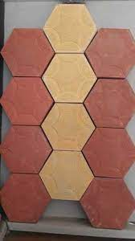

[[](https://www.tradeindia.com/products/cosmic-interlocking-paver-block-6121132.html)](https://www.tradeindia.com/products/cosmic-interlocking-paver-block-6121132.html" \o "Red Cosmic Interlocking Paver Block at Best Price in Ahmedabad | Ghanshyam  Tiles" \t "_blank)

[TradeIndia](https://www.tradeindia.com/products/cosmic-interlocking-paver-block-6121132.html" \o "Red Cosmic Interlocking Paver Block at Best Price in Ahmedabad | Ghanshyam  Tiles" \t "_blank)

[Red Cosmic Interlocking Paver Block at ...](https://www.tradeindia.com/products/cosmic-interlocking-paver-block-6121132.html" \o "Red Cosmic Interlocking Paver Block at Best Price in Ahmedabad | Ghanshyam  Tiles" \t "_blank)

**Premium Photo | Colored paving slab with a beautiful highquality texture close up**

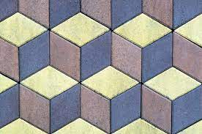

[[](https://www.freepik.com/premium-photo/colored-paving-slab-with-beautiful-highquality-texture-close-up_33003557.htm)](https://www.freepik.com/premium-photo/colored-paving-slab-with-beautiful-highquality-texture-close-up_33003557.htm" \o "Premium Photo | Colored paving slab with a beautiful highquality texture  close up" \t "_blank)

[Freepik](https://www.freepik.com/premium-photo/colored-paving-slab-with-beautiful-highquality-texture-close-up_33003557.htm" \o "Premium Photo | Colored paving slab with a beautiful highquality texture  close up" \t "_blank)

[Premium Photo | Colored paving slab ...](https://www.freepik.com/premium-photo/colored-paving-slab-with-beautiful-highquality-texture-close-up_33003557.htm" \o "Premium Photo | Colored paving slab with a beautiful highquality texture  close up" \t "_blank)

**2,304 Interlocked Floor Concrete Images, Stock Photos & Vectors | Shutterstock**

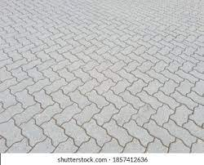

[[](https://www.shutterstock.com/search/interlocked-floor-concrete)](https://www.shutterstock.com/search/interlocked-floor-concrete" \o "2,304 Interlocked Floor Concrete Images, Stock Photos & Vectors |  Shutterstock" \t "_blank)

[Shutterstock](https://www.shutterstock.com/search/interlocked-floor-concrete" \o "2,304 Interlocked Floor Concrete Images, Stock Photos & Vectors |  Shutterstock" \t "_blank)

[2,304 Interlocked Floor Concrete Images ...](https://www.shutterstock.com/search/interlocked-floor-concrete" \o "2,304 Interlocked Floor Concrete Images, Stock Photos & Vectors |  Shutterstock" \t "_blank)

**A variety of designs and patterns with attractive color combinations for your paving desires. JR Rubber Industries Thada… | Paving design, Tile design, Paver tiles**

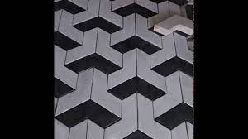

[[](https://www.pinterest.com/pin/a-variety-of-designs-and-patterns-with-attractive-color-combinations-for-your-paving-desires-jr-rubber-industries-thada--723531496359818607/)](https://www.pinterest.com/pin/a-variety-of-designs-and-patterns-with-attractive-color-combinations-for-your-paving-desires-jr-rubber-industries-thada--723531496359818607/" \o "A variety of designs and patterns with attractive color combinations for  your paving desires. JR Rubber Industries Thada… | Paving design, Tile  design, Paver tiles" \t "_blank)

[Pinterest](https://www.pinterest.com/pin/a-variety-of-designs-and-patterns-with-attractive-color-combinations-for-your-paving-desires-jr-rubber-industries-thada--723531496359818607/" \o "A variety of designs and patterns with attractive color combinations for  your paving desires. JR Rubber Industries Thada… | Paving design, Tile  design, Paver tiles" \t "_blank)

[Paving design, Tile design, Paver tiles](https://www.pinterest.com/pin/a-variety-of-designs-and-patterns-with-attractive-color-combinations-for-your-paving-desires-jr-rubber-industries-thada--723531496359818607/" \o "A variety of designs and patterns with attractive color combinations for  your paving desires. JR Rubber Industries Thada… | Paving design, Tile  design, Paver tiles" \t "_blank)

Related searches

[[](https://www.google.com/search?q=interlock%20design%20patterns&tbm=isch&hl=en&bih=722&biw=1519&rlz=1C1YTUH_enIN1004IN1004&sa=X&ved=0CCUQrNwCKABqFwoTCMDX8LTBkv0CFQAAAAAdAAAAABAE)](https://www.google.com/search?q=interlock%20design%20patterns&tbm=isch&hl=en&bih=722&biw=1519&rlz=1C1YTUH_enIN1004IN1004&sa=X&ved=0CCUQrNwCKABqFwoTCMDX8LTBkv0CFQAAAAAdAAAAABAE)

[interlock design patterns](https://www.google.com/search?q=interlock%20design%20patterns&tbm=isch&hl=en&bih=722&biw=1519&rlz=1C1YTUH_enIN1004IN1004&sa=X&ved=0CCUQrNwCKABqFwoTCMDX8LTBkv0CFQAAAAAdAAAAABAE)

[[](https://www.google.com/search?q=modern%20interlock%20designs&tbm=isch&hl=en&bih=722&biw=1519&rlz=1C1YTUH_enIN1004IN1004&sa=X&ved=0CCcQrNwCKAFqFwoTCMDX8LTBkv0CFQAAAAAdAAAAABAE)](https://www.google.com/search?q=modern%20interlock%20designs&tbm=isch&hl=en&bih=722&biw=1519&rlz=1C1YTUH_enIN1004IN1004&sa=X&ved=0CCcQrNwCKAFqFwoTCMDX8LTBkv0CFQAAAAAdAAAAABAE)

[modern interlock designs](https://www.google.com/search?q=modern%20interlock%20designs&tbm=isch&hl=en&bih=722&biw=1519&rlz=1C1YTUH_enIN1004IN1004&sa=X&ved=0CCcQrNwCKAFqFwoTCMDX8LTBkv0CFQAAAAAdAAAAABAE)

[[](https://www.google.com/search?q=outdoor%20paver%20tiles&tbm=isch&hl=en&bih=722&biw=1519&rlz=1C1YTUH_enIN1004IN1004&sa=X&ved=0CCkQrNwCKAJqFwoTCMDX8LTBkv0CFQAAAAAdAAAAABAE)](https://www.google.com/search?q=outdoor%20paver%20tiles&tbm=isch&hl=en&bih=722&biw=1519&rlz=1C1YTUH_enIN1004IN1004&sa=X&ved=0CCkQrNwCKAJqFwoTCMDX8LTBkv0CFQAAAAAdAAAAABAE)

**[outdoor paver](https://www.google.com/search?q=outdoor%20paver%20tiles&tbm=isch&hl=en&bih=722&biw=1519&rlz=1C1YTUH_enIN1004IN1004&sa=X&ved=0CCkQrNwCKAJqFwoTCMDX8LTBkv0CFQAAAAAdAAAAABAE)**[tiles](https://www.google.com/search?q=outdoor%20paver%20tiles&tbm=isch&hl=en&bih=722&biw=1519&rlz=1C1YTUH_enIN1004IN1004&sa=X&ved=0CCkQrNwCKAJqFwoTCMDX8LTBkv0CFQAAAAAdAAAAABAE)

**Automatic Interlocking Paving Kerb Stone Hydraulic Fly Ash Cement Concrete Block Moulding Machine Of Ground Tile - Buy Concrete Block Moulding Machine Of Ground Tile / Hollow Block Machine For Sale,Interlocking Blocks**

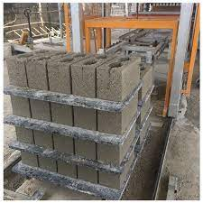

[[](https://www.alibaba.com/product-detail/Automatic-interlocking-paving-kerb-stone-hydraulic_62316756619.html)](https://www.alibaba.com/product-detail/Automatic-interlocking-paving-kerb-stone-hydraulic_62316756619.html" \o "Automatic Interlocking Paving Kerb Stone Hydraulic Fly Ash Cement Concrete  Block Moulding Machine Of Ground Tile - Buy Concrete Block Moulding Machine  Of Ground Tile / Hollow Block Machine For Sale,Interlocking Blocks" \t "_blank)

[Alibaba.com](https://www.alibaba.com/product-detail/Automatic-interlocking-paving-kerb-stone-hydraulic_62316756619.html" \o "Automatic Interlocking Paving Kerb Stone Hydraulic Fly Ash Cement Concrete  Block Moulding Machine Of Ground Tile - Buy Concrete Block Moulding Machine  Of Ground Tile / Hollow Block Machine For Sale,Interlocking Blocks" \t "_blank)

[Buy Concrete Block Moulding Machine Of ...](https://www.alibaba.com/product-detail/Automatic-interlocking-paving-kerb-stone-hydraulic_62316756619.html" \o "Automatic Interlocking Paving Kerb Stone Hydraulic Fly Ash Cement Concrete  Block Moulding Machine Of Ground Tile - Buy Concrete Block Moulding Machine  Of Ground Tile / Hollow Block Machine For Sale,Interlocking Blocks" \t "_blank)

**Interlocking Stone Deck Tiles 12''x12''Pebble Tiles(Pack of 4)PURE ERA - PURE ERA**

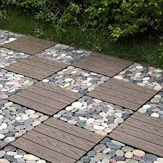

[[](https://www.pure-era.com/products/stone-deck-tiles-sliced-mixed-color)](https://www.pure-era.com/products/stone-deck-tiles-sliced-mixed-color" \o "Interlocking Stone Deck Tiles 12''x12''Pebble Tiles(Pack of 4)PURE ERA -  PURE ERA" \t "_blank)

[PURE ERA](https://www.pure-era.com/products/stone-deck-tiles-sliced-mixed-color" \o "Interlocking Stone Deck Tiles 12''x12''Pebble Tiles(Pack of 4)PURE ERA -  PURE ERA" \t "_blank)

[Interlocking Stone Deck Tiles 12''x12 ...](https://www.pure-era.com/products/stone-deck-tiles-sliced-mixed-color" \o "Interlocking Stone Deck Tiles 12''x12''Pebble Tiles(Pack of 4)PURE ERA -  PURE ERA" \t "_blank)

**Gold Yellow Swimming Pool Coping Pavers,Golden Beige Quartzite Pool Deck Pavers,More Yellow Less Grey Interlocking Patio Pavers,Beige Color Pool Pavers Tiles from China - StoneContact.com**

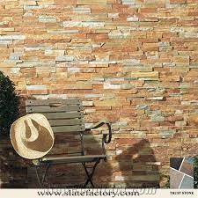

[[](https://www.stonecontact.com/products-193480/gold-yellow-swimming-pool-coping-pavers)](https://www.stonecontact.com/products-193480/gold-yellow-swimming-pool-coping-pavers" \o "Gold Yellow Swimming Pool Coping Pavers,Golden Beige Quartzite Pool Deck  Pavers,More Yellow Less Grey Interlocking Patio Pavers,Beige Color Pool Pavers  Tiles from China - StoneContact.com" \t "_blank)

[StoneContact.com](https://www.stonecontact.com/products-193480/gold-yellow-swimming-pool-coping-pavers" \o "Gold Yellow Swimming Pool Coping Pavers,Golden Beige Quartzite Pool Deck  Pavers,More Yellow Less Grey Interlocking Patio Pavers,Beige Color Pool Pavers  Tiles from China - StoneContact.com" \t "_blank)

[Gold Yellow Swimming Pool Coping Pavers ...](https://www.stonecontact.com/products-193480/gold-yellow-swimming-pool-coping-pavers" \o "Gold Yellow Swimming Pool Coping Pavers,Golden Beige Quartzite Pool Deck  Pavers,More Yellow Less Grey Interlocking Patio Pavers,Beige Color Pool Pavers  Tiles from China - StoneContact.com" \t "_blank)

**Nature Spring Interlocking Diamond Pattern Outdoor Flooring Patio And Deck Tiles – Gray, Set Of 6 : Target**

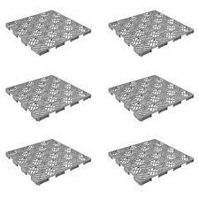

[[](https://www.target.com/p/nature-spring-interlocking-diamond-pattern-outdoor-flooring-patio-and-deck-tiles-gray-set-of-6/-/A-84305434)](https://www.target.com/p/nature-spring-interlocking-diamond-pattern-outdoor-flooring-patio-and-deck-tiles-gray-set-of-6/-/A-84305434" \o "Nature Spring Interlocking Diamond Pattern Outdoor Flooring Patio And Deck  Tiles – Gray, Set Of 6 : Target" \t "_blank)

[Target](https://www.target.com/p/nature-spring-interlocking-diamond-pattern-outdoor-flooring-patio-and-deck-tiles-gray-set-of-6/-/A-84305434" \o "Nature Spring Interlocking Diamond Pattern Outdoor Flooring Patio And Deck  Tiles – Gray, Set Of 6 : Target" \t "_blank)

[Deck Tiles – Gray ...](https://www.target.com/p/nature-spring-interlocking-diamond-pattern-outdoor-flooring-patio-and-deck-tiles-gray-set-of-6/-/A-84305434" \o "Nature Spring Interlocking Diamond Pattern Outdoor Flooring Patio And Deck  Tiles – Gray, Set Of 6 : Target" \t "_blank)

**Interlock Tiles Price & Design Thrissur, Kerala - Terracon Tiles**

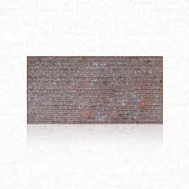

[[](http://www.terracontilesindia.com/paving-tiles-thrissur-kerala/)](http://www.terracontilesindia.com/paving-tiles-thrissur-kerala/" \o "Interlock Tiles Price & Design Thrissur, Kerala - Terracon Tiles" \t "_blank)

[Terracon Tiles](http://www.terracontilesindia.com/paving-tiles-thrissur-kerala/" \o "Interlock Tiles Price & Design Thrissur, Kerala - Terracon Tiles" \t "_blank)

[Interlock Tiles Price & Design Thrissur ...](http://www.terracontilesindia.com/paving-tiles-thrissur-kerala/" \o "Interlock Tiles Price & Design Thrissur, Kerala - Terracon Tiles" \t "_blank)

**Rubik Polypropylene Plastic Outdoor Floor Decking and Patio Interlocking Tile Flooring Pavers Composite Decking- Pack of 9 Tiles (Dark Grey) price in UAE | Amazon UAE | kanbkam**

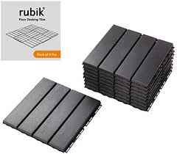

[[](https://www.kanbkam.com/ae/en/rubik-polypropylene-plastic-outdoor-floor-decking-and-patio-interlocking-tile-flooring-pavers-composite-decking-pack-of-9-tiles-dark-grey-B07RY1TLT2)](https://www.kanbkam.com/ae/en/rubik-polypropylene-plastic-outdoor-floor-decking-and-patio-interlocking-tile-flooring-pavers-composite-decking-pack-of-9-tiles-dark-grey-B07RY1TLT2" \o "Rubik Polypropylene Plastic Outdoor Floor Decking and Patio Interlocking  Tile Flooring Pavers Composite Decking- Pack of 9 Tiles (Dark Grey) price  in UAE | Amazon UAE | kanbkam" \t "_blank)

[Kanbkam UAE](https://www.kanbkam.com/ae/en/rubik-polypropylene-plastic-outdoor-floor-decking-and-patio-interlocking-tile-flooring-pavers-composite-decking-pack-of-9-tiles-dark-grey-B07RY1TLT2" \o "Rubik Polypropylene Plastic Outdoor Floor Decking and Patio Interlocking  Tile Flooring Pavers Composite Decking- Pack of 9 Tiles (Dark Grey) price  in UAE | Amazon UAE | kanbkam" \t "_blank)

[Rubik Polypropylene Plastic Outdoor ...](https://www.kanbkam.com/ae/en/rubik-polypropylene-plastic-outdoor-floor-decking-and-patio-interlocking-tile-flooring-pavers-composite-decking-pack-of-9-tiles-dark-grey-B07RY1TLT2" \o "Rubik Polypropylene Plastic Outdoor Floor Decking and Patio Interlocking  Tile Flooring Pavers Composite Decking- Pack of 9 Tiles (Dark Grey) price  in UAE | Amazon UAE | kanbkam" \t "_blank)

**Interlocking pavers - Interlock**

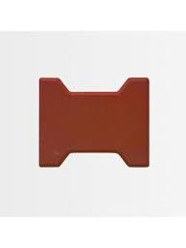

[[](https://store.artic.com.sa/interlock/interlocking-pavers.html)](https://store.artic.com.sa/interlock/interlocking-pavers.html" \o "Interlocking pavers - Interlock" \t "_blank)

[Artic Store](https://store.artic.com.sa/interlock/interlocking-pavers.html" \o "Interlocking pavers - Interlock" \t "_blank)

[Interlocking pavers - Interlock](https://store.artic.com.sa/interlock/interlocking-pavers.html" \o "Interlocking pavers - Interlock" \t "_blank)

**Interlocking Paver Blocks & RCC Tiles Manufacturer - YouTube**



[[](https://www.youtube.com/watch?v=bhiQmD8vFJs)](https://www.youtube.com/watch?v=bhiQmD8vFJs" \o "Interlocking Paver Blocks & RCC Tiles Manufacturer - YouTube" \t "_blank)

[YouTube](https://www.youtube.com/watch?v=bhiQmD8vFJs" \o "Interlocking Paver Blocks & RCC Tiles Manufacturer - YouTube" \t "_blank)

[Interlocking Paver Blocks & RCC Tiles ...](https://www.youtube.com/watch?v=bhiQmD8vFJs" \o "Interlocking Paver Blocks & RCC Tiles Manufacturer - YouTube" \t "_blank)

**Modern cement multi-colored paving slabs. The background of a beautiful pedestrian walkway from..., Stock Photo, Picture And Low Budget Royalty Free Image. Pic. ESY-056493900 | agefotostock**

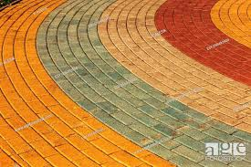

[[](https://www.agefotostock.com/age/en/details-photo/modern-cement-multi-colored-paving-slabs-the-background-of-a-beautiful-pedestrian-walkway-from-modern-fashionable-paving-tiles-as-a-staged-background-for-a/ESY-056493900)](https://www.agefotostock.com/age/en/details-photo/modern-cement-multi-colored-paving-slabs-the-background-of-a-beautiful-pedestrian-walkway-from-modern-fashionable-paving-tiles-as-a-staged-background-for-a/ESY-056493900" \o "Modern cement multi-colored paving slabs. The background of a beautiful  pedestrian walkway from..., Stock Photo, Picture And Low Budget Royalty  Free Image. Pic. ESY-056493900 | agefotostock" \t "_blank)

[agefotostock](https://www.agefotostock.com/age/en/details-photo/modern-cement-multi-colored-paving-slabs-the-background-of-a-beautiful-pedestrian-walkway-from-modern-fashionable-paving-tiles-as-a-staged-background-for-a/ESY-056493900" \o "Modern cement multi-colored paving slabs. The background of a beautiful  pedestrian walkway from..., Stock Photo, Picture And Low Budget Royalty  Free Image. Pic. ESY-056493900 | agefotostock" \t "_blank)

[Modern cement multi-colored paving ...](https://www.agefotostock.com/age/en/details-photo/modern-cement-multi-colored-paving-slabs-the-background-of-a-beautiful-pedestrian-walkway-from-modern-fashionable-paving-tiles-as-a-staged-background-for-a/ESY-056493900" \o "Modern cement multi-colored paving slabs. The background of a beautiful  pedestrian walkway from..., Stock Photo, Picture And Low Budget Royalty  Free Image. Pic. ESY-056493900 | agefotostock" \t "_blank)

**Driveway Interlocking Pavers Adelaide | Driveway Pavers Adelaide**

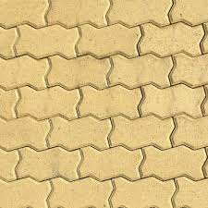

[[](https://australianpaving.com/product/driveway-interlocking-pavers/)](https://australianpaving.com/product/driveway-interlocking-pavers/" \o "Driveway Interlocking Pavers Adelaide | Driveway Pavers Adelaide" \t "_blank)

[Australian Paving Centre](https://australianpaving.com/product/driveway-interlocking-pavers/" \o "Driveway Interlocking Pavers Adelaide | Driveway Pavers Adelaide" \t "_blank)

[Driveway Interlocking Pavers Adelaide ...](https://australianpaving.com/product/driveway-interlocking-pavers/" \o "Driveway Interlocking Pavers Adelaide | Driveway Pavers Adelaide" \t "_blank)

**Rectangular Outdoor Interlocking Concrete Pavers (200x100x60)mm Grey Colour, For Pavement at Rs 500/sq mt in Gurgaon**

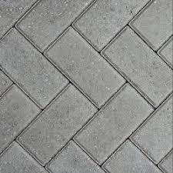

[[](https://www.indiamart.com/proddetail/interlocking-concrete-pavers-200x100x60-mm-grey-colour-23356539255.html)](https://www.indiamart.com/proddetail/interlocking-concrete-pavers-200x100x60-mm-grey-colour-23356539255.html" \o "Rectangular Outdoor Interlocking Concrete Pavers (200x100x60)mm Grey Colour,  For Pavement at Rs 500/sq mt in Gurgaon" \t "_blank)

[IndiaMART](https://www.indiamart.com/proddetail/interlocking-concrete-pavers-200x100x60-mm-grey-colour-23356539255.html" \o "Rectangular Outdoor Interlocking Concrete Pavers (200x100x60)mm Grey Colour,  For Pavement at Rs 500/sq mt in Gurgaon" \t "_blank)

[Rectangular Outdoor Interlocking ...](https://www.indiamart.com/proddetail/interlocking-concrete-pavers-200x100x60-mm-grey-colour-23356539255.html" \o "Rectangular Outdoor Interlocking Concrete Pavers (200x100x60)mm Grey Colour,  For Pavement at Rs 500/sq mt in Gurgaon" \t "_blank)

**551 Interlocking Paving Stone Stock Photos and Images - 123RF**

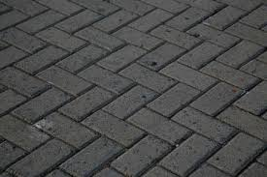

[[](https://www.123rf.com/stock-photo/interlocking_paving_stone.html)](https://www.123rf.com/stock-photo/interlocking_paving_stone.html" \o "551 Interlocking Paving Stone Stock Photos and Images - 123RF" \t "_blank)

[123RF](https://www.123rf.com/stock-photo/interlocking_paving_stone.html" \o "551 Interlocking Paving Stone Stock Photos and Images - 123RF" \t "_blank)

[551 Interlocking Paving Stone Stock ...](https://www.123rf.com/stock-photo/interlocking_paving_stone.html" \o "551 Interlocking Paving Stone Stock Photos and Images - 123RF" \t "_blank)

**INTERLOCKING TILES ∕ PAVERS**

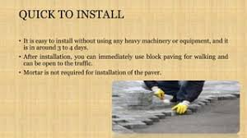

[[](https://www.slideshare.net/sanjeevsingh462/interlocking-tiles-pavers)](https://www.slideshare.net/sanjeevsingh462/interlocking-tiles-pavers" \o "INTERLOCKING TILES ∕ PAVERS" \t "_blank)

[SlideShare](https://www.slideshare.net/sanjeevsingh462/interlocking-tiles-pavers" \o "INTERLOCKING TILES ∕ PAVERS" \t "_blank)

[INTERLOCKING TILES ∕ PAVERS](https://www.slideshare.net/sanjeevsingh462/interlocking-tiles-pavers" \o "INTERLOCKING TILES ∕ PAVERS" \t "_blank)

**Concrete Paver Block And Tiles Making Process. | RED IRON OXIDE PIGMENT, INTERLOCKING TILE MAKING MACHINE, PAVER MOULD**

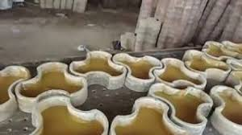

[[](https://srikrishnaplasto.com/interlocking-pvc-paver-mould/concrete-paver-block-and-tiles-making-process.html)](https://srikrishnaplasto.com/interlocking-pvc-paver-mould/concrete-paver-block-and-tiles-making-process.html" \o "Concrete Paver Block And Tiles Making Process. | RED IRON OXIDE PIGMENT, INTERLOCKING  TILE MAKING MACHINE, PAVER MOULD" \t "_blank)

[RED IRON OXIDE PIGMENT, INTERLOCKING TILE MAKING MACHINE, PAVER MOULD](https://srikrishnaplasto.com/interlocking-pvc-paver-mould/concrete-paver-block-and-tiles-making-process.html" \o "Concrete Paver Block And Tiles Making Process. | RED IRON OXIDE PIGMENT, INTERLOCKING  TILE MAKING MACHINE, PAVER MOULD" \t "_blank)

[Concrete Paver Block And Tiles Making ...](https://srikrishnaplasto.com/interlocking-pvc-paver-mould/concrete-paver-block-and-tiles-making-process.html" \o "Concrete Paver Block And Tiles Making Process. | RED IRON OXIDE PIGMENT, INTERLOCKING  TILE MAKING MACHINE, PAVER MOULD" \t "_blank)

**Reyal Mould and Concrete Spacers Tri-Hexa Paver Block Mould 60mm (Black PVC Rubber) | DIY Paver Mould | For Outdoor Garden Road Paving Tiles | Pathmaker Mould : Amazon.in: Industrial & Scientific**

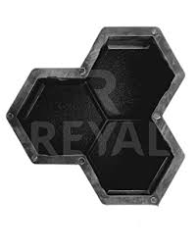

[[](https://www.amazon.in/Reyal-Rubber-Tri-Hexa-Paver-Mould/dp/B0979HD2LT)](https://www.amazon.in/Reyal-Rubber-Tri-Hexa-Paver-Mould/dp/B0979HD2LT" \o "Reyal Mould and Concrete Spacers Tri-Hexa Paver Block Mould 60mm (Black PVC  Rubber) | DIY Paver Mould | For Outdoor Garden Road Paving Tiles |  Pathmaker Mould : Amazon.in: Industrial & Scientific" \t "_blank)

[Amazon.in](https://www.amazon.in/Reyal-Rubber-Tri-Hexa-Paver-Mould/dp/B0979HD2LT" \o "Reyal Mould and Concrete Spacers Tri-Hexa Paver Block Mould 60mm (Black PVC  Rubber) | DIY Paver Mould | For Outdoor Garden Road Paving Tiles |  Pathmaker Mould : Amazon.in: Industrial & Scientific" \t "_blank)

[Tri-Hexa Paver Block Mould 60mm ...](https://www.amazon.in/Reyal-Rubber-Tri-Hexa-Paver-Mould/dp/B0979HD2LT" \o "Reyal Mould and Concrete Spacers Tri-Hexa Paver Block Mould 60mm (Black PVC  Rubber) | DIY Paver Mould | For Outdoor Garden Road Paving Tiles |  Pathmaker Mould : Amazon.in: Industrial & Scientific" \t "_blank)

**Chequered Tiles | Interlocking Tiles | Paver Tiles - Pavers India**

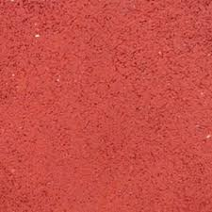

[[](https://www.paversindia.com/product/landscaping-tiles)](https://www.paversindia.com/product/landscaping-tiles" \o "Chequered Tiles | Interlocking Tiles | Paver Tiles - Pavers India" \t "_blank)

[Pavers India](https://www.paversindia.com/product/landscaping-tiles" \o "Chequered Tiles | Interlocking Tiles | Paver Tiles - Pavers India" \t "_blank)

[Chequered Tiles | Interlocking Tiles ...](https://www.paversindia.com/product/landscaping-tiles" \o "Chequered Tiles | Interlocking Tiles | Paver Tiles - Pavers India" \t "_blank)

**Rsd - Manufacturer of Interlocking Paver & Chequered Tiles - MILANO INTERLOCKING PAVER COLOR - YELLOW (60 MM) | Facebook**

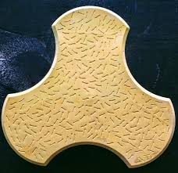

[[](https://m.facebook.com/rsdmipct/photos/a.735791319930720/782084651968053/?type=3)](https://m.facebook.com/rsdmipct/photos/a.735791319930720/782084651968053/?type=3" \o "Rsd - Manufacturer of Interlocking Paver & Chequered Tiles - MILANO INTERLOCKING  PAVER COLOR - YELLOW (60 MM) | Facebook" \t "_blank)

[Facebook](https://m.facebook.com/rsdmipct/photos/a.735791319930720/782084651968053/?type=3" \o "Rsd - Manufacturer of Interlocking Paver & Chequered Tiles - MILANO INTERLOCKING  PAVER COLOR - YELLOW (60 MM) | Facebook" \t "_blank)

[MILANO INTERLOCKING PAVER COLOR ...](https://m.facebook.com/rsdmipct/photos/a.735791319930720/782084651968053/?type=3" \o "Rsd - Manufacturer of Interlocking Paver & Chequered Tiles - MILANO INTERLOCKING  PAVER COLOR - YELLOW (60 MM) | Facebook" \t "_blank)

**Zig Zag Tiles Latest Price from Manufacturers, Suppliers & Traders**

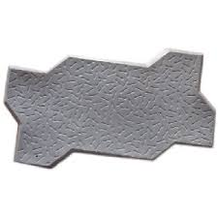

[[](https://www.exportersindia.com/indian-suppliers/zig-zag-tiles.htm)](https://www.exportersindia.com/indian-suppliers/zig-zag-tiles.htm" \o "Zig Zag Tiles Latest Price from Manufacturers, Suppliers & Traders" \t "_blank)

[Exporters India](https://www.exportersindia.com/indian-suppliers/zig-zag-tiles.htm" \o "Zig Zag Tiles Latest Price from Manufacturers, Suppliers & Traders" \t "_blank)

[Zig Zag Tiles Latest Price from ...](https://www.exportersindia.com/indian-suppliers/zig-zag-tiles.htm" \o "Zig Zag Tiles Latest Price from Manufacturers, Suppliers & Traders" \t "_blank)

**Interlocking Paver Block in Vikas-Nagar at best price by A C Tiles - Justdial**

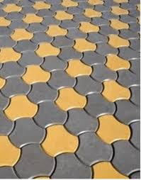

[[](https://www.justdial.com/jdmart/Vikas-Nagar/Interlocking-Paver-Block/pid-2027559153/9999PX135-X135-190507112430-A2U7)](https://www.justdial.com/jdmart/Vikas-Nagar/Interlocking-Paver-Block/pid-2027559153/9999PX135-X135-190507112430-A2U7" \o "Interlocking Paver Block in Vikas-Nagar at best price by A C Tiles -  Justdial" \t "_blank)

[Justdial](https://www.justdial.com/jdmart/Vikas-Nagar/Interlocking-Paver-Block/pid-2027559153/9999PX135-X135-190507112430-A2U7" \o "Interlocking Paver Block in Vikas-Nagar at best price by A C Tiles -  Justdial" \t "_blank)

[Interlocking Paver Block in Vikas-Nagar ...](https://www.justdial.com/jdmart/Vikas-Nagar/Interlocking-Paver-Block/pid-2027559153/9999PX135-X135-190507112430-A2U7" \o "Interlocking Paver Block in Vikas-Nagar at best price by A C Tiles -  Justdial" \t "_blank)

**Villa Acacia Wood Tiles, Outdoor Patio and Deck Interlocking Pavers - 12 x 12 Inch, Pack of 10, 6 Slat in Oman | Whizz Materials**

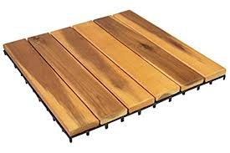

[[](https://oman.whizzcart.com/product/3806813/villa-acacia-wood-tiles-outdoor-patio-and-deck-interlocking-pavers-12-x-12-inch-pack-of-10-6-slat/)](https://oman.whizzcart.com/product/3806813/villa-acacia-wood-tiles-outdoor-patio-and-deck-interlocking-pavers-12-x-12-inch-pack-of-10-6-slat/" \o "Villa Acacia Wood Tiles, Outdoor Patio and Deck Interlocking Pavers - 12 x  12 Inch, Pack of 10, 6 Slat in Oman | Whizz Materials" \t "_blank)

[Whizzcart.com](https://oman.whizzcart.com/product/3806813/villa-acacia-wood-tiles-outdoor-patio-and-deck-interlocking-pavers-12-x-12-inch-pack-of-10-6-slat/" \o "Villa Acacia Wood Tiles, Outdoor Patio and Deck Interlocking Pavers - 12 x  12 Inch, Pack of 10, 6 Slat in Oman | Whizz Materials" \t "_blank)

[Villa Acacia Wood Tiles, Outdoor Patio ...](https://oman.whizzcart.com/product/3806813/villa-acacia-wood-tiles-outdoor-patio-and-deck-interlocking-pavers-12-x-12-inch-pack-of-10-6-slat/" \o "Villa Acacia Wood Tiles, Outdoor Patio and Deck Interlocking Pavers - 12 x  12 Inch, Pack of 10, 6 Slat in Oman | Whizz Materials" \t "_blank)

**12x12&#039;&#039; Deck Tiles Interlocking Patio Acacia Wood Flooring Pavers Tiles Outdoor | eBay**

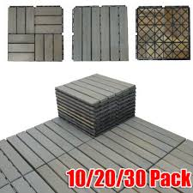

[[](https://www.ebay.com/itm/403906428538)](https://www.ebay.com/itm/403906428538" \o "12x12&#039;&#039; Deck Tiles Interlocking Patio Acacia Wood Flooring Pavers  Tiles Outdoor | eBay" \t "_blank)

[eBay](https://www.ebay.com/itm/403906428538" \o "12x12&#039;&#039; Deck Tiles Interlocking Patio Acacia Wood Flooring Pavers  Tiles Outdoor | eBay" \t "_blank)

[Deck Tiles Interlocking Patio Acacia ...](https://www.ebay.com/itm/403906428538" \o "12x12&#039;&#039; Deck Tiles Interlocking Patio Acacia Wood Flooring Pavers  Tiles Outdoor | eBay" \t "_blank)

**High Precision Interlocking Paver Plastic Moulds for Garden - China Paver Stone Mold and Molds for Pavers Tiles**

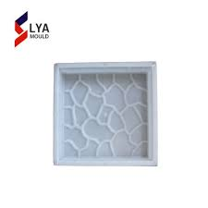

[[](https://zzlyags.en.made-in-china.com/product/UvXmpSjuXzre/China-High-Precision-Interlocking-Paver-Plastic-Moulds-for-Garden.html)](https://zzlyags.en.made-in-china.com/product/UvXmpSjuXzre/China-High-Precision-Interlocking-Paver-Plastic-Moulds-for-Garden.html" \o "High Precision Interlocking Paver Plastic Moulds for Garden - China Paver  Stone Mold and Molds for Pavers Tiles" \t "_blank)

[ZHENGZHOU LYA MACHINERY CO., LTD.](https://zzlyags.en.made-in-china.com/product/UvXmpSjuXzre/China-High-Precision-Interlocking-Paver-Plastic-Moulds-for-Garden.html" \o "High Precision Interlocking Paver Plastic Moulds for Garden - China Paver  Stone Mold and Molds for Pavers Tiles" \t "_blank)

[Paver Stone Mold and Molds for Pavers Tiles](https://zzlyags.en.made-in-china.com/product/UvXmpSjuXzre/China-High-Precision-Interlocking-Paver-Plastic-Moulds-for-Garden.html" \o "High Precision Interlocking Paver Plastic Moulds for Garden - China Paver  Stone Mold and Molds for Pavers Tiles" \t "_blank)

**Close up of soft rubber tiles for covering at outdoor gym of stadium at preschool yard Stock Photo - Alamy**

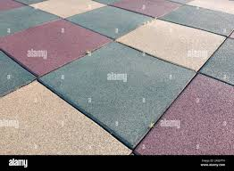

[[](https://www.alamy.com/close-up-of-soft-rubber-tiles-for-covering-at-outdoor-gym-of-stadium-at-preschool-yard-image332239505.html)](https://www.alamy.com/close-up-of-soft-rubber-tiles-for-covering-at-outdoor-gym-of-stadium-at-preschool-yard-image332239505.html" \o "Close up of soft rubber tiles for covering at outdoor gym of stadium at  preschool yard Stock Photo - Alamy" \t "_blank)

[Alamy](https://www.alamy.com/close-up-of-soft-rubber-tiles-for-covering-at-outdoor-gym-of-stadium-at-preschool-yard-image332239505.html" \o "Close up of soft rubber tiles for covering at outdoor gym of stadium at  preschool yard Stock Photo - Alamy" \t "_blank)

[Close up of soft rubber tiles for ...](https://www.alamy.com/close-up-of-soft-rubber-tiles-for-covering-at-outdoor-gym-of-stadium-at-preschool-yard-image332239505.html" \o "Close up of soft rubber tiles for covering at outdoor gym of stadium at  preschool yard Stock Photo - Alamy" \t "_blank)

**Patterned Paving Tiles Cement Brick Floor Background Stock Photo - Download Image Now - iStock**

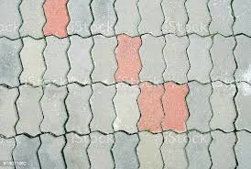

[[](https://www.istockphoto.com/photo/patterned-paving-tiles-cement-brick-floor-background-gm618858104-107807155)](https://www.istockphoto.com/photo/patterned-paving-tiles-cement-brick-floor-background-gm618858104-107807155" \o "Patterned Paving Tiles Cement Brick Floor Background Stock Photo - Download  Image Now - iStock" \t "_blank)

[iStock](https://www.istockphoto.com/photo/patterned-paving-tiles-cement-brick-floor-background-gm618858104-107807155" \o "Patterned Paving Tiles Cement Brick Floor Background Stock Photo - Download  Image Now - iStock" \t "_blank)

[Patterned Paving Tiles Cement Brick ...](https://www.istockphoto.com/photo/patterned-paving-tiles-cement-brick-floor-background-gm618858104-107807155" \o "Patterned Paving Tiles Cement Brick Floor Background Stock Photo - Download  Image Now - iStock" \t "_blank)

Related searches

[[](https://www.google.com/search?q=interlock%20tiles%20design%20in%20punjab&tbm=isch&hl=en&bih=722&biw=1519&rlz=1C1YTUH_enIN1004IN1004&sa=X&ved=0CGQQrNwCKABqFwoTCMDX8LTBkv0CFQAAAAAdAAAAABAE)](https://www.google.com/search?q=interlock%20tiles%20design%20in%20punjab&tbm=isch&hl=en&bih=722&biw=1519&rlz=1C1YTUH_enIN1004IN1004&sa=X&ved=0CGQQrNwCKABqFwoTCMDX8LTBkv0CFQAAAAAdAAAAABAE)

**[interlock](https://www.google.com/search?q=interlock%20tiles%20design%20in%20punjab&tbm=isch&hl=en&bih=722&biw=1519&rlz=1C1YTUH_enIN1004IN1004&sa=X&ved=0CGQQrNwCKABqFwoTCMDX8LTBkv0CFQAAAAAdAAAAABAE)**[tiles](https://www.google.com/search?q=interlock%20tiles%20design%20in%20punjab&tbm=isch&hl=en&bih=722&biw=1519&rlz=1C1YTUH_enIN1004IN1004&sa=X&ved=0CGQQrNwCKABqFwoTCMDX8LTBkv0CFQAAAAAdAAAAABAE)**[design in punjab](https://www.google.com/search?q=interlock%20tiles%20design%20in%20punjab&tbm=isch&hl=en&bih=722&biw=1519&rlz=1C1YTUH_enIN1004IN1004&sa=X&ved=0CGQQrNwCKABqFwoTCMDX8LTBkv0CFQAAAAAdAAAAABAE)**

[[](https://www.google.com/search?q=house%20interlock%20tiles&tbm=isch&hl=en&bih=722&biw=1519&rlz=1C1YTUH_enIN1004IN1004&sa=X&ved=0CGYQrNwCKAFqFwoTCMDX8LTBkv0CFQAAAAAdAAAAABAE)](https://www.google.com/search?q=house%20interlock%20tiles&tbm=isch&hl=en&bih=722&biw=1519&rlz=1C1YTUH_enIN1004IN1004&sa=X&ved=0CGYQrNwCKAFqFwoTCMDX8LTBkv0CFQAAAAAdAAAAABAE)

**[house interlock](https://www.google.com/search?q=house%20interlock%20tiles&tbm=isch&hl=en&bih=722&biw=1519&rlz=1C1YTUH_enIN1004IN1004&sa=X&ved=0CGYQrNwCKAFqFwoTCMDX8LTBkv0CFQAAAAAdAAAAABAE)**[tiles](https://www.google.com/search?q=house%20interlock%20tiles&tbm=isch&hl=en&bih=722&biw=1519&rlz=1C1YTUH_enIN1004IN1004&sa=X&ved=0CGYQrNwCKAFqFwoTCMDX8LTBkv0CFQAAAAAdAAAAABAE)

[[](https://www.google.com/search?q=garden%20paver%20block%20design&tbm=isch&hl=en&bih=722&biw=1519&rlz=1C1YTUH_enIN1004IN1004&sa=X&ved=0CGgQrNwCKAJqFwoTCMDX8LTBkv0CFQAAAAAdAAAAABAE)](https://www.google.com/search?q=garden%20paver%20block%20design&tbm=isch&hl=en&bih=722&biw=1519&rlz=1C1YTUH_enIN1004IN1004&sa=X&ved=0CGgQrNwCKAJqFwoTCMDX8LTBkv0CFQAAAAAdAAAAABAE)

[garden paver block design](https://www.google.com/search?q=garden%20paver%20block%20design&tbm=isch&hl=en&bih=722&biw=1519&rlz=1C1YTUH_enIN1004IN1004&sa=X&ved=0CGgQrNwCKAJqFwoTCMDX8LTBkv0CFQAAAAAdAAAAABAE)

**Rubber Dog Bone Tile Red 200x160x43mm - Duncan Equine Australia**

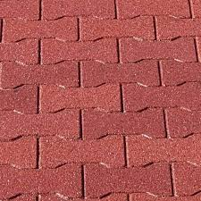

[[](https://duncanequine.com.au/product/rubber-dog-bone-tile/)](https://duncanequine.com.au/product/rubber-dog-bone-tile/" \o "Rubber Dog Bone Tile Red 200x160x43mm - Duncan Equine Australia" \t "_blank)

[Duncan Equine](https://duncanequine.com.au/product/rubber-dog-bone-tile/" \o "Rubber Dog Bone Tile Red 200x160x43mm - Duncan Equine Australia" \t "_blank)

[Rubber Dog Bone Tile Red 200x160x43mm ...](https://duncanequine.com.au/product/rubber-dog-bone-tile/" \o "Rubber Dog Bone Tile Red 200x160x43mm - Duncan Equine Australia" \t "_blank)

**Premium Photo | Paving from stone figured tiles. top view.**

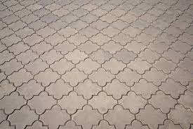

[[](https://www.freepik.com/premium-photo/paving-from-stone-figured-tiles-top-view_5122072.htm)](https://www.freepik.com/premium-photo/paving-from-stone-figured-tiles-top-view_5122072.htm" \o "Premium Photo | Paving from stone figured tiles. top view." \t "_blank)

[Freepik](https://www.freepik.com/premium-photo/paving-from-stone-figured-tiles-top-view_5122072.htm" \o "Premium Photo | Paving from stone figured tiles. top view." \t "_blank)

[Paving from stone figured tiles ...](https://www.freepik.com/premium-photo/paving-from-stone-figured-tiles-top-view_5122072.htm" \o "Premium Photo | Paving from stone figured tiles. top view." \t "_blank)

**Cobble Enhancer | Color Enhancing Sealer | Brick Enhancer Sealer**

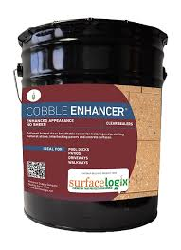

[[](https://www.diamondtoolstore.com/products/cobble-enhancer)](https://www.diamondtoolstore.com/products/cobble-enhancer" \o "Cobble Enhancer | Color Enhancing Sealer | Brick Enhancer Sealer" \t "_blank)

[Diamond Tool Store](https://www.diamondtoolstore.com/products/cobble-enhancer" \o "Cobble Enhancer | Color Enhancing Sealer | Brick Enhancer Sealer" \t "_blank)

[Cobble Enhancer | Color Enhancing ...](https://www.diamondtoolstore.com/products/cobble-enhancer" \o "Cobble Enhancer | Color Enhancing Sealer | Brick Enhancer Sealer" \t "_blank)

**Choose the Right Paving Tiles Designs - Charbhujatiles**

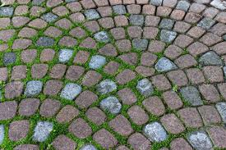

[[](https://charbhujatiles.com/blog-details/choose-the-right-paving-tiles-designs-with-these-useful-tips)](https://charbhujatiles.com/blog-details/choose-the-right-paving-tiles-designs-with-these-useful-tips" \o "Choose the Right Paving Tiles Designs - Charbhujatiles" \t "_blank)

[Charbhuja Tiles](https://charbhujatiles.com/blog-details/choose-the-right-paving-tiles-designs-with-these-useful-tips" \o "Choose the Right Paving Tiles Designs - Charbhujatiles" \t "_blank)

[Choose the Right Paving Tiles Designs ...](https://charbhujatiles.com/blog-details/choose-the-right-paving-tiles-designs-with-these-useful-tips" \o "Choose the Right Paving Tiles Designs - Charbhujatiles" \t "_blank)

**Gardenised Gray Plastic Garden Path Track Interlocking Stone Look Design Pathway Tile Floor Paver (Pack of 4) QI004108.4 - The Home Depot**

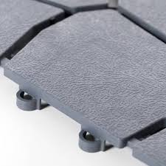

[[](https://www.homedepot.com/p/Gardenised-Gray-Plastic-Garden-Path-Track-Interlocking-Stone-Look-Design-Pathway-Tile-Floor-Paver-Pack-of-4-QI004108-4/317909834)](https://www.homedepot.com/p/Gardenised-Gray-Plastic-Garden-Path-Track-Interlocking-Stone-Look-Design-Pathway-Tile-Floor-Paver-Pack-of-4-QI004108-4/317909834" \o "Gardenised Gray Plastic Garden Path Track Interlocking Stone Look Design  Pathway Tile Floor Paver (Pack of 4) QI004108.4 - The Home Depot" \t "_blank)

[The Home Depot](https://www.homedepot.com/p/Gardenised-Gray-Plastic-Garden-Path-Track-Interlocking-Stone-Look-Design-Pathway-Tile-Floor-Paver-Pack-of-4-QI004108-4/317909834" \o "Gardenised Gray Plastic Garden Path Track Interlocking Stone Look Design  Pathway Tile Floor Paver (Pack of 4) QI004108.4 - The Home Depot" \t "_blank)

[Gardenised Gray Plastic Garden Path ...](https://www.homedepot.com/p/Gardenised-Gray-Plastic-Garden-Path-Track-Interlocking-Stone-Look-Design-Pathway-Tile-Floor-Paver-Pack-of-4-QI004108-4/317909834" \o "Gardenised Gray Plastic Garden Path Track Interlocking Stone Look Design  Pathway Tile Floor Paver (Pack of 4) QI004108.4 - The Home Depot" \t "_blank)

**Metro Stone 16-in L x 16-in W x 2-in H Tahoe Blend Concrete Interlocking Paver in the Pavers & Stepping Stones department at Lowes.com**

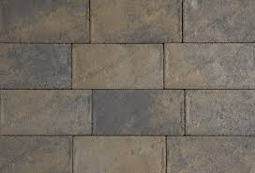

[[](https://www.lowes.com/pd/CastleLite-Metro-Stone-Tahoe-Blend-Paver/1002733378)](https://www.lowes.com/pd/CastleLite-Metro-Stone-Tahoe-Blend-Paver/1002733378" \o "Metro Stone 16-in L x 16-in W x 2-in H Tahoe Blend Concrete Interlocking  Paver in the Pavers & Stepping Stones department at Lowes.com" \t "_blank)

[Lowe's](https://www.lowes.com/pd/CastleLite-Metro-Stone-Tahoe-Blend-Paver/1002733378" \o "Metro Stone 16-in L x 16-in W x 2-in H Tahoe Blend Concrete Interlocking  Paver in the Pavers & Stepping Stones department at Lowes.com" \t "_blank)

[Tahoe Blend Concrete Interlocking Paver ...](https://www.lowes.com/pd/CastleLite-Metro-Stone-Tahoe-Blend-Paver/1002733378" \o "Metro Stone 16-in L x 16-in W x 2-in H Tahoe Blend Concrete Interlocking  Paver in the Pavers & Stepping Stones department at Lowes.com" \t "_blank)

**Zebra Interlocking Paver (Color - Grey) 80 Mm at Best Price in Patna | Rsd - Manufacturer Of Interlocking Paver & Chequered Tiles**

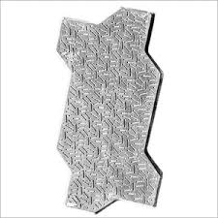

[[](https://www.tradeindia.com/products/zebra-interlocking-paver-color-grey-80-mm-c3818089.html)](https://www.tradeindia.com/products/zebra-interlocking-paver-color-grey-80-mm-c3818089.html" \o "Zebra Interlocking Paver (Color - Grey) 80 Mm at Best Price in Patna | Rsd  - Manufacturer Of Interlocking Paver & Chequered Tiles" \t "_blank)

[TradeIndia](https://www.tradeindia.com/products/zebra-interlocking-paver-color-grey-80-mm-c3818089.html" \o "Zebra Interlocking Paver (Color - Grey) 80 Mm at Best Price in Patna | Rsd  - Manufacturer Of Interlocking Paver & Chequered Tiles" \t "_blank)

[Zebra Interlocking Paver (Color - Grey ...](https://www.tradeindia.com/products/zebra-interlocking-paver-color-grey-80-mm-c3818089.html" \o "Zebra Interlocking Paver (Color - Grey) 80 Mm at Best Price in Patna | Rsd  - Manufacturer Of Interlocking Paver & Chequered Tiles" \t "_blank)

**Multi-color pavers combined in a variety of sizes and shaped into multiple circles. #custom #pavers #outdoorliving … | Stone pavement, Paver patterns, Paver designs**

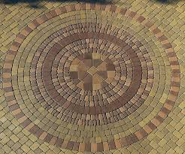

[[](https://www.pinterest.com/pin/multicolor-pavers-combined-in-a-variety-of-sizes-and-shaped-into-multiple-circles-custom-pavers-outdoor--281826889164862407/)](https://www.pinterest.com/pin/multicolor-pavers-combined-in-a-variety-of-sizes-and-shaped-into-multiple-circles-custom-pavers-outdoor--281826889164862407/" \o "Multi-color pavers combined in a variety of sizes and shaped into multiple  circles. #custom #pavers #outdoorliving … | Stone pavement, Paver patterns,  Paver designs" \t "_blank)

[Pinterest](https://www.pinterest.com/pin/multicolor-pavers-combined-in-a-variety-of-sizes-and-shaped-into-multiple-circles-custom-pavers-outdoor--281826889164862407/" \o "Multi-color pavers combined in a variety of sizes and shaped into multiple  circles. #custom #pavers #outdoorliving … | Stone pavement, Paver patterns,  Paver designs" \t "_blank)

[Paver patterns ...](https://www.pinterest.com/pin/multicolor-pavers-combined-in-a-variety-of-sizes-and-shaped-into-multiple-circles-custom-pavers-outdoor--281826889164862407/" \o "Multi-color pavers combined in a variety of sizes and shaped into multiple  circles. #custom #pavers #outdoorliving … | Stone pavement, Paver patterns,  Paver designs" \t "_blank)

**Color Concrete Interlock Paver Tile Holo Blocks Making Machine - Buy Holo Blocks Machine,Interlock Tile Making Machine,Color Concrete Paver Block Making Machine Product on Alibaba.com**

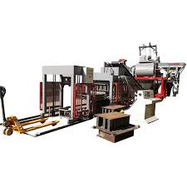

[[](https://www.alibaba.com/product-detail/Color-Concrete-Interlock-Paver-Tile-Holo_1600230269896.html)](https://www.alibaba.com/product-detail/Color-Concrete-Interlock-Paver-Tile-Holo_1600230269896.html" \o "Color Concrete Interlock Paver Tile Holo Blocks Making Machine - Buy Holo  Blocks Machine,Interlock Tile Making Machine,Color Concrete Paver Block  Making Machine Product on Alibaba.com" \t "_blank)

[Alibaba](https://www.alibaba.com/product-detail/Color-Concrete-Interlock-Paver-Tile-Holo_1600230269896.html" \o "Color Concrete Interlock Paver Tile Holo Blocks Making Machine - Buy Holo  Blocks Machine,Interlock Tile Making Machine,Color Concrete Paver Block  Making Machine Product on Alibaba.com" \t "_blank)

[Color Concrete Interlock Paver Tile ...](https://www.alibaba.com/product-detail/Color-Concrete-Interlock-Paver-Tile-Holo_1600230269896.html" \o "Color Concrete Interlock Paver Tile Holo Blocks Making Machine - Buy Holo  Blocks Machine,Interlock Tile Making Machine,Color Concrete Paver Block  Making Machine Product on Alibaba.com" \t "_blank)

**Interlocking Stone Deck Tiles 12''x12''Pebble Tiles(Pack of 4)PURE ERA - PURE ERA**

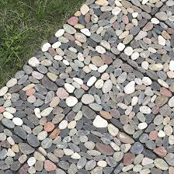

[[](https://www.pure-era.com/products/stone-deck-tiles-sliced-mixed-color)](https://www.pure-era.com/products/stone-deck-tiles-sliced-mixed-color" \o "Interlocking Stone Deck Tiles 12''x12''Pebble Tiles(Pack of 4)PURE ERA -  PURE ERA" \t "_blank)

[PURE ERA](https://www.pure-era.com/products/stone-deck-tiles-sliced-mixed-color" \o "Interlocking Stone Deck Tiles 12''x12''Pebble Tiles(Pack of 4)PURE ERA -  PURE ERA" \t "_blank)

[Interlocking Stone Deck Tiles 12''x12 ...](https://www.pure-era.com/products/stone-deck-tiles-sliced-mixed-color" \o "Interlocking Stone Deck Tiles 12''x12''Pebble Tiles(Pack of 4)PURE ERA -  PURE ERA" \t "_blank)

**Grey,Red Concrete Wave Interlocking Tiles, For Pavement, Thickness: 50 Mm at Rs 12/piece in Gurgaon**

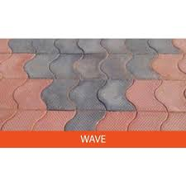

[[](https://www.indiamart.com/proddetail/wave-interlocking-tiles-23043503962.html)](https://www.indiamart.com/proddetail/wave-interlocking-tiles-23043503962.html" \o "Grey,Red Concrete Wave Interlocking Tiles, For Pavement, Thickness: 50 Mm  at Rs 12/piece in Gurgaon" \t "_blank)

[IndiaMART](https://www.indiamart.com/proddetail/wave-interlocking-tiles-23043503962.html" \o "Grey,Red Concrete Wave Interlocking Tiles, For Pavement, Thickness: 50 Mm  at Rs 12/piece in Gurgaon" \t "_blank)

[Red Concrete Wave Interlocking Tiles ...](https://www.indiamart.com/proddetail/wave-interlocking-tiles-23043503962.html" \o "Grey,Red Concrete Wave Interlocking Tiles, For Pavement, Thickness: 50 Mm  at Rs 12/piece in Gurgaon" \t "_blank)

**Scabos Travertine 6x12 3cm Tumbled Paver**

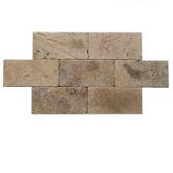

[[](https://tileandmosaicdepot.com/products/scabas-travertine-6x12-3cm-tumbled-paver)](https://tileandmosaicdepot.com/products/scabas-travertine-6x12-3cm-tumbled-paver" \o "Scabos Travertine 6x12 3cm Tumbled Paver" \t "_blank)

[TILE & MOSAIC DEPOT](https://tileandmosaicdepot.com/products/scabas-travertine-6x12-3cm-tumbled-paver" \o "Scabos Travertine 6x12 3cm Tumbled Paver" \t "_blank)

[Scabos Travertine 6x12 3cm Tumbled Paver](https://tileandmosaicdepot.com/products/scabas-travertine-6x12-3cm-tumbled-paver" \o "Scabos Travertine 6x12 3cm Tumbled Paver" \t "_blank)

**887 Interlocking Concrete Pavers Images, Stock Photos & Vectors | Shutterstock**

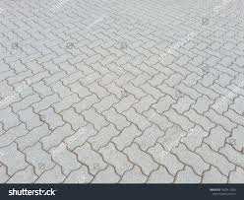

[[](https://www.shutterstock.com/search/interlocking-concrete-pavers)](https://www.shutterstock.com/search/interlocking-concrete-pavers" \o "887 Interlocking Concrete Pavers Images, Stock Photos & Vectors |  Shutterstock" \t "_blank)

[Shutterstock](https://www.shutterstock.com/search/interlocking-concrete-pavers" \o "887 Interlocking Concrete Pavers Images, Stock Photos & Vectors |  Shutterstock" \t "_blank)

[887 Interlocking Concrete Pavers Images ...](https://www.shutterstock.com/search/interlocking-concrete-pavers" \o "887 Interlocking Concrete Pavers Images, Stock Photos & Vectors |  Shutterstock" \t "_blank)

**551 Interlocking Paving Stone Stock Photos and Images - 123RF**

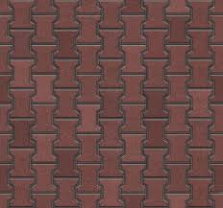

[[](https://www.123rf.com/stock-photo/interlocking_paving_stone.html)](https://www.123rf.com/stock-photo/interlocking_paving_stone.html" \o "551 Interlocking Paving Stone Stock Photos and Images - 123RF" \t "_blank)

[123RF](https://www.123rf.com/stock-photo/interlocking_paving_stone.html" \o "551 Interlocking Paving Stone Stock Photos and Images - 123RF" \t "_blank)

[551 Interlocking Paving Stone Stock ...](https://www.123rf.com/stock-photo/interlocking_paving_stone.html" \o "551 Interlocking Paving Stone Stock Photos and Images - 123RF" \t "_blank)

**Reyal Plastic Brooks Paver Block Mould 60mm | DIY Paver Mould | For Outdoor Garden Road Paving Tiles : Amazon.in: Industrial & Scientific**

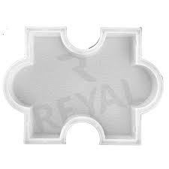

[[](https://www.amazon.in/Reyal-Plastic-Brooks-Outdoor-Garden/dp/B09Q1XN5NB)](https://www.amazon.in/Reyal-Plastic-Brooks-Outdoor-Garden/dp/B09Q1XN5NB" \o "Reyal Plastic Brooks Paver Block Mould 60mm | DIY Paver Mould | For Outdoor  Garden Road Paving Tiles : Amazon.in: Industrial & Scientific" \t "_blank)

[Amazon.in](https://www.amazon.in/Reyal-Plastic-Brooks-Outdoor-Garden/dp/B09Q1XN5NB" \o "Reyal Plastic Brooks Paver Block Mould 60mm | DIY Paver Mould | For Outdoor  Garden Road Paving Tiles : Amazon.in: Industrial & Scientific" \t "_blank)

[Reyal Plastic Brooks Paver Block Mould ...](https://www.amazon.in/Reyal-Plastic-Brooks-Outdoor-Garden/dp/B09Q1XN5NB" \o "Reyal Plastic Brooks Paver Block Mould 60mm | DIY Paver Mould | For Outdoor  Garden Road Paving Tiles : Amazon.in: Industrial & Scientific" \t "_blank)

**Permapave Paving in Different Colors,Pebble Stone Interlocking Plastic Base Deck Tile Ff Board from China - StoneContact.com**

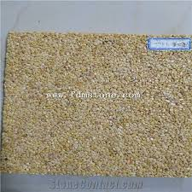

[[](https://www.stonecontact.com/products-533375/permapave-paving-in-different-colors)](https://www.stonecontact.com/products-533375/permapave-paving-in-different-colors" \o "Permapave Paving in Different Colors,Pebble Stone Interlocking Plastic Base  Deck Tile Ff Board from China - StoneContact.com" \t "_blank)

[StoneContact.com](https://www.stonecontact.com/products-533375/permapave-paving-in-different-colors" \o "Permapave Paving in Different Colors,Pebble Stone Interlocking Plastic Base  Deck Tile Ff Board from China - StoneContact.com" \t "_blank)

[Permapave Paving in Different Colors ...](https://www.stonecontact.com/products-533375/permapave-paving-in-different-colors" \o "Permapave Paving in Different Colors,Pebble Stone Interlocking Plastic Base  Deck Tile Ff Board from China - StoneContact.com" \t "_blank)

**Double-T interlocking paver block, seamless texture map, seams of tile displace Stock Illustration | Adobe Stock**



[[](https://stock.adobe.com/images/double-t-interlocking-paver-block-seamless-texture-map-seams-of-tile-displace/218489524)](https://stock.adobe.com/images/double-t-interlocking-paver-block-seamless-texture-map-seams-of-tile-displace/218489524" \o "Double-T interlocking paver block, seamless texture map, seams of tile  displace Stock Illustration | Adobe Stock" \t "_blank)

[Adobe Stock](https://stock.adobe.com/images/double-t-interlocking-paver-block-seamless-texture-map-seams-of-tile-displace/218489524" \o "Double-T interlocking paver block, seamless texture map, seams of tile  displace Stock Illustration | Adobe Stock" \t "_blank)

[Double-T interlocking paver block ...](https://stock.adobe.com/images/double-t-interlocking-paver-block-seamless-texture-map-seams-of-tile-displace/218489524" \o "Double-T interlocking paver block, seamless texture map, seams of tile  displace Stock Illustration | Adobe Stock" \t "_blank)

**Interlocking Paver Block Making Process. | RED IRON OXIDE PIGMENT, INTERLOCKING TILE MAKING MACHINE, PAVER MOULD**

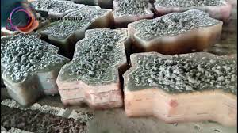

[[](https://srikrishnaplasto.com/interlocking-pvc-paver-mould/interlocking-paver-block-making-process.html)](https://srikrishnaplasto.com/interlocking-pvc-paver-mould/interlocking-paver-block-making-process.html" \o "Interlocking Paver Block Making Process. | RED IRON OXIDE PIGMENT, INTERLOCKING  TILE MAKING MACHINE, PAVER MOULD" \t "_blank)

[RED IRON OXIDE PIGMENT, INTERLOCKING TILE MAKING MACHINE, PAVER MOULD](https://srikrishnaplasto.com/interlocking-pvc-paver-mould/interlocking-paver-block-making-process.html" \o "Interlocking Paver Block Making Process. | RED IRON OXIDE PIGMENT, INTERLOCKING  TILE MAKING MACHINE, PAVER MOULD" \t "_blank)

[Interlocking Paver Block Making Process ...](https://srikrishnaplasto.com/interlocking-pvc-paver-mould/interlocking-paver-block-making-process.html" \o "Interlocking Paver Block Making Process. | RED IRON OXIDE PIGMENT, INTERLOCKING  TILE MAKING MACHINE, PAVER MOULD" \t "_blank)

**INTERLOCKING TILES ∕ PAVERS**

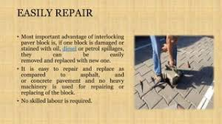

[[](https://www.slideshare.net/sanjeevsingh462/interlocking-tiles-pavers)](https://www.slideshare.net/sanjeevsingh462/interlocking-tiles-pavers" \o "INTERLOCKING TILES ∕ PAVERS" \t "_blank)

[SlideShare](https://www.slideshare.net/sanjeevsingh462/interlocking-tiles-pavers" \o "INTERLOCKING TILES ∕ PAVERS" \t "_blank)

[INTERLOCKING TILES ∕ PAVERS](https://www.slideshare.net/sanjeevsingh462/interlocking-tiles-pavers" \o "INTERLOCKING TILES ∕ PAVERS" \t "_blank)

**how to make glossy coloured interlock paver making easily - YouTube**



[[](https://www.youtube.com/watch?v=7PPBOGUF6a8)](https://www.youtube.com/watch?v=7PPBOGUF6a8" \o "how to make glossy coloured interlock paver making easily - YouTube" \t "_blank)

[YouTube](https://www.youtube.com/watch?v=7PPBOGUF6a8" \o "how to make glossy coloured interlock paver making easily - YouTube" \t "_blank)

[coloured interlock paver making ...](https://www.youtube.com/watch?v=7PPBOGUF6a8" \o "how to make glossy coloured interlock paver making easily - YouTube" \t "_blank)

**Royal Interlocking Paver Tile in Kottayam at best price by Zion Guard Interlocking Tiles and Pavings - Justdial**

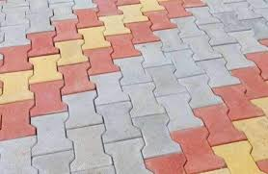

[[](https://www.justdial.com/jdmart/Kottayam/Royal-Interlocking-Paver-Tile/pid-2216814852/9999PX481-X481-221011203956-J6J7?jdtracker=internaljd_b2bplistingcarousel_10272620)](https://www.justdial.com/jdmart/Kottayam/Royal-Interlocking-Paver-Tile/pid-2216814852/9999PX481-X481-221011203956-J6J7?jdtracker=internaljd_b2bplistingcarousel_10272620" \o "Royal Interlocking Paver Tile in Kottayam at best price by Zion Guard Interlocking  Tiles and Pavings - Justdial" \t "_blank)

[Justdial](https://www.justdial.com/jdmart/Kottayam/Royal-Interlocking-Paver-Tile/pid-2216814852/9999PX481-X481-221011203956-J6J7?jdtracker=internaljd_b2bplistingcarousel_10272620" \o "Royal Interlocking Paver Tile in Kottayam at best price by Zion Guard Interlocking  Tiles and Pavings - Justdial" \t "_blank)

[Royal Interlocking Paver Tile in ...](https://www.justdial.com/jdmart/Kottayam/Royal-Interlocking-Paver-Tile/pid-2216814852/9999PX481-X481-221011203956-J6J7?jdtracker=internaljd_b2bplistingcarousel_10272620" \o "Royal Interlocking Paver Tile in Kottayam at best price by Zion Guard Interlocking  Tiles and Pavings - Justdial" \t "_blank)

**Interlocking Paver tile and Blocks**

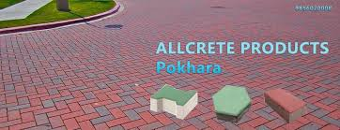

[[](https://www.facebook.com/allcrete.pkr/)](https://www.facebook.com/allcrete.pkr/" \o "Interlocking Paver tile and Blocks" \t "_blank)

[Facebook](https://www.facebook.com/allcrete.pkr/" \o "Interlocking Paver tile and Blocks" \t "_blank)

[Interlocking Paver tile and Blocks](https://www.facebook.com/allcrete.pkr/" \o "Interlocking Paver tile and Blocks" \t "_blank)

**Plastic Molds for Precast Interlocking Pavers Tile Mold Price - China Interlocking Brick Paver Mold and Pavement Brick Moulds**

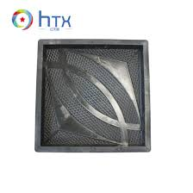

[[](https://zzhtxags.en.made-in-china.com/product/PSuJtdLMXCrW/China-Plastic-Molds-for-Precast-Interlocking-Pavers-Tile-Mold-Price.html)](https://zzhtxags.en.made-in-china.com/product/PSuJtdLMXCrW/China-Plastic-Molds-for-Precast-Interlocking-Pavers-Tile-Mold-Price.html" \o "Plastic Molds for Precast Interlocking Pavers Tile Mold Price - China  Interlocking Brick Paver Mold and Pavement Brick Moulds" \t "_blank)

[HENAN HTX GROUP CO., LTD.](https://zzhtxags.en.made-in-china.com/product/PSuJtdLMXCrW/China-Plastic-Molds-for-Precast-Interlocking-Pavers-Tile-Mold-Price.html" \o "Plastic Molds for Precast Interlocking Pavers Tile Mold Price - China  Interlocking Brick Paver Mold and Pavement Brick Moulds" \t "_blank)

[Plastic Molds for Precast Interlocking ...](https://zzhtxags.en.made-in-china.com/product/PSuJtdLMXCrW/China-Plastic-Molds-for-Precast-Interlocking-Pavers-Tile-Mold-Price.html" \o "Plastic Molds for Precast Interlocking Pavers Tile Mold Price - China  Interlocking Brick Paver Mold and Pavement Brick Moulds" \t "_blank)

**Interlocking Decking Tiles Outdoor, BTMWAY 12" x 12" (Set of 10 Tiles) Wooden Floor Tiles for Indoor and Outdoor, Outdoor Floor Tiles Patio Tiles Garage Tiles Patio Pavers, Gray, A6865 - Walmart.com**

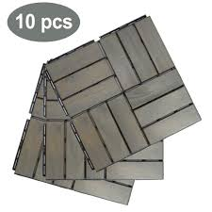

[[](https://www.walmart.com/ip/Interlocking-Decking-Tiles-Outdoor-BTMWAY-12-x-Set-10-Tiles-Wooden-Floor-Indoor-Outdoor-Patio-Garage-Pavers-Gray-A6865/991972169)](https://www.walmart.com/ip/Interlocking-Decking-Tiles-Outdoor-BTMWAY-12-x-Set-10-Tiles-Wooden-Floor-Indoor-Outdoor-Patio-Garage-Pavers-Gray-A6865/991972169" \o "Interlocking Decking Tiles Outdoor, BTMWAY 12\" x 12\" (Set of 10 Tiles)  Wooden Floor Tiles for Indoor and Outdoor, Outdoor Floor Tiles Patio Tiles  Garage Tiles Patio Pavers, Gray, A6865 - Walmart.com" \t "_blank)

[Walmart](https://www.walmart.com/ip/Interlocking-Decking-Tiles-Outdoor-BTMWAY-12-x-Set-10-Tiles-Wooden-Floor-Indoor-Outdoor-Patio-Garage-Pavers-Gray-A6865/991972169" \o "Interlocking Decking Tiles Outdoor, BTMWAY 12\" x 12\" (Set of 10 Tiles)  Wooden Floor Tiles for Indoor and Outdoor, Outdoor Floor Tiles Patio Tiles  Garage Tiles Patio Pavers, Gray, A6865 - Walmart.com" \t "_blank)

[Interlocking Decking Tiles Outdoor ...](https://www.walmart.com/ip/Interlocking-Decking-Tiles-Outdoor-BTMWAY-12-x-Set-10-Tiles-Wooden-Floor-Indoor-Outdoor-Patio-Garage-Pavers-Gray-A6865/991972169" \o "Interlocking Decking Tiles Outdoor, BTMWAY 12\" x 12\" (Set of 10 Tiles)  Wooden Floor Tiles for Indoor and Outdoor, Outdoor Floor Tiles Patio Tiles  Garage Tiles Patio Pavers, Gray, A6865 - Walmart.com" \t "_blank)

Related searches

[[](https://www.google.com/search?q=interlock%20tiles%20price&tbm=isch&hl=en&bih=722&biw=1519&rlz=1C1YTUH_enIN1004IN1004&sa=X&ved=0CJ8BEKzcAigAahcKEwjA1_C0wZL9AhUAAAAAHQAAAAAQBA)](https://www.google.com/search?q=interlock%20tiles%20price&tbm=isch&hl=en&bih=722&biw=1519&rlz=1C1YTUH_enIN1004IN1004&sa=X&ved=0CJ8BEKzcAigAahcKEwjA1_C0wZL9AhUAAAAAHQAAAAAQBA)

**[interlock](https://www.google.com/search?q=interlock%20tiles%20price&tbm=isch&hl=en&bih=722&biw=1519&rlz=1C1YTUH_enIN1004IN1004&sa=X&ved=0CJ8BEKzcAigAahcKEwjA1_C0wZL9AhUAAAAAHQAAAAAQBA)**[tiles](https://www.google.com/search?q=interlock%20tiles%20price&tbm=isch&hl=en&bih=722&biw=1519&rlz=1C1YTUH_enIN1004IN1004&sa=X&ved=0CJ8BEKzcAigAahcKEwjA1_C0wZL9AhUAAAAAHQAAAAAQBA)**[price](https://www.google.com/search?q=interlock%20tiles%20price&tbm=isch&hl=en&bih=722&biw=1519&rlz=1C1YTUH_enIN1004IN1004&sa=X&ved=0CJ8BEKzcAigAahcKEwjA1_C0wZL9AhUAAAAAHQAAAAAQBA)**

[[](https://www.google.com/search?q=interlock%20tiles%20texture&tbm=isch&hl=en&bih=722&biw=1519&rlz=1C1YTUH_enIN1004IN1004&sa=X&ved=0CKEBEKzcAigBahcKEwjA1_C0wZL9AhUAAAAAHQAAAAAQBA)](https://www.google.com/search?q=interlock%20tiles%20texture&tbm=isch&hl=en&bih=722&biw=1519&rlz=1C1YTUH_enIN1004IN1004&sa=X&ved=0CKEBEKzcAigBahcKEwjA1_C0wZL9AhUAAAAAHQAAAAAQBA)

**[interlock](https://www.google.com/search?q=interlock%20tiles%20texture&tbm=isch&hl=en&bih=722&biw=1519&rlz=1C1YTUH_enIN1004IN1004&sa=X&ved=0CKEBEKzcAigBahcKEwjA1_C0wZL9AhUAAAAAHQAAAAAQBA)**[tiles](https://www.google.com/search?q=interlock%20tiles%20texture&tbm=isch&hl=en&bih=722&biw=1519&rlz=1C1YTUH_enIN1004IN1004&sa=X&ved=0CKEBEKzcAigBahcKEwjA1_C0wZL9AhUAAAAAHQAAAAAQBA)**[texture](https://www.google.com/search?q=interlock%20tiles%20texture&tbm=isch&hl=en&bih=722&biw=1519&rlz=1C1YTUH_enIN1004IN1004&sa=X&ved=0CKEBEKzcAigBahcKEwjA1_C0wZL9AhUAAAAAHQAAAAAQBA)**

[[](https://www.google.com/search?q=zig%20zag%20paver%20block%20design&tbm=isch&hl=en&bih=722&biw=1519&rlz=1C1YTUH_enIN1004IN1004&sa=X&ved=0CKMBEKzcAigCahcKEwjA1_C0wZL9AhUAAAAAHQAAAAAQBA)](https://www.google.com/search?q=zig%20zag%20paver%20block%20design&tbm=isch&hl=en&bih=722&biw=1519&rlz=1C1YTUH_enIN1004IN1004&sa=X&ved=0CKMBEKzcAigCahcKEwjA1_C0wZL9AhUAAAAAHQAAAAAQBA)

[zig zag paver block design](https://www.google.com/search?q=zig%20zag%20paver%20block%20design&tbm=isch&hl=en&bih=722&biw=1519&rlz=1C1YTUH_enIN1004IN1004&sa=X&ved=0CKMBEKzcAigCahcKEwjA1_C0wZL9AhUAAAAAHQAAAAAQBA)

**12"Grey Wood Plastic Flooring Interlocking Wood Patio Paver Tile indoor outdoor | eBay**

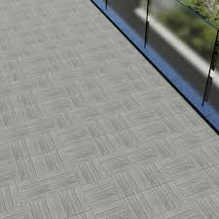

[[](https://www.ebay.com/itm/265540281377)](https://www.ebay.com/itm/265540281377" \o "12\"Grey Wood Plastic Flooring Interlocking Wood Patio Paver Tile indoor  outdoor | eBay" \t "_blank)

[eBay](https://www.ebay.com/itm/265540281377" \o "12\"Grey Wood Plastic Flooring Interlocking Wood Patio Paver Tile indoor  outdoor | eBay" \t "_blank)

[12"Grey Wood Plastic Flooring ...](https://www.ebay.com/itm/265540281377" \o "12\"Grey Wood Plastic Flooring Interlocking Wood Patio Paver Tile indoor  outdoor | eBay" \t "_blank)

**Zig Zag Tiles Latest Price from Manufacturers, Suppliers & Traders**

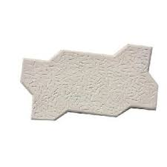

[[](https://www.exportersindia.com/indian-suppliers/zig-zag-tiles.htm)](https://www.exportersindia.com/indian-suppliers/zig-zag-tiles.htm" \o "Zig Zag Tiles Latest Price from Manufacturers, Suppliers & Traders" \t "_blank)

[Exporters India](https://www.exportersindia.com/indian-suppliers/zig-zag-tiles.htm" \o "Zig Zag Tiles Latest Price from Manufacturers, Suppliers & Traders" \t "_blank)

[Zig Zag Tiles Latest Price from ...](https://www.exportersindia.com/indian-suppliers/zig-zag-tiles.htm" \o "Zig Zag Tiles Latest Price from Manufacturers, Suppliers & Traders" \t "_blank)

**Artmore Tile Landscape Gray 12-in x 12-in Natural Stone Slate Pebble Stone Look Floor and Wall Tile in the Tile department at Lowes.com**

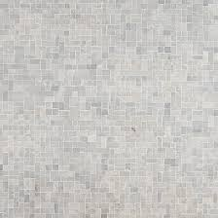

[[](https://www.lowes.com/pd/Artmore-Tile-Landscape-Interlocking-12-in-x-12-in-Gray-Floor-and-Wall-Mosaic-Tile-0-97-Sq-Ft-per-Sheet/5013704839)](https://www.lowes.com/pd/Artmore-Tile-Landscape-Interlocking-12-in-x-12-in-Gray-Floor-and-Wall-Mosaic-Tile-0-97-Sq-Ft-per-Sheet/5013704839" \o "Artmore Tile Landscape Gray 12-in x 12-in Natural Stone Slate Pebble Stone  Look Floor and Wall Tile in the Tile department at Lowes.com" \t "_blank)

[Lowe's](https://www.lowes.com/pd/Artmore-Tile-Landscape-Interlocking-12-in-x-12-in-Gray-Floor-and-Wall-Mosaic-Tile-0-97-Sq-Ft-per-Sheet/5013704839" \o "Artmore Tile Landscape Gray 12-in x 12-in Natural Stone Slate Pebble Stone  Look Floor and Wall Tile in the Tile department at Lowes.com" \t "_blank)

[Artmore Tile Landscape Gray 12-in x 12 ...](https://www.lowes.com/pd/Artmore-Tile-Landscape-Interlocking-12-in-x-12-in-Gray-Floor-and-Wall-Mosaic-Tile-0-97-Sq-Ft-per-Sheet/5013704839" \o "Artmore Tile Landscape Gray 12-in x 12-in Natural Stone Slate Pebble Stone  Look Floor and Wall Tile in the Tile department at Lowes.com" \t "_blank)

**I Dumble Interlocking Paver Block (Color -Red,Yellow) Application: Floor Tiles at Best Price in Patna | Rsd - Manufacturer Of Interlocking Paver & Chequered Tiles**

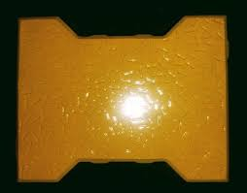

[[](https://www.tradeindia.com/products/i-dumble-interlocking-paver-block-color-red-yellow-4001772.html)](https://www.tradeindia.com/products/i-dumble-interlocking-paver-block-color-red-yellow-4001772.html" \o "I Dumble Interlocking Paver Block (Color -Red,Yellow) Application: Floor  Tiles at Best Price in Patna | Rsd - Manufacturer Of Interlocking Paver &  Chequered Tiles" \t "_blank)

[TradeIndia](https://www.tradeindia.com/products/i-dumble-interlocking-paver-block-color-red-yellow-4001772.html" \o "I Dumble Interlocking Paver Block (Color -Red,Yellow) Application: Floor  Tiles at Best Price in Patna | Rsd - Manufacturer Of Interlocking Paver &  Chequered Tiles" \t "_blank)

[Dumble Interlocking Paver Block (Color ...](https://www.tradeindia.com/products/i-dumble-interlocking-paver-block-color-red-yellow-4001772.html" \o "I Dumble Interlocking Paver Block (Color -Red,Yellow) Application: Floor  Tiles at Best Price in Patna | Rsd - Manufacturer Of Interlocking Paver &  Chequered Tiles" \t "_blank)

**How to Make Colored Concrete Paver Blocks | paving block making machine | interlocking tiles machine - YouTube | Interlocking tile, Paver blocks, Making machine**

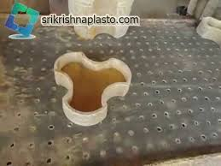

[[](https://www.pinterest.com/pin/755901118693404270/)](https://www.pinterest.com/pin/755901118693404270/" \o "How to Make Colored Concrete Paver Blocks | paving block making machine | interlocking  tiles machine - YouTube | Interlocking tile, Paver blocks, Making machine" \t "_blank)

[Pinterest](https://www.pinterest.com/pin/755901118693404270/" \o "How to Make Colored Concrete Paver Blocks | paving block making machine | interlocking  tiles machine - YouTube | Interlocking tile, Paver blocks, Making machine" \t "_blank)

[Colored Concrete Paver Blocks ...](https://www.pinterest.com/pin/755901118693404270/" \o "How to Make Colored Concrete Paver Blocks | paving block making machine | interlocking  tiles machine - YouTube | Interlocking tile, Paver blocks, Making machine" \t "_blank)

**Choose the Right Paving Tiles Designs - Charbhujatiles**

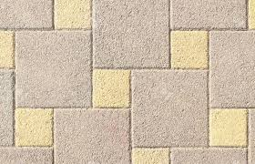

[[](https://charbhujatiles.com/blog-details/choose-the-right-paving-tiles-designs-with-these-useful-tips)](https://charbhujatiles.com/blog-details/choose-the-right-paving-tiles-designs-with-these-useful-tips" \o "Choose the Right Paving Tiles Designs - Charbhujatiles" \t "_blank)

[Charbhuja Tiles](https://charbhujatiles.com/blog-details/choose-the-right-paving-tiles-designs-with-these-useful-tips" \o "Choose the Right Paving Tiles Designs - Charbhujatiles" \t "_blank)

[Choose the Right Paving Tiles Designs ...](https://charbhujatiles.com/blog-details/choose-the-right-paving-tiles-designs-with-these-useful-tips" \o "Choose the Right Paving Tiles Designs - Charbhujatiles" \t "_blank)

**60mm Interlock Concrete Paving Stone Tiles, Size: 10x10 Inch, Flooring at Rs 45/sq ft in Angamaly**

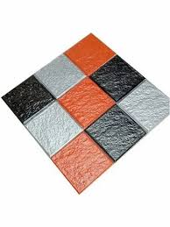

[[](https://www.indiamart.com/proddetail/60mm-interlock-concrete-paving-stone-tiles-23368954697.html)](https://www.indiamart.com/proddetail/60mm-interlock-concrete-paving-stone-tiles-23368954697.html" \o "60mm Interlock Concrete Paving Stone Tiles, Size: 10x10 Inch, Flooring at  Rs 45/sq ft in Angamaly" \t "_blank)

[IndiaMART](https://www.indiamart.com/proddetail/60mm-interlock-concrete-paving-stone-tiles-23368954697.html" \o "60mm Interlock Concrete Paving Stone Tiles, Size: 10x10 Inch, Flooring at  Rs 45/sq ft in Angamaly" \t "_blank)

[60mm Interlock Concrete Paving Stone ...](https://www.indiamart.com/proddetail/60mm-interlock-concrete-paving-stone-tiles-23368954697.html" \o "60mm Interlock Concrete Paving Stone Tiles, Size: 10x10 Inch, Flooring at  Rs 45/sq ft in Angamaly" \t "_blank)

**MSI Santa Barbara 18 in. x 24 in. Rectangle Natural Slate Meshed Flagstone Paver Tile (48 Pieces/132 sq. ft./Pallet) LHDCGMESHRANDOM - The Home Depot**

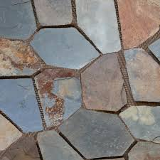

[[](https://www.homedepot.com/p/MSI-Santa-Barbara-18-in-x-24-in-Rectangle-Natural-Slate-Meshed-Flagstone-Paver-Tile-48-Pieces-132-sq-ft-Pallet-LHDCGMESHRANDOM/202407453)](https://www.homedepot.com/p/MSI-Santa-Barbara-18-in-x-24-in-Rectangle-Natural-Slate-Meshed-Flagstone-Paver-Tile-48-Pieces-132-sq-ft-Pallet-LHDCGMESHRANDOM/202407453" \o "MSI Santa Barbara 18 in. x 24 in. Rectangle Natural Slate Meshed Flagstone Paver  Tile (48 Pieces/132 sq. ft./Pallet) LHDCGMESHRANDOM - The Home Depot" \t "_blank)

[The Home Depot](https://www.homedepot.com/p/MSI-Santa-Barbara-18-in-x-24-in-Rectangle-Natural-Slate-Meshed-Flagstone-Paver-Tile-48-Pieces-132-sq-ft-Pallet-LHDCGMESHRANDOM/202407453" \o "MSI Santa Barbara 18 in. x 24 in. Rectangle Natural Slate Meshed Flagstone Paver  Tile (48 Pieces/132 sq. ft./Pallet) LHDCGMESHRANDOM - The Home Depot" \t "_blank)

[MSI Santa Barbara 18 in. x 24 in ...](https://www.homedepot.com/p/MSI-Santa-Barbara-18-in-x-24-in-Rectangle-Natural-Slate-Meshed-Flagstone-Paver-Tile-48-Pieces-132-sq-ft-Pallet-LHDCGMESHRANDOM/202407453" \o "MSI Santa Barbara 18 in. x 24 in. Rectangle Natural Slate Meshed Flagstone Paver  Tile (48 Pieces/132 sq. ft./Pallet) LHDCGMESHRANDOM - The Home Depot" \t "_blank)

**3,247 Interlocking Brick Pattern Images, Stock Photos & Vectors | Shutterstock**

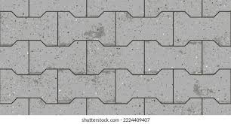

[[](https://www.shutterstock.com/search/interlocking-brick-pattern)](https://www.shutterstock.com/search/interlocking-brick-pattern" \o "3,247 Interlocking Brick Pattern Images, Stock Photos & Vectors |  Shutterstock" \t "_blank)

[Shutterstock](https://www.shutterstock.com/search/interlocking-brick-pattern" \o "3,247 Interlocking Brick Pattern Images, Stock Photos & Vectors |  Shutterstock" \t "_blank)

[3,247 Interlocking Brick Pattern Images ...](https://www.shutterstock.com/search/interlocking-brick-pattern" \o "3,247 Interlocking Brick Pattern Images, Stock Photos & Vectors |  Shutterstock" \t "_blank)

**Garden Path Tiles Cobblestone Paver Mats Interlocking Paver - Buy Cobblestone Paver Mats,Mesh Cobblestone Pavers,Cobblestone Driveway Pavers Product on Alibaba.com**

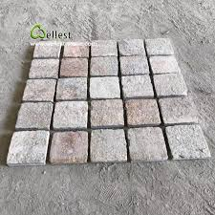

[[](https://www.alibaba.com/product-detail/Garden-path-tiles-cobblestone-paver-mats_60799289854.html)](https://www.alibaba.com/product-detail/Garden-path-tiles-cobblestone-paver-mats_60799289854.html" \o "Garden Path Tiles Cobblestone Paver Mats Interlocking Paver - Buy  Cobblestone Paver Mats,Mesh Cobblestone Pavers,Cobblestone Driveway Pavers  Product on Alibaba.com" \t "_blank)

[Alibaba.com](https://www.alibaba.com/product-detail/Garden-path-tiles-cobblestone-paver-mats_60799289854.html" \o "Garden Path Tiles Cobblestone Paver Mats Interlocking Paver - Buy  Cobblestone Paver Mats,Mesh Cobblestone Pavers,Cobblestone Driveway Pavers  Product on Alibaba.com" \t "_blank)

[Garden Path Tiles Cobblestone Paver ...](https://www.alibaba.com/product-detail/Garden-path-tiles-cobblestone-paver-mats_60799289854.html" \o "Garden Path Tiles Cobblestone Paver Mats Interlocking Paver - Buy  Cobblestone Paver Mats,Mesh Cobblestone Pavers,Cobblestone Driveway Pavers  Product on Alibaba.com" \t "_blank)

**Reyal Plastic Paver Block Mould Zigzag (Pack of 2) Interlocking Block Mold For Flooring Garden Outdoor Home Cement Paver Block : Amazon.in: Industrial & Scientific**

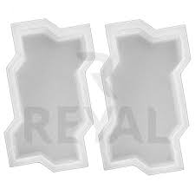

[[](https://www.amazon.in/Reyal-Plastic-Interlocking-Flooring-Outdoor/dp/B09PR6VSW7)](https://www.amazon.in/Reyal-Plastic-Interlocking-Flooring-Outdoor/dp/B09PR6VSW7" \o "Reyal Plastic Paver Block Mould Zigzag (Pack of 2) Interlocking Block Mold  For Flooring Garden Outdoor Home Cement Paver Block : Amazon.in: Industrial  & Scientific" \t "_blank)

[Amazon.in](https://www.amazon.in/Reyal-Plastic-Interlocking-Flooring-Outdoor/dp/B09PR6VSW7" \o "Reyal Plastic Paver Block Mould Zigzag (Pack of 2) Interlocking Block Mold  For Flooring Garden Outdoor Home Cement Paver Block : Amazon.in: Industrial  & Scientific" \t "_blank)

[Reyal Plastic Paver Block Mould Zigzag ...](https://www.amazon.in/Reyal-Plastic-Interlocking-Flooring-Outdoor/dp/B09PR6VSW7" \o "Reyal Plastic Paver Block Mould Zigzag (Pack of 2) Interlocking Block Mold  For Flooring Garden Outdoor Home Cement Paver Block : Amazon.in: Industrial  & Scientific" \t "_blank)

**colour floor paver block & tiles making machinery moulds - YouTube**



[[](https://www.youtube.com/watch?v=yJ7hBuq9hI0)](https://www.youtube.com/watch?v=yJ7hBuq9hI0" \o "colour floor paver block & tiles making machinery moulds - YouTube" \t "_blank)

[YouTube](https://www.youtube.com/watch?v=yJ7hBuq9hI0" \o "colour floor paver block & tiles making machinery moulds - YouTube" \t "_blank)

[colour floor paver block & tiles making ...](https://www.youtube.com/watch?v=yJ7hBuq9hI0" \o "colour floor paver block & tiles making machinery moulds - YouTube" \t "_blank)

**Interlocking Paver Tile in Nandyal at best price by MSV Building Materials - Justdial**

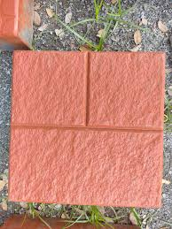

[[](https://www.justdial.com/jdmart/Nandyal/Interlocking-Paver-Tile/pid-2216966500/9999P4146-4146-221129011519-A8S2)](https://www.justdial.com/jdmart/Nandyal/Interlocking-Paver-Tile/pid-2216966500/9999P4146-4146-221129011519-A8S2" \o "Interlocking Paver Tile in Nandyal at best price by MSV Building Materials  - Justdial" \t "_blank)

[Justdial](https://www.justdial.com/jdmart/Nandyal/Interlocking-Paver-Tile/pid-2216966500/9999P4146-4146-221129011519-A8S2" \o "Interlocking Paver Tile in Nandyal at best price by MSV Building Materials  - Justdial" \t "_blank)

[Interlocking Paver Tile in Nandyal at ...](https://www.justdial.com/jdmart/Nandyal/Interlocking-Paver-Tile/pid-2216966500/9999P4146-4146-221129011519-A8S2" \o "Interlocking Paver Tile in Nandyal at best price by MSV Building Materials  - Justdial" \t "_blank)

**Interlocking Paver tile and Blocks**

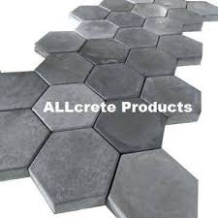

[[](https://www.facebook.com/allcrete.pkr/)](https://www.facebook.com/allcrete.pkr/" \o "Interlocking Paver tile and Blocks" \t "_blank)

[Facebook](https://www.facebook.com/allcrete.pkr/" \o "Interlocking Paver tile and Blocks" \t "_blank)

[Interlocking Paver tile and Blocks](https://www.facebook.com/allcrete.pkr/" \o "Interlocking Paver tile and Blocks" \t "_blank)

**INTERLOCKING TILES ∕ PAVERS**



[[](https://www.slideshare.net/sanjeevsingh462/interlocking-tiles-pavers)](https://www.slideshare.net/sanjeevsingh462/interlocking-tiles-pavers" \o "INTERLOCKING TILES ∕ PAVERS" \t "_blank)

[SlideShare](https://www.slideshare.net/sanjeevsingh462/interlocking-tiles-pavers" \o "INTERLOCKING TILES ∕ PAVERS" \t "_blank)

[INTERLOCKING TILES ∕ PAVERS](https://www.slideshare.net/sanjeevsingh462/interlocking-tiles-pavers" \o "INTERLOCKING TILES ∕ PAVERS" \t "_blank)

**Interlocking Paver Tile Concrete Stone Plastic Rubber Molds Nigeria - China Paver Molds and Pavement Brick Moulds**

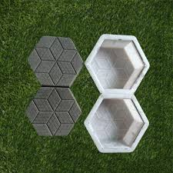

[[](https://zzhtxags.en.made-in-china.com/product/ZBIQDkNKQwUv/China-Interlocking-Paver-Tile-Concrete-Stone-Plastic-Rubber-Molds-Nigeria.html)](https://zzhtxags.en.made-in-china.com/product/ZBIQDkNKQwUv/China-Interlocking-Paver-Tile-Concrete-Stone-Plastic-Rubber-Molds-Nigeria.html" \o "Interlocking Paver Tile Concrete Stone Plastic Rubber Molds Nigeria - China  Paver Molds and Pavement Brick Moulds" \t "_blank)

[HENAN HTX GROUP CO., LTD.](https://zzhtxags.en.made-in-china.com/product/ZBIQDkNKQwUv/China-Interlocking-Paver-Tile-Concrete-Stone-Plastic-Rubber-Molds-Nigeria.html" \o "Interlocking Paver Tile Concrete Stone Plastic Rubber Molds Nigeria - China  Paver Molds and Pavement Brick Moulds" \t "_blank)

[Interlocking Paver Tile Concrete Stone ...](https://zzhtxags.en.made-in-china.com/product/ZBIQDkNKQwUv/China-Interlocking-Paver-Tile-Concrete-Stone-Plastic-Rubber-Molds-Nigeria.html" \o "Interlocking Paver Tile Concrete Stone Plastic Rubber Molds Nigeria - China  Paver Molds and Pavement Brick Moulds" \t "_blank)

**551 Interlocking Paving Stone Stock Photos and Images - 123RF**

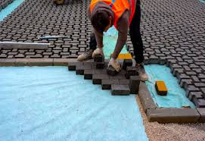

[[](https://www.123rf.com/stock-photo/interlocking_paving_stone.html)](https://www.123rf.com/stock-photo/interlocking_paving_stone.html" \o "551 Interlocking Paving Stone Stock Photos and Images - 123RF" \t "_blank)

[123RF](https://www.123rf.com/stock-photo/interlocking_paving_stone.html" \o "551 Interlocking Paving Stone Stock Photos and Images - 123RF" \t "_blank)

[551 Interlocking Paving Stone Stock ...](https://www.123rf.com/stock-photo/interlocking_paving_stone.html" \o "551 Interlocking Paving Stone Stock Photos and Images - 123RF" \t "_blank)

**MSI Golden White 18 in. x 24 in. Multi-coloured Meshed Flagstone Paver Tile - Walmart.com**

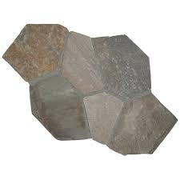

[[](https://www.walmart.com/ip/MSI-Golden-White-18-in-x-24-in-Multi-coloured-Meshed-Flagstone-Paver-Tile/37138656)](https://www.walmart.com/ip/MSI-Golden-White-18-in-x-24-in-Multi-coloured-Meshed-Flagstone-Paver-Tile/37138656" \o "MSI Golden White 18 in. x 24 in. Multi-coloured Meshed Flagstone Paver Tile  - Walmart.com" \t "_blank)

[Walmart](https://www.walmart.com/ip/MSI-Golden-White-18-in-x-24-in-Multi-coloured-Meshed-Flagstone-Paver-Tile/37138656" \o "MSI Golden White 18 in. x 24 in. Multi-coloured Meshed Flagstone Paver Tile  - Walmart.com" \t "_blank)

[Meshed Flagstone Paver Tile ...](https://www.walmart.com/ip/MSI-Golden-White-18-in-x-24-in-Multi-coloured-Meshed-Flagstone-Paver-Tile/37138656" \o "MSI Golden White 18 in. x 24 in. Multi-coloured Meshed Flagstone Paver Tile  - Walmart.com" \t "_blank)

**30pcs Deck Tiles Interlocking Patio Flooring Pavers Tiles Outdoor Balcony Tiles | eBay**

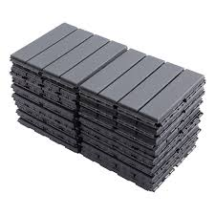

[[](https://www.ebay.com/itm/255899765375)](https://www.ebay.com/itm/255899765375" \o "30pcs Deck Tiles Interlocking Patio Flooring Pavers Tiles Outdoor Balcony  Tiles | eBay" \t "_blank)

[eBay](https://www.ebay.com/itm/255899765375" \o "30pcs Deck Tiles Interlocking Patio Flooring Pavers Tiles Outdoor Balcony  Tiles | eBay" \t "_blank)

[30pcs Deck Tiles Interlocking Patio ...](https://www.ebay.com/itm/255899765375" \o "30pcs Deck Tiles Interlocking Patio Flooring Pavers Tiles Outdoor Balcony  Tiles | eBay" \t "_blank)

**Techo-Bloc Modern Yard Milan 13-in L x 6.5-in W x 2.375-in H Chesnut Brown Concrete Interlocking Paver in the Pavers & Stepping Stones department at Lowes.com**

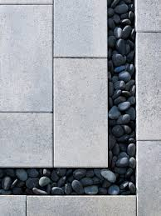

[[](https://www.lowes.com/pd/The-Modern-Yard-Chesnut-Brown-Concrete-Interlocking-Paver-Common-6-5-in-x-13-in-Actual-6-5-in-x-13-in/1002807674)](https://www.lowes.com/pd/The-Modern-Yard-Chesnut-Brown-Concrete-Interlocking-Paver-Common-6-5-in-x-13-in-Actual-6-5-in-x-13-in/1002807674" \o "Techo-Bloc Modern Yard Milan 13-in L x 6.5-in W x 2.375-in H Chesnut Brown Concrete  Interlocking Paver in the Pavers & Stepping Stones department at Lowes.com" \t "_blank)

[Lowe's](https://www.lowes.com/pd/The-Modern-Yard-Chesnut-Brown-Concrete-Interlocking-Paver-Common-6-5-in-x-13-in-Actual-6-5-in-x-13-in/1002807674" \o "Techo-Bloc Modern Yard Milan 13-in L x 6.5-in W x 2.375-in H Chesnut Brown Concrete  Interlocking Paver in the Pavers & Stepping Stones department at Lowes.com" \t "_blank)

[Techo-Bloc Modern Yard Milan 13-in L x ...](https://www.lowes.com/pd/The-Modern-Yard-Chesnut-Brown-Concrete-Interlocking-Paver-Common-6-5-in-x-13-in-Actual-6-5-in-x-13-in/1002807674" \o "Techo-Bloc Modern Yard Milan 13-in L x 6.5-in W x 2.375-in H Chesnut Brown Concrete  Interlocking Paver in the Pavers & Stepping Stones department at Lowes.com" \t "_blank)

**Cosmic Interlocking Paver ( Color Yellow) at Best Price in Patna | Rsd - Manufacturer Of Interlocking Paver & Chequered Tiles**

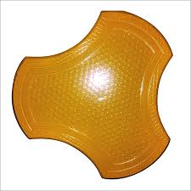

[[](https://www.tradeindia.com/products/cosmic-interlocking-paver-color-yellow-c3768238.html)](https://www.tradeindia.com/products/cosmic-interlocking-paver-color-yellow-c3768238.html" \o "Cosmic Interlocking Paver ( Color Yellow) at Best Price in Patna | Rsd -  Manufacturer Of Interlocking Paver & Chequered Tiles" \t "_blank)

[TradeIndia](https://www.tradeindia.com/products/cosmic-interlocking-paver-color-yellow-c3768238.html" \o "Cosmic Interlocking Paver ( Color Yellow) at Best Price in Patna | Rsd -  Manufacturer Of Interlocking Paver & Chequered Tiles" \t "_blank)

[Cosmic Interlocking Paver ( Color ...](https://www.tradeindia.com/products/cosmic-interlocking-paver-color-yellow-c3768238.html" \o "Cosmic Interlocking Paver ( Color Yellow) at Best Price in Patna | Rsd -  Manufacturer Of Interlocking Paver & Chequered Tiles" \t "_blank)

**Zigzag pavers | Pavers block | Pavers tiles in #Delhi #Noida. #ZigzagPavers #InterlockingTiles #PaversTiles #Flyas… | Interlocking pavers, Paver tiles, Paver blocks**

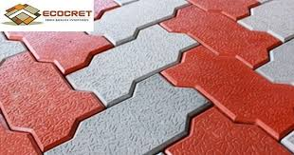

[[](https://www.pinterest.com/pin/830914199969567731/)](https://www.pinterest.com/pin/830914199969567731/" \o "Zigzag pavers | Pavers block | Pavers tiles in #Delhi #Noida. #ZigzagPavers  #InterlockingTiles #PaversTiles #Flyas… | Interlocking pavers, Paver tiles,  Paver blocks" \t "_blank)

[Pinterest](https://www.pinterest.com/pin/830914199969567731/" \o "Zigzag pavers | Pavers block | Pavers tiles in #Delhi #Noida. #ZigzagPavers  #InterlockingTiles #PaversTiles #Flyas… | Interlocking pavers, Paver tiles,  Paver blocks" \t "_blank)

[Interlocking pavers, Paver tiles ...](https://www.pinterest.com/pin/830914199969567731/" \o "Zigzag pavers | Pavers block | Pavers tiles in #Delhi #Noida. #ZigzagPavers  #InterlockingTiles #PaversTiles #Flyas… | Interlocking pavers, Paver tiles,  Paver blocks" \t "_blank)

**Interlocking Paver Block Latest Price from Manufacturers, Suppliers & Traders**

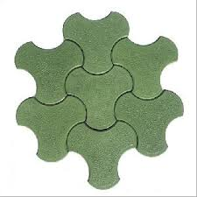

[[](https://www.exportersindia.com/indian-suppliers/interlocking-paver-block.htm)](https://www.exportersindia.com/indian-suppliers/interlocking-paver-block.htm" \o "Interlocking Paver Block Latest Price from Manufacturers, Suppliers &  Traders" \t "_blank)

[Exporters India](https://www.exportersindia.com/indian-suppliers/interlocking-paver-block.htm" \o "Interlocking Paver Block Latest Price from Manufacturers, Suppliers &  Traders" \t "_blank)

[Interlocking Paver Block Latest Price ...](https://www.exportersindia.com/indian-suppliers/interlocking-paver-block.htm" \o "Interlocking Paver Block Latest Price from Manufacturers, Suppliers &  Traders" \t "_blank)

**71,253 Interlocking Images, Stock Photos & Vectors | Shutterstock**



[[](https://www.shutterstock.com/search/interlocking)](https://www.shutterstock.com/search/interlocking" \o "71,253 Interlocking Images, Stock Photos & Vectors | Shutterstock" \t "_blank)

[Shutterstock](https://www.shutterstock.com/search/interlocking" \o "71,253 Interlocking Images, Stock Photos & Vectors | Shutterstock" \t "_blank)

[71,253 Interlocking Images, Stock ...](https://www.shutterstock.com/search/interlocking" \o "71,253 Interlocking Images, Stock Photos & Vectors | Shutterstock" \t "_blank)

Related searches

[[](https://www.google.com/search?q=paver%20tiles%20design&tbm=isch&hl=en&bih=722&biw=1519&rlz=1C1YTUH_enIN1004IN1004&sa=X&ved=0CNkBEKzcAigAahcKEwjA1_C0wZL9AhUAAAAAHQAAAAAQBA)](https://www.google.com/search?q=paver%20tiles%20design&tbm=isch&hl=en&bih=722&biw=1519&rlz=1C1YTUH_enIN1004IN1004&sa=X&ved=0CNkBEKzcAigAahcKEwjA1_C0wZL9AhUAAAAAHQAAAAAQBA)

**[paver](https://www.google.com/search?q=paver%20tiles%20design&tbm=isch&hl=en&bih=722&biw=1519&rlz=1C1YTUH_enIN1004IN1004&sa=X&ved=0CNkBEKzcAigAahcKEwjA1_C0wZL9AhUAAAAAHQAAAAAQBA)**[tiles](https://www.google.com/search?q=paver%20tiles%20design&tbm=isch&hl=en&bih=722&biw=1519&rlz=1C1YTUH_enIN1004IN1004&sa=X&ved=0CNkBEKzcAigAahcKEwjA1_C0wZL9AhUAAAAAHQAAAAAQBA)**[design](https://www.google.com/search?q=paver%20tiles%20design&tbm=isch&hl=en&bih=722&biw=1519&rlz=1C1YTUH_enIN1004IN1004&sa=X&ved=0CNkBEKzcAigAahcKEwjA1_C0wZL9AhUAAAAAHQAAAAAQBA)**

[[](https://www.google.com/search?q=dumble%20interlock%20tiles%20design%20in%20punjab&tbm=isch&hl=en&bih=722&biw=1519&rlz=1C1YTUH_enIN1004IN1004&sa=X&ved=0CNsBEKzcAigBahcKEwjA1_C0wZL9AhUAAAAAHQAAAAAQBA)](https://www.google.com/search?q=dumble%20interlock%20tiles%20design%20in%20punjab&tbm=isch&hl=en&bih=722&biw=1519&rlz=1C1YTUH_enIN1004IN1004&sa=X&ved=0CNsBEKzcAigBahcKEwjA1_C0wZL9AhUAAAAAHQAAAAAQBA)

**[dumble interlock](https://www.google.com/search?q=dumble%20interlock%20tiles%20design%20in%20punjab&tbm=isch&hl=en&bih=722&biw=1519&rlz=1C1YTUH_enIN1004IN1004&sa=X&ved=0CNsBEKzcAigBahcKEwjA1_C0wZL9AhUAAAAAHQAAAAAQBA)**[tiles](https://www.google.com/search?q=dumble%20interlock%20tiles%20design%20in%20punjab&tbm=isch&hl=en&bih=722&biw=1519&rlz=1C1YTUH_enIN1004IN1004&sa=X&ved=0CNsBEKzcAigBahcKEwjA1_C0wZL9AhUAAAAAHQAAAAAQBA)**[design in punjab](https://www.google.com/search?q=dumble%20interlock%20tiles%20design%20in%20punjab&tbm=isch&hl=en&bih=722&biw=1519&rlz=1C1YTUH_enIN1004IN1004&sa=X&ved=0CNsBEKzcAigBahcKEwjA1_C0wZL9AhUAAAAAHQAAAAAQBA)**

[[](https://www.google.com/search?q=house%20interlock%20design&tbm=isch&hl=en&bih=722&biw=1519&rlz=1C1YTUH_enIN1004IN1004&sa=X&ved=0CN0BEKzcAigCahcKEwjA1_C0wZL9AhUAAAAAHQAAAAAQBA)](https://www.google.com/search?q=house%20interlock%20design&tbm=isch&hl=en&bih=722&biw=1519&rlz=1C1YTUH_enIN1004IN1004&sa=X&ved=0CN0BEKzcAigCahcKEwjA1_C0wZL9AhUAAAAAHQAAAAAQBA)

[house interlock design](https://www.google.com/search?q=house%20interlock%20design&tbm=isch&hl=en&bih=722&biw=1519&rlz=1C1YTUH_enIN1004IN1004&sa=X&ved=0CN0BEKzcAigCahcKEwjA1_C0wZL9AhUAAAAAHQAAAAAQBA)

**Gardenised Gray Plastic Garden Path Track Interlocking Stone Look Design Pathway Tile Floor Paver (Pack of 4) QI004108.4 - The Home Depot**

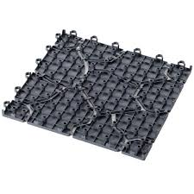

[[](https://www.homedepot.com/p/Gardenised-Gray-Plastic-Garden-Path-Track-Interlocking-Stone-Look-Design-Pathway-Tile-Floor-Paver-Pack-of-4-QI004108-4/317909834)](https://www.homedepot.com/p/Gardenised-Gray-Plastic-Garden-Path-Track-Interlocking-Stone-Look-Design-Pathway-Tile-Floor-Paver-Pack-of-4-QI004108-4/317909834" \o "Gardenised Gray Plastic Garden Path Track Interlocking Stone Look Design  Pathway Tile Floor Paver (Pack of 4) QI004108.4 - The Home Depot" \t "_blank)

[The Home Depot](https://www.homedepot.com/p/Gardenised-Gray-Plastic-Garden-Path-Track-Interlocking-Stone-Look-Design-Pathway-Tile-Floor-Paver-Pack-of-4-QI004108-4/317909834" \o "Gardenised Gray Plastic Garden Path Track Interlocking Stone Look Design  Pathway Tile Floor Paver (Pack of 4) QI004108.4 - The Home Depot" \t "_blank)

[Gardenised Gray Plastic Garden Path ...](https://www.homedepot.com/p/Gardenised-Gray-Plastic-Garden-Path-Track-Interlocking-Stone-Look-Design-Pathway-Tile-Floor-Paver-Pack-of-4-QI004108-4/317909834" \o "Gardenised Gray Plastic Garden Path Track Interlocking Stone Look Design  Pathway Tile Floor Paver (Pack of 4) QI004108.4 - The Home Depot" \t "_blank)

**Rodi Dust Cement Uni Paver Interlock Tiles, Thickness: 50 Mm at Rs 13/piece in Gurgaon**

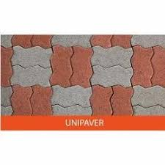

[[](https://www.indiamart.com/proddetail/uni-paver-interlock-tiles-23043476173.html)](https://www.indiamart.com/proddetail/uni-paver-interlock-tiles-23043476173.html" \o "Rodi Dust Cement Uni Paver Interlock Tiles, Thickness: 50 Mm at Rs 13/piece  in Gurgaon" \t "_blank)

[IndiaMART](https://www.indiamart.com/proddetail/uni-paver-interlock-tiles-23043476173.html" \o "Rodi Dust Cement Uni Paver Interlock Tiles, Thickness: 50 Mm at Rs 13/piece  in Gurgaon" \t "_blank)

[Rodi Dust Cement Uni Paver Interlock ...](https://www.indiamart.com/proddetail/uni-paver-interlock-tiles-23043476173.html" \o "Rodi Dust Cement Uni Paver Interlock Tiles, Thickness: 50 Mm at Rs 13/piece  in Gurgaon" \t "_blank)

**Seamless Ceramic Interlocking Paver Block in Nagpur at best price by Zeal Pavers and Tiles - Justdial**

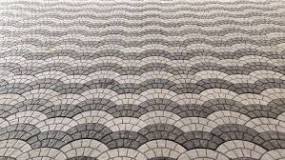

[[](https://www.justdial.com/jdmart/Nagpur/Seamless-Ceramic-Interlocking-Paver-Block/pid-800950265/0712PX712-X712-180720204101-B3J1?idx=0&flow=result)](https://www.justdial.com/jdmart/Nagpur/Seamless-Ceramic-Interlocking-Paver-Block/pid-800950265/0712PX712-X712-180720204101-B3J1?idx=0&flow=result" \o "Seamless Ceramic Interlocking Paver Block in Nagpur at best price by Zeal  Pavers and Tiles - Justdial" \t "_blank)

[Justdial](https://www.justdial.com/jdmart/Nagpur/Seamless-Ceramic-Interlocking-Paver-Block/pid-800950265/0712PX712-X712-180720204101-B3J1?idx=0&flow=result" \o "Seamless Ceramic Interlocking Paver Block in Nagpur at best price by Zeal  Pavers and Tiles - Justdial" \t "_blank)

[Seamless Ceramic Interlocking Paver ...](https://www.justdial.com/jdmart/Nagpur/Seamless-Ceramic-Interlocking-Paver-Block/pid-800950265/0712PX712-X712-180720204101-B3J1?idx=0&flow=result" \o "Seamless Ceramic Interlocking Paver Block in Nagpur at best price by Zeal  Pavers and Tiles - Justdial" \t "_blank)

**Area Of A Lock Pavement In Red And Yellow Color Stock Photo - Download Image Now - Asphalt, Asphalt Paving Machine, Block Shape - iStock**

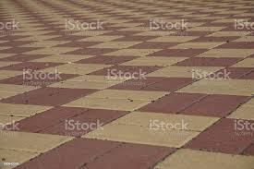

[[](https://www.istockphoto.com/photo/area-of-a-lock-pavement-in-red-and-yellow-color-gm530942076-93582693)](https://www.istockphoto.com/photo/area-of-a-lock-pavement-in-red-and-yellow-color-gm530942076-93582693" \o "Area Of A Lock Pavement In Red And Yellow Color Stock Photo - Download  Image Now - Asphalt, Asphalt Paving Machine, Block Shape - iStock" \t "_blank)

[iStock](https://www.istockphoto.com/photo/area-of-a-lock-pavement-in-red-and-yellow-color-gm530942076-93582693" \o "Area Of A Lock Pavement In Red And Yellow Color Stock Photo - Download  Image Now - Asphalt, Asphalt Paving Machine, Block Shape - iStock" \t "_blank)

[Asphalt, Asphalt Paving Machine ...](https://www.istockphoto.com/photo/area-of-a-lock-pavement-in-red-and-yellow-color-gm530942076-93582693" \o "Area Of A Lock Pavement In Red And Yellow Color Stock Photo - Download  Image Now - Asphalt, Asphalt Paving Machine, Block Shape - iStock" \t "_blank)

**Wholesale interlock paver tiles For Great Surface Protection - Alibaba.com**

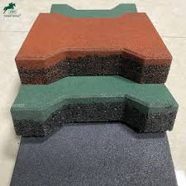

[[](https://www.alibaba.com/showroom/interlock-paver-tiles.html)](https://www.alibaba.com/showroom/interlock-paver-tiles.html" \o "Wholesale interlock paver tiles For Great Surface Protection - Alibaba.com" \t "_blank)

[Alibaba.com](https://www.alibaba.com/showroom/interlock-paver-tiles.html" \o "Wholesale interlock paver tiles For Great Surface Protection - Alibaba.com" \t "_blank)

[Wholesale interlock paver tiles For ...](https://www.alibaba.com/showroom/interlock-paver-tiles.html" \o "Wholesale interlock paver tiles For Great Surface Protection - Alibaba.com" \t "_blank)

**INTERLOCKING TILES ∕ PAVERS**

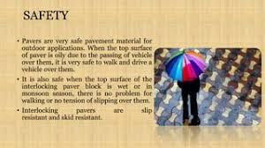

[[](https://www.slideshare.net/sanjeevsingh462/interlocking-tiles-pavers)](https://www.slideshare.net/sanjeevsingh462/interlocking-tiles-pavers" \o "INTERLOCKING TILES ∕ PAVERS" \t "_blank)

[SlideShare](https://www.slideshare.net/sanjeevsingh462/interlocking-tiles-pavers" \o "INTERLOCKING TILES ∕ PAVERS" \t "_blank)

[INTERLOCKING TILES ∕ PAVERS](https://www.slideshare.net/sanjeevsingh462/interlocking-tiles-pavers" \o "INTERLOCKING TILES ∕ PAVERS" \t "_blank)

**Plastic Molds for Precast Interlocking Pavers Tile Mold Price - China Interlocking Brick Paver Mold and Pavement Brick Moulds**

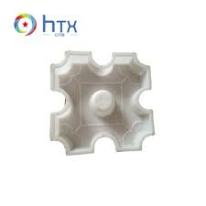

[[](https://zzhtxags.en.made-in-china.com/product/PSuJtdLMXCrW/China-Plastic-Molds-for-Precast-Interlocking-Pavers-Tile-Mold-Price.html)](https://zzhtxags.en.made-in-china.com/product/PSuJtdLMXCrW/China-Plastic-Molds-for-Precast-Interlocking-Pavers-Tile-Mold-Price.html" \o "Plastic Molds for Precast Interlocking Pavers Tile Mold Price - China  Interlocking Brick Paver Mold and Pavement Brick Moulds" \t "_blank)

[HENAN HTX GROUP CO., LTD.](https://zzhtxags.en.made-in-china.com/product/PSuJtdLMXCrW/China-Plastic-Molds-for-Precast-Interlocking-Pavers-Tile-Mold-Price.html" \o "Plastic Molds for Precast Interlocking Pavers Tile Mold Price - China  Interlocking Brick Paver Mold and Pavement Brick Moulds" \t "_blank)

[Plastic Molds for Precast Interlocking ...](https://zzhtxags.en.made-in-china.com/product/PSuJtdLMXCrW/China-Plastic-Molds-for-Precast-Interlocking-Pavers-Tile-Mold-Price.html" \o "Plastic Molds for Precast Interlocking Pavers Tile Mold Price - China  Interlocking Brick Paver Mold and Pavement Brick Moulds" \t "_blank)

**Reyal Plastic Star Paver Block Mould 60mm | DIY Paver Mould | For Outdoor Garden Road Paving Tiles : Amazon.in: Industrial & Scientific**

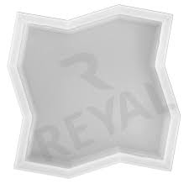

[[](https://www.amazon.in/Reyal-Plastic-Outdoor-Garden-Paving/dp/B09Q1YPWD4)](https://www.amazon.in/Reyal-Plastic-Outdoor-Garden-Paving/dp/B09Q1YPWD4" \o "Reyal Plastic Star Paver Block Mould 60mm | DIY Paver Mould | For Outdoor  Garden Road Paving Tiles : Amazon.in: Industrial & Scientific" \t "_blank)

[Amazon.in](https://www.amazon.in/Reyal-Plastic-Outdoor-Garden-Paving/dp/B09Q1YPWD4" \o "Reyal Plastic Star Paver Block Mould 60mm | DIY Paver Mould | For Outdoor  Garden Road Paving Tiles : Amazon.in: Industrial & Scientific" \t "_blank)

[Reyal Plastic Star Paver Block Mould ...](https://www.amazon.in/Reyal-Plastic-Outdoor-Garden-Paving/dp/B09Q1YPWD4" \o "Reyal Plastic Star Paver Block Mould 60mm | DIY Paver Mould | For Outdoor  Garden Road Paving Tiles : Amazon.in: Industrial & Scientific" \t "_blank)

**22pcs 12&#034;x12&#039;&#039; Outdoor Deck Tiles Interlocking Patio Wood Flooring Pavers Tiles | eBay**

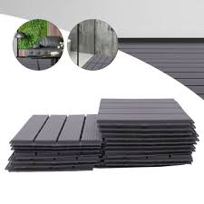

[[](https://www.ebay.com/itm/334535704639)](https://www.ebay.com/itm/334535704639" \o "22pcs 12&#034;x12&#039;&#039; Outdoor Deck Tiles Interlocking Patio Wood  Flooring Pavers Tiles | eBay" \t "_blank)

[eBay](https://www.ebay.com/itm/334535704639" \o "22pcs 12&#034;x12&#039;&#039; Outdoor Deck Tiles Interlocking Patio Wood  Flooring Pavers Tiles | eBay" \t "_blank)

[Outdoor Deck Tiles Interlocking Patio ...](https://www.ebay.com/itm/334535704639" \o "22pcs 12&#034;x12&#039;&#039; Outdoor Deck Tiles Interlocking Patio Wood  Flooring Pavers Tiles | eBay" \t "_blank)

**how to make glossy coloured interlock paver making easily - YouTube**

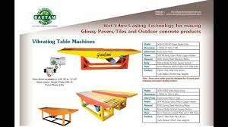

[[](https://www.youtube.com/watch?v=7PPBOGUF6a8)](https://www.youtube.com/watch?v=7PPBOGUF6a8" \o "how to make glossy coloured interlock paver making easily - YouTube" \t "_blank)

[YouTube](https://www.youtube.com/watch?v=7PPBOGUF6a8" \o "how to make glossy coloured interlock paver making easily - YouTube" \t "_blank)

[coloured interlock paver making ...](https://www.youtube.com/watch?v=7PPBOGUF6a8" \o "how to make glossy coloured interlock paver making easily - YouTube" \t "_blank)

**Reds / Pinks Outdoor Interlocking Paver Floor Tiles at Best Price in Bathinda | Manav Eco Pavers**

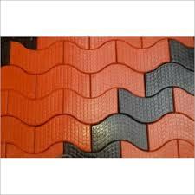

[[](https://www.tradeindia.com/products/outdoor-interlocking-paver-floor-tiles-c6462175.html)](https://www.tradeindia.com/products/outdoor-interlocking-paver-floor-tiles-c6462175.html" \o "Reds / Pinks Outdoor Interlocking Paver Floor Tiles at Best Price in  Bathinda | Manav Eco Pavers" \t "_blank)

[TradeIndia](https://www.tradeindia.com/products/outdoor-interlocking-paver-floor-tiles-c6462175.html" \o "Reds / Pinks Outdoor Interlocking Paver Floor Tiles at Best Price in  Bathinda | Manav Eco Pavers" \t "_blank)

[Pinks Outdoor Interlocking Paver Floor ...](https://www.tradeindia.com/products/outdoor-interlocking-paver-floor-tiles-c6462175.html" \o "Reds / Pinks Outdoor Interlocking Paver Floor Tiles at Best Price in  Bathinda | Manav Eco Pavers" \t "_blank)

**Oldcastle 84-Pack Trailway 24-in L x 13-in W x 2-in H Rio Concrete Interlocking Stepping Stone at Lowes.com**

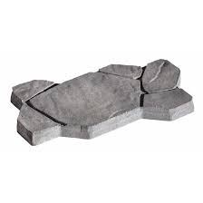

[[](https://www.lowes.com/pd/Oldcastle/5013649753)](https://www.lowes.com/pd/Oldcastle/5013649753" \o "Oldcastle 84-Pack Trailway 24-in L x 13-in W x 2-in H Rio Concrete  Interlocking Stepping Stone at Lowes.com" \t "_blank)

[Lowe's](https://www.lowes.com/pd/Oldcastle/5013649753" \o "Oldcastle 84-Pack Trailway 24-in L x 13-in W x 2-in H Rio Concrete  Interlocking Stepping Stone at Lowes.com" \t "_blank)

[Oldcastle 84-Pack Trailway 24-in L x 13 ...](https://www.lowes.com/pd/Oldcastle/5013649753" \o "Oldcastle 84-Pack Trailway 24-in L x 13-in W x 2-in H Rio Concrete  Interlocking Stepping Stone at Lowes.com" \t "_blank)

**Choose the Right Paving Tiles Designs - Charbhujatiles**

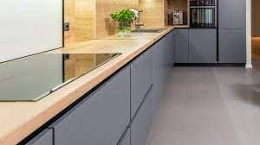

[[](https://charbhujatiles.com/blog-details/choose-the-right-paving-tiles-designs-with-these-useful-tips)](https://charbhujatiles.com/blog-details/choose-the-right-paving-tiles-designs-with-these-useful-tips" \o "Choose the Right Paving Tiles Designs - Charbhujatiles" \t "_blank)

[Charbhuja Tiles](https://charbhujatiles.com/blog-details/choose-the-right-paving-tiles-designs-with-these-useful-tips" \o "Choose the Right Paving Tiles Designs - Charbhujatiles" \t "_blank)

[Choose the Right Paving Tiles Designs ...](https://charbhujatiles.com/blog-details/choose-the-right-paving-tiles-designs-with-these-useful-tips" \o "Choose the Right Paving Tiles Designs - Charbhujatiles" \t "_blank)

**52 Best INTERLOCKING PAVERS ideas | interlocking pavers, pavers, paver**

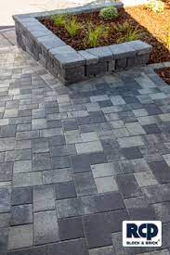

[[](https://www.pinterest.com/rcpblock/interlocking-pavers/)](https://www.pinterest.com/rcpblock/interlocking-pavers/" \o "52 Best INTERLOCKING PAVERS ideas | interlocking pavers, pavers, paver" \t "_blank)

[Pinterest](https://www.pinterest.com/rcpblock/interlocking-pavers/" \o "52 Best INTERLOCKING PAVERS ideas | interlocking pavers, pavers, paver" \t "_blank)

[52 Best INTERLOCKING PAVERS ideas ...](https://www.pinterest.com/rcpblock/interlocking-pavers/" \o "52 Best INTERLOCKING PAVERS ideas | interlocking pavers, pavers, paver" \t "_blank)

**Interlocking Pavers in Haryana - Manufacturers and Suppliers India**

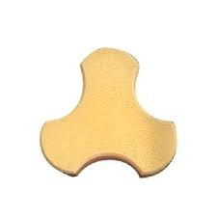

[[](https://www.exportersindia.com/haryana/interlocking-pavers.htm)](https://www.exportersindia.com/haryana/interlocking-pavers.htm" \o "Interlocking Pavers in Haryana - Manufacturers and Suppliers India" \t "_blank)

[Exporters India](https://www.exportersindia.com/haryana/interlocking-pavers.htm" \o "Interlocking Pavers in Haryana - Manufacturers and Suppliers India" \t "_blank)

[Interlocking Pavers in Haryana ...](https://www.exportersindia.com/haryana/interlocking-pavers.htm" \o "Interlocking Pavers in Haryana - Manufacturers and Suppliers India" \t "_blank)

**Holland 8.5 in. x 4.25 in. x 2.375 in. Rectangle Antique Copper Concrete Paver (400-Pieces/98 sq. ft./Pallet) HL602HOL6 - The Home Depot**

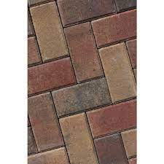

[[](https://www.homedepot.com/p/Holland-8-5-in-x-4-25-in-x-2-375-in-Rectangle-Antique-Copper-Concrete-Paver-400-Pieces-98-sq-ft-Pallet-HL602HOL6/316415119)](https://www.homedepot.com/p/Holland-8-5-in-x-4-25-in-x-2-375-in-Rectangle-Antique-Copper-Concrete-Paver-400-Pieces-98-sq-ft-Pallet-HL602HOL6/316415119" \o "Holland 8.5 in. x 4.25 in. x 2.375 in. Rectangle Antique Copper Concrete  Paver (400-Pieces/98 sq. ft./Pallet) HL602HOL6 - The Home Depot" \t "_blank)

[The Home Depot](https://www.homedepot.com/p/Holland-8-5-in-x-4-25-in-x-2-375-in-Rectangle-Antique-Copper-Concrete-Paver-400-Pieces-98-sq-ft-Pallet-HL602HOL6/316415119" \o "Holland 8.5 in. x 4.25 in. x 2.375 in. Rectangle Antique Copper Concrete  Paver (400-Pieces/98 sq. ft./Pallet) HL602HOL6 - The Home Depot" \t "_blank)

[Rectangle Antique Copper Concrete Paver ...](https://www.homedepot.com/p/Holland-8-5-in-x-4-25-in-x-2-375-in-Rectangle-Antique-Copper-Concrete-Paver-400-Pieces-98-sq-ft-Pallet-HL602HOL6/316415119" \o "Holland 8.5 in. x 4.25 in. x 2.375 in. Rectangle Antique Copper Concrete  Paver (400-Pieces/98 sq. ft./Pallet) HL602HOL6 - The Home Depot" \t "_blank)

**Top Interlocking Paver Tile Manufacturers in Azamgarh - इंटरलॉकिंग पावेर टाइल मनुफक्चरर्स, आजमगढ़ - Justdial**

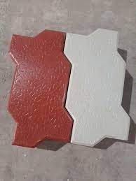

[[](https://www.justdial.com/Azamgarh/Interlocking-Paver-Tile-Manufacturers/nct-10951868)](https://www.justdial.com/Azamgarh/Interlocking-Paver-Tile-Manufacturers/nct-10951868" \o "Top Interlocking Paver Tile Manufacturers in Azamgarh - इंटरलॉकिंग पावेर  टाइल मनुफक्चरर्स, आजमगढ़ - Justdial" \t "_blank)

[Justdial](https://www.justdial.com/Azamgarh/Interlocking-Paver-Tile-Manufacturers/nct-10951868" \o "Top Interlocking Paver Tile Manufacturers in Azamgarh - इंटरलॉकिंग पावेर  टाइल मनुफक्चरर्स, आजमगढ़ - Justdial" \t "_blank)

[Interlocking Paver Tile Manufacturers ...](https://www.justdial.com/Azamgarh/Interlocking-Paver-Tile-Manufacturers/nct-10951868" \o "Top Interlocking Paver Tile Manufacturers in Azamgarh - इंटरलॉकिंग पावेर  टाइल मनुफक्चरर्स, आजमगढ़ - Justdial" \t "_blank)

**Red, Grey Interlocking Pavers Tiles, Usage: Landscaping at Rs 37/square feet in Sangrur**

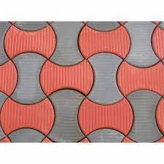

[[](https://www.indiamart.com/proddetail/interlocking-pavers-tiles-16666948162.html)](https://www.indiamart.com/proddetail/interlocking-pavers-tiles-16666948162.html" \o "Red, Grey Interlocking Pavers Tiles, Usage: Landscaping at Rs 37/square  feet in Sangrur" \t "_blank)

[IndiaMART](https://www.indiamart.com/proddetail/interlocking-pavers-tiles-16666948162.html" \o "Red, Grey Interlocking Pavers Tiles, Usage: Landscaping at Rs 37/square  feet in Sangrur" \t "_blank)

[Red, Grey Interlocking Pavers Tiles ...](https://www.indiamart.com/proddetail/interlocking-pavers-tiles-16666948162.html" \o "Red, Grey Interlocking Pavers Tiles, Usage: Landscaping at Rs 37/square  feet in Sangrur" \t "_blank)

**INTERLOCKING TILES ∕ PAVERS**

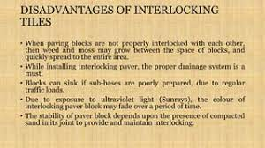

[[](https://www.slideshare.net/sanjeevsingh462/interlocking-tiles-pavers)](https://www.slideshare.net/sanjeevsingh462/interlocking-tiles-pavers" \o "INTERLOCKING TILES ∕ PAVERS" \t "_blank)

[SlideShare](https://www.slideshare.net/sanjeevsingh462/interlocking-tiles-pavers" \o "INTERLOCKING TILES ∕ PAVERS" \t "_blank)

[INTERLOCKING TILES ∕ PAVERS](https://www.slideshare.net/sanjeevsingh462/interlocking-tiles-pavers" \o "INTERLOCKING TILES ∕ PAVERS" \t "_blank)

**Plastic Molds for Precast Interlocking Pavers Tile Mold Price - China Interlocking Brick Paver Mold and Pavement Brick Moulds**

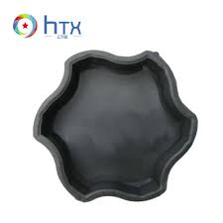

[[](https://zzhtxags.en.made-in-china.com/product/PSuJtdLMXCrW/China-Plastic-Molds-for-Precast-Interlocking-Pavers-Tile-Mold-Price.html)](https://zzhtxags.en.made-in-china.com/product/PSuJtdLMXCrW/China-Plastic-Molds-for-Precast-Interlocking-Pavers-Tile-Mold-Price.html" \o "Plastic Molds for Precast Interlocking Pavers Tile Mold Price - China  Interlocking Brick Paver Mold and Pavement Brick Moulds" \t "_blank)

[HENAN HTX GROUP CO., LTD.](https://zzhtxags.en.made-in-china.com/product/PSuJtdLMXCrW/China-Plastic-Molds-for-Precast-Interlocking-Pavers-Tile-Mold-Price.html" \o "Plastic Molds for Precast Interlocking Pavers Tile Mold Price - China  Interlocking Brick Paver Mold and Pavement Brick Moulds" \t "_blank)

[Plastic Molds for Precast Interlocking ...](https://zzhtxags.en.made-in-china.com/product/PSuJtdLMXCrW/China-Plastic-Molds-for-Precast-Interlocking-Pavers-Tile-Mold-Price.html" \o "Plastic Molds for Precast Interlocking Pavers Tile Mold Price - China  Interlocking Brick Paver Mold and Pavement Brick Moulds" \t "_blank)

**Outdoor Interlocking Flooring Tiles, Weather Resistant and Anti-Slip Patio Pavers, Outdoor Four Slat Plastic Composite Interlocking Composite Decking Tile, 12 Pieces : Amazon.in: Home Improvement**

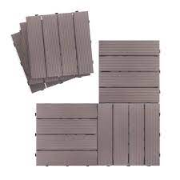

[[](https://www.amazon.in/ART-TO-REAL-Outdoor-Tiles/dp/B08DCVL14X)](https://www.amazon.in/ART-TO-REAL-Outdoor-Tiles/dp/B08DCVL14X" \o "Outdoor Interlocking Flooring Tiles, Weather Resistant and Anti-Slip Patio  Pavers, Outdoor Four Slat Plastic Composite Interlocking Composite Decking  Tile, 12 Pieces : Amazon.in: Home Improvement" \t "_blank)

[Amazon.in](https://www.amazon.in/ART-TO-REAL-Outdoor-Tiles/dp/B08DCVL14X" \o "Outdoor Interlocking Flooring Tiles, Weather Resistant and Anti-Slip Patio  Pavers, Outdoor Four Slat Plastic Composite Interlocking Composite Decking  Tile, 12 Pieces : Amazon.in: Home Improvement" \t "_blank)

[Outdoor Interlocking Flooring Tiles ...](https://www.amazon.in/ART-TO-REAL-Outdoor-Tiles/dp/B08DCVL14X" \o "Outdoor Interlocking Flooring Tiles, Weather Resistant and Anti-Slip Patio  Pavers, Outdoor Four Slat Plastic Composite Interlocking Composite Decking  Tile, 12 Pieces : Amazon.in: Home Improvement" \t "_blank)

**High Strength cobblestone interlocking pavers For DIYers and Pros - Alibaba.com**

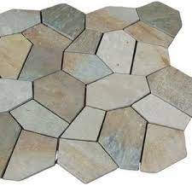

[[](https://www.alibaba.com/showroom/cobblestone-interlocking-pavers.html)](https://www.alibaba.com/showroom/cobblestone-interlocking-pavers.html" \o "High Strength cobblestone interlocking pavers For DIYers and Pros -  Alibaba.com" \t "_blank)

[Alibaba.com](https://www.alibaba.com/showroom/cobblestone-interlocking-pavers.html" \o "High Strength cobblestone interlocking pavers For DIYers and Pros -  Alibaba.com" \t "_blank)

[cobblestone interlocking pavers ...](https://www.alibaba.com/showroom/cobblestone-interlocking-pavers.html" \o "High Strength cobblestone interlocking pavers For DIYers and Pros -  Alibaba.com" \t "_blank)

**30Pcs Deck Patio Tile Interlocking PP Plastic Flooring Pavers Tiles Outdoor 12'' | eBay**

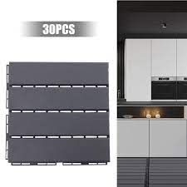

[[](https://www.ebay.com/itm/134378400068)](https://www.ebay.com/itm/134378400068" \o "30Pcs Deck Patio Tile Interlocking PP Plastic Flooring Pavers Tiles Outdoor  12'' | eBay" \t "_blank)

[eBay](https://www.ebay.com/itm/134378400068" \o "30Pcs Deck Patio Tile Interlocking PP Plastic Flooring Pavers Tiles Outdoor  12'' | eBay" \t "_blank)

[30Pcs Deck Patio Tile Interlocking PP ...](https://www.ebay.com/itm/134378400068" \o "30Pcs Deck Patio Tile Interlocking PP Plastic Flooring Pavers Tiles Outdoor  12'' | eBay" \t "_blank)

**I Dumble Interlocking Paver Block (Color -Red,Yellow) Application: Floor Tiles at Best Price in Patna | Rsd - Manufacturer Of Interlocking Paver & Chequered Tiles**

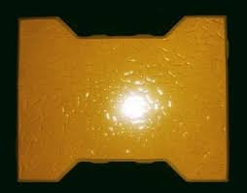

[[](https://www.tradeindia.com/products/i-dumble-interlocking-paver-block-color-red-yellow-4001772.html)](https://www.tradeindia.com/products/i-dumble-interlocking-paver-block-color-red-yellow-4001772.html" \o "I Dumble Interlocking Paver Block (Color -Red,Yellow) Application: Floor  Tiles at Best Price in Patna | Rsd - Manufacturer Of Interlocking Paver &  Chequered Tiles" \t "_blank)

[TradeIndia](https://www.tradeindia.com/products/i-dumble-interlocking-paver-block-color-red-yellow-4001772.html" \o "I Dumble Interlocking Paver Block (Color -Red,Yellow) Application: Floor  Tiles at Best Price in Patna | Rsd - Manufacturer Of Interlocking Paver &  Chequered Tiles" \t "_blank)

[Dumble Interlocking Paver Block (Color ...](https://www.tradeindia.com/products/i-dumble-interlocking-paver-block-color-red-yellow-4001772.html" \o "I Dumble Interlocking Paver Block (Color -Red,Yellow) Application: Floor  Tiles at Best Price in Patna | Rsd - Manufacturer Of Interlocking Paver &  Chequered Tiles" \t "_blank)

Popular searches

[[](https://www.google.com/search?q=interlock%20tiles%20price&tbm=isch&hl=en&bih=722&biw=1519&rlz=1C1YTUH_enIN1004IN1004&sa=X&ved=0CBoQrNwCKABqFwoTCMDX8LTBkv0CFQAAAAAdAAAAABAF)](https://www.google.com/search?q=interlock%20tiles%20price&tbm=isch&hl=en&bih=722&biw=1519&rlz=1C1YTUH_enIN1004IN1004&sa=X&ved=0CBoQrNwCKABqFwoTCMDX8LTBkv0CFQAAAAAdAAAAABAF)

**[interlock](https://www.google.com/search?q=interlock%20tiles%20price&tbm=isch&hl=en&bih=722&biw=1519&rlz=1C1YTUH_enIN1004IN1004&sa=X&ved=0CBoQrNwCKABqFwoTCMDX8LTBkv0CFQAAAAAdAAAAABAF)**[tiles](https://www.google.com/search?q=interlock%20tiles%20price&tbm=isch&hl=en&bih=722&biw=1519&rlz=1C1YTUH_enIN1004IN1004&sa=X&ved=0CBoQrNwCKABqFwoTCMDX8LTBkv0CFQAAAAAdAAAAABAF)**[price](https://www.google.com/search?q=interlock%20tiles%20price&tbm=isch&hl=en&bih=722&biw=1519&rlz=1C1YTUH_enIN1004IN1004&sa=X&ved=0CBoQrNwCKABqFwoTCMDX8LTBkv0CFQAAAAAdAAAAABAF)**

[[](https://www.google.com/search?q=paver%20tiles&tbm=isch&hl=en&bih=722&biw=1519&rlz=1C1YTUH_enIN1004IN1004&sa=X&ved=0CBwQrNwCKAFqFwoTCMDX8LTBkv0CFQAAAAAdAAAAABAF)](https://www.google.com/search?q=paver%20tiles&tbm=isch&hl=en&bih=722&biw=1519&rlz=1C1YTUH_enIN1004IN1004&sa=X&ved=0CBwQrNwCKAFqFwoTCMDX8LTBkv0CFQAAAAAdAAAAABAF)

**[paver](https://www.google.com/search?q=paver%20tiles&tbm=isch&hl=en&bih=722&biw=1519&rlz=1C1YTUH_enIN1004IN1004&sa=X&ved=0CBwQrNwCKAFqFwoTCMDX8LTBkv0CFQAAAAAdAAAAABAF)**[tiles](https://www.google.com/search?q=paver%20tiles&tbm=isch&hl=en&bih=722&biw=1519&rlz=1C1YTUH_enIN1004IN1004&sa=X&ved=0CBwQrNwCKAFqFwoTCMDX8LTBkv0CFQAAAAAdAAAAABAF)

[[](https://www.google.com/search?q=interlock%20tiles&tbm=isch&hl=en&bih=722&biw=1519&rlz=1C1YTUH_enIN1004IN1004&sa=X&ved=0CB4QrNwCKAJqFwoTCMDX8LTBkv0CFQAAAAAdAAAAABAF)](https://www.google.com/search?q=interlock%20tiles&tbm=isch&hl=en&bih=722&biw=1519&rlz=1C1YTUH_enIN1004IN1004&sa=X&ved=0CB4QrNwCKAJqFwoTCMDX8LTBkv0CFQAAAAAdAAAAABAF)

**[interlock](https://www.google.com/search?q=interlock%20tiles&tbm=isch&hl=en&bih=722&biw=1519&rlz=1C1YTUH_enIN1004IN1004&sa=X&ved=0CB4QrNwCKAJqFwoTCMDX8LTBkv0CFQAAAAAdAAAAABAF)**[tiles](https://www.google.com/search?q=interlock%20tiles&tbm=isch&hl=en&bih=722&biw=1519&rlz=1C1YTUH_enIN1004IN1004&sa=X&ved=0CB4QrNwCKAJqFwoTCMDX8LTBkv0CFQAAAAAdAAAAABAF)

**Wide Path City Park Paving Tiles Stock Photo 1488910424 | Shutterstock**

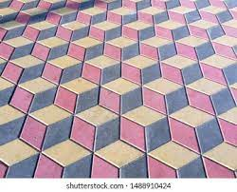

[[](https://www.shutterstock.com/image-photo/wide-path-city-park-paving-tiles-1488910424)](https://www.shutterstock.com/image-photo/wide-path-city-park-paving-tiles-1488910424" \o "Wide Path City Park Paving Tiles Stock Photo 1488910424 | Shutterstock" \t "_blank)

[Shutterstock](https://www.shutterstock.com/image-photo/wide-path-city-park-paving-tiles-1488910424" \o "Wide Path City Park Paving Tiles Stock Photo 1488910424 | Shutterstock" \t "_blank)

[Wide Path City Park Paving Tiles Stock ...](https://www.shutterstock.com/image-photo/wide-path-city-park-paving-tiles-1488910424" \o "Wide Path City Park Paving Tiles Stock Photo 1488910424 | Shutterstock" \t "_blank)

**Get latest designs of interlocking paver tiles & Zigzag pavers - Ecocret #ZigzagPavers #InterlockingTiles #Paver… | Interlocking pavers, Paver tiles, Fly ash bricks**

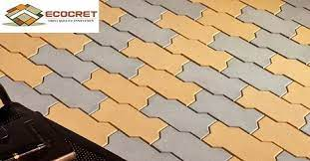

[[](https://www.pinterest.com/pin/get-latest-designs-of-interlocking-paver-tiles-zigzag-pavers-ecocret-zigzagpavers-interlockingtiles-paver--830914199969595969/)](https://www.pinterest.com/pin/get-latest-designs-of-interlocking-paver-tiles-zigzag-pavers-ecocret-zigzagpavers-interlockingtiles-paver--830914199969595969/" \o "Get latest designs of interlocking paver tiles & Zigzag pavers - Ecocret  #ZigzagPavers #InterlockingTiles #Paver… | Interlocking pavers, Paver tiles,  Fly ash bricks" \t "_blank)

[Pinterest](https://www.pinterest.com/pin/get-latest-designs-of-interlocking-paver-tiles-zigzag-pavers-ecocret-zigzagpavers-interlockingtiles-paver--830914199969595969/" \o "Get latest designs of interlocking paver tiles & Zigzag pavers - Ecocret  #ZigzagPavers #InterlockingTiles #Paver… | Interlocking pavers, Paver tiles,  Fly ash bricks" \t "_blank)

[Interlocking pavers, Paver tiles, Fly ...](https://www.pinterest.com/pin/get-latest-designs-of-interlocking-paver-tiles-zigzag-pavers-ecocret-zigzagpavers-interlockingtiles-paver--830914199969595969/" \o "Get latest designs of interlocking paver tiles & Zigzag pavers - Ecocret  #ZigzagPavers #InterlockingTiles #Paver… | Interlocking pavers, Paver tiles,  Fly ash bricks" \t "_blank)

**RCP Block & Brick - Bella Vista Catalan Pavers Color: Brownstone Pattern: Modified Basketweave https://www.rcpblock.com/pavers-catalan.html | Facebook**

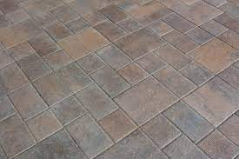

[[](https://m.facebook.com/rcpblock/photos/a.10155930173362294/10158279562182294/)](https://m.facebook.com/rcpblock/photos/a.10155930173362294/10158279562182294/" \o "RCP Block & Brick - Bella Vista Catalan Pavers Color: Brownstone Pattern:  Modified Basketweave https://www.rcpblock.com/pavers-catalan.html | Facebook" \t "_blank)

[Facebook](https://m.facebook.com/rcpblock/photos/a.10155930173362294/10158279562182294/" \o "RCP Block & Brick - Bella Vista Catalan Pavers Color: Brownstone Pattern:  Modified Basketweave https://www.rcpblock.com/pavers-catalan.html | Facebook" \t "_blank)

[RCP Block & Brick - Bella Vista Catalan ...](https://m.facebook.com/rcpblock/photos/a.10155930173362294/10158279562182294/" \o "RCP Block & Brick - Bella Vista Catalan Pavers Color: Brownstone Pattern:  Modified Basketweave https://www.rcpblock.com/pavers-catalan.html | Facebook" \t "_blank)

**Holland 8.5 in. x 4.25 in. x 2.375 in. Rectangle Moonlight Gray Concrete Paver (400-Pieces/98 sq. ft./Pallet) HL607HOL6 - The Home Depot**

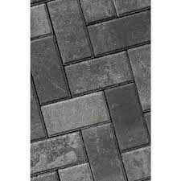

[[](https://www.homedepot.com/p/Holland-8-5-in-x-4-25-in-x-2-375-in-Rectangle-Moonlight-Gray-Concrete-Paver-400-Pieces-98-sq-ft-Pallet-HL607HOL6/316415016)](https://www.homedepot.com/p/Holland-8-5-in-x-4-25-in-x-2-375-in-Rectangle-Moonlight-Gray-Concrete-Paver-400-Pieces-98-sq-ft-Pallet-HL607HOL6/316415016" \o "Holland 8.5 in. x 4.25 in. x 2.375 in. Rectangle Moonlight Gray Concrete  Paver (400-Pieces/98 sq. ft./Pallet) HL607HOL6 - The Home Depot" \t "_blank)

[The Home Depot](https://www.homedepot.com/p/Holland-8-5-in-x-4-25-in-x-2-375-in-Rectangle-Moonlight-Gray-Concrete-Paver-400-Pieces-98-sq-ft-Pallet-HL607HOL6/316415016" \o "Holland 8.5 in. x 4.25 in. x 2.375 in. Rectangle Moonlight Gray Concrete  Paver (400-Pieces/98 sq. ft./Pallet) HL607HOL6 - The Home Depot" \t "_blank)

[Rectangle Moonlight Gray Concrete Paver ...](https://www.homedepot.com/p/Holland-8-5-in-x-4-25-in-x-2-375-in-Rectangle-Moonlight-Gray-Concrete-Paver-400-Pieces-98-sq-ft-Pallet-HL607HOL6/316415016" \o "Holland 8.5 in. x 4.25 in. x 2.375 in. Rectangle Moonlight Gray Concrete  Paver (400-Pieces/98 sq. ft./Pallet) HL607HOL6 - The Home Depot" \t "_blank)

**Riccobene Terra Shell (Cobble Systems) 23.5-in L x 12.25-in W x 1-in H Slate Concrete Interlocking Patio Stone in the Pavers & Stepping Stones department at Lowes.com**

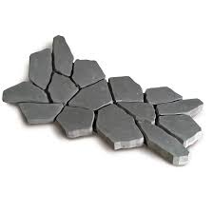

[[](https://www.lowes.com/pd/Riccobene-Terra-Shell-Articulating-Paving-Mat-Slate-Light-Gray-Concrete-Patio-Stone-Common-12-25-in-x-23-5-in-Actual-12-25-in-x-23-5-in/1001857612)](https://www.lowes.com/pd/Riccobene-Terra-Shell-Articulating-Paving-Mat-Slate-Light-Gray-Concrete-Patio-Stone-Common-12-25-in-x-23-5-in-Actual-12-25-in-x-23-5-in/1001857612" \o "Riccobene Terra Shell (Cobble Systems) 23.5-in L x 12.25-in W x 1-in H  Slate Concrete Interlocking Patio Stone in the Pavers & Stepping Stones  department at Lowes.com" \t "_blank)

[Lowe's](https://www.lowes.com/pd/Riccobene-Terra-Shell-Articulating-Paving-Mat-Slate-Light-Gray-Concrete-Patio-Stone-Common-12-25-in-x-23-5-in-Actual-12-25-in-x-23-5-in/1001857612" \o "Riccobene Terra Shell (Cobble Systems) 23.5-in L x 12.25-in W x 1-in H  Slate Concrete Interlocking Patio Stone in the Pavers & Stepping Stones  department at Lowes.com" \t "_blank)

[Riccobene Terra Shell (Cobble Systems ...](https://www.lowes.com/pd/Riccobene-Terra-Shell-Articulating-Paving-Mat-Slate-Light-Gray-Concrete-Patio-Stone-Common-12-25-in-x-23-5-in-Actual-12-25-in-x-23-5-in/1001857612" \o "Riccobene Terra Shell (Cobble Systems) 23.5-in L x 12.25-in W x 1-in H  Slate Concrete Interlocking Patio Stone in the Pavers & Stepping Stones  department at Lowes.com" \t "_blank)

**Top Interlocking Paver Tile Manufacturers in Jammu - इंटरलॉकिंग पावेर टाइल मनुफक्चरर्स, जम्मू - Justdial**

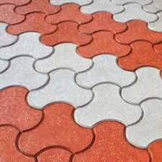

[[](https://www.justdial.com/Jammu/Interlocking-Paver-Tile-Manufacturers/nct-10951868)](https://www.justdial.com/Jammu/Interlocking-Paver-Tile-Manufacturers/nct-10951868" \o "Top Interlocking Paver Tile Manufacturers in Jammu - इंटरलॉकिंग पावेर टाइल  मनुफक्चरर्स, जम्मू - Justdial" \t "_blank)

[Justdial](https://www.justdial.com/Jammu/Interlocking-Paver-Tile-Manufacturers/nct-10951868" \o "Top Interlocking Paver Tile Manufacturers in Jammu - इंटरलॉकिंग पावेर टाइल  मनुफक्चरर्स, जम्मू - Justdial" \t "_blank)

[Interlocking Paver Tile Manufacturers ...](https://www.justdial.com/Jammu/Interlocking-Paver-Tile-Manufacturers/nct-10951868" \o "Top Interlocking Paver Tile Manufacturers in Jammu - इंटरलॉकिंग पावेर टाइल  मनुफक्चरर्स, जम्मू - Justdial" \t "_blank)

**Cosmic Design Paver Interlocking Tiles For Pavement, Thickness: 60 mm at Rs 18/piece in Saharanpur**

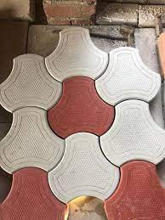

[[](https://www.indiamart.com/proddetail/cosmic-design-paver-interlocking-tiles-20574791591.html)](https://www.indiamart.com/proddetail/cosmic-design-paver-interlocking-tiles-20574791591.html" \o "Cosmic Design Paver Interlocking Tiles For Pavement, Thickness: 60 mm at Rs  18/piece in Saharanpur" \t "_blank)

[IndiaMART](https://www.indiamart.com/proddetail/cosmic-design-paver-interlocking-tiles-20574791591.html" \o "Cosmic Design Paver Interlocking Tiles For Pavement, Thickness: 60 mm at Rs  18/piece in Saharanpur" \t "_blank)

[Cosmic Design Paver Interlocking Tiles ...](https://www.indiamart.com/proddetail/cosmic-design-paver-interlocking-tiles-20574791591.html" \o "Cosmic Design Paver Interlocking Tiles For Pavement, Thickness: 60 mm at Rs  18/piece in Saharanpur" \t "_blank)

**INTERLOCKING TILES ∕ PAVERS**

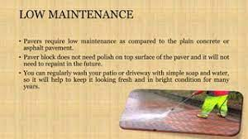

[[](https://www.slideshare.net/sanjeevsingh462/interlocking-tiles-pavers)](https://www.slideshare.net/sanjeevsingh462/interlocking-tiles-pavers" \o "INTERLOCKING TILES ∕ PAVERS" \t "_blank)

[SlideShare](https://www.slideshare.net/sanjeevsingh462/interlocking-tiles-pavers" \o "INTERLOCKING TILES ∕ PAVERS" \t "_blank)

[INTERLOCKING TILES ∕ PAVERS](https://www.slideshare.net/sanjeevsingh462/interlocking-tiles-pavers" \o "INTERLOCKING TILES ∕ PAVERS" \t "_blank)

**Hot! ! ! DIY WPC Garden DIY Interlocking Nature Stone Tiles Price for Engineer Exterior Flooring - China DIY Stone Tiles and Interlock Stone Flooring**

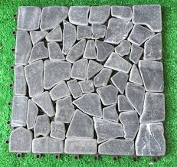

[[](https://www.made-in-china.com/showroom/merry1986/product-detailTXExRngDTOVJ/China-Hot-DIY-WPC-Garden-DIY-Interlocking-Nature-Stone-Tiles-Price-for-Engineer-Exterior-Flooring.html)](https://www.made-in-china.com/showroom/merry1986/product-detailTXExRngDTOVJ/China-Hot-DIY-WPC-Garden-DIY-Interlocking-Nature-Stone-Tiles-Price-for-Engineer-Exterior-Flooring.html" \o "Hot! ! ! DIY WPC Garden DIY Interlocking Nature Stone Tiles Price for  Engineer Exterior Flooring - China DIY Stone Tiles and Interlock Stone  Flooring" \t "_blank)

[Made-in-China.com](https://www.made-in-china.com/showroom/merry1986/product-detailTXExRngDTOVJ/China-Hot-DIY-WPC-Garden-DIY-Interlocking-Nature-Stone-Tiles-Price-for-Engineer-Exterior-Flooring.html" \o "Hot! ! ! DIY WPC Garden DIY Interlocking Nature Stone Tiles Price for  Engineer Exterior Flooring - China DIY Stone Tiles and Interlock Stone  Flooring" \t "_blank)

[Stone Tiles and Interlock Stone Flooring](https://www.made-in-china.com/showroom/merry1986/product-detailTXExRngDTOVJ/China-Hot-DIY-WPC-Garden-DIY-Interlocking-Nature-Stone-Tiles-Price-for-Engineer-Exterior-Flooring.html" \o "Hot! ! ! DIY WPC Garden DIY Interlocking Nature Stone Tiles Price for  Engineer Exterior Flooring - China DIY Stone Tiles and Interlock Stone  Flooring" \t "_blank)

**Reyal Plastic Damru Paver Block Mould 60mm | DIY Paver Mould | For Outdoor Garden Road Paving Tiles : Amazon.in: Industrial & Scientific**



[[](https://www.amazon.in/Reyal-Plastic-Outdoor-Garden-Paving/dp/B09Q213R65)](https://www.amazon.in/Reyal-Plastic-Outdoor-Garden-Paving/dp/B09Q213R65" \o "Reyal Plastic Damru Paver Block Mould 60mm | DIY Paver Mould | For Outdoor  Garden Road Paving Tiles : Amazon.in: Industrial & Scientific" \t "_blank)

[Amazon.in](https://www.amazon.in/Reyal-Plastic-Outdoor-Garden-Paving/dp/B09Q213R65" \o "Reyal Plastic Damru Paver Block Mould 60mm | DIY Paver Mould | For Outdoor  Garden Road Paving Tiles : Amazon.in: Industrial & Scientific" \t "_blank)

[Reyal Plastic Damru Paver Block Mould ...](https://www.amazon.in/Reyal-Plastic-Outdoor-Garden-Paving/dp/B09Q213R65" \o "Reyal Plastic Damru Paver Block Mould 60mm | DIY Paver Mould | For Outdoor  Garden Road Paving Tiles : Amazon.in: Industrial & Scientific" \t "_blank)

**Color Concrete Interlock Paver Tile Holo Blocks Making Machine - Buy Holo Blocks Machine,Interlock Tile Making Machine,Color Concrete Paver Block Making Machine Product on Alibaba.com**

[Alibaba](https://www.alibaba.com/product-detail/Color-Concrete-Interlock-Paver-Tile-Holo_1600230269896.html" \o "Color Concrete Interlock Paver Tile Holo Blocks Making Machine - Buy Holo  Blocks Machine,Interlock Tile Making Machine,Color Concrete Paver Block  Making Machine Product on Alibaba.com" \t "_blank)

[Color Concrete Interlock Paver Tile ...](https://www.alibaba.com/product-detail/Color-Concrete-Interlock-Paver-Tile-Holo_1600230269896.html" \o "Color Concrete Interlock Paver Tile Holo Blocks Making Machine - Buy Holo  Blocks Machine,Interlock Tile Making Machine,Color Concrete Paver Block  Making Machine Product on Alibaba.com" \t "_blank)

**Interlocking Designer Square Paver Application: Floor Tiles at Best Price in Gurugram | R.S.D. Pavers**

[TradeIndia](https://www.tradeindia.com/products/interlocking-designer-square-paver-1720007.html" \o "Interlocking Designer Square Paver Application: Floor Tiles at Best Price  in Gurugram | R.S.D. Pavers" \t "_blank)

[Interlocking Designer Square Paver ...](https://www.tradeindia.com/products/interlocking-designer-square-paver-1720007.html" \o "Interlocking Designer Square Paver Application: Floor Tiles at Best Price  in Gurugram | R.S.D. Pavers" \t "_blank)

**Charcoal grey pavers – McNear Brick and Block | Interlocking pavers, Outdoor pavers, Color textures**

[Pinterest](https://www.pinterest.com/pin/320318592249183157/" \o "Charcoal grey pavers – McNear Brick and Block | Interlocking pavers,  Outdoor pavers, Color textures" \t "_blank)

[Interlocking pavers ...](https://www.pinterest.com/pin/320318592249183157/" \o "Charcoal grey pavers – McNear Brick and Block | Interlocking pavers,  Outdoor pavers, Color textures" \t "_blank)

**CONCRETE PAVING INTERLOCKING GARDEN PATH SLAB BRICK PLASTIC FLOOR TILE MOULD | eBay**

[eBay](https://www.ebay.com/itm/321695093703" \o "CONCRETE PAVING INTERLOCKING GARDEN PATH SLAB BRICK PLASTIC FLOOR TILE  MOULD | eBay" \t "_blank)

[CONCRETE PAVING INTERLOCKING GARDEN ...](https://www.ebay.com/itm/321695093703" \o "CONCRETE PAVING INTERLOCKING GARDEN PATH SLAB BRICK PLASTIC FLOOR TILE  MOULD | eBay" \t "_blank)

**Top Interlocking Paver Tile Manufacturers in Nagpur - इंटरलॉकिंग पावेर टाइल मनुफक्चरर्स, नागपुर - Justdial**

[Justdial](https://www.justdial.com/Nagpur/Interlocking-Paver-Tile-Manufacturers/nct-10951868" \o "Top Interlocking Paver Tile Manufacturers in Nagpur - इंटरलॉकिंग पावेर टाइल  मनुफक्चरर्स, नागपुर - Justdial" \t "_blank)

[Interlocking Paver Tile Manufacturers ...](https://www.justdial.com/Nagpur/Interlocking-Paver-Tile-Manufacturers/nct-10951868" \o "Top Interlocking Paver Tile Manufacturers in Nagpur - इंटरलॉकिंग पावेर टाइल  मनुफक्चरर्स, नागपुर - Justdial" \t "_blank)

**Grey Concrete Interlocking Tiles Paver, For Pavement, Thickness: 60 at Rs 33/sq ft in New Delhi**

[IndiaMART](https://www.indiamart.com/proddetail/interlocking-tiles-paver-25630494255.html" \o "Grey Concrete Interlocking Tiles Paver, For Pavement, Thickness: 60 at Rs  33/sq ft in New Delhi" \t "_blank)

[Grey Concrete Interlocking Tiles Paver ...](https://www.indiamart.com/proddetail/interlocking-tiles-paver-25630494255.html" \o "Grey Concrete Interlocking Tiles Paver, For Pavement, Thickness: 60 at Rs  33/sq ft in New Delhi" \t "_blank)

**INTERLOCKING TILES ∕ PAVERS**

[SlideShare](https://www.slideshare.net/sanjeevsingh462/interlocking-tiles-pavers" \o "INTERLOCKING TILES ∕ PAVERS" \t "_blank)

[INTERLOCKING TILES ∕ PAVERS](https://www.slideshare.net/sanjeevsingh462/interlocking-tiles-pavers" \o "INTERLOCKING TILES ∕ PAVERS" \t "_blank)

**Plastic Paving Stone Forming Interlock Paver Tile Moulds - China Paver Molds and PVC Paver Mould**

[ZHENGZHOU LYA MACHINERY CO., LTD.](https://zzlyags.en.made-in-china.com/product/SvBEOXKjkLrx/China-Plastic-Paving-Stone-Forming-Interlock-Paver-Tile-Moulds.html" \o "Plastic Paving Stone Forming Interlock Paver Tile Moulds - China Paver  Molds and PVC Paver Mould" \t "_blank)

[Interlock Paver Tile Moulds ...](https://zzlyags.en.made-in-china.com/product/SvBEOXKjkLrx/China-Plastic-Paving-Stone-Forming-Interlock-Paver-Tile-Moulds.html" \o "Plastic Paving Stone Forming Interlock Paver Tile Moulds - China Paver  Molds and PVC Paver Mould" \t "_blank)

**Reyal Plastic Cosmic Paver Block Mould 60mm | DIY Paver Mould | for Outdoor Garden Road Paving Tiles : Amazon.in: Industrial & Scientific**

[Amazon.in](https://www.amazon.in/Reyal-Plastic-Cosmic-Paver-Mould/dp/B094FQXX2W" \o "Reyal Plastic Cosmic Paver Block Mould 60mm | DIY Paver Mould | for Outdoor  Garden Road Paving Tiles : Amazon.in: Industrial & Scientific" \t "_blank)

[Reyal Plastic Cosmic Paver Block Mould ...](https://www.amazon.in/Reyal-Plastic-Cosmic-Paver-Mould/dp/B094FQXX2W" \o "Reyal Plastic Cosmic Paver Block Mould 60mm | DIY Paver Mould | for Outdoor  Garden Road Paving Tiles : Amazon.in: Industrial & Scientific" \t "_blank)

**Zebra Interlocking Paver (Color Yellow, Red) at Best Price in Patna | Rsd - Manufacturer Of Interlocking Paver & Chequered Tiles**

[TradeIndia](https://www.tradeindia.com/products/zebra-interlocking-paver-color-yellow-red-c3768248.html" \o "Zebra Interlocking Paver (Color Yellow, Red) at Best Price in Patna | Rsd -  Manufacturer Of Interlocking Paver & Chequered Tiles" \t "_blank)

[Zebra Interlocking Paver (Color Yellow ...](https://www.tradeindia.com/products/zebra-interlocking-paver-color-yellow-red-c3768248.html" \o "Zebra Interlocking Paver (Color Yellow, Red) at Best Price in Patna | Rsd -  Manufacturer Of Interlocking Paver & Chequered Tiles" \t "_blank)

**We provide you a vast range of Interlocking Paver Block PVC Mould, PVC Kerbstone Mould Manufacturers, PVC Door Fr… | Paver blocks, Door frame molding, Paving design**

[Pinterest](https://www.pinterest.com/pin/559150109978642771/" \o "We provide you a vast range of Interlocking Paver Block PVC Mould, PVC  Kerbstone Mould Manufacturers, PVC Door Fr… | Paver blocks, Door frame  molding, Paving design" \t "_blank)

[Interlocking Paver Block PVC Mould ...](https://www.pinterest.com/pin/559150109978642771/" \o "We provide you a vast range of Interlocking Paver Block PVC Mould, PVC  Kerbstone Mould Manufacturers, PVC Door Fr… | Paver blocks, Door frame  molding, Paving design" \t "_blank)

**Natural Stone Tiles Seamless Texture Granite Stock Photo 1460340482 | Shutterstock**

[Shutterstock](https://www.shutterstock.com/image-photo/natural-stone-tiles-seamless-texture-granite-1460340482" \o "Natural Stone Tiles Seamless Texture Granite Stock Photo 1460340482 |  Shutterstock" \t "_blank)

[Natural Stone Tiles Seamless Texture ...](https://www.shutterstock.com/image-photo/natural-stone-tiles-seamless-texture-granite-1460340482" \o "Natural Stone Tiles Seamless Texture Granite Stock Photo 1460340482 |  Shutterstock" \t "_blank)

**CONCRETE INTERLOCKING PAVING GARDEN MOULD FLOOR TILE BRICK best price | eBay**

[eBay](https://www.ebay.com/itm/CONCRETE-INTERLOCKING-PAVING-GARDEN-MOULD-FLOOR-TILE-BRICK-best-price-/263191307612" \o "CONCRETE INTERLOCKING PAVING GARDEN MOULD FLOOR TILE BRICK best price | eBay" \t "_blank)

[CONCRETE INTERLOCKING PAVING GARDEN ...](https://www.ebay.com/itm/CONCRETE-INTERLOCKING-PAVING-GARDEN-MOULD-FLOOR-TILE-BRICK-best-price-/263191307612" \o "CONCRETE INTERLOCKING PAVING GARDEN MOULD FLOOR TILE BRICK best price | eBay" \t "_blank)

**Top Interlocking Paver Tile Dealers in Mangalore - इंटरलॉकिंग पावेर टाइल डीलर्स, मंगलौर - Justdial**

[Justdial](https://www.justdial.com/Mangalore/Interlocking-Paver-Tile-Dealers/nct-10946805" \o "Top Interlocking Paver Tile Dealers in Mangalore - इंटरलॉकिंग पावेर टाइल  डीलर्स, मंगलौर - Justdial" \t "_blank)

[Top Interlocking Paver Tile Dealers in ...](https://www.justdial.com/Mangalore/Interlocking-Paver-Tile-Dealers/nct-10946805" \o "Top Interlocking Paver Tile Dealers in Mangalore - इंटरलॉकिंग पावेर टाइल  डीलर्स, मंगलौर - Justdial" \t "_blank)

Popular searches

[paver block](https://www.google.com/search?q=paver%20block&tbm=isch&hl=en&bih=722&biw=1519&rlz=1C1YTUH_enIN1004IN1004&sa=X&ved=0CFIQrNwCKABqFwoTCMDX8LTBkv0CFQAAAAAdAAAAABAF)

[interlock colors](https://www.google.com/search?q=interlock%20colors&tbm=isch&hl=en&bih=722&biw=1519&rlz=1C1YTUH_enIN1004IN1004&sa=X&ved=0CFQQrNwCKAFqFwoTCMDX8LTBkv0CFQAAAAAdAAAAABAF)

**[paving interlock](https://www.google.com/search?q=paving%20interlock%20tiles%20texture&tbm=isch&hl=en&bih=722&biw=1519&rlz=1C1YTUH_enIN1004IN1004&sa=X&ved=0CFYQrNwCKAJqFwoTCMDX8LTBkv0CFQAAAAAdAAAAABAF)**[tiles](https://www.google.com/search?q=paving%20interlock%20tiles%20texture&tbm=isch&hl=en&bih=722&biw=1519&rlz=1C1YTUH_enIN1004IN1004&sa=X&ved=0CFYQrNwCKAJqFwoTCMDX8LTBkv0CFQAAAAAdAAAAABAF)**[texture](https://www.google.com/search?q=paving%20interlock%20tiles%20texture&tbm=isch&hl=en&bih=722&biw=1519&rlz=1C1YTUH_enIN1004IN1004&sa=X&ved=0CFYQrNwCKAJqFwoTCMDX8LTBkv0CFQAAAAAdAAAAABAF)**

**Red And Grey Concrete Interlocking Paver Tile, For Flooring, Thickness: 12 - 14 Mm at Rs 14/piece in Jalandhar**

[IndiaMART](https://www.indiamart.com/proddetail/concrete-interlocking-paver-tile-21867008233.html" \o "Red And Grey Concrete Interlocking Paver Tile, For Flooring, Thickness: 12  - 14 Mm at Rs 14/piece in Jalandhar" \t "_blank)

[Grey Concrete Interlocking Paver Tile ...](https://www.indiamart.com/proddetail/concrete-interlocking-paver-tile-21867008233.html" \o "Red And Grey Concrete Interlocking Paver Tile, For Flooring, Thickness: 12  - 14 Mm at Rs 14/piece in Jalandhar" \t "_blank)

**INTERLOCKING TILES ∕ PAVERS**

[SlideShare](https://www.slideshare.net/sanjeevsingh462/interlocking-tiles-pavers" \o "INTERLOCKING TILES ∕ PAVERS" \t "_blank)

[INTERLOCKING TILES ∕ PAVERS](https://www.slideshare.net/sanjeevsingh462/interlocking-tiles-pavers" \o "INTERLOCKING TILES ∕ PAVERS" \t "_blank)

**Interlocking Paver Tile Concrete Stone Plastic Rubber Molds Nigeria - China Paver Molds and Pavement Brick Moulds**

[HENAN HTX GROUP CO., LTD.](https://zzhtxags.en.made-in-china.com/product/ZBIQDkNKQwUv/China-Interlocking-Paver-Tile-Concrete-Stone-Plastic-Rubber-Molds-Nigeria.html" \o "Interlocking Paver Tile Concrete Stone Plastic Rubber Molds Nigeria - China  Paver Molds and Pavement Brick Moulds" \t "_blank)

[Interlocking Paver Tile Concrete Stone ...](https://zzhtxags.en.made-in-china.com/product/ZBIQDkNKQwUv/China-Interlocking-Paver-Tile-Concrete-Stone-Plastic-Rubber-Molds-Nigeria.html" \o "Interlocking Paver Tile Concrete Stone Plastic Rubber Molds Nigeria - China  Paver Molds and Pavement Brick Moulds" \t "_blank)

**PURE ERA Pebble Interlocking Floor Deck Tiles Polished Real Stone Tile Indoor Outdoor Use 11.8”x11.8” (4Pcs, 4 sq. Ft, Polished Mixed Color)- Great Upgrade to Patio Backyard Pathway : Amazon.ca: Tools &**

[Amazon.ca](https://www.amazon.ca/PURE-ERA-Interlocking-Polished-Backyard/dp/B097N8Q4K6" \o "PURE ERA Pebble Interlocking Floor Deck Tiles Polished Real Stone Tile  Indoor Outdoor Use 11.8\”x11.8\” (4Pcs, 4 sq. Ft, Polished Mixed Color)-  Great Upgrade to Patio Backyard Pathway : Amazon.ca: Tools &" \t "_blank)

[Pebble Interlocking Floor Deck Tiles ...](https://www.amazon.ca/PURE-ERA-Interlocking-Polished-Backyard/dp/B097N8Q4K6" \o "PURE ERA Pebble Interlocking Floor Deck Tiles Polished Real Stone Tile  Indoor Outdoor Use 11.8\”x11.8\” (4Pcs, 4 sq. Ft, Polished Mixed Color)-  Great Upgrade to Patio Backyard Pathway : Amazon.ca: Tools &" \t "_blank)

**Paving Round Dumble Interlocking Pavers (Color Grey) 60Mm at Best Price in Patna | Rsd - Manufacturer Of Interlocking Paver & Chequered Tiles**

[TradeIndia](https://www.tradeindia.com/products/round-dumble-interlocking-pavers-color-grey-60mm-4141948.html" \o "Paving Round Dumble Interlocking Pavers (Color Grey) 60Mm at Best Price in  Patna | Rsd - Manufacturer Of Interlocking Paver & Chequered Tiles" \t "_blank)

[Paving Round Dumble Interlocking Pavers ...](https://www.tradeindia.com/products/round-dumble-interlocking-pavers-color-grey-60mm-4141948.html" \o "Paving Round Dumble Interlocking Pavers (Color Grey) 60Mm at Best Price in  Patna | Rsd - Manufacturer Of Interlocking Paver & Chequered Tiles" \t "_blank)

**G623 Interlocking Paving Blocks - Buy Interlocking Paving Blocks,Garden Paving Tiles,Paving Tile Product on Alibaba.com**

[Alibaba.com](https://www.alibaba.com/product-detail/G623-interlocking-paving-blocks_60487777621.html" \o "G623 Interlocking Paving Blocks - Buy Interlocking Paving Blocks,Garden Paving  Tiles,Paving Tile Product on Alibaba.com" \t "_blank)

[G623 Interlocking Paving Blocks - Buy ...](https://www.alibaba.com/product-detail/G623-interlocking-paving-blocks_60487777621.html" \o "G623 Interlocking Paving Blocks - Buy Interlocking Paving Blocks,Garden Paving  Tiles,Paving Tile Product on Alibaba.com" \t "_blank)

**California Pavingstone | Interlocking pavers, Ashlar pattern, Pavers**

[Pinterest](https://in.pinterest.com/pin/554083560411456469/" \o "California Pavingstone | Interlocking pavers, Ashlar pattern, Pavers" \t "_blank)

[Interlocking pavers ...](https://in.pinterest.com/pin/554083560411456469/" \o "California Pavingstone | Interlocking pavers, Ashlar pattern, Pavers" \t "_blank)

**12&#034; X 12&#034; Walnut Wood Deck Tiles Interlocking Patio Stripe Pattern Oak Pavers 9P | eBay**

[eBay](https://www.ebay.com/itm/384959646490" \o "12&#034; X 12&#034; Walnut Wood Deck Tiles Interlocking Patio Stripe  Pattern Oak Pavers 9P | eBay" \t "_blank)

[Walnut Wood Deck Tiles Interlocking ...](https://www.ebay.com/itm/384959646490" \o "12&#034; X 12&#034; Walnut Wood Deck Tiles Interlocking Patio Stripe  Pattern Oak Pavers 9P | eBay" \t "_blank)

**Top Interlocking Paver Block Dealers in Bangalore - Best Paver Block Distributors - Justdial**

[Justdial](https://www.justdial.com/Bangalore/Interlocking-Paver-Block-Dealers/nct-10272619" \o "Top Interlocking Paver Block Dealers in Bangalore - Best Paver Block  Distributors - Justdial" \t "_blank)

[Top Interlocking Paver Block Dealers in ...](https://www.justdial.com/Bangalore/Interlocking-Paver-Block-Dealers/nct-10272619" \o "Top Interlocking Paver Block Dealers in Bangalore - Best Paver Block  Distributors - Justdial" \t "_blank)

**Red,Black Concrete Colored Interlocking Paver Block, Thickness: 60mm,80mm (available), for Pavement at Rs 38/square feet in Nagpur**

[IndiaMART](https://www.indiamart.com/proddetail/colored-interlocking-paver-block-21202677288.html" \o "Red,Black Concrete Colored Interlocking Paver Block, Thickness: 60mm,80mm  (available), for Pavement at Rs 38/square feet in Nagpur" \t "_blank)

[Red,Black Concrete Colored Interlocking ...](https://www.indiamart.com/proddetail/colored-interlocking-paver-block-21202677288.html" \o "Red,Black Concrete Colored Interlocking Paver Block, Thickness: 60mm,80mm  (available), for Pavement at Rs 38/square feet in Nagpur" \t "_blank)

**INTERLOCKING TILES ∕ PAVERS**

[SlideShare](https://www.slideshare.net/sanjeevsingh462/interlocking-tiles-pavers" \o "INTERLOCKING TILES ∕ PAVERS" \t "_blank)

[INTERLOCKING TILES ∕ PAVERS](https://www.slideshare.net/sanjeevsingh462/interlocking-tiles-pavers" \o "INTERLOCKING TILES ∕ PAVERS" \t "_blank)

**TILE CONNECTION Block Tile Tan/White/ Grey 11 in. x 11 in. x 9.5mm Indonesian Marble Mosaic Tile (9.28 sq. ft. / case) xq3rtwg - The Home Depot**

[The Home Depot](https://www.homedepot.com/p/TILE-CONNECTION-Block-Tile-Tan-White-Grey-11-in-x-11-in-x-9-5mm-Indonesian-Marble-Mosaic-Tile-9-28-sq-ft-case-xq3rtwg/303563760" \o "TILE CONNECTION Block Tile Tan/White/ Grey 11 in. x 11 in. x 9.5mm  Indonesian Marble Mosaic Tile (9.28 sq. ft. / case) xq3rtwg - The Home Depot" \t "_blank)

[Indonesian Marble Mosaic Tile ...](https://www.homedepot.com/p/TILE-CONNECTION-Block-Tile-Tan-White-Grey-11-in-x-11-in-x-9-5mm-Indonesian-Marble-Mosaic-Tile-9-28-sq-ft-case-xq3rtwg/303563760" \o "TILE CONNECTION Block Tile Tan/White/ Grey 11 in. x 11 in. x 9.5mm  Indonesian Marble Mosaic Tile (9.28 sq. ft. / case) xq3rtwg - The Home Depot" \t "_blank)

**Pencil Chequered Tile (Color Red) at Best Price in Patna | Rsd - Manufacturer Of Interlocking Paver & Chequered Tiles**

[TradeIndia](https://www.tradeindia.com/products/pencil-chequered-tile-color-red-c3768226.html" \o "Pencil Chequered Tile (Color Red) at Best Price in Patna | Rsd -  Manufacturer Of Interlocking Paver & Chequered Tiles" \t "_blank)

[Pencil Chequered Tile (Color Red) at ...](https://www.tradeindia.com/products/pencil-chequered-tile-color-red-c3768226.html" \o "Pencil Chequered Tile (Color Red) at Best Price in Patna | Rsd -  Manufacturer Of Interlocking Paver & Chequered Tiles" \t "_blank)

**Arlai Composite Decking, Wood Deck Tiles, Interlocking Flooring Tiles, Patio & Flooring Pavers 30cm x 30cm/12”×12”, Pack of 4 : Amazon.in: Home Improvement**

[Amazon.in](https://www.amazon.in/Arlai-Composite-Decking-Interlocking-Flooring/dp/B07QMCWHZZ" \o "Arlai Composite Decking, Wood Deck Tiles, Interlocking Flooring Tiles,  Patio & Flooring Pavers 30cm x 30cm/12\”×12\”, Pack of 4 : Amazon.in: Home  Improvement" \t "_blank)

[Arlai Composite Decking, Wood Deck ...](https://www.amazon.in/Arlai-Composite-Decking-Interlocking-Flooring/dp/B07QMCWHZZ" \o "Arlai Composite Decking, Wood Deck Tiles, Interlocking Flooring Tiles,  Patio & Flooring Pavers 30cm x 30cm/12\”×12\”, Pack of 4 : Amazon.in: Home  Improvement" \t "_blank)

**China Paver Tile, Paver Tile Manufacturers, Suppliers, Price | Made-in-China.com**

[Made-in-China.com](https://www.made-in-china.com/products-search/hot-china-products/Paver_Tile.html" \o "China Paver Tile, Paver Tile Manufacturers, Suppliers, Price |  Made-in-China.com" \t "_blank)

[Paver Tile Manufacturers ...](https://www.made-in-china.com/products-search/hot-china-products/Paver_Tile.html" \o "China Paver Tile, Paver Tile Manufacturers, Suppliers, Price |  Made-in-China.com" \t "_blank)

**Patio Paving Tile Stone Floor Tiles Driveway Swimming Pool Random Mesh Edging Pavers Interlocking Pavers Slate Mosaic - Buy Walkway Stone Brown Slate,Slate Mosaic Tile,Stone Slate French Pattern Product on Alibaba.com**

[Alibaba.com](https://www.alibaba.com/product-detail/Patio-paving-tile-stone-floor-tiles_1600129203458.html" \o "Patio Paving Tile Stone Floor Tiles Driveway Swimming Pool Random Mesh  Edging Pavers Interlocking Pavers Slate Mosaic - Buy Walkway Stone Brown  Slate,Slate Mosaic Tile,Stone Slate French Pattern Product on Alibaba.com" \t "_blank)

[Patio Paving Tile Stone Floor Tiles ...](https://www.alibaba.com/product-detail/Patio-paving-tile-stone-floor-tiles_1600129203458.html" \o "Patio Paving Tile Stone Floor Tiles Driveway Swimming Pool Random Mesh  Edging Pavers Interlocking Pavers Slate Mosaic - Buy Walkway Stone Brown  Slate,Slate Mosaic Tile,Stone Slate French Pattern Product on Alibaba.com" \t "_blank)

**CONCRETE INTERLOCKING PAVING GARDEN MOULD SLAB FLOOR TILE BRICK | eBay**

[eBay](https://www.ebay.com/itm/263191283287" \o "CONCRETE INTERLOCKING PAVING GARDEN MOULD SLAB FLOOR TILE BRICK | eBay" \t "_blank)

[CONCRETE INTERLOCKING PAVING GARDEN ...](https://www.ebay.com/itm/263191283287" \o "CONCRETE INTERLOCKING PAVING GARDEN MOULD SLAB FLOOR TILE BRICK | eBay" \t "_blank)

**Balcony Flooring Options | Porcelain Pavers and Interlocking Deck Tiles | Balcony flooring, Balcony tiles, Flooring**

[Pinterest](https://www.pinterest.com/pin/balcony-flooring-options--737323770257695803/" \o "Balcony Flooring Options | Porcelain Pavers and Interlocking Deck Tiles |  Balcony flooring, Balcony tiles, Flooring" \t "_blank)

[Interlocking Deck Tiles ...](https://www.pinterest.com/pin/balcony-flooring-options--737323770257695803/" \o "Balcony Flooring Options | Porcelain Pavers and Interlocking Deck Tiles |  Balcony flooring, Balcony tiles, Flooring" \t "_blank)

**Top Interlocking Paver Tile Manufacturers in Ranchi - इंटरलॉकिंग पावेर टाइल मनुफक्चरर्स, रांची - Justdial**

[Justdial](https://www.justdial.com/Ranchi/Interlocking-Paver-Tile-Manufacturers/nct-10951868" \o "Top Interlocking Paver Tile Manufacturers in Ranchi - इंटरलॉकिंग पावेर टाइल  मनुफक्चरर्स, रांची - Justdial" \t "_blank)

[Interlocking Paver Tile Manufacturers ...](https://www.justdial.com/Ranchi/Interlocking-Paver-Tile-Manufacturers/nct-10951868" \o "Top Interlocking Paver Tile Manufacturers in Ranchi - इंटरलॉकिंग पावेर टाइल  मनुफक्चरर्स, रांची - Justdial" \t "_blank)

**Concrete Square 5 Series Flexi Pavers, For Flooring, Thickness: 60 Mm at Rs 45/piece in Bengaluru**

[IndiaMART](https://www.indiamart.com/proddetail/5-series-flexi-pavers-22305964255.html" \o "Concrete Square 5 Series Flexi Pavers, For Flooring, Thickness: 60 Mm at Rs  45/piece in Bengaluru" \t "_blank)

[Concrete Square 5 Series Flexi Pavers ...](https://www.indiamart.com/proddetail/5-series-flexi-pavers-22305964255.html" \o "Concrete Square 5 Series Flexi Pavers, For Flooring, Thickness: 60 Mm at Rs  45/piece in Bengaluru" \t "_blank)

**INTERLOCKING TILES ∕ PAVERS**

[SlideShare](https://www.slideshare.net/sanjeevsingh462/interlocking-tiles-pavers" \o "INTERLOCKING TILES ∕ PAVERS" \t "_blank)

[INTERLOCKING TILES ∕ PAVERS](https://www.slideshare.net/sanjeevsingh462/interlocking-tiles-pavers" \o "INTERLOCKING TILES ∕ PAVERS" \t "_blank)

**Zebra Interlocking Pavers (80Mm) Usage: Heavy Load Paving at Best Price in Patna | Rsd - Manufacturer Of Interlocking Paver & Chequered Tiles**

[TradeIndia](https://www.tradeindia.com/products/zebra-interlocking-pavers-80mm-4141910.html" \o "Zebra Interlocking Pavers (80Mm) Usage: Heavy Load Paving at Best Price in  Patna | Rsd - Manufacturer Of Interlocking Paver & Chequered Tiles" \t "_blank)

[Zebra Interlocking Pavers (80Mm) Usage ...](https://www.tradeindia.com/products/zebra-interlocking-pavers-80mm-4141910.html" \o "Zebra Interlocking Pavers (80Mm) Usage: Heavy Load Paving at Best Price in  Patna | Rsd - Manufacturer Of Interlocking Paver & Chequered Tiles" \t "_blank)

**Interlocking Paver Tile Concrete Stone Plastic Rubber Molds Nigeria - Buy Interlocking Paver Plastic Mould For Sale,Interlocking Block Mold Plastic Rubber Mold To Make Precast Concrete,Interlocking Pavers Plastic Moulds Concrete Precast Block**

[Alibaba.com](https://www.alibaba.com/product-detail/Interlocking-paver-tile-concrete-stone-plastic_1700003940343.html" \o "Interlocking Paver Tile Concrete Stone Plastic Rubber Molds Nigeria - Buy Interlocking  Paver Plastic Mould For Sale,Interlocking Block Mold Plastic Rubber Mold To  Make Precast Concrete,Interlocking Pavers Plastic Moulds Concrete Precast  Block" \t "_blank)

[Interlocking Paver Tile Concrete Stone ...](https://www.alibaba.com/product-detail/Interlocking-paver-tile-concrete-stone-plastic_1700003940343.html" \o "Interlocking Paver Tile Concrete Stone Plastic Rubber Molds Nigeria - Buy Interlocking  Paver Plastic Mould For Sale,Interlocking Block Mold Plastic Rubber Mold To  Make Precast Concrete,Interlocking Pavers Plastic Moulds Concrete Precast  Block" \t "_blank)

**SET OF 4 CONCRETE INTERLOCKING PAVING GARDEN SLAB FLOOR TILE MOULD | eBay**

[eBay](https://www.ebay.co.uk/itm/323391717577" \o "SET OF 4 CONCRETE INTERLOCKING PAVING GARDEN SLAB FLOOR TILE MOULD | eBay" \t "_blank)

[SET OF 4 CONCRETE INTERLOCKING PAVING ...](https://www.ebay.co.uk/itm/323391717577" \o "SET OF 4 CONCRETE INTERLOCKING PAVING GARDEN SLAB FLOOR TILE MOULD | eBay" \t "_blank)

Related searches

**[outdoor](https://www.google.com/search?q=outdoor%20interlocking%20tiles&tbm=isch&hl=en&bih=722&biw=1519&rlz=1C1YTUH_enIN1004IN1004&sa=X&ved=0CI0BEKzcAigAahcKEwjA1_C0wZL9AhUAAAAAHQAAAAAQBQ)**[interlocking tiles](https://www.google.com/search?q=outdoor%20interlocking%20tiles&tbm=isch&hl=en&bih=722&biw=1519&rlz=1C1YTUH_enIN1004IN1004&sa=X&ved=0CI0BEKzcAigAahcKEwjA1_C0wZL9AhUAAAAAHQAAAAAQBQ)

**[outdoor interlock](https://www.google.com/search?q=outdoor%20interlock%20tiles%20design&tbm=isch&hl=en&bih=722&biw=1519&rlz=1C1YTUH_enIN1004IN1004&sa=X&ved=0CI8BEKzcAigBahcKEwjA1_C0wZL9AhUAAAAAHQAAAAAQBQ)**[tiles](https://www.google.com/search?q=outdoor%20interlock%20tiles%20design&tbm=isch&hl=en&bih=722&biw=1519&rlz=1C1YTUH_enIN1004IN1004&sa=X&ved=0CI8BEKzcAigBahcKEwjA1_C0wZL9AhUAAAAAHQAAAAAQBQ)**[design](https://www.google.com/search?q=outdoor%20interlock%20tiles%20design&tbm=isch&hl=en&bih=722&biw=1519&rlz=1C1YTUH_enIN1004IN1004&sa=X&ved=0CI8BEKzcAigBahcKEwjA1_C0wZL9AhUAAAAAHQAAAAAQBQ)**

[interlocking](https://www.google.com/search?q=interlocking%20paver%20block%20design&tbm=isch&hl=en&bih=722&biw=1519&rlz=1C1YTUH_enIN1004IN1004&sa=X&ved=0CJEBEKzcAigCahcKEwjA1_C0wZL9AhUAAAAAHQAAAAAQBQ)**[paver block design](https://www.google.com/search?q=interlocking%20paver%20block%20design&tbm=isch&hl=en&bih=722&biw=1519&rlz=1C1YTUH_enIN1004IN1004&sa=X&ved=0CJEBEKzcAigCahcKEwjA1_C0wZL9AhUAAAAAHQAAAAAQBQ)**

**Interlocking Paver Block Tiles in Nashik at best price by Shivshambhu Cement Articles - Justdial**

[Justdial](https://www.justdial.com/jdmart/Nashik/Interlocking-Paver-Block-Tiles/pid-2188012236/0253PX253-X253-200106101002-C2R2" \o "Interlocking Paver Block Tiles in Nashik at best price by Shivshambhu  Cement Articles - Justdial" \t "_blank)

[Interlocking Paver Block Tiles in ...](https://www.justdial.com/jdmart/Nashik/Interlocking-Paver-Block-Tiles/pid-2188012236/0253PX253-X253-200106101002-C2R2" \o "Interlocking Paver Block Tiles in Nashik at best price by Shivshambhu  Cement Articles - Justdial" \t "_blank)

**Reyal White Plastic Chequered Mould Big Wave Paver Block Mould (Size : 12" x 12" Inch)(Make In India) DIY Paver Mould | For Outdoor Garden Road Paving Tiles : Amazon.in: Industrial &**

[Amazon.in](https://www.amazon.in/Reyal-White-Plastic-Chequered-Mould/dp/B09Q59VTFM" \o "Reyal White Plastic Chequered Mould Big Wave Paver Block Mould (Size : 12\"  x 12\" Inch)(Make In India) DIY Paver Mould | For Outdoor Garden Road Paving  Tiles : Amazon.in: Industrial &" \t "_blank)

[Reyal White Plastic Chequered Mould Big ...](https://www.amazon.in/Reyal-White-Plastic-Chequered-Mould/dp/B09Q59VTFM" \o "Reyal White Plastic Chequered Mould Big Wave Paver Block Mould (Size : 12\"  x 12\" Inch)(Make In India) DIY Paver Mould | For Outdoor Garden Road Paving  Tiles : Amazon.in: Industrial &" \t "_blank)

**Paver Block Iron Oxide Colour Pigment - interlocking Tile Iron Oxide Pigment Manufacturer from New Delhi**

[IndiaMART](https://www.indiamart.com/jsdesignertiles/paver-block-iron-oxide-colour-pigment.html" \o "Paver Block Iron Oxide Colour Pigment - interlocking Tile Iron Oxide  Pigment Manufacturer from New Delhi" \t "_blank)

[Paver Block Iron Oxide Colour Pigment ...](https://www.indiamart.com/jsdesignertiles/paver-block-iron-oxide-colour-pigment.html" \o "Paver Block Iron Oxide Colour Pigment - interlocking Tile Iron Oxide  Pigment Manufacturer from New Delhi" \t "_blank)

**Pin on Interlocking paver blocks**

[Pinterest](https://in.pinterest.com/pin/interlocking-paver-blocks--862087553659225558/" \o "Pin on Interlocking paver blocks" \t "_blank)

[Pin on Interlocking paver blocks](https://in.pinterest.com/pin/interlocking-paver-blocks--862087553659225558/" \o "Pin on Interlocking paver blocks" \t "_blank)

**INTERLOCKING TILES ∕ PAVERS**

[SlideShare](https://www.slideshare.net/sanjeevsingh462/interlocking-tiles-pavers" \o "INTERLOCKING TILES ∕ PAVERS" \t "_blank)

[INTERLOCKING TILES ∕ PAVERS](https://www.slideshare.net/sanjeevsingh462/interlocking-tiles-pavers" \o "INTERLOCKING TILES ∕ PAVERS" \t "_blank)

**Brick Shape Interlocking Paver Size: 60 Mm at Best Price in Gurugram | Acme Cc Products**

[TradeIndia](https://www.tradeindia.com/products/brick-shape-interlocking-paver-c5211473.html" \o "Brick Shape Interlocking Paver Size: 60 Mm at Best Price in Gurugram | Acme  Cc Products" \t "_blank)

[Brick Shape Interlocking Paver Size: 60 ...](https://www.tradeindia.com/products/brick-shape-interlocking-paver-c5211473.html" \o "Brick Shape Interlocking Paver Size: 60 Mm at Best Price in Gurugram | Acme  Cc Products" \t "_blank)

**Interlocking Paver Tile Concrete Stone Plastic Rubber Molds Nigeria - Buy Interlocking Paver Plastic Mould For Sale,Interlocking Block Mold Plastic Rubber Mold To Make Precast Concrete,Interlocking Pavers Plastic Moulds Concrete Precast Block**

[Alibaba.com](https://www.alibaba.com/product-detail/Interlocking-paver-tile-concrete-stone-plastic_1700003940343.html" \o "Interlocking Paver Tile Concrete Stone Plastic Rubber Molds Nigeria - Buy Interlocking  Paver Plastic Mould For Sale,Interlocking Block Mold Plastic Rubber Mold To  Make Precast Concrete,Interlocking Pavers Plastic Moulds Concrete Precast  Block" \t "_blank)

[Interlocking Paver Tile Concrete Stone ...](https://www.alibaba.com/product-detail/Interlocking-paver-tile-concrete-stone-plastic_1700003940343.html" \o "Interlocking Paver Tile Concrete Stone Plastic Rubber Molds Nigeria - Buy Interlocking  Paver Plastic Mould For Sale,Interlocking Block Mold Plastic Rubber Mold To  Make Precast Concrete,Interlocking Pavers Plastic Moulds Concrete Precast  Block" \t "_blank)

**Top Interlocking Pavers in Amritsar - इंटरलॉकिंग पावेर ब्लॉक मनुफक्चरर्स, अमृतसर - Best Interlocking Block Pavers - Justdial**

[Justdial](https://www.justdial.com/Amritsar/Interlocking-Paver-Block-Manufacturers/nct-10272620" \o "Top Interlocking Pavers in Amritsar - इंटरलॉकिंग पावेर ब्लॉक मनुफक्चरर्स,  अमृतसर - Best Interlocking Block Pavers - Justdial" \t "_blank)

[Top Interlocking Pavers in Amritsar ...](https://www.justdial.com/Amritsar/Interlocking-Paver-Block-Manufacturers/nct-10272620" \o "Top Interlocking Pavers in Amritsar - इंटरलॉकिंग पावेर ब्लॉक मनुफक्चरर्स,  अमृतसर - Best Interlocking Block Pavers - Justdial" \t "_blank)

**Color option available Concrete Interlocking Square Paver Block, For Landscaping, Size: 200 X 200 X 60mm at Rs 50/square feet in Howrah**

[IndiaMART](https://www.indiamart.com/proddetail/interlocking-square-paver-block-10515372155.html" \o "Color option available Concrete Interlocking Square Paver Block, For  Landscaping, Size: 200 X 200 X 60mm at Rs 50/square feet in Howrah" \t "_blank)

[Color option available Concrete ...](https://www.indiamart.com/proddetail/interlocking-square-paver-block-10515372155.html" \o "Color option available Concrete Interlocking Square Paver Block, For  Landscaping, Size: 200 X 200 X 60mm at Rs 50/square feet in Howrah" \t "_blank)

**Set of 10/20/30 Deck Patio Tile Interlocking Wood Flooring Pavers Tiles Outdoor | eBay**

[eBay](https://www.ebay.com/itm/364080192630" \o "Set of 10/20/30 Deck Patio Tile Interlocking Wood Flooring Pavers Tiles  Outdoor | eBay" \t "_blank)

[Set of 10/20/30 Deck Patio Tile ...](https://www.ebay.com/itm/364080192630" \o "Set of 10/20/30 Deck Patio Tile Interlocking Wood Flooring Pavers Tiles  Outdoor | eBay" \t "_blank)

**Hardwood Interlocking Patio Deck Tiles (Pack of 10, 12" x 12"), Acacia Wood Deck Tiles Interlocking Outdoor, Patio Tiles Outdoor Interlocking Waterproof All Weather(12Slat-Natural Color) : Amazon.ca: Tools & Home Improvement**

[Amazon.ca](https://www.amazon.ca/Hardwood-Interlocking-Outdoor-Waterproof-12Slat-Natural/dp/B08Q7P1ND1" \o "Hardwood Interlocking Patio Deck Tiles (Pack of 10, 12\" x 12\"), Acacia Wood  Deck Tiles Interlocking Outdoor, Patio Tiles Outdoor Interlocking  Waterproof All Weather(12Slat-Natural Color) : Amazon.ca: Tools & Home  Improvement" \t "_blank)

[Hardwood Interlocking Patio Deck Tiles ...](https://www.amazon.ca/Hardwood-Interlocking-Outdoor-Waterproof-12Slat-Natural/dp/B08Q7P1ND1" \o "Hardwood Interlocking Patio Deck Tiles (Pack of 10, 12\" x 12\"), Acacia Wood  Deck Tiles Interlocking Outdoor, Patio Tiles Outdoor Interlocking  Waterproof All Weather(12Slat-Natural Color) : Amazon.ca: Tools & Home  Improvement" \t "_blank)

**plastic paver brick mold/PP material injection interlocking brick mold | Diy molding, Pavement design, Paving design**

[Pinterest](https://www.pinterest.com/pin/717198309420622668/" \o "plastic paver brick mold/PP material injection interlocking brick mold |  Diy molding, Pavement design, Paving design" \t "_blank)

[plastic paver brick mold/PP material ...](https://www.pinterest.com/pin/717198309420622668/" \o "plastic paver brick mold/PP material injection interlocking brick mold |  Diy molding, Pavement design, Paving design" \t "_blank)

**Designer Interlocking Multi Color Tile at Best Price in Kanjirappalli | Maricon Designer Pavers Pvt. Ltd.**

[TradeIndia](https://www.tradeindia.com/products/designer-interlocking-multi-color-tile-5815934.html" \o "Designer Interlocking Multi Color Tile at Best Price in Kanjirappalli |  Maricon Designer Pavers Pvt. Ltd." \t "_blank)

[Designer Interlocking Multi Color Tile ...](https://www.tradeindia.com/products/designer-interlocking-multi-color-tile-5815934.html" \o "Designer Interlocking Multi Color Tile at Best Price in Kanjirappalli |  Maricon Designer Pavers Pvt. Ltd." \t "_blank)

**Grey Cement Interlocking Paver Block, Thickness: 60 Mm in Malda at best price by Bengal Paver & Tiles Factory - Justdial**

[Justdial](https://www.justdial.com/jdmart/Malda/Grey-Cement-Interlocking-Paver-Block-Thickness-60-Mm/pid-2214378240/9999P3512-3512-210524021824-G5D6?idx=0" \o "Grey Cement Interlocking Paver Block, Thickness: 60 Mm in Malda at best  price by Bengal Paver & Tiles Factory - Justdial" \t "_blank)

[Grey Cement Interlocking Paver Block ...](https://www.justdial.com/jdmart/Malda/Grey-Cement-Interlocking-Paver-Block-Thickness-60-Mm/pid-2214378240/9999P3512-3512-210524021824-G5D6?idx=0" \o "Grey Cement Interlocking Paver Block, Thickness: 60 Mm in Malda at best  price by Bengal Paver & Tiles Factory - Justdial" \t "_blank)

**Red,Yellow Cement,Concrete Interlocking Paver Block, Size: 22x10 Cm, Thickness: 3 Cm at Rs 9/piece in Dera bassi**

[IndiaMART](https://www.indiamart.com/proddetail/interlocking-paver-block-22154828012.html" \o "Red,Yellow Cement,Concrete Interlocking Paver Block, Size: 22x10 Cm,  Thickness: 3 Cm at Rs 9/piece in Dera bassi" \t "_blank)

[Red,Yellow Cement,Concrete Interlocking ...](https://www.indiamart.com/proddetail/interlocking-paver-block-22154828012.html" \o "Red,Yellow Cement,Concrete Interlocking Paver Block, Size: 22x10 Cm,  Thickness: 3 Cm at Rs 9/piece in Dera bassi" \t "_blank)

**Patio Paving Tile Stone Floor Tiles Driveway Swimming Pool Random Mesh Edging Pavers Interlocking Pavers Slate Mosaic - Buy Walkway Stone Brown Slate,Slate Mosaic Tile,Stone Slate French Pattern Product on Alibaba.com**

[Alibaba.com](https://www.alibaba.com/product-detail/Patio-paving-tile-stone-floor-tiles_1600129203458.html" \o "Patio Paving Tile Stone Floor Tiles Driveway Swimming Pool Random Mesh  Edging Pavers Interlocking Pavers Slate Mosaic - Buy Walkway Stone Brown  Slate,Slate Mosaic Tile,Stone Slate French Pattern Product on Alibaba.com" \t "_blank)

[Patio Paving Tile Stone Floor Tiles ...](https://www.alibaba.com/product-detail/Patio-paving-tile-stone-floor-tiles_1600129203458.html" \o "Patio Paving Tile Stone Floor Tiles Driveway Swimming Pool Random Mesh  Edging Pavers Interlocking Pavers Slate Mosaic - Buy Walkway Stone Brown  Slate,Slate Mosaic Tile,Stone Slate French Pattern Product on Alibaba.com" \t "_blank)

**Permeable surfaces | Build Blog | Interlocking pavers, Permeable pavers, Paver**

[Pinterest](https://www.pinterest.com/pin/801711171164832153/" \o "Permeable surfaces | Build Blog | Interlocking pavers, Permeable pavers,  Paver" \t "_blank)

[Interlocking pavers, Permeable pavers ...](https://www.pinterest.com/pin/801711171164832153/" \o "Permeable surfaces | Build Blog | Interlocking pavers, Permeable pavers,  Paver" \t "_blank)

**Zig Zag Pvc Interlocking Paver Block at Best Price in Jaipur | Dynamic Industries**

[TradeIndia](https://www.tradeindia.com/products/zig-zag-pvc-interlocking-paver-block-5301479.html" \o "Zig Zag Pvc Interlocking Paver Block at Best Price in Jaipur | Dynamic  Industries" \t "_blank)

[Zig Zag Pvc Interlocking Paver Block at ...](https://www.tradeindia.com/products/zig-zag-pvc-interlocking-paver-block-5301479.html" \o "Zig Zag Pvc Interlocking Paver Block at Best Price in Jaipur | Dynamic  Industries" \t "_blank)

**Top Interlocking Paver Block Dealers in Kozhikode - Best Paver Block Distributors - Justdial**

[Justdial](https://www.justdial.com/Kozhikode/Interlocking-Paver-Block-Dealers/nct-10272619" \o "Top Interlocking Paver Block Dealers in Kozhikode - Best Paver Block  Distributors - Justdial" \t "_blank)

[Top Interlocking Paver Block Dealers in ...](https://www.justdial.com/Kozhikode/Interlocking-Paver-Block-Dealers/nct-10272619" \o "Top Interlocking Paver Block Dealers in Kozhikode - Best Paver Block  Distributors - Justdial" \t "_blank)

**Red Concrete Interlocking Pavers, Size: 8 Inch X 8 Inch,1ft X 1ft, Thickness: 25mm,60mm at Rs 25/square feet in Bengaluru**

[IndiaMART](https://www.indiamart.com/proddetail/interlocking-pavers-22962651130.html" \o "Red Concrete Interlocking Pavers, Size: 8 Inch X 8 Inch,1ft X 1ft,  Thickness: 25mm,60mm at Rs 25/square feet in Bengaluru" \t "_blank)

[Red Concrete Interlocking Pavers, Size ...](https://www.indiamart.com/proddetail/interlocking-pavers-22962651130.html" \o "Red Concrete Interlocking Pavers, Size: 8 Inch X 8 Inch,1ft X 1ft,  Thickness: 25mm,60mm at Rs 25/square feet in Bengaluru" \t "_blank)

**Paving ideas | Paver designs, Brick decor, Paving design**

[Pinterest](https://www.pinterest.com/pin/paving-ideas--692780355174938923/" \o "Paving ideas | Paver designs, Brick decor, Paving design" \t "_blank)

[Paver designs, Brick decor, Paving design](https://www.pinterest.com/pin/paving-ideas--692780355174938923/" \o "Paving ideas | Paver designs, Brick decor, Paving design" \t "_blank)

**Outsunny 27 Pcs Floor Tiles Interlocking Solid Wood DIY Deck Tiles Indoor Outdoor Flooring, Black : Amazon.ca: Patio, Lawn & Garden**

[Amazon.ca](https://www.amazon.ca/Outsunny-Interlocking-Indoor-Outdoor-Flooring/dp/B08QZ6XR9L" \o "Outsunny 27 Pcs Floor Tiles Interlocking Solid Wood DIY Deck Tiles Indoor  Outdoor Flooring, Black : Amazon.ca: Patio, Lawn & Garden" \t "_blank)

[Outsunny 27 Pcs Floor Tiles ...](https://www.amazon.ca/Outsunny-Interlocking-Indoor-Outdoor-Flooring/dp/B08QZ6XR9L" \o "Outsunny 27 Pcs Floor Tiles Interlocking Solid Wood DIY Deck Tiles Indoor  Outdoor Flooring, Black : Amazon.ca: Patio, Lawn & Garden" \t "_blank)

**Paving Round Dumble Interlocking Pavers (Color Red) 60Mm at Best Price in Patna | Rsd - Manufacturer Of Interlocking Paver & Chequered Tiles**

[TradeIndia](https://www.tradeindia.com/products/round-dumble-interlocking-pavers-color-red-60mm-4141950.html" \o "Paving Round Dumble Interlocking Pavers (Color Red) 60Mm at Best Price in  Patna | Rsd - Manufacturer Of Interlocking Paver & Chequered Tiles" \t "_blank)

[Paving Round Dumble Interlocking Pavers ...](https://www.tradeindia.com/products/round-dumble-interlocking-pavers-color-red-60mm-4141950.html" \o "Paving Round Dumble Interlocking Pavers (Color Red) 60Mm at Best Price in  Patna | Rsd - Manufacturer Of Interlocking Paver & Chequered Tiles" \t "_blank)

**Interlocking Paver Tile Concrete Stone Plastic Rubber Molds Nigeria - Buy Interlocking Paver Plastic Mould For Sale,Interlocking Block Mold Plastic Rubber Mold To Make Precast Concrete,Interlocking Pavers Plastic Moulds Concrete Precast Block**

[Alibaba.com](https://www.alibaba.com/product-detail/Interlocking-paver-tile-concrete-stone-plastic_1700003940343.html" \o "Interlocking Paver Tile Concrete Stone Plastic Rubber Molds Nigeria - Buy Interlocking  Paver Plastic Mould For Sale,Interlocking Block Mold Plastic Rubber Mold To  Make Precast Concrete,Interlocking Pavers Plastic Moulds Concrete Precast  Block" \t "_blank)

[Interlocking Paver Tile Concrete Stone ...](https://www.alibaba.com/product-detail/Interlocking-paver-tile-concrete-stone-plastic_1700003940343.html" \o "Interlocking Paver Tile Concrete Stone Plastic Rubber Molds Nigeria - Buy Interlocking  Paver Plastic Mould For Sale,Interlocking Block Mold Plastic Rubber Mold To  Make Precast Concrete,Interlocking Pavers Plastic Moulds Concrete Precast  Block" \t "_blank)

Related searches

[interlock design patterns](https://www.google.com/search?q=interlock%20design%20patterns&tbm=isch&hl=en&bih=722&biw=1519&rlz=1C1YTUH_enIN1004IN1004&sa=X&ved=0CMQBEKzcAigAahcKEwjA1_C0wZL9AhUAAAAAHQAAAAAQBQ)

[modern interlock designs](https://www.google.com/search?q=modern%20interlock%20designs&tbm=isch&hl=en&bih=722&biw=1519&rlz=1C1YTUH_enIN1004IN1004&sa=X&ved=0CMYBEKzcAigBahcKEwjA1_C0wZL9AhUAAAAAHQAAAAAQBQ)

**[outdoor paver](https://www.google.com/search?q=outdoor%20paver%20tiles&tbm=isch&hl=en&bih=722&biw=1519&rlz=1C1YTUH_enIN1004IN1004&sa=X&ved=0CMgBEKzcAigCahcKEwjA1_C0wZL9AhUAAAAAHQAAAAAQBQ)**[tiles](https://www.google.com/search?q=outdoor%20paver%20tiles&tbm=isch&hl=en&bih=722&biw=1519&rlz=1C1YTUH_enIN1004IN1004&sa=X&ved=0CMgBEKzcAigCahcKEwjA1_C0wZL9AhUAAAAAHQAAAAAQBQ)

**Square Pattern - Interlocking Paver Blocks in Pune at best price by Morbi Galicha Tiles Co - Justdial**

[Justdial](https://www.justdial.com/jdmart/Pune/Square-Pattern-Interlocking-Paver-Blocks/pid-2018150775/020PXX20-XX20-100225115945-U8N7" \o "Square Pattern - Interlocking Paver Blocks in Pune at best price by Morbi  Galicha Tiles Co - Justdial" \t "_blank)

[Square Pattern - Interlocking Paver ...](https://www.justdial.com/jdmart/Pune/Square-Pattern-Interlocking-Paver-Blocks/pid-2018150775/020PXX20-XX20-100225115945-U8N7" \o "Square Pattern - Interlocking Paver Blocks in Pune at best price by Morbi  Galicha Tiles Co - Justdial" \t "_blank)

**Red,Grey Cement,Concrete 2 Inch Interlocking Paver Block, For Pavement at Rs 11/piece in Dera bassi**

[IndiaMART](https://www.indiamart.com/proddetail/2-inch-interlocking-paver-block-22154858748.html" \o "Red,Grey Cement,Concrete 2 Inch Interlocking Paver Block, For Pavement at  Rs 11/piece in Dera bassi" \t "_blank)

[Interlocking Paver Block ...](https://www.indiamart.com/proddetail/2-inch-interlocking-paver-block-22154858748.html" \o "Red,Grey Cement,Concrete 2 Inch Interlocking Paver Block, For Pavement at  Rs 11/piece in Dera bassi" \t "_blank)

**Amazon.com: Progoal Interlocking Flooring Tiles Solid Wood 12"×12" Composite Decking, Flooring & Patio Pavers Check Pattern Indoor and Outdoor (6pcs Light Color Flooring Tiles) : Tools & Home Improvement**

[Amazon.com](https://www.amazon.com/Progoal-Interlocking-Flooring-Composite-Decking/dp/B08V8R879Q" \o "Amazon.com: Progoal Interlocking Flooring Tiles Solid Wood 12\"×12\"  Composite Decking, Flooring & Patio Pavers Check Pattern Indoor and Outdoor  (6pcs Light Color Flooring Tiles) : Tools & Home Improvement" \t "_blank)

[Progoal Interlocking Flooring Tiles ...](https://www.amazon.com/Progoal-Interlocking-Flooring-Composite-Decking/dp/B08V8R879Q" \o "Amazon.com: Progoal Interlocking Flooring Tiles Solid Wood 12\"×12\"  Composite Decking, Flooring & Patio Pavers Check Pattern Indoor and Outdoor  (6pcs Light Color Flooring Tiles) : Tools & Home Improvement" \t "_blank)

**Check Design Chequered Tile (Color Grey) at Best Price in Patna | Rsd - Manufacturer Of Interlocking Paver & Chequered Tiles**

[TradeIndia](https://www.tradeindia.com/products/check-design-chequered-tile-color-grey-c3768222.html" \o "Check Design Chequered Tile (Color Grey) at Best Price in Patna | Rsd -  Manufacturer Of Interlocking Paver & Chequered Tiles" \t "_blank)

[Interlocking Paver & Chequered Tiles](https://www.tradeindia.com/products/check-design-chequered-tile-color-grey-c3768222.html" \o "Check Design Chequered Tile (Color Grey) at Best Price in Patna | Rsd -  Manufacturer Of Interlocking Paver & Chequered Tiles" \t "_blank)

**Qt4-26 Malaysia Factory Price Hollow Interlocking Paving Tile Mould Cement Brick Making Machines For Sale - Buy Cement Brick Making Machines For Sale,Hollow Interlocking Paving Tile Mould Cement Brick Making Machines,Cement Brick**

[Alibaba.com](https://www.alibaba.com/product-detail/QT4-26-Malaysia-factory-price-hollow_1600480828640.html" \o "Qt4-26 Malaysia Factory Price Hollow Interlocking Paving Tile Mould Cement  Brick Making Machines For Sale - Buy Cement Brick Making Machines For  Sale,Hollow Interlocking Paving Tile Mould Cement Brick Making  Machines,Cement Brick" \t "_blank)

[Qt4-26 Malaysia Factory Price Hollow ...](https://www.alibaba.com/product-detail/QT4-26-Malaysia-factory-price-hollow_1600480828640.html" \o "Qt4-26 Malaysia Factory Price Hollow Interlocking Paving Tile Mould Cement  Brick Making Machines For Sale - Buy Cement Brick Making Machines For  Sale,Hollow Interlocking Paving Tile Mould Cement Brick Making  Machines,Cement Brick" \t "_blank)

**10 Paver Patterns & Colors ideas | paver patterns, paver, paving pattern**

[Pinterest](https://www.pinterest.com/pacinterlock/paver-patterns-colors/" \o "10 Paver Patterns & Colors ideas | paver patterns, paver, paving pattern" \t "_blank)

[10 Paver Patterns & Colors ideas ...](https://www.pinterest.com/pacinterlock/paver-patterns-colors/" \o "10 Paver Patterns & Colors ideas | paver patterns, paver, paving pattern" \t "_blank)

**Interlocking Paver Tile in Mumbai at best price by Kalyan Precast - Justdial**

[Justdial](https://www.justdial.com/jdmart/Mumbai/Interlocking-Paver-Tile/pid-2028749790/022PXX22-XX22-110718085431-C8L8" \o "Interlocking Paver Tile in Mumbai at best price by Kalyan Precast - Justdial" \t "_blank)

[Interlocking Paver Tile in Mumbai at ...](https://www.justdial.com/jdmart/Mumbai/Interlocking-Paver-Tile/pid-2028749790/022PXX22-XX22-110718085431-C8L8" \o "Interlocking Paver Tile in Mumbai at best price by Kalyan Precast - Justdial" \t "_blank)

**Square Grey Interlocking Concrete Paver Block, Dimensions: 10x10 Inch, Thickness: 55mm at Rs 50/square feet in Kozhikode**

[IndiaMART](https://www.indiamart.com/proddetail/interlocking-concrete-paver-block-22874304073.html" \o "Square Grey Interlocking Concrete Paver Block, Dimensions: 10x10 Inch,  Thickness: 55mm at Rs 50/square feet in Kozhikode" \t "_blank)

[Square Grey Interlocking Concrete Paver ...](https://www.indiamart.com/proddetail/interlocking-concrete-paver-block-22874304073.html" \o "Square Grey Interlocking Concrete Paver Block, Dimensions: 10x10 Inch,  Thickness: 55mm at Rs 50/square feet in Kozhikode" \t "_blank)

**Cobblestone Interlocking Pavers at Best Price in Gurugram, Haryana | Acme Cc Products**

[TradeIndia](https://www.tradeindia.com/products/cobblestone-interlocking-pavers-c7243119.html" \o "Cobblestone Interlocking Pavers at Best Price in Gurugram, Haryana | Acme  Cc Products" \t "_blank)

[Cobblestone Interlocking Pavers at Best ...](https://www.tradeindia.com/products/cobblestone-interlocking-pavers-c7243119.html" \o "Cobblestone Interlocking Pavers at Best Price in Gurugram, Haryana | Acme  Cc Products" \t "_blank)

**Amazon.com: Progoal Interlocking Flooring Tiles Solid Wood 12"×12" Composite Decking, Flooring & Patio Pavers Check Pattern Indoor and Outdoor (6pcs Light Color Flooring Tiles) : Tools & Home Improvement**

[Amazon.com](https://www.amazon.com/Progoal-Interlocking-Flooring-Composite-Decking/dp/B08V8R879Q" \o "Amazon.com: Progoal Interlocking Flooring Tiles Solid Wood 12\"×12\"  Composite Decking, Flooring & Patio Pavers Check Pattern Indoor and Outdoor  (6pcs Light Color Flooring Tiles) : Tools & Home Improvement" \t "_blank)

[Progoal Interlocking Flooring Tiles ...](https://www.amazon.com/Progoal-Interlocking-Flooring-Composite-Decking/dp/B08V8R879Q" \o "Amazon.com: Progoal Interlocking Flooring Tiles Solid Wood 12\"×12\"  Composite Decking, Flooring & Patio Pavers Check Pattern Indoor and Outdoor  (6pcs Light Color Flooring Tiles) : Tools & Home Improvement" \t "_blank)

**Interlocking Paver Tile Concrete Stone Plastic Rubber Molds Nigeria - Buy Interlocking Paver Plastic Mould For Sale,Interlocking Block Mold Plastic Rubber Mold To Make Precast Concrete,Interlocking Pavers Plastic Moulds Concrete Precast Block**

[Alibaba.com](https://www.alibaba.com/product-detail/Interlocking-paver-tile-concrete-stone-plastic_1700003940343.html" \o "Interlocking Paver Tile Concrete Stone Plastic Rubber Molds Nigeria - Buy Interlocking  Paver Plastic Mould For Sale,Interlocking Block Mold Plastic Rubber Mold To  Make Precast Concrete,Interlocking Pavers Plastic Moulds Concrete Precast  Block" \t "_blank)

[Interlocking Paver Tile Concrete Stone ...](https://www.alibaba.com/product-detail/Interlocking-paver-tile-concrete-stone-plastic_1700003940343.html" \o "Interlocking Paver Tile Concrete Stone Plastic Rubber Molds Nigeria - Buy Interlocking  Paver Plastic Mould For Sale,Interlocking Block Mold Plastic Rubber Mold To  Make Precast Concrete,Interlocking Pavers Plastic Moulds Concrete Precast  Block" \t "_blank)

**interlocking colored pavers | Tijolo, Pré moldados, Construção**

[Pinterest](https://www.pinterest.com/pin/766667536543367045/" \o "interlocking colored pavers | Tijolo, Pré moldados, Construção" \t "_blank)

[interlocking colored pavers | Tijolo ...](https://www.pinterest.com/pin/766667536543367045/" \o "interlocking colored pavers | Tijolo, Pré moldados, Construção" \t "_blank)

**interlocking paver tile in Gurgaon at best price by Modern Tiles - Justdial**

**Dumble Concrete Colored Interlocking Paver, Thickness: 60mm at Rs 35/sq ft in Hyderabad**

**Flooring Cosmic Interlocking Pavers (Color Yellow) 60Mm at Best Price in Patna | Rsd - Manufacturer Of Interlocking Paver & Chequered Tiles**

**Amazon.com: Yaheetech 27 Pack Patio Tiles 12 x 12'' Decking Tiles Balcony Flooring Outdoor Solid Wood Tiles Interlocking Flooring Tiles for Garden Poolside Front/Back Yard, Black : Tools & Home Improvement**

2 days ago